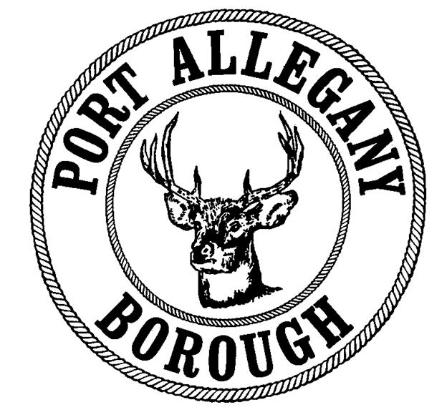 | Port Allegany Borough  Application for Soliciting / Peddling License  Applications and payment must be returned to the Port Allegany Borough Office  45 W. Maple Street, Port Allegany, PA 16749

I. Applicant Information
Applicant’s Name
Street Address
City |  |  |  | State |  | Zip

Are you self employed? Yes No

II. Employer’s Information (if not self employed)
Employer’s Name
Street Address
City |  |  |  | State |  | Zip

III. Length of License
Length | Start Date | End Date
1 day ($10)
1 month ($15)
3 months ($25)
1 year ($75)

IV. Description of Goods, Services, or Wares Offered for Sale

V. Vehicle Information
Make |  |  |  |  | Model
License Plate # |  |  | State Registered |  |  |  | Color

VI. Criminal History
Have you ever been convicted of a crime? Yes No

If yes, what were the nature of the offense(s) and the punishment imposed?

All applicants are required to submit a photograph of himself / herself , which will be
retained by the borough. Copies of driver’s licenses will be accepted.

In making this application, the undersigned agrees that upon application approval, the applicant will be bound by the provisions contained in the pertinent ordinances, rules, and regulations of the Port Allegany Borough. By signing below, the applicant also attests that all information provided on this application is true and accurate to the best of their knowledge

Signature: Date:

For Office Use Only – the person whose name appears above has applied for and received a license to peddle and/or solicit the above referenced goods and/or services within the Borough of Port Allegany for the date(s) shown.
Payment Method:  Cash Check / Money Order #: | Amount Paid:
Approved by: | Date:

