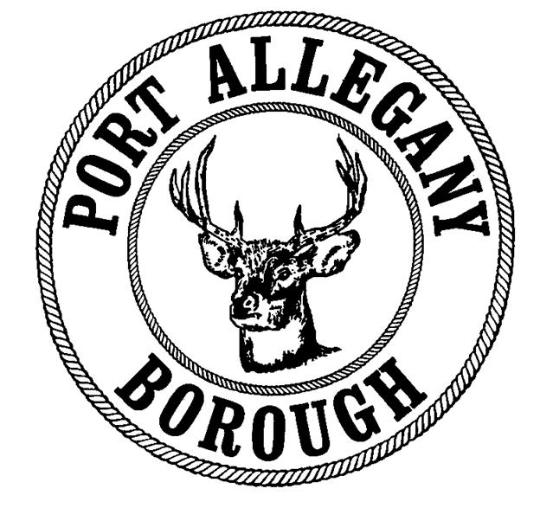 | Port Allegany Borough  Application for Special Event / Activity

The submission of a completed Application for Special Event does not guarantee approval. It may be necessary to meet with representatives of all departments affected by the proposed event (Borough Administration, Public Works, Road Crew, and/or Police) to arrange for needs at the event. Applicants should submit this application at least one (1) month in advance of the event, and may want to delay publicity until approval is granted.

I. Requested By
Name |  |  | Phone Number
Organization
Address
City |  |  |  | State |  |  | Zip
Email

II. Event Information
Event Title
↓Event Date(s) |  | ↓Start Time | ↓End Time

What is the estimated attendance for the event?

Will you be charging an admission fee for the event? Yes No

What is the admission fee? / person / family / organization

What will the proceeds from admission fees be used for?
Support a non-profit organization, please provide name:
For profit activity

III. Type of Event (check all that apply)
Festival or Event on Town Square – complete section IV
Use of Street or Street Closing for Special Event - complete section V
Fireworks Display – complete section VI

IV. Events on Town Square
- Please provide a brief description of the event including the purpose of the event, activities, and intended audience.

- Will food be served at this event? Yes No

- Will goods, services or wares be sold at this event? Yes No

- Do you need access to electric? Yes No

- Electric Costs
# Days | Cost of $25/day for electric | Total Electric Cost
Events utilizing electricity to operate items other than lights or small appliances may be charged a higher rate for electric usage.

- Will you be decorating the Town Square? Yes No
The individual or organization sponsoring the event is responsible for removal of all decorations and debris from the square and sidewalks left from the event.

- Will the event involve animals and/or will animals be allowed at the event?
Yes No
The individual or organization sponsoring the event is responsible for removal of any debris from the square or sidewalks left from the event.

- Will this event involve any rides? Yes No

- If the event involves rides, what types of rides will be offered?
Animal Rides
Inflatable Rides
Mechanical Rides
Other: please describe

- Will a port-a-potty be provided for use by event attendees? Yes No
Port-a-potty fees, set-up, cleaning, and removal are the responsibility of the sponsoring organization.

V. Use of Street or Street Closing
- Please provide a brief description of the event including the purpose of the event, activities, proposed route, and intended audience.

- Please highlight the proposed route for the event on the attached map of the Borough.

- Will any of the roads on the proposed route need closed? Yes No

- If roads need closed, please identify what sections of the road(s) need closed.

- Will any businesses be impacted by your proposed road closures? Yes No
If businesses will be impacted, all businesses must be contacted by the sponsoring organization prior to the event and notified of the proposed closure so they have the opportunity to provide feedback to the Borough on their support or lack of support for a road closure. Business notification is the responsibility of the sponsoring organization.

- Do the proposed road closures involve any State Roads? Yes No
If State Roads are involved, a special permit must be requested from PennDOT. The sponsoring organization is responsible for applying for the PennDOT special permit and must provide adequate time for their request to be reviewed and processed by the State.

- Do you need barricades for this event? Yes No
Barricades can be picked up and returned at the Borough Office between 8:00 AM and 3:00 PM Monday through Friday. Barricades must be returned on the first working day following the event.

- Do you need traffic control for this event? Yes No

- If you need traffic control would you prefer?
Traffic Control Provided by Borough Police Department (fees will apply)
Traffic Control Provided by Volunteers from Your Organization (free of charge)
If you/your organization is providing traffic control, please provide a list of volunteers that includes names, addresses and phone numbers of individuals authorized to represent your organization in this capacity. In addition, the Borough Police Department reserves the right to require traffic control based on their evaluation of the event, regardless of your answer to question “f”, and in some instances involving a State Route or special circumstances, traffic control may need to be provided by the Borough Police Department.

- Will food be served at this event? Yes No

- Will goods, services or wares be sold at this event? Yes No

- Will you be decorating the streets? Yes No
The individual or organization sponsoring the event is responsible for removal of all decorations or debris left on the road or sidewalks from the event.

- Will the event involve animals and/or will animals be allowed at the event?
Yes No
The individual or organization sponsoring the event is responsible for removal of any debris left on the roads or sidewalks from the event.

VI. Fireworks Display
- What is the proposed shooting/launching location for Fireworks Show?
Property Owners Name
Address |  |  |  |  | Phone Number
City |  |  |  |  | State |  |  | Zip
Email

- Do you have permission from the property owner to shoot/launch fireworks from this location? Yes No

- Have you notified the following agencies of your intent to shoot/launch fireworks including detailed directions on how to access the site in the event of an emergency?

Port Allegany Ambulance Service
Star Hose Fire Department
Port Allegany Police Department

- Will the fireworks be shot/launched by a qualified shooter? Yes No

- Please provide a summary of the proposed shooter’s qualifications and experience.

VII. Fees
Electric Usage ($25/day) | $
Traffic Control ($25/hour) | $
Total Fees Due | $

VIII. Terms and Condition
- Certificate of Insurance Requirements
- Festival or Event on the Town Square - $1,000,000 Minimum General Liability
- Use of Street or Street Closing - $1,000,000 Minimum General Liability
- Fireworks Display from Private Property - $1,000,000 Minimum General Liability
- Event involving Mechanical Rides - $5,000,000 Minimum General Liability plus an additional endorsement added to the vender’s policy that guarantees the Borough a $5,000,000 per occurrence limit
- Event sponsors are required to sign a hold harmless and indemnity statement.
- All road closures must still maintain access for emergency vehicles including the fire department, ambulance service, police department, water department, sewer department, or other agencies.
- For fireworks displays, in addition to the certificate of insurance, the governing body of the municipality shall require a bond deemed adequate by it from the licensee in a sum not less than five hundred dollars ($500) conditioned for the payment of all damages which may be caused either to a person or persons, or to property by reason of the licensed display and arising from any acts of the licensee, his agents, employees or subcontractors.
- Events involving high risk activities including but not limited to: sports, mechanical rides, animals, or fireworks may require additional insurance coverage at the recommendation of the Borough’s Insurance provider.
- Events utilizing electric for purposes other than lighting or operating small appliances will be charged a higher rate to be determined by the Borough Manager.
- Applicant is responsible for publicizing and conducting the event. Event planners should use common sense regarding participant health and safety.
- In making this application, the undersigned agrees that upon application approval, the applicant will be bound by the provisions contained in the pertinent ordinances, rules, and regulations of the Port Allegany Borough. By signing below, the applicant also attests that all information provided on this application is true and accurate to the best of their knowledge.

Applicant Signature Date

Property Owner Signature Date
(only required for Fireworks Display Permits)

Fire Chief Approval Date
(only required for Fireworks Display Permits)

Police Chief Approval Date
(review of traffic control requirements)

Borough Approval Date

Borough of Port Allegany
Hold Harmless and Indemnification Agreement
For use of Borough Property, Roads, Electric Connection, or Public Fireworks Display

The _______________________________________ requests permission to use the Borough
name of organization requesting use of property

of Port Allegany’s ______________________________________________premises and conduct
name of property requested

activities thereon from ___________________________ to_______________________________.
event start date/time event end date / time

The ________________________________________ does hereby agree to save, hold
name of organization requesting use of property

harmless, defend, and indemnify the Borough of Port Allegany and its officials, employees, and

volunteers from any and all claims, demands, or causes of action heretofore or hereafter arising or

relating to use of the Borough of Port Allegany’s premises and our activities conducted thereon.

The undersigned does hereby knowingly, voluntarily, and willingly executes this release as

of this _____________ day of __________________, 20_______.
date month year

_______________________________
Signature Title

