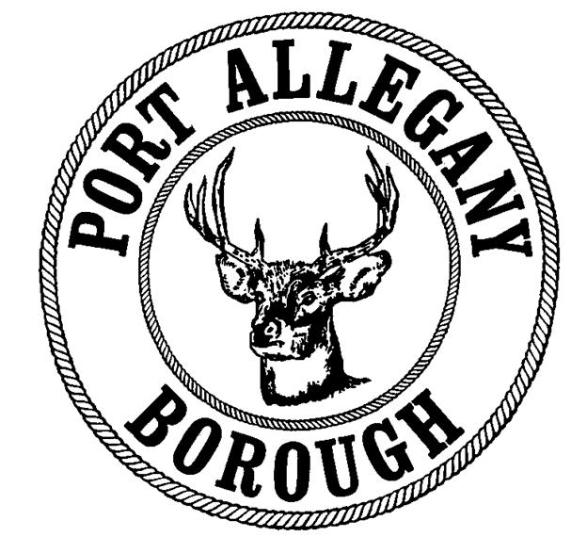 | Port Allegany Borough  Uniform Construction Permit Application

Application Number:
To be completed by inspector

Location of Proposed Work or Improvement
Municipality
Site Address |  |  |  |  |  | Tax Parcel #
Lot # |  |  | Subdivision/Land Development |  | Phase |  |  |  | Section

Applicant Information
Applicant |  |  | Phone |  | Fax
Mailing Address
Email

Property Owner Information
Owner |  |  | Phone |  | Fax
Mailing Address
Email

Contractor Information
Principal Contractor |  |  | Phone |  | Fax
Mailing Address
Email Address

Architect Information
Architect |  |  |  | Phone |  | Fax
Mailing Address
Email

Type of Work or Improvement (check one)

New Building
Addition
Alteration
Repair
Demolition
Relocation
Foundation Only
Change of Use
Plumbing
Mechanical
Electrical

Describe the proposed work:

Please include foundation and structural drawings

Estimated Cost of Construction (reasonable fair market value) $

Description of Building Use (check one)
Residential | Non-Residential
One-Family Dwelling (R-3) | Specific Use:
Two Family Dwelling (R-3) | Use Group:
Multi-Family (R-2) | Change in Use: |  |  | Yes No
Hotels (R-1) | If Yes, Indicate former:
 | Maximum Occupancy Load:
 | Maximum Live Load:

Building/Site Characteristics
Number of Residential Dwelling Units: |  | Current/Existing |  |  |  | Proposed
Mechanical (indicate the type of heating/ventilation/air conditioning. i.e. electric, gas, oil, etc)
Water Service (Check) | Public Private
Sewer Service | Public Private |  |  | Septic Permit #
Does or will your building contain any of the following
Fireplace(s) | Number: |  |  | Type of Fuel: |  |  | BTU’s: |  | Vent Type:
Elevator/Escalators/Lifts/Moving Walks: |  |  |  |  | Yes No
Sprinkler System |  | Yes No
Pressure Vessels |  | Yes No
Refrigeration Systems |  |  | Yes No
Asbestos |  |  | Yes No

Building Dimensions
Existing Building Area |  | Sq. Ft. |  | Number of Stories:
Proposed Building Area |  | Sq. Ft. |  | Height of Structure Above Grade |  |  |  | Ft.
Total Building Area: |  | Sq. Ft. |  | Area of the Largest Floor |  |  |  | Sq. Ft.

Floodplain
Is the proposed project located within any of the following flood areas as defined in chapter 100 of the Borough Code and/or the current FEMA Flood Insurance Rate Map?
Floodway Yes No Flood Fringe Area Yes No Floodplain Area Yes No

Owner/agent shall verify that any proposed construction activity complies with the requirements of the National Flood Insurance Program and the Pennsylvania Flood Plain Management Act (Act 166-1978), specifically Section 60.3 (d).

Land Disturbance
How much land will be disturbed (graded, filled, excavated, etc) to complete this project?
< 1 acre ≥ 1 Acre (43,600 square feet) or more

Directions to Site:

Building Inspector / Code Enforcement Agency – Which certified inspector will inspect your project?
Kelmar Services, LLC  Code Enforcement Agency on  contract with Port Allegany Borough | Other (applicants may use any certified inspector)  Name:  Phone:  Email:

Applicant Signature
The applicant certifies that all information on this application is correct and the work will be completed in accordance with the “approved” construction documents and PA Act 45 (Uniform Construction Code) and any additional approved building code requirements adopted by the municipality. The property owner and applicant assumes the responsibility of locating all property lines, setback lines, easements, rights-of way, flood areas, etc. Issuance of a permit and approval of construction documents shall not be construed as authority to violate, cancel or set aside any provision of the codes or ordinances of the municipality or any other governing body. The applicant certifies he/she understands all the applicable codes, ordinances and regulations.

Application for a permit shall be made by the owner or lessee of the building or structure, or agent of either, or by the registered design professional employed in connection with the proposed work.

I certify that the building inspector, code administrator, or the code administrator’s authorized representative shall have the authority to enter areas covered by such permit at any reasonable hour to enforce the provisions of the code(s) applicable to such permit.

Signature of Owner or Authorized Agent | Date |  | Print Name of Owner or Authorized Agent

Return Completed Application to Port Allegany Borough
In Person or By Mail  Port Allegany Borough Office  45 W. Maple Street  Port Allegany, PA 16743 | Fax  (814) 642-5095 | Email  clerk@portalleganypa.org

