|  |  |
| --- | --- |
| Port A borough seal.jpg | **Port Allegany Borough**  **Application for Special Event / Activity** |

**The submission of a completed Application does not guarantee approval.**

*It may be necessary to meet with representatives of all departments affected by the proposed event (Borough Administration, Public Works, and/or Police) to arrange for needs at the event. Applicants should submit this application at least* ***one (1) month in advance*** *of the event, and may want to delay publicity until approval is granted.*

**I. Requested By**

|  |  |  |  |  |  |  |  |
| --- | --- | --- | --- | --- | --- | --- | --- |
| Organization |  | Phone Number | | |  | | |
| Contact Name |  | | | | | | |
| Address |  | | | | | | |
| City |  | | State |  | | Zip |  |
| Email |  | | | | | | |

**II. Event Information**

|  |  |  |  |
| --- | --- | --- | --- |
| Event Title |  | | |
| ↓Event Date(s) | | ↓Start Time | ↓End Time |
|  | |  |  |
|  | |  |  |
|  | |  |  |
|  | |  |  |
|  | |  |  |

What is the estimated attendance for the event?

Will you be charging an admission fee for the event?  Yes  No

What is the admission fee?       / person       / family       / organization

What will the proceeds from admission fees be used for?

Support a non-profit organization, please provide name:

For profit activity

**III. Type of Event (check all that apply)**

Festival or Event on Town Square – complete section IV

Use of Street or Street Closing for Special Event - complete section V

**IV. Events on Town Square**

1. Please provide a brief description of the event including the purpose of the event, activities, and intended audience.

|  |
| --- |
|  |

1. Will food be served at this event?  Yes  No
2. Will goods, services or wares be sold at this event?  Yes  No
3. Do you need access to electric?  Yes  No
4. Electric Costs

|  |  |  |
| --- | --- | --- |
| # Days | Cost of $25/day for electric | Total Electric Cost |
|  |  |  |

*Events utilizing electricity to operate items other than lights or small appliances may be charged a higher rate for electric usage.*

1. Will you be decorating the Town Square?  Yes  No

*Only non-damaging items may be used on the Gazebo (nothing that leaves residue, holes, or other damage). The individual or organization sponsoring the event is responsible for removal of all decorations and debris from the square and sidewalks left from the event.*

1. Will the event involve animals and/or will animals be allowed at the event?

Yes  No

*The individual or organization sponsoring the event is responsible for removal of any debris from the square or sidewalks left from the event.*

1. Will this event involve any rides?  Yes  No
2. If the event involves rides, what types of rides will be offered?

Animal Rides

Inflatable Rides

Mechanical Rides

Other: please describe

1. Will a port-a-potty be provided for use by event attendees?  Yes  No

*Port-a-potty fees, set-up, cleaning, and removal are the responsibility of the sponsoring organization.*

**PLEASE NOTE: No vehicles are permitted on the Square at any time.**

**V. Use of Street or Street Closing**

1. Please provide a brief description of the intended purpose of the event.

|  |
| --- |
|  |

1. Please list all streets along the proposed route for the event.

|  |
| --- |
|  |

1. Will any of the roads on the proposed route need closed?  Yes  No

If roads need closed, please identify what sections of the road(s) need closed.

|  |
| --- |
|  |

1. Will any businesses be impacted by your proposed road closures?  Yes  No

*If businesses will be impacted, all businesses must be contacted by the sponsoring organization prior to the event and notified of the proposed closure so they have the opportunity to provide feedback to the Borough on their support or lack of support for a road closure.* ***Business notification is the responsibility of the sponsoring organization****.*

1. Do the proposed road closures involve any State Roads?  Yes  No

*If State Roads are involved, a special permit must be requested from PennDOT. The sponsoring organization is responsible for applying for the PennDOT special permit and must provide adequate time for their request to be reviewed and processed by the State.*

1. Do you need barricades for this event?  Yes  No

*Barricades can be picked up and returned at the Borough Office between 8:00 am and 3:00 pm Monday - Friday. Barricades must be returned the first working day following the event.*

1. Do you need traffic control for this event?  Yes  No

What type of traffic control will be needed?

Traffic Control Provided by Borough Police Department ($25/hour per officer)

Traffic Control Provided by Volunteers from Your Organization

*If you/your organization is providing traffic control, please provide a list of volunteers that includes names, addresses and phone numbers of individuals authorized to represent your organization in this capacity. In addition, the Borough Police Department reserves the right to require traffic control based on their evaluation of the event, regardless of your answer to question “g”. In some instances involving a State Route or special circumstances, traffic control by the Borough Police Department is required.*

1. Will food be served at this event?  Yes  No
2. Will goods, services, or wares be sold at this event?  Yes  No
3. Will you be decorating the streets?  Yes  No

*The individual or organization sponsoring the event is responsible for removal of all decorations or debris left on the road or sidewalks from the event.*

1. Will the event involve animals and/or will animals be allowed at the event?

Yes  No

*The individual or organization sponsoring the event is responsible for removal of any debris left on the roads or sidewalks from the event.*

**VI. Terms and Condition**

1. Certificate of Insurance Requirements

* Festival or Event on the Town Square - $1,000,000 Minimum General Liability
* Use of Street or Street Closing - $1,000,000 Minimum General Liability
* Event involving Mechanical Rides - $5,000,000 Minimum General Liability plus an additional endorsement added to the vender’s policy that guarantees the Borough a $5,000,000 per occurrence limit
* Certificates of Insurance must be received by the Borough within 7 days of event approval.

1. Event sponsors are required to sign a hold harmless and indemnity statement.
2. All road closures must still maintain access for emergency vehicles including the fire department, ambulance service, police department, water department, sewer department, or other agencies.
3. Events involving high risk activities including but not limited to: sports, mechanical rides, or animals may require additional insurance coverage at the recommendation of the Borough’s Insurance provider.
4. Events utilizing electric for purposes other than lighting or operating small appliances will be charged a higher rate to be determined by the Borough Manager.
5. Applicant is responsible for publicizing and conducting the event. Event planners should use common sense regarding participant health and safety.
6. In making this application, the undersigned agrees that upon application approval, the applicant will be bound by the provisions contained in the pertinent ordinances, rules, and regulations of the Port Allegany Borough. By signing below, the applicant also attests that all information provided on this application is true and accurate to the best of their knowledge.

Applicant Signature Date

Police Chief Approval Date

(only for Use of Street or Street Closing)

Borough Manager Approval Date

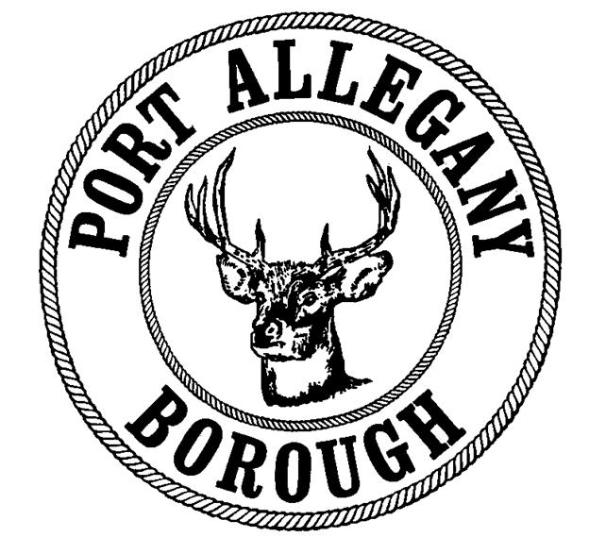

**Borough of Port Allegany**

**Hold Harmless and Indemnification Agreement   
For use of Borough Property / Roads / Electric Connection**

The                                     requests permission to use the Borough of Port Allegany’s

(name of organization)

Town Square / Streets and conduct activities thereon from            to           .

(circle one)

The                                     does hereby agree to save, hold harmless, defend, and

(name of organization)

indemnify the Borough of Port Allegany and its officials, employees, and volunteers from any and all claims,

demands, or causes of action heretofore or hereafter arising or relating to use of the Borough of Port Allegany’s

premises and our activities conducted thereon.

The undersigned does hereby knowingly, voluntarily, and willingly execute this release as of this       day of                     , 20     .

Signature Title