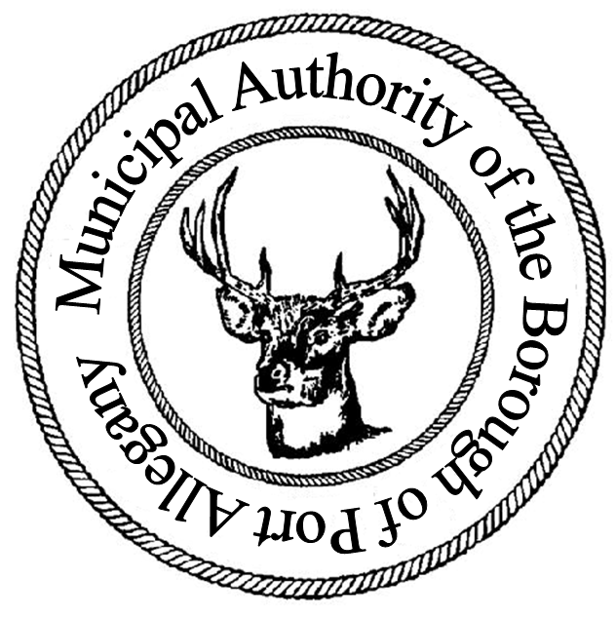 | Municipal Authority of the Borough of Port Allegany  Application for Water/Sewer Service  Application and payment must be returned to the Port Allegany Borough Office  45 W. Maple Street, Port Allegany, PA 16743 814-642-2526

I. Applicant Information
Name |  |  | Phone #
Email
Service Start Date

II. Service Address
Street Address
City |  |  | State |  | Zip

III. Billing Address (if different than service address)
Street Address
City |  |  | State |  | Zip

VI. Type of Service
Standard Metered (property must have an approved meter) Senior (65+)

A copy of a valid driver’s license or photo ID must be attached

Applicant Signature:
In making this application, the undersigned agrees that upon application approval, the applicant will be bound by the provisions contained in the pertinent ordinances, rules, and regulations of the Port Allegany Borough and Port Allegany Municipal Authority and that the service applied for may be provided on condition of compliance with all applicable ordinances, rules, and regulations. By signing below, the applicant also attests that all information provided on this application is true and accurate to the best of his/her knowledge.

Signature: Date:

