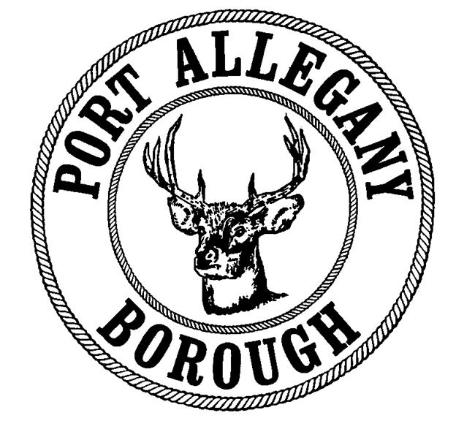 | Port Allegany Borough  For Calendar Year  Soliciting/Peddling License

I. Business Information
Business Name
Owner/Applicant Name |  |  |  |  | Phone #
Street Address
City |  |  |  | State |  |  |  | Zip

II. Description of Goods, Services, or Wares Offered for Sale

III. Vehicle Information
Make |  |  |  |  | Model
License Plate # |  |  | State Registered |  |  |  | Color

IV. Criminal History
Have you ever been convicted of a crime? Yes No

If yes, what was the nature of the offense(s) and the punishment imposed?

V. Dates for Licensing at $50/day (can be added to throughout the year)
Date | Date Paid |  | Date | Date Paid
All applicants must submit a valid driver’s license or photo ID.

VI. Display of License
Every solicitor or peddler shall, at all times when engaged in soliciting or peddling in the borough, carry the approved license upon his or her person and shall exhibit it upon request to all citizens, police officers, and borough officials.

No solicitor or peddler shall engage in selling any product or service not shown on the license.

In making this application, the undersigned agrees that upon application approval, the applicant will be bound by the provisions contained in the pertinent ordinances, rules, and regulations of the Port Allegany Borough. By signing below, the applicant also attests that all information provided on this application is true and accurate to the best of their knowledge

Signature: Date:

For Office Use Only – the person whose name appears above has applied for and received a license to peddle and/or solicit the above referenced goods and/or services within the Borough of Port Allegany for the date(s) shown.
Approved by: | Date:

