Ionia Community Theatre

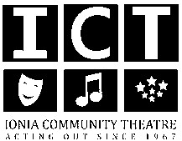

**Photo Release**

I hereby authorize Ionia Community Theater and its members the right to publish photos and videos for use in ICTs printed publications and website. I understand that these photos or videos may:

• Appear on the official Ionia Community Theater website at ioniaact.com

• Be used for publicity on Facebook, YouTube, and other social networks

• Be the content of posters for publicity and marketing

I understand that these photos or videos will be used for publicity and artistic expression and assume all associated risks of publication. I understand that this publication is voluntary and therefore will seek no profit from these photos or videos.

I HAVE READ THE RELEASE OF LIABILITY, FULLY UNDERSTAND ITS TERMS, UNDERSTAND THAT I HAVE GIVEN UP RIGHTS BY SIGNING IT, AND SIGN FREELY AND VOLUNTARILY WITHOUT ANY INDUCEMENT.