Draft copy for edits and additions to the 5 year update (2017)
Polk County Local Water Plan

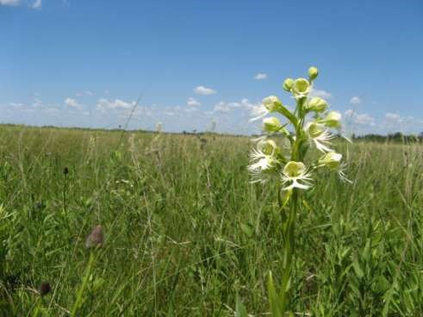

Local Water Management Coordinators

East Polk Soil & Water Conservation District
West Polk Soil and Water Conservation District

Polk County Board of Commissioners

Donald Diedrich
32620 200 th St. SW
Warren, MN 56762

Warren Strandell
2024 10th St. SE
East Grand Forks, MN 56721

Gerald Jacobson
42310 Center Ave. S.
Fertile, MN 56540

Gary Willhite
618 Lowell St.
Crookston, MN 56716

Joan Lee
28292 300th St. SE
McIntosh, MN 56556

Polk County Water Plan Committee

Joan Lee | County Commissioner
Jerry Jacobson | County Commissioner
Lisa Newton | East Polk Soil & Water Conservation District
Sarah Mielke | East Polk Soil & Water Conservation District
Ken Pederson | East Polk Soil & Water Conservation District
John Sorenson | West Polk Soil & Water Conservation District
Nicole Bernd | West Polk Soil & Water Conservation District
Brett Arne | MN Board of Water & Soil Resources
Josh Holte | Polk County Environmental Services
Emily Hutchins, Stephanie Klamm | MN Department of Natural Resources
 | Natural Resources Conservation Service
Dan Wilkens | Sand Hill River Watershed District
Corey Hanson | Red Lake Watershed District
Christine Slowinski | Middle River Snake River Watershed District
Denise Oakes | MN Pollution Control Agency
Michael Knudson | IWI
Laurie Fairchild | U.S. Fish & Wildlife Service
Rob Sip | MN Department of Agriculture
Jennilynn Marchand | MN Department of Health
Richard Rock | Union Lake Improvement District
Mike Schulz | Maple Lake Improvement District
Bob Baird | City of Crookston
Mike Powers | City of East Grand Forks
 | Assoc. of Townships

Table of Contents

County Commissioners……………………………………………………………….2

Task Force Committee…………………………………………….………………….3

I. Executive Summary………………………………………………………5
Introduction
Purpose of the Local Water Management Plan
Local Water Management Update Process
Description of Priority Concerns
Consistency with Other Plans
Watersheds in Polk County

II. Priority Concerns………………………………………………………..20
Assessment of Priority Concern 1
Assessment of Priority Concern 2
Assessment of Priority Concern 3
Assessment of Priority Concern 4

III. Goals and Objectives…………………………………………………….65
Priority Concern 1
Priority Concern 2
Priority Concern 3
Priority Concern 4

IV. Implementation Schedule…………………………………..……………78
Priority Concern 1
Priority Concern 2
Priority Concern 3
Priority Concern 4

V. Ongoing Activities…………………………………………………….….89

Appendix A: Acronyms for Cooperators…………………………………………...92
Appendix B: Priority Concerns Scoping Document……………………………….93

I. Executive Summary

Introduction
Polk County is located in northwest Minnesota. According to the U.S. Census Bureau, the county has a total area of 1,998 square miles, of which 1,971 square miles are land and 27 square miles are water. According to the April 1, 2010 census, the population of Polk County was 31,600. Projected population change as reported by the Minnesota Demographic Center, (June, 2007) show the population increases slightly (32,610) by the year 2015. The County seat is located in Crookston and the largest community is East Grand Forks. There are 58 townships and 15 cities within the county.

Polk County includes three general physiographic areas; glacial-lake plain, glacial lake-washed till plain, and glacial moraine area. The western third of Polk County is glacial-lake plain. This area is extremely flat, sloping only a few feet per mile. At one time it was the floor of glacial Lake Agassiz. The silty loam sediments that accumulated there formed fertile soils making one of North America’s most fertile farming regions. The glacial lake-washed till plain is flat to gently rolling area that has local relief up to 15 feet and is located mid-county. The western part of the glacial lake-washed till plain is traversed by north-south and northeast-southwest trending long, narrow beach ridges, some are as much as 20 feet high. The glacial moraine is an area of hills and depressions that has local relief up to 150 feet and is present in the eastern part of Polk County. (U.S. Geological Survey, Water-Resources Investigation Report 95-4201, 1996).

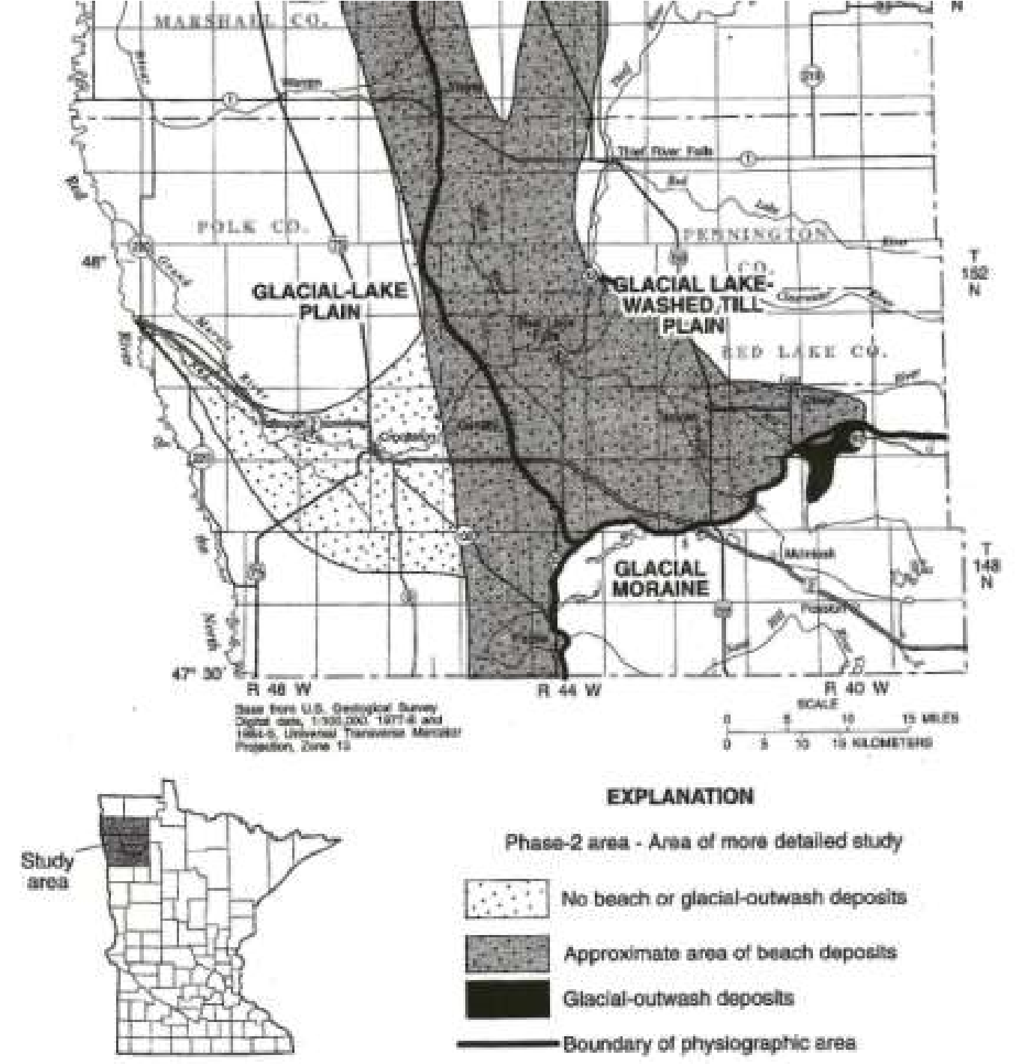
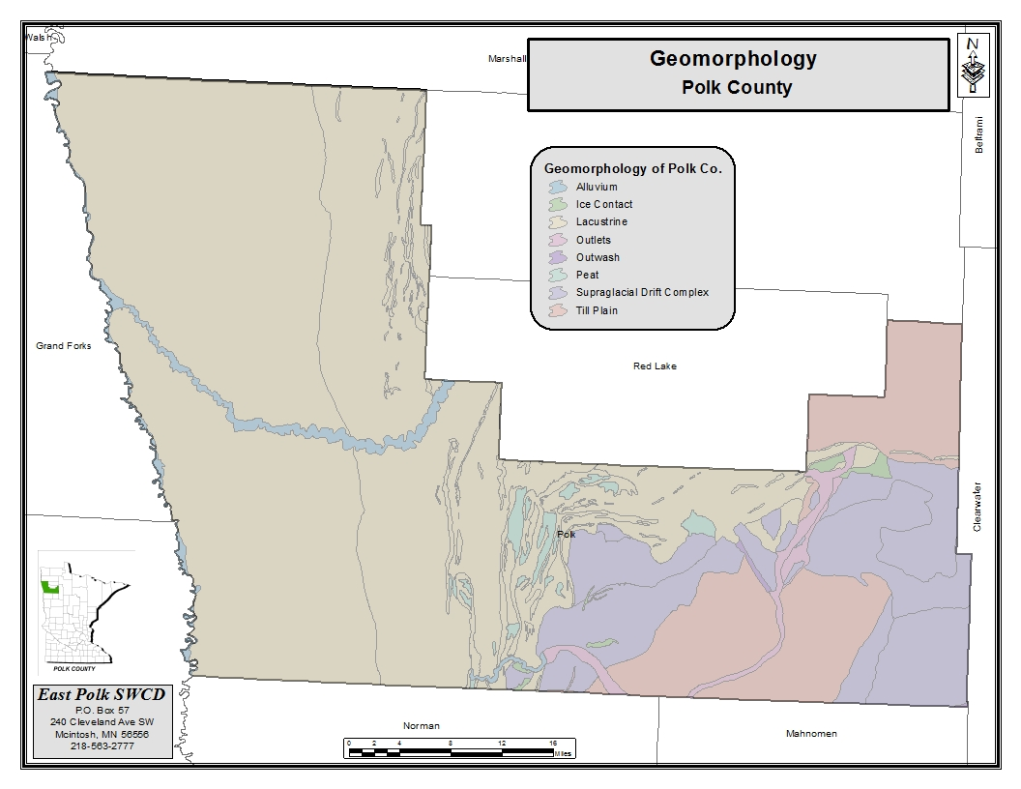
Polk County lies within the Red River of the North Basin Watershed. Due to the unique lake/river basin soils left by Glacial Lake Agassiz the primary land use of Polk County is agriculturally based, approximately 78%. The 2012 Census of Agriculture County Data from the USDA National Agriculture Statistic Service shows the number of farms in Polk County is 1,322 with the average farm size at 828 acres. The total cropland acres are991,405, with 9,423 acres being irrigated land. Land use practices in the beach ridge areas have previously been gravel mining and agriculture. These areas are now trending toward the restoration of pre-settlement conditions.

Four major watersheds are predominant within the jurisdictional boundaries of Polk County.
They include the Grand Marais Creek, Red Lake River, Sand Hill River and the Clearwater River Watersheds. Three other major watersheds have small acreage within the County. They are the Wild Rice, Snake, and Marsh Watersheds.

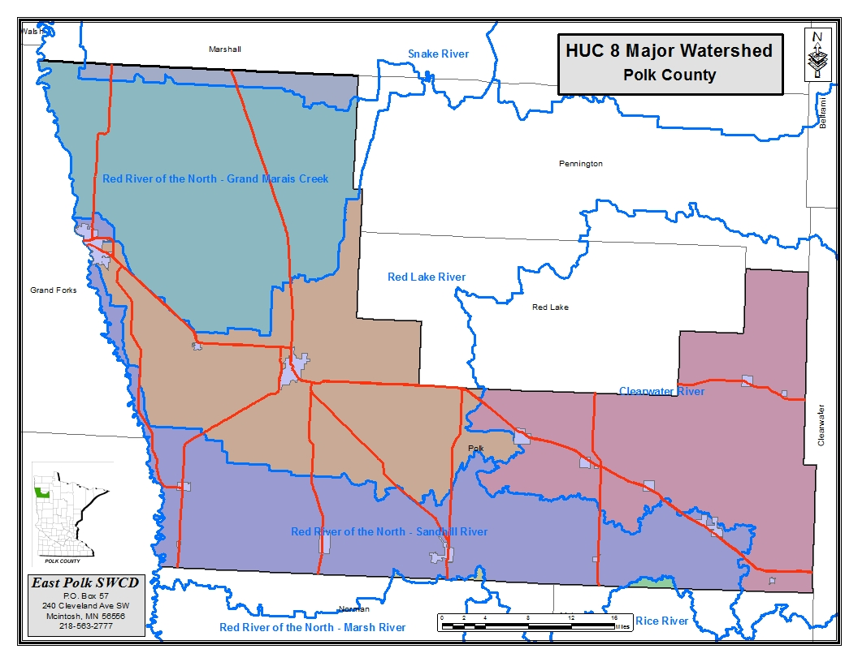

Purpose of the Local Water Management Plan:

The purpose of this updated Local Water Management Plan (LWMP) is to identify existing and potential problems and opportunities for protection, management and development of water resources and related land resources in Polk County. Pursuant to the requirements of Minn. Stat.
103B311 subd.4, the five requirements of this plan are as follows:
- The plan must cover the entire county.

- The plan must address problems in the context of watershed units and groundwater systems.

- The plan must be based upon principals of sound hydrologic management of water, effective environmental protection, and efficient management.

- The plan must be consistent with local water management plans prepared by counties and watershed management organizations wholly or partially within a single watershed unit or ground water system.

- The plan will cover a ten year period (2012 – 2022) with an implementation plan that will cover a five year period (2012 – 2017) and will then be updated for the remaining five years.

Polk County Local Water Management Plan’s Update Process
The Polk County Water Plan focuses on water and related land resource issues. The county has gathered and studied available information relating to the physical environment, including, but not limited to, the surface and ground water resources, and their related land use.
Concerns were identified, analyzed, and prioritized by the Polk County Water Plan Committee within the context of the watershed units and ground water systems where appropriate. The plan applies to the entire area within the county.

The Polk County Water Plan is coordinated and administered by the East Polk Soil and Water Conservation District and the West Polk Soil and Water Conservation District.
The Polk County Water Plan (previously known as the Polk County Comprehensive Local Water
Plan) was first developed and approved by the Minnesota Board of Water and Soil Resources in 1990. It was developed as a five year plan and was updated in 1997 (the 1990-1995 Plan was granted a two year extension). The 1997-2002 Plan was granted a two year extension. The 2005 to 2009 plan was also granted a two year extension which expired December 31, 2011.

Priority Concerns of Polk County Priority Concern #1
The Polk County Local Water Management Plan will focus on protection and enhancement of surface water quality. Specific areas of focus will be:

Lake Region in the eastern part of the county, with specific focus on the human impacts.
- Increases in development around smaller, non-recreational lakes and larger wetland complexes should be assessed to determine if adverse impacts have affected the water quality of these smaller bodies of water. Reference the Sand Hill River Watershed and Grand Marais Watershed WRAPs.
- For nearly all of the lakes in this ecoregion phosphorus is the limiting factor. Major management efforts related to water quality are directed at limiting the amount of phosphorus loading into the lakes. o Sediment loading has also become a major concern to the water quality of the lakes. Proper land use management and implementation of Best Management Practices needs to be analyzed and addressed. Reference the Sand Hill River Watershed TMDL and the Minnesota Buffer Law at http://bwsr.state.mn.us/buffers/ .
Surface water and ground waters in the western part of the county. o The City of East Grand Forks receives its public water supply from the Red Lake River.

o The Red Lake River is impaired for turbidity and management efforts should focus on sediment loading into the Red Lake River and its tributaries.
- In addition to the above mentions specific areas of concern for Polk County, The County Board, Watershed Districts and SWCD’s will actively pursue efforts to address surface water quality concerns within the county.
- Although surface water is of primary concern for Polk County we will be responsive to the need to monitor and protect our groundwater resources. We will participate to our fullest capacity but state and federal agencies such as Minnesota Department of Health (MDH) and United States Geological Survey (USGS) will need to be the primary source for groundwater protection and management.

Priority Concern #2
Polk County is subject to frequent flooding. Some factors such as topography and increase precipitation are unmanageable. Other factors such as flood plain encroachment, channelization of waterways, land use practices and effective private drainage into public systems, are factors that can be influenced by Best Management Practices.
Polk County Local Water Management Plan will focus on the quantity of water passing through the County and its associated watersheds by inventorying, assessing and evaluating the drainage infrastructure.

Priority Concern #3
Polk County is concerned with the preservation and enhancement of its natural resources. The geology of Polk County is divided into 3 distinct areas; the glacial-lake plain, glacial lake beach ridges, and washed glacial till plain. These major areas, because of their size, unique geographical features, and wide diversity of natural resources are of significant benefit to the area and citizens.
Polk County in cooperation with other local, state, and federal agencies will work to restore, enhance and protect these areas through programs and projects that accomplish this; cautious it is not done at the expense of the local economy.

Priority Concern #4
Polk County Local Water Management Plan will identify any new or yet to date undiscovered exotic and invasive species for prevention and management practices and will manage for any existing known species. Reference the Minnesota Prairie Conservation Plan at http://www.dnr.state.mn.us/prairieplan/index.html

Consistency with Other Plans

In preparation of the Polk County Local Water Plan the most recent plans from several entities were examined to ensure consistency with their concerns. Major plans reviewed were the Sand Hill Watershed District Watershed Management Plan, Sand Hill River Watershed WRAPs, Red Lake River Watershed One Watershed One Plan, .Red Lake River Watershed WRAPs. Local plans include Local Water Plans from adjacent counties, and local annual plans from SWCD’s and Polk County Environmental Services. The Polk County Local Water Management Plan Update has utilized appropriate action items to support these plans and is consistent with goals and objectives presented in these plans.

The plan is also based on key economic and environmental principles, and is consistent with other plans that exist for Polk County, including Watershed Districts, Soil and Water
Conservation Districts, Environmental Service agencies, Red River Valley Basin organizations, and appropriate state and federal agencies.

The plan also takes into consideration the adjacent County Local Water Management Plans in its water management strategies. All the river systems flowing through Polk County are influenced by watersheds that go beyond the jurisdictional boundary of Polk County, therefore to manage water on a watershed bases coordination with adjacent counties with common watersheds to Polk County will be required.

The five major watersheds that have drainage areas within the boundaries of Polk County include the Grand Marais Creek, Red Lake River, Clearwater River Watersheds, which are within the boundaries of the Red Lake Watershed District, Snake River Watershed which is in the Middle-Snake-Tamarac Rivers Watershed District, and the Sand Hill River which is the boundary for the Sand Hill River Watershed District. Having been an active participant in the updating processes of the Red Lake Watershed District Overall Plan, which was updated in 2006, and the Sand Hill River Watershed District Overall Plan in 2012 it is the intentions of Polk County Board of Commissioners and the Board of Supervisors for the West and East Polk SWCDs to recognize these Watershed District overall plans as a major reference documents for the implementation strategies for the priority concerns identified in the Polk County Local Water Management Plan. We support this approach based on the principles that water management is best managed on a comprehensive watershed basis. We realize we only make up portions of four of the sub-watersheds addressed in these 2 Watershed overall plans. We intend to reference these frequently as we proceed to implement local water management in our county.

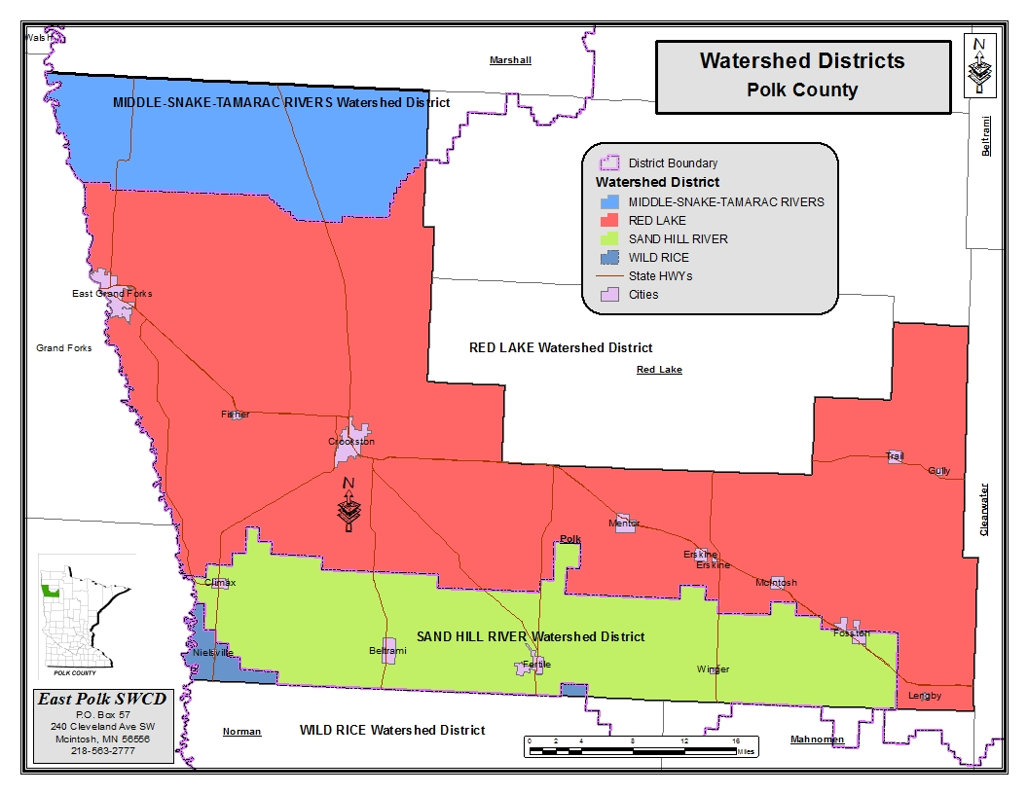

Watersheds in Polk County

Under legislative mandate, revisions to County Water Plans must be written within a watershed context. The purpose of this requirement is to ensure that counties look beyond the jurisdictional boundaries when making assessments and goals for water quality issues. By doing this, the county will be able to identify trends, problems and opportunities that are specific to a watershed rather than assuming the problem or issue is confined to political boundaries.

For the County to have an enduring impact on water management issues on a watershed basis, be it for water quality or quantity Polk County will need to implement actions that are in concert with those of other jurisdictions within a watershed such as other counties, SWCDs, or in the case of Polk County, Watershed Districts.

Four major watersheds are predominant within the jurisdictional boundaries of Polk County. They include the Grand Marais Creek, Red Lake River, Sand Hill River and the Clearwater River Watersheds. Three other major watersheds have small acreage within the County. They are the Wild Rice, Snake, and Marsh Watersheds.

Grand Marais Creek Watershed

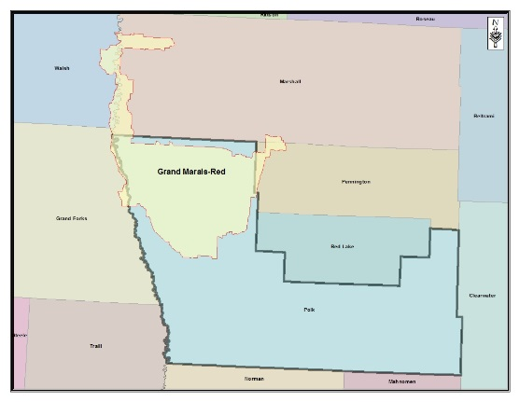
The Grand Marais Watershed lies in the northwestern portion of Polk County. It totals 466 square miles including portions in Polk, Marshall and Pennington Counties in Minnesota; North Dakota, counties include Walsh and Grand Forks. In Polk County the watershed includes 358 square miles, making up 76.9 percent of the watershed. Polk County communities within this watershed are: Angus, Euclid, Sherack, and Tabor. Reference NRCS Rapid Watershed Assessment for more information

https://www.nrcs.usda.gov/Internet/FSE_DOCUMENTS/nrcs142p2_022281.pdf

In Polk County the majority of the watershed lies within the Agassiz Lake Plain. Beach ridge areas of the watershed can be found in Helgeland, Brandt, Belgium and Parnell Townships. No lakes are located in within this watershed. Land use is primarily agriculture production and is extensively drained. Few wetlands
remain in the Agassiz Lake Plain. Wetlands can be found in the beach ridge areas, and the potential for calcareous fens exists in these areas.

The main resource concerns in the watershed are wind and water erosion, nutrient management, wetland management, surface water quality, flood damage reduction, and wildlife habitat. Many of the resource concerns relate directly to flooding and increased sediment and pollutant loadings to surface waters.

The following information is taken from the One Watershed One Plan (1W1P).. The Grand Marais watershed is dominated by private lands in agricultural production and a series of ditches that drain into the Grand Marais Creek. The portion of this watershed west of
U.S. Highway 75 is almost 100 percent agricultural land. West of U.S. Highway 75, narrow bands of natural lands are found along the Red River and along the Grand Marais Creek. East of U.S. Highway 75, there is a mix of grasslands and agricultural lands with some wetlands. Two WMAs in this area also provide some quality habitats; however, CRP lands provide the majority of grassland and wetland habitats. This area east of U.S. Highway 75 lies along the Campbell Beach Ridge.

Quality habitats in the western portion of this subwatershed are limited to the areas adjacent to Grand Marais Creek and the Red River. These habitats provide seasonal and permanent homes to a variety of species including game species such as white-tailed deer and waterfowl. Quality habitats in the eastern portion of the subwatershed include grasslands, wetlands and some brushlands. These areas provide seasonal and permanent habitats to a variety of species including game species such as white-tailed deer, prairie chicken and sharp-tail grouse. The prairie chicken population is declining due to loss of grassland habitat coming out of CRP and wet summers 2015-2016 (poor chick survival/nest failure).

The Grand Marais Creek is the primary waterway in this subwatershed. The waterway provides limited seasonal habitat to a few fish species. The alignment of most of this creek has not been significantly changed but adjacent land use and its hydrology have significantly changed. Large drainage system ditches outlet directly into the Grand Marais at almost every mile and roads cross the waterway almost every mile. The natural outlet of the Grand
Marais was bypassed and the waterway now flows straight west to the Red River. This outlet is unstable and has likely altered fish passage between the Red River and the Creek. The hydrology of this subwatershed has been modified due to drainage and land use changes (flashy flows extended periods of low flow). Historically, there is anecdotal evidence that the waterway and its corridor provided quality habitats for waterfowl nesting and production.

The Grand Marais subwatershed consists of an approximately 317 square mile area. The watershed outlets into the Red River approximately nine miles north of East Grand Forks and begins just west of the Goose Lake Swamp area. The watershed is located mainly within the Red River Valley ecoregion with the extreme eastern potion entering the Glacial Lake Agassiz/Aspen Parklands ecoregion. Soil textures range from fine in the western two-thirds of the watershed to sandy-loam/fine-loam in the eastern third of the watershed. The area consists largely of agricultural land (94 percent), but is also made up forest, wetlands, urban and grassland. Elevations range from 1000 feet mean sea level (msl) in the east to 800 feet msl along the Red River of the North.

Project 60F - http://www.redlakewatershed.org/PDF_Files/Final_Report%2007-20-2012]%20(ID%203789).pdf

Red Lake Watershed

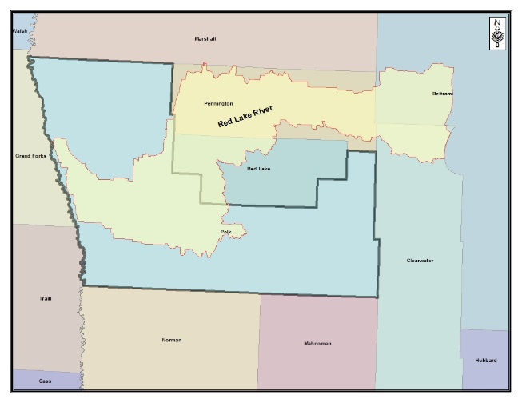
This watershed lies in the west central portion of Polk
County and into western portions of Red Lake and Pennington Counties. The Red Lake Watershed totals 1,420 square miles with 480 square miles included in Polk County. The river flows southwesterly through the towns of Thief River Falls, Red Lake Falls, and Crookston before converging with the Red River of the North in East Grand Forks. Polk County communities within this watershed are: Crookston, Fisher, Gentilly, and Mentor. This river is of great importance for recreation, wildlife habitat and drinking water. The river supports a healthy diversity of fish species as well as retaining a quality vegetative riparian buffer zone in the glacial moraine and glacial moraine-washed tilled plain (beach ridge) physiographic areas of the watershed. It is used as a source for public water supply for the cities of Thief River Falls, East Grand Forks and Grand Forks.

NRCS Rapid Watershed Assessment publication for information
https://www.nrcs.usda.gov/Internet/FSE_DOCUMENTS/nrcs142p2_022515.pdf

In Polk County the watershed lies within the Agassiz Lake Plain to the west with beach ridge areas in the eastern portion. Land use is primarily agricultural production in the Agassiz Lake Plains area with main crops being small grain, sugar beets, corn and soybeans. This area is extensively drained; few wetlands remain in the western portion of the watershed. Land use in the beach ridge area is primarily agricultural consisting of crops, cattle production and temporary restoration (CRP) of native habitat. Sand and gravel mining are significant natural resources that are mined on the beach ridges. Glacial Ridge National Wildlife Refuge, the United States’ largest tall grass prairie and wetland restoration project is located in the beach ridge area of the watershed.

The main resource concerns in the watershed are wind and water erosion, nutrient management, wetland management, surface water quality, flood damage reduction, and wildlife habitat. Many resource concerns relate directly to flooding and increased sediment and pollutant loadings to surface waters.

The following information is taken from the 1W1P.
The Lower Red Lake River basin includes the Heartsville Coulee, Burnham Creek and Lower Red Lake River minor subwatersheds. The Heartsville Coulee and most of the Burnham Creek watershed areas are dominated by lands in agricultural production. Small patches of woodland and grassland habitat exist near waterways and along the Red Lake River and Red River. Tributaries and ditches in the area provide some seasonal habitat for fish while the lower Red Lake River and Red River provide a diversity of fish and wildlife habitats year round. Many tributaries (natural and ditches) are unstable with large amounts of active erosion
The Lower Red Lake River watershed (generally east of U.S. Highway 9) and eastern portions of the Burnham Creek watersheds have more diverse habitats including agriculture, grasslands, wetlands, brushlands and woodlands. Included in these areas are numerous WMAs, waterfowl protection areas (WPAs).

CRP lands are also common along State Highway 102 (until about 8 miles west of U.S. Highway 9) and in areas along and east of U.S. Highway 9. These lands provide seasonal and permanent habitats to a variety of species including game species such as white-tailed deer, sandhill crane, waterfowl, prairie chicken and sharp-tail grouse. The prairie chicken population has decreased in recent years.

Burnham Creek and Heartsville Coulee provide some seasonal habitat for fish. The Lower Red Lake River provides a diversity of habitats year round. Many tributaries to these streams (natural and ditches) are unstable with large amounts of active erosion. A dam on the Red Lake River at Thief River Falls limits fish passage and the potential for this watershed to produce fish. An important historical lake sturgeon spawning bed is located at the confluence of the Lower Red Lake and Clearwater rivers.

http://www.bwsr.state.mn.us/cleanwaterfund/stories/factsheets/2013/cwa/West%20Polk%20SWCD_Burnham%20Creek%20WSD_CWF13-125_CWA.pdf

The Lower Red Lake River watershed consists of an approximately 874 square mile area. The watershed outlets into the Red River of the North at East Grand Forks, and begins just downstream of the dam in Thief River Falls. The watershed is located mainly within the Red River Valley and Glacial Lake Agassiz/Aspen Parklands ecoregions. Soil textures range from fine in the western portion of the watershed to sandy loam in the east portion of the watershed. There are two sand ridges west of Thief River Falls along what is commonly termed the Pembina Trail. The area consists largely of agricultural land, but is also made up of forest, wetlands, urban and grassland.

This subwatershed is also comprised of two minor subwatersheds which outlet into the Red Lake
River. They are the Heartsville
Coulee and Burnham Creek minor subwatersheds. The Heartsville Coulee drains an area of approximately 33 square miles in West Polk County and joins the Red Lake River in East Grand Forks. The Lower Red Lake River subwatershed is bordered along its north side by the Grand Marais subwatershed. The drainage from within the smaller minor subwatersheds ends up in the Red Lake River in the western half of the watershed. The Thief River and Upper Red Lake River subwatersheds are tributaries to the Lower Red Lake River subwatershed in Thief River Falls. The Clearwater River subwatershed is a tributary to the Lower Red Lake River in Red Lake Falls.

There are no lakes in this subwatershed. Wetland areas are scattered throughout the area. These wetland areas are somewhat denser in the extreme southeastern portion of the subwatershed, generally south of U.S. Highway 2 and east of State Highway 102, known as Glacial Ridge. Many of the wetlands in this watershed have been altered by farm drainage for the purpose of agricultural production. Drainage systems in this subwatershed are a complex network of natural streams and legal ditch systems. Generally the ditch systems are under the administration of the county or watershed district in which they reside.
Glacial Ridge is the largest prairie and wetland restoration project in U.S. history. When The Nature Conservancy and its partners initiated the project in 2000, only about 3,000 acres of the more than 24,000 acres purchased by the Conservancy was native prairie; the rest had been used for gravel extraction, crop production and cattle and sheep grazing. The restored grasslands and wetlands provide excellent habitat for prairie nesting birds, threatened prairie plants and wildlife.

The land acquired by the Conservancy forms the core of what is now the Glacial Ridge National Wildlife Refuge, which in time may expand to more than 37,000 acres. The refuge, which is part of the 150-million acre National Wildlife Refuge System, is expected to include more than 8,000 acres of wetlands and about 20,000 acres of tallgrass prairie.

The subwatershed is located in the Lake Plain physiographic area of the RLWD. The surficial geology of the area consists of mainly clay with small regions of silt, sand, sand and gravel ridges and lake-washed till. Clay deposits dominate the Lower Red Lake River subwatershed and are characterized as being very dense, uniform and of low permeability. Thicknesses can range from a few feet in the eastern part of the watershed to more than 120 feet in the western portions. Nearly level topography in this region also relates to poor drainage. Sand and gravel ridges, known as beach ridges from Glacial Lake Agassiz, occur in mainly north-south trending ridges that range in thickness from a few feet to 30 feet in some areas. Drainage is good within the ridges, but can be poor in the inter-ridge areas where deposits of peat are evident. The fine sand or silt deposits in the area are fairly uniform and are underlain by till and clay. Thicknesses for both deposits are generally less than 20 feet. Lake-washed till deposits are described as sandy, clay-silt loam that contains fine to medium gravel with a scattering of boulders. The deposits are generally not well drained.

Glacial aquifers in the region only provide moderate amounts of groundwater. Suitable yields of 5 gpm, or more for domestic use, are mainly found in sand and gravel deposits in the till. Beach ridge deposits are limited in aerial extent and saturation is limited to a few bottom feet. Groundwater supplies from the smaller beach deposits are unreliable due to periods of limited precipitation. Groundwater supply for industrial use and irrigation is generally poor. Quantities and quality for such uses are inadequate. Hardness of the groundwater is commonly greater than 180 mg/l.

Paleozoic sediments consisting of shales and limestones are discontinuous and underlie the glacial lake deposits along the western side of the subwatershed. The western tip of the subwatershed near East Grand Forks contains Paleozoic limestone and sandstone that is thin and discontinuous. Paleozoic deposits contain highly saline groundwater. Precambrian crystalline rocks underlie most of the subwatershed, forming the base of the groundwater reservoir for most of the watershed. The fractured surface of crystalline rocks may provide an adequate supply of groundwater for limited domestic use.

Clearwater Watershed

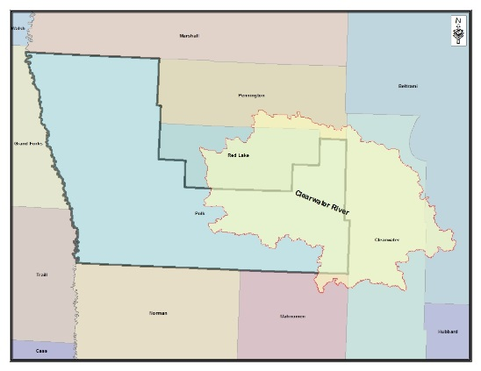
The Clearwater Watershed is approximately 1,385 square miles in size with 493 square miles located in the eastern portion of Polk County. The Clearwater River begins in western Clearwater County and flows to the northwest and southwest, eventually emptying into the Red Lake River inRed Lake Falls. Polk County communities within this watershed are: Erskine, Gully, Lengby, McIntosh, and Trail.

In Polk County this watershed contains beach ridge areas in the western portion and moraine areas in the eastern portion. Landforms in this area contain hill and depressional areas. Rydell National Wildlife Refuge is located on the beach ridge prairie to forest transition zone. Polk County land use in this watershed is
agricultural production, gravel mining, recreation, forest, and residential/commercial development. Many wetland areas remain throughout the watershed. Calcareous fens exist in this area as do rare and endangered plants.

The main resource concerns in the watershed are wind and water erosion, nutrient management, wetland management, surface water quality, flood damage reduction, and wildlife habitat. Many of the resource concerns relate directly to flooding and increased sediment and pollutant loadings to surface waters.

The following information is taken from the Red Lake Watershed 10 Year Comprehensive Plan. The Clearwater basin includes Upper and Lower Badger Creeks, Clearwater River, Hill
River, Lost River and Poplar River minor subwatersheds. The landscapes in these subwatersheds provide a diversity of habitats with farmlands, grasslands, woodlands, wetlands, riparian areas and lakes. Public lands with quality habitats include numerous WMAs, WPAs and Rydell NWR. The majority of these lands are in the beach ridge areas. These include a mix of uplands and wetlands with some woodland areas. These lands provide seasonal and permanent habitats to a variety of species including game species such as white-tailed deer, sandhill crane, waterfowl, prairie chicken and sharp-tail grouse. CRP lands are present throughout the watershed with a concentrated band running east to west generally along the southeast border of Red Lake County (along a beach ridge area). These CRP lands are primarily grasslands. Several wild rice operations also provide some migratory wildlife habitat.

Lakes are prominent and important resources in this watershed. In particular, a number of small lakes are found throughout the southern half of the watershed. These include a mix of fishing and natural environment lakes that provide seasonal and migratory habitat for a variety of species.

Six natural waterways and their tributary networks are also important natural resource features of this watershed. These streams provide a variety of permanent and seasonal habitats for a variety of fish species. The Clearwater River is a trout stream from Clearwater Lake to the west Clearwater county line. The stream is somewhat degraded upstream from this area. From lake to confluence with Ruffy Brook the stream is in good shape. Pasture and woodlands form its corridor. Some wild rice production is present near its confluence with Ruffy Brook and there is an ongoing USACE project in the reach from Ruffy Brook to about five miles east of Plummer.

The Poplar River, Hill River, Lost River and Upper and Lower Badger Creek are smaller systems than the Clearwater and primarily provide spawning and rearing habitat for fish. In most areas they have intact corridors that include some pasture areas. Portions of some streams have been dredged in the past but have become naturalized (e.g., Lost River between Oklee and Gully). This subwatershed is also comprised of five smaller subwatersheds which outlet into the
Clearwater River. These four subwatersheds include the, Badger Creek, Hill River, Lost River and Poplar River subwatersheds. The Clearwater River subwatershed is bordered along its north side by the Upper Red Lake River subwatershed. All of the drainage from within the smaller subwatersheds ends up in the Clearwater River. All of the water comes together in the Clearwater River and outlets at the confluence with the Red Lake River in Red Lake Falls.

The watershed outlets into the Red Lake River at Sportsman’s Park in Red Lake Falls, MN. The Lost, Hill and Poplar rivers are minor tributaries to the Clearwater River. The watershed is located mainly within the Glacial Lake Agassiz/Aspen Parklands and Glacial Moraine ecoregions, but is bordered by the Northern Minnesota Drift and Lake Plains ecoregion. Soil textures range from loamy-skeletal in the southeastern portion of the watershed to sandy in the west portion of the watershed. The area consists largely of agricultural and forest land, but is also made up of wetland, urban and grassland.

There are many lakes in the Clearwater River subwatershed. There are 28 lakes larger than
100 acres and 107 lakes smaller than 100 acres. Major lakes for recreation include Maple, Cameron, Badger, Clearwater, Pine, Oak, Cross, Turtle, Bradleyand Whitefish. The larger lakes typically support a fishery, with the majority of smaller lakes only supporting waterfowl and hunting as a recreation. Much of the shoreline is developed on the larger lakes, and the majority of small lakeshores are undeveloped.
Wetland areas are scattered throughout the area. These wetland areas are considerably denser in the extreme northeastern portion of the subwatershed, especially within the Red Lake Reservation, where the original wetlands are intact. Many of the wetlands have been altered by farm drainage with intent of using for agricultural production.

Sand Hill River Watershed

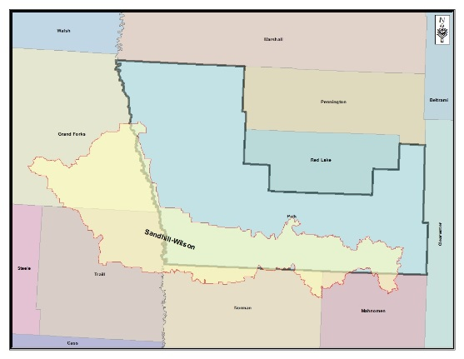
The Sand Hill River Watershed (SHRWD) lies in the southern portion of Polk County and comprises an area of 483 square miles. Norman and Mahnomen counties comprise the remaining small areas 5 percent and 6.4 percent respectively. The watershed map shows the Sand Hill-Wilson watershed including the North Dakota portion. The total area of the Sand Hill-Wilson watershed is 1,107 square miles.

The Sand Hill River is relatively unbranched as it traverses the district. One notable exception is Kittleson Creek. Kittleson Creek is located in the north central part of the district and joins the Sand Hill River between Fertile and Beltrami. These watercourses consist of an
intermingling of natural streams and public and private drainage systems. Most of the land traversed by the Sand Hill River is characterized by low relief and is in agricultural production. The Sand Hill River flows to the west from Sand Hill Lake south of Fosston through Winger, Fertile, Beltrami and Nielsville to the confluence with the Red River of the North near
Climax. .

https://www.pca.state.mn.us/water/watersheds/red-river-north-sand-hill-river

https://www.nrcs.usda.gov/Internet/FSE_DOCUMENTS/nrcs142p2_021584.pdf

https://www.nrcs.usda.gov/wps/portal/nrcs/detail/mn/technical/?cid=nrcs142p2_023632

http://mrbdc.mnsu.edu/mnnutrients/watersheds/red-river-north-sandhill-river

Other watersheds bordering the SHRWD are the Wild Rice River (south and east), and Red Lake River (north and east). The western boundary is the Red River of the North. Polk County communities within this watershed are Beltrami, Climax, Fertile, Fosston, Nielsville, and Winger.

In Polk County the watershed lies within the Agassiz Lake Plain to the west with beach ridge area of the watershed in the south/central portions and moraines to the east. Land use is primarily agricultural production in the Agassiz Lake Plain area and is extensively drained. Very few wetlands remain in the western portion of the watershed. Wetlands are common in the glacial moraine region as well as in low areas between the beach ridges. There are many small lakes within the north-central portion of the SHRWD between Fertile and Winger. All of the lakes are in Polk County. Most of these lakes tend to be closed basins or have poorly developed outlets.
Union and Sarah Lakes are the largest and most heavily developed in the District. Cable, Sand
Hill, Union and Sarah Lakes are considered Recreational Development Lakes on the DNR
Protected Waters Inventory. Kittleson Lake is also a recreationally important lake in the District.

The main resource concerns in the watershed are wind and water erosion, nutrient management, wetland management, surface water quality, flood damage reduction, and wildlife habitat. Many of the resource concerns relate directly to flooding and increased sediment and pollutant loadings to surface waters.

The following information is taken from the Sand Hill Watershed District Watershed
Management Plan (Approved January 2012). The geology of the Red River Basin and the SHRWD, as a microcosm, consist of glacial lake deposits, lakeshore deposits, till and a small amount of ice contact deposits overlying the bedrock. Bedrock in the east part of the basin consists of Precambrian, undifferentiated igneous, and metamorphic rock. Bedrock in the west part of the basin consists of a small band of Cretaceous, fine grained sandstone and shell. Clay and silt lake deposits dominate the Lake Agassiz plain bordering the Red River of the North. A transition zone between the lake plain and the glacial moraine areas is formed by lakeshore deposits, delta sand, and gravel.

Species of wildlife hunted in the area include whitetail deer, waterfowl, pheasants, and ruffed grouse. The hunting of waterfowl is attractive because many ducks and geese are produced locally in the SHRWD’s numerous prairie potholes, and the watershed lies in the path of the Mississippi flyway. Geese, mallards, wood ducks, and blue-winged teal are most common in the pothole area.

The primary watercourse within the District is the Sand Hill River. A number of tributaries with differing channel size, slope and drainage area join the Sand Hill River as it flows west toward the Red River of the North. Kittleson Creek outlets into the Sand Hill River in the north central portion of the District. Very few additional discrete tributaries join the Sand Hill River within the western part of the District, rather, legal drainage systems serving agricultural land outlet into the Sand Hill River in the extreme western portion of the District.

The parent material for the soils in the western portion of the District is comprised of lacustrine sediments formed by glacial Lake Agassiz. Typical soils in this area vary from fine-silty clays along the western edge to very fine clay. In the central portion of the District soils range from clay loams and sandy loams mixed with sands and gravels. Soils in the eastern portion of the region consist of rolling and hilly areas of dark colored medium texture soils characterized as fine-loamy.

II. Priority Concern Assessments

Priority Concern 1: Surface Water Quality

A) The Polk County Local Water Management Plan will focus on protection and enhancement of surface water quality. Specific areas of focus will be:

Lake Region in the eastern part of the county, with specific focus on the human impacts.

- Increases in development around smaller, non-recreational lakes and larger wetland complexes should be assessed to determine if adverse impacts have affected the water quality of these smaller bodies of water.
- For nearly all of the lakes in this ecoregion phosphorus is the limiting factor. Major management efforts related to water quality are directed at limiting the amount of phosphorus loading into the lakes.
- Sediment loading has also become a major concern to the water quality of the lakes. Proper land use management and implementation of Best Management Practices needs to be analyzed and addressed.

The Lakes region of the County has a direct impact on the economy of not only the county but the region. Lakes in this region are used for recreation, including boating, fishing, waterfowl hunting, swimming, and camping. They are used by permanent residents, summer home residents, and tourists who are attracted to this area from all over the United States and Canada. Public access and campgrounds are available for public use on many lakes. Many year-round residences and summer residences have been built in part because of the recreational and aesthetic appeal of the area. Fishing is popular in these lakes. Common fish found in these waters include bass, northern pike, and pan fish. To maintain this it is vitally important to have good water quality in and around the Counties lakes. That is why the County has identified this specific area so that these valuable natural resources may be preserved.

Lake Water Quality Data

The Minnesota Department of Natural Resources Lake Water Quality Data Summary for lakes in Polk County indicates that lakes are categorized by trophic status. Trophic status is the level of growth or productivity of a lake as measured by phosphorus content, algae abundance, and depth of light penetration. Eutrophic lakes are defined as nutrient rich lakes, usually shallow, “green” and with limited oxygen in the bottom layer of water. Mesotrophic lakes are defined as midway in nutrient levels between the eutrophic and oligotrophic lakes. Oligotrophic lakes are relatively nutrient poor, clear and deep with bottom waters high in dissolved oxygen. No lakes in Polk County are considered oligotrophic. The Minnesota Department of Natural Resources Lakefinder website offers information on 60 lakes in Polk County. Lake information, maps, water levels, water quality, topography and more can be found at: www.dnr.state.mn.us/lakefind/index.html .

MN DNR Lake Water Quality

Waterbody | Trophic Status
Badger | Mesotrophic
Breeze | Mesotrophic
Cable | Eutrophic
Cameron | Eutrophic
Hill River | Eutrophic
Maple | Eutrophic
Poplar | Eutrophic
Sand Hill | Mesotrophic
Sarah | Eutrophic
Store | Eutrophic
Turtle | Eutrophic
Union | Mesotrophic
Whitefish | Eutrophic

Sand Hill River Watershed

The following information is taken from the Sand Hill River Watershed District Management
Plan. In the mid 1990’s, the MPCA evaluated the ability of lakes within the Sand Hill River Watershed to meet the goal of being swimmable and aesthetically pleasing. The MPCA based the assessment primarily on the trophic status of lakes with the Sand Hill River Watershed through the use of actual lake water quality data. This analysis showed “good” water quality for Union, Sarah, Cable, and Sand. This determination of good water quality was based on comparison to other similar lakes within the ecoregion.

Increased demands on these water bodies, however, also leads to a risk of water quality degradation. While there are varying degrees of reduced water quality, impacts can already be seen on some of the SHRWD lakes. Twenty-four lakes in the Sand Hill River Watershed District have been identified as priority lakes for management. More information on the SHRWD lake management framework can be found in the Sand Hill River Watershed District Watershed Management Plan (January 2012).

General Characteristics of Lakes in the Sand Hill River Watershed District
Lake Name | ID | Lake Area | Quality | Sensitivity to  Disturbance
LaDuc | 03030400 | 101 | high | Moderate
Ketchum | 03064800 | 170 | high | Moderate
Frethem | 03064600 | 65 | marginal | High
Allen | 03031300 | 156 | high | Moderate
Eastland | 03065900 | 41 | high | Moderate
Simonson | 03065700 | 137 | high | Moderate
Sand Hill | 14009900 | 598 | marginal | High
Labrie | 14002100 | 193 | high | Moderate
Hilligas | 14001900 | 130 | marginal | High
Strand | 03061900 | 28 | impaired | High
Clydes | 03029200 | 47 | moderate | Moderate
Newton | 03052800 | 46 | moderate | High
Matson | 03030200 | 42 | moderate | Moderate
Union | 03052600 | 910 | moderate | Moderate
Sarah | 60020200 | 43
Bungum | 03029300 | 67 | moderate | Moderate
Halverson | 03043000 | 161 | moderate | Moderate
Maltrod | 03024100 | 20 | moderate | Moderate
Rindahl | 14008900 | 54 | moderate | High
Cable | 14003000 | 82 | moderate | Moderate
Arthur | 14010000 | 123 | moderate | Moderate
Lundby | 14007800 | 33 | moderate | Moderate
Kittleson | 03035200 | 304 | moderate | Low
Chicog | 03057900 | 113 | moderate | Low

Fisheries in Polk County

The Minnesota Department of Natural Resources fisheries managers stock walleyes in several Polk County lakes. Stocking levels are adjusted up and down as necessary. The goal of these manipulations is to find appropriate stocking levels that increase or maintain healthy walleye populations. The following chart shows fish stocking rates for the previous three years. More information on fish stocking can be found on the MN DNR website: www.dnr.state.mn.us MN DNR Stocking Rates in Polk County

Lake | Year | Species |  | Fry | Fingerling | Yearling | Adult | Total  LBS
Badger | 2016 | Walleye | 260,000 |  |  |  |  | 2.2
Erskine Kid's Pond | 2016 | Bluegill Sunfish | 0 |  | 0 | 0 | 900 | 300
Maple | 2016 | Walleye | 0 |  | 15,372 | 1,864 | 511 | 1,576
Red Lake River | 2016 | Lake Sturgeon | 114,090 |  |  |  |  | 4.5
Sarah | 2016 | Walleye | 230,000 |  | 0 | 0 | 0 | 2.0
Spring | 2016 | Walleye | 0 |  | 900 | 0 | 0 | 45
Union | 2016 | Walleye | 591,000 |  | 0 | 0 | 0 | 5.1
Badger | 2015 | Walleye | 260,000 |  |  |  |  | 2.3
Cross | 2015 | Walleye | 303,000 |  | 0 | 0 | 0 | 2.7
Erskine Kid's Pond | 2015 | Bluegill Sunfish | 0 |  | 0 | 0 | 660 | 220
Hill River | 2015 | Walleye | 67000 |  | 0 | 0 | 0 | 0.6
Maple | 2015 | Walleye | 0 |  | 6,121 | 14,837 | 13 | 1,576
Red Lake River | 2015 | Lake Sturgeon | 100,000 |  |  |  |  | 4.0
Store | 2015 | Walleye | 50,000 |  | 0 | 0 | 0 | 0.5
Whitefish | 2015 | Walleye | 183,000 |  | 0 | 0 | 0 | 1.6
Badger | 2014 | Walleye | 260,000 |  |  |  |  | 2.3
Erskine Kid's Pond | 2014 | Bluegill Sunfish | 0 |  | 0 | 0 | 1,860 | 310
Maple | 2014 | Walleye | 0 |  | 964 | 31,545 | 24 | 1,576
Red Lake River | 2014 | Lake Sturgeon | 58,000 |  |  |  |  | 3.6
Sarah | 2014 | Walleye | 180,000 |  |  |  |  | 1.6
Spring | 2014 | Walleye | 0 |  | 1,056 | 0 | 0 | 44
Union | 2014 | Walleye | 591,000 |  | 0 | 0 | 0 | 5.2

Shoreland Development

The Annual Shoreland Report from the Polk County Planning & Zoning Administrator reports
115 Shoreland permits were approved in 2016. In 2015, 89Shoreland Permits were granted and in 2014 the number of shoreland permits approved was 97. The 2013 list data for shorelandpermits located within shoreland area (1000 feet lakes/ 300 feet rivers) reports 64 permits granted. This data indicates an increasing pattern of shoreland development around the lakes in Polk County. Development pressure has been increasing steadily on Natural Environment lakes, posing potential concerns of water quality risks. There is a need to determine what and how much this increased development impacts these smaller basins.

Potential Water Quality Risk in Polk County

The following map will be used to estimate areas of potential water quality risk in Polk County.
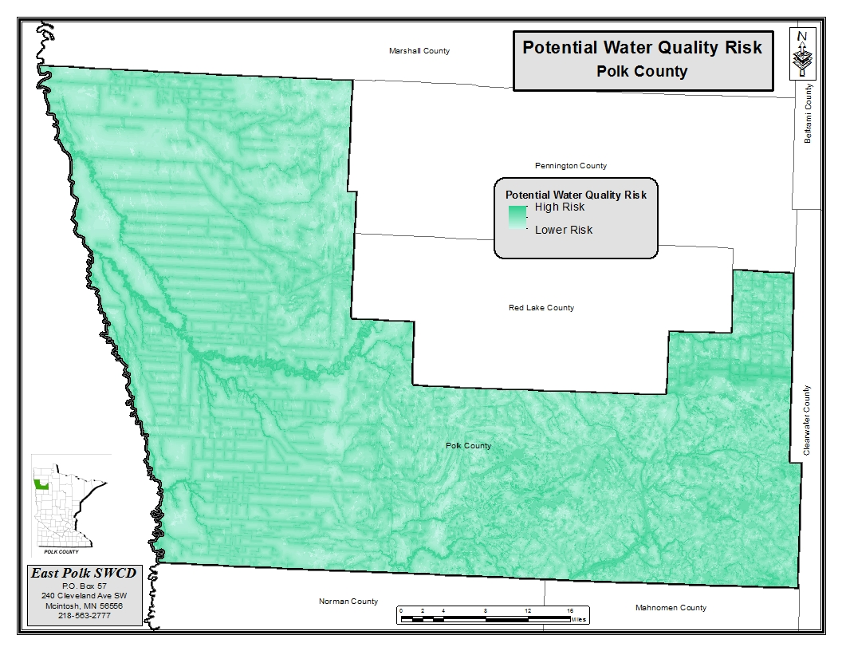

B) Surface water supplies in the western part of the county.
o The cities of East Grand Forks and Grand Forks receives their public water supply from the Red Lake River. East Grand Forks City Municipal Waterworks are permitted the use of 700 MGY/ 5,600 GPM for domestic water supply, while Grand Forks City Municipal Waterworks is permitted to use 3500 MGY/13900 GMP for their water supply.
o The Red Lake River is impaired for turbidity and management efforts should focus on sediment loading into the Red Lake River and its tributaries.

The City of East Grand Forks obtains its drinking water exclusively from the Red Lake River.
The City of Grand Forks, North Dakota, also uses the Red Lake River as a drinking water source. The MDH tests all public water supply systems for a variety of constituents. The testing is completed on “finished” water after any treatment processes. Large industries, such as power generating plants, sugar and potato processing plants rely on rivers for their water supply. It is necessary to filter and disinfect all river water used for municipal and industrial purposes. During high spring run-off, water purification problems are increased. Naturally occurring organics, sediment, micro-organisms, and turbidity are the most common issues.

Permittee | Use Name | Resource Name | Permit  Volume  (MGY) | Permit  GPM | Use  2016 (MGY)
GRAND FORKS, CITY OF | Municipal Waterworks | Red Lake River | 3,500 | 13,900 | 481,194,000
EAST GRAND FORKS | Municipal Waterworks | Red Lake River | 700 | 5,600 | 361,502,000

City of East Grand Forks Source Water Assessment

The 1996 Amendments to the federal Safe Drinking Water Act (SDWA) require the Minnesota Department of Health (MDH) to complete source water assessments for public water systems. The contaminants of concern are the contaminants regulated under the federal SDWA. They are divided into organic chemicals, inorganic chemicals, radionuclides, and microorganisms. A listing can be found at: http://www.epa.gov/safewater. Of greatest concern are naturally occurring organics, sediment, free ammonia, microorganisms, and turbidity. The cities of East Grand Forks and Grand Forks have also identified pharmaceuticals and endocrine disrupting chemicals as emerging issues. These types of potential contaminants are not well understood at this time.

http://www.egf.mn/DocumentCenter/View/3913

Typical draw from the river by the East Grand Forks Water and Light Department is 1.3-1.5 million gallons per day with the plant rated to a 4 million gallon per day capacity. Typical draw for the Grand Forks system is 8 million gallons per day (76 percent from the Red Lake River and 24 percent from the Red River) with the facility rated to a maximum volume of 16.5 million gallons per day. Because of an interconnection, the cities have the ability to transfer approximately 2 million gallons of finished water per day between the two systems. The current agreement allows either mayor to request water from the other in an emergency. River flow averages 918 million gallons per day.

Water Use in Polk County

Water use in Polk County as determined by United States Geological Survey provides estimates of public supply deliveries for domestic use. The population of Polk County served by a public supply of groundwater or surface water is 14,437. The domestic, self supplied population utilizing groundwater withdrawals and deliveries from public supply totals 8,927 residents. Polk County estimates the following public supply population served by ground water and surface water.

Estimated Domestic Supply Water Use In Polk County in 2010, USGS

Total  Population  Served By  Groundwater | Total  Population  Served by  Surface water | Self  Supplied  Population | Total  Population of County
12,080 | 7,910 | 11,610 | 31,600

USGS estimates that the total groundwater withdrawals in Polk County are 2.43 Millions of gallons per day (Mgal/d). The total surface water withdrawals total 10.70 Mgal/d. Below are several estimates of water demand by use. Other uses not included on the chart below but contribute to the total demand are aquaculture, irrigation, mining, and livestock use.

Water Withdrawn for use in Polk County in Millions of Gallons per day
USGS Data, 2010

Source of Withdrawal | Public  Supply  Ground- water | Public  Supply surfacewater | Domestic groundwater | Domestic  Delivery from  Public  Supply |  | Industrial  Groundwater | Industrial  Surfacewater | Irrigation (5,100 Acres)
Mgal/d | 0.88 | 7.06 | 0.81 | 1.06 | 0.08 |  | 0.01 | 3.54

Impaired Waters and Total Maximum Daily Loads

The MPCA is the state agency responsible for protecting Minnesota’s water quality. Every two years an updated list of impaired streams and lakes is published. This list can be found on the MPCA Website at www.pca.state.mn.us/water/tmdl/index.html. The Clean Water Act requires the Minnesota Pollution Control Agency (MPCA) to identify and restore impaired waters.

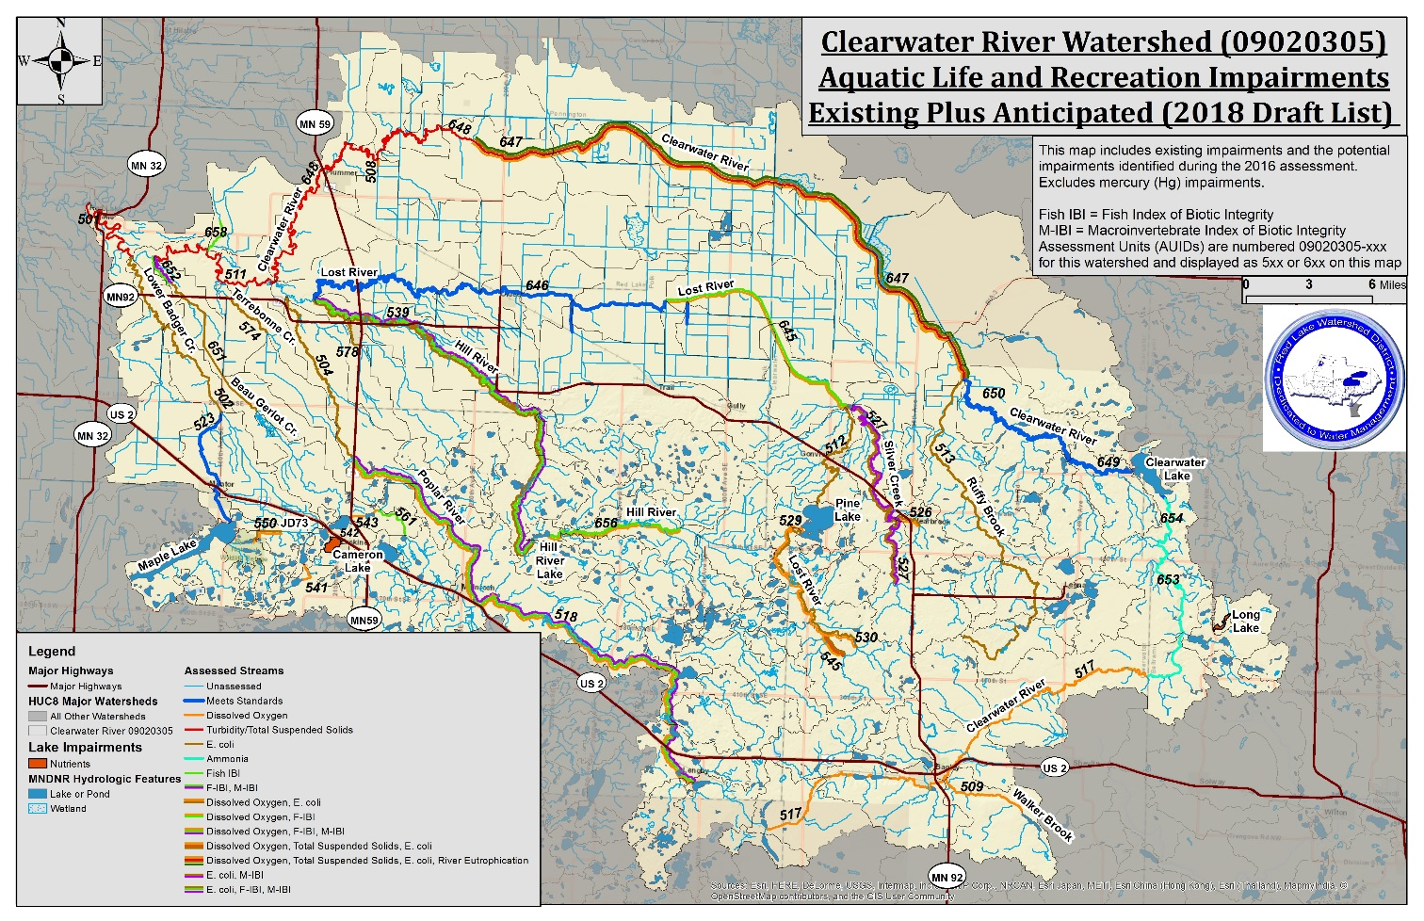

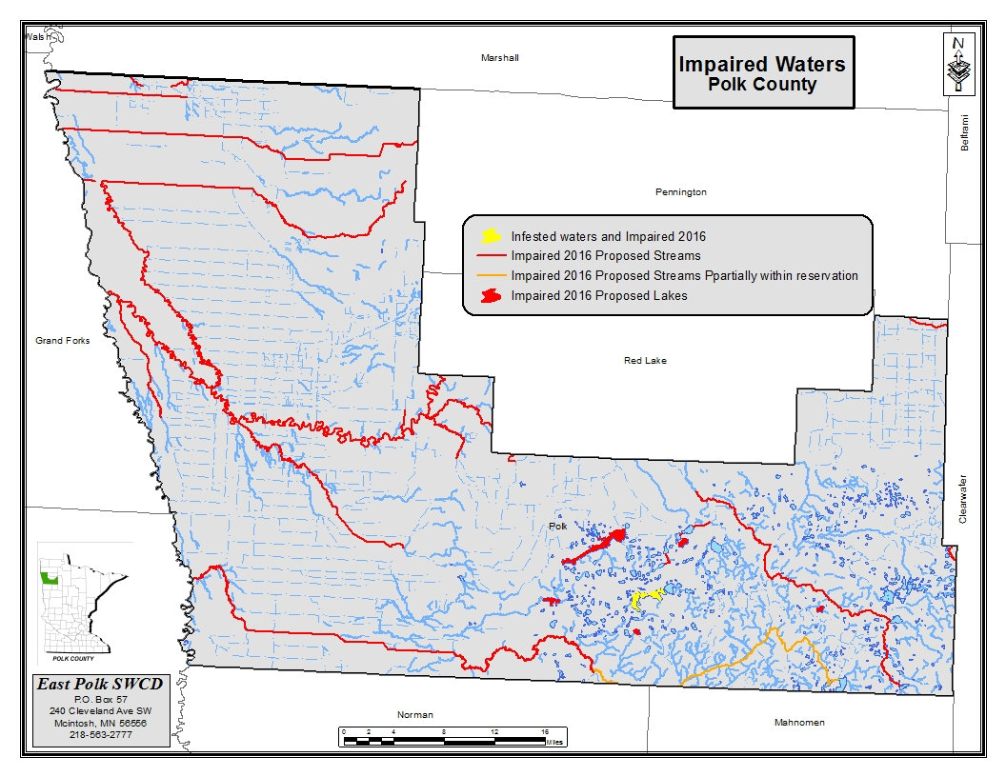

Polk County 2016 Impaired Rivers and Lakes
Water body name | Water body description | Year added to List | Watershed name | Pollutant or stressor | Affected designated use
Cameron | Lake or Reservoir | 2008 | Clearwater River | Nutrient/eutrophication biological indicators | Aquatic Recreation
Maple | Lake or Reservoir | 1998 | Clearwater River | Mercury in fish tissue | Aquatic Consumption
Poplar River | Spring Lk to Highway 59 | 2002 | Clearwater River | Dissolved oxygen | Aquatic Life
Poplar River Diversion | Unnamed ditch to Badger Lk | 2006 | Clearwater River | Dissolved oxygen | Aquatic Life
Unnamed creek | Eighteen Lk to Bee Lk | 2006 | Clearwater River | Dissolved oxygen | Aquatic Life
Unnamed creek | Mitchell Lk to Badger Lk | 2006 | Clearwater River | Dissolved oxygen | Aquatic Life
Burnham Creek | CD 106 to Polk CD 15 | 2016 | Red Lake River | Aquatic macroinvertebrate bioassessments | Aquatic Life
Burnham Creek | CD 106 to Polk CD 15 | 2016 | Red Lake River | Fishes bioassessments | Aquatic Life
Burnham Creek | Polk CD 15 to Red Lake R | 2016 | Red Lake River | Aquatic macroinvertebrate bioassessments | Aquatic Life
Burnham Creek | Polk CD 15 to Red Lake R | 2016 | Red Lake River | Fishes bioassessments | Aquatic Life
Gentilly River | CD 140 to Red Lake R | 2016 | Red Lake River | Aquatic macroinvertebrate bioassessments | Aquatic Life
Gentilly River | CD 140 to Red Lake R | 2016 | Red Lake River | Escherichia coli | Aquatic Recreation
Gentilly River | CD 140 to Red Lake R | 2016 | Red Lake River | Fishes bioassessments | Aquatic Life
Judicial Ditch 60 | Lateral DItch 4 to Red Lake R | 2016 | Red Lake River | Dissolved oxygen | Aquatic Life
Kripple Creek | Unnamed cr to Gentilly R | 2016 | Red Lake River | Aquatic macroinvertebrate bioassessments | Aquatic Life
Kripple Creek | Unnamed cr to Gentilly R | 2016 | Red Lake River | Escherichia coli | Aquatic Recreation
Kripple Creek | Unnamed cr to Gentilly R | 2016 | Red Lake River | Fishes bioassessments | Aquatic Life
Red Lake River | Burnham Cr to Unnamed cr | 1998 | Red Lake River | Mercury in fish tissue | Aquatic Consumption
Red Lake River | Burnham Cr to Unnamed cr | 1998 | Red Lake River | Turbidity | Aquatic Life
Red Lake River | County Ditch 99 to Burnham Cr | 1998 | Red Lake River | Mercury in fish tissue | Aquatic Consumption
Red Lake River | County Ditch 99 to Burnham Cr | 2008 | Red Lake River | Turbidity | Aquatic Life
Red Lake River | Gentilly R to County Ditch 99 | 1998 | Red Lake River | Mercury in fish tissue | Aquatic Consumption
Red Lake River | Gentilly R to County Ditch 99 | 2008 | Red Lake River | Turbidity | Aquatic Life
Red Lake River | Unnamed cr to Red R | 1998 | Red Lake River | Mercury in fish tissue | Aquatic Consumption
Red Lake River | Unnamed cr to Red R | 2002 | Red Lake River | Turbidity | Aquatic Life
Unnamed creek | CD 115 to Red Lake R | 2016 | Red Lake River | Dissolved oxygen | Aquatic Life
County Ditch 2 | CD 66 to Grand Marais Cr | 2016 | Red River of the North - Grand Marais Creek | Aquatic macroinvertebrate bioassessments | Aquatic Life
County Ditch 2 | CD 66 to Grand Marais Cr | 2016 | Red River of the North - Grand Marais Creek | Escherichia coli | Aquatic Recreation
County Ditch 2 | CD 66 to Grand Marais Cr | 2016 | Red River of the North - Grand Marais Creek | Fishes bioassessments | Aquatic Life
County Ditch 43 (Judicial Ditch 75) | Unnamed ditch to CD 7 | 2016 | Red River of the North - Grand Marais Creek | Aquatic macroinvertebrate bioassessments | Aquatic Life
County Ditch 43 (Judicial Ditch 75) | Unnamed ditch to CD 7 | 2016 | Red River of the North - Grand Marais Creek | Fishes bioassessments | Aquatic Life
Grand Marais Creek | Headwaters to CD 2 | 2006 | Red River of the North - Grand Marais Creek | Dissolved oxygen | Aquatic Life
Grand Marais Creek | Headwaters to CD 2 | 2006 | Red River of the North - Grand Marais Creek | Turbidity | Aquatic Life
Grand Marais Cutoff Channel | Grand Marais Cr to Red R | 2016 | Red River of the North - Grand Marais Creek | Chlorpyrifos | Aquatic Life
Judicial Ditch 1 | County Ditch 7 to Red River | 2016 | Red River of the North - Grand Marais Creek | Escherichia coli | Aquatic Recreation
Judicial Ditch 75 | County Ditch 7 to Red River | 2016 | Red River of the North - Grand Marais Creek | Escherichia coli | Aquatic Recreation
Judicial Ditch 75 | County Ditch 7 to Red River | 2016 | Red River of the North - Grand Marais Creek | Fishes bioassessments | Aquatic Life
Red River of the North | English Coulee (ND) to Grand Marais Cr | 1998 | Red River of the North - Grand Marais Creek | Mercury in fish tissue | Aquatic Consumption
Red River of the North | English Coulee (ND) to Grand Marais Cr | 1998 | Red River of the North - Grand Marais Creek | PCB in fish tissue | Aquatic Consumption
Unnamed creek (Red Lake Watershed Ditch 15) | Headwaters to CD 66 | 2016 | Red River of the North - Grand Marais Creek | Dissolved oxygen | Aquatic Life
County Ditch 17 | Garden Slough to Sand Hill R | 2014 | Red River of the North - Sandhill River | Aquatic macroinvertebrate bioassessments | Aquatic Life
Kittleson | Lake or Reservoir | 2014 | Red River of the North - Sandhill River | Nutrient/eutrophication biological indicators | Aquatic Recreation
Red River of the North | Buffalo Coulee (ND) to Cole Cr (ND) | 1998 | Red River of the North - Sandhill River | Mercury in fish tissue | Aquatic Consumption
Red River of the North | Buffalo Coulee (ND) to Cole Cr (ND) | 1998 | Red River of the North - Sandhill River | PCB in fish tissue | Aquatic Consumption
Red River of the North | Cole Cr (ND) to Red Lake R | 2008 | Red River of the North - Sandhill River | Arsenic | Aquatic Consumption
Red River of the North | Cole Cr (ND) to Red Lake R | 2010 | Red River of the North - Sandhill River | Dissolved oxygen | Aquatic Life
Red River of the North | Cole Cr (ND) to Red Lake R | 1998 | Red River of the North - Sandhill River | Mercury in fish tissue | Aquatic Consumption
Red River of the North | Cole Cr (ND) to Red Lake R | 1998 | Red River of the North - Sandhill River | PCB in fish tissue | Aquatic Consumption
Red River of the North | Cole Cr (ND) to Red Lake R | 1996 | Red River of the North - Sandhill River | Turbidity | Aquatic Life
Red River of the North | Grand Forks Dam to English Coulee (ND) | 1998 | Red River of the North - Sandhill River | Mercury in fish tissue | Aquatic Consumption
Red River of the North | Grand Forks Dam to English Coulee (ND) | 1998 | Red River of the North - Sandhill River | PCB in fish tissue | Aquatic Consumption
Red River of the North | Marsh R to Sand Hill R | 1998 | Red River of the North - Sandhill River | Mercury in fish tissue | Aquatic Consumption
Red River of the North | Marsh R to Sand Hill R | 1998 | Red River of the North - Sandhill River | PCB in fish tissue | Aquatic Consumption
Red River of the North | Red Lake R to Grand Forks Dam | 1998 | Red River of the North - Sandhill River | Mercury in fish tissue | Aquatic Consumption
Red River of the North | Red Lake R to Grand Forks Dam | 1998 | Red River of the North - Sandhill River | PCB in fish tissue | Aquatic Consumption
Red River of the North | Red Lake R to Grand Forks Dam | 2008 | Red River of the North - Sandhill River | Turbidity | Aquatic Life
Red River of the North | Sand Hill R to Buffalo Coulee (ND) | 1998 | Red River of the North - Sandhill River | Mercury in fish tissue | Aquatic Consumption
Red River of the North | Sand Hill R to Buffalo Coulee (ND) | 1998 | Red River of the North - Sandhill River | PCB in fish tissue | Aquatic Consumption
Red River of the North | Sand Hill R to Buffalo Coulee (ND) | 2008 | Red River of the North - Sandhill River | Turbidity | Aquatic Life
Sand Hill River | CD 17 to Kittleson Cr | 2014 | Red River of the North - Sandhill River | Escherichia coli | Aquatic Recreation
Sand Hill River | CD 17 to Kittleson Cr | 2014 | Red River of the North - Sandhill River | Fishes bioassessments | Aquatic Life
Sand Hill River | Headwaters to CD 17 | 2014 | Red River of the North - Sandhill River | Aquatic macroinvertebrate bioassessments | Aquatic Life
Sand Hill River | Headwaters to CD 17 | 2008 | Red River of the North - Sandhill River | Dissolved oxygen | Aquatic Life
Sand Hill River | Headwaters to CD 17 | 2014 | Red River of the North - Sandhill River | Escherichia coli | Aquatic Recreation
Sand Hill River | Headwaters to CD 17 | 2014 | Red River of the North - Sandhill River | Fishes bioassessments | Aquatic Life
Sand Hill River | Headwaters to CD 17 | 2010 | Red River of the North - Sandhill River | Turbidity | Aquatic Life
Sand Hill River | Kittleson Cr to Unnamed cr | 2014 | Red River of the North - Sandhill River | Escherichia coli | Aquatic Recreation
Sand Hill River | Kittleson Cr to Unnamed cr | 2014 | Red River of the North - Sandhill River | Mercury in fish tissue | Aquatic Consumption
Sand Hill River | Unnamed cr to Red R | 2014 | Red River of the North - Sandhill River | Escherichia coli | Aquatic Recreation
Sand Hill River | Unnamed cr to Red R | 2014 | Red River of the North - Sandhill River | Mercury in fish tissue | Aquatic Consumption
Sand Hill River | Unnamed cr to Red R | 2010 | Red River of the North - Sandhill River | Turbidity | Aquatic Life
Uff | Lake or Reservoir | 2014 | Red River of the North - Sandhill River | Nutrient/eutrophication biological indicators | Aquatic Recreation
Union | Lake or Reservoir | 2014 | Red River of the North - Sandhill River | Mercury in fish tissue | Aquatic Consumption
Unnamed | Lake or Reservoir | 2014 | Red River of the North - Sandhill River | Nutrient/eutrophication biological indicators | Aquatic Recreation

- WRAPS status:
  - Red Lake River: Draft TMDL and WRAPS documents were completed at the end of 2016. Currently, those drafts are being edited in preparation for EPA review and public comment. The MPCA has released Watershed Monitoring and Assessment and Stressor Identification Reports for the watershed.
    - Monitoring and Assessment Report: https://www.pca.state.mn.us/sites/default/files/wq-ws3-09020303b.pdf
    - Stressor Identification Report: https://www.pca.state.mn.us/sites/default/files/wq-ws5-09020303a.pdf
    - Most recent draft of the WRAPS: Http://www.redlakewatershed.org/waterquality/Temp_Share/Red%20Lake%20River%20WRAPS%20Draft%20-%20December%202016.docx
    - Most recent draft of the TMDL: www.redlakewatershed.org/waterquality/Temp_Share/Red%20Lake%20River%20Watershed%20TMDL%20Dec16.docx
  - Grand Marais Creek: Draft TMDL and WRAPS documents have been completed, but have not proceeded to public comment yet. The MPCA has released Watershed Monitoring and Assessment and Stressor Identification Reports for the watershed.
    - Monitoring and Assessment Report: https://www.pca.state.mn.us/sites/default/files/wq-ws3-09020306b.pdf
    - Stressor Identification Report: https://www.pca.state.mn.us/sites/default/files/wq-ws5-09020306a.pdf
    - Draft TMDL: https://www.pca.state.mn.us/sites/default/files/wq-iw5-13b.pdf
  - Clearwater River: The RLWD is in the process of writing draft Total Maximum Daily Load (TMDL) and Watershed Restoration and Protection Strategy (WRAPS) reports. The MPCA has not made stressor identification or monitoring and assessment reports for this watershed public yet. A draft stressor identification report has been written, though.
  - Sand Hill River: Draft TMDL and WRAPS documents have been completed and are available online, as well as the monitoring and assessment report and stressor identification report for the watershed.
    - Sand Hill River Monitoring and Assessment Report: https://www.pca.state.mn.us/sites/default/files/wq-ws3-09020301b.pdf
    - Sand Hill River Stressor Identification Report: https://www.pca.state.mn.us/sites/default/files/wq-ws5-09020301.pdf
    - Sand Hill River Watershed TMDL: https://www.pca.state.mn.us/sites/default/files/wq-iw5-10e.pdf
    - Sand Hill River Watershed Restoration and Protection Strategy: https://www.pca.state.mn.us/sites/default/files/wq-ws4-26a.pdf

C) In addition to the above mentioned specific areas of concern for Polk County, The County Board, Watershed Districts and SWCDs will actively pursue efforts to address surface quality concerns within the County.

Grand Marias Creek Watershed

Refer to the One Watershed, One Plan (1W1P).

Lower Red Lake Watershed

Refer to the One Watershed One Plan (1W1P).

Clearwater River Watershed

The MPCA has identified the Clearwater River as an impaired water body due to high levels of turbidity, TSS, fecal coliforms (E. coli) and low dissolved oxygen during periods of low flow.
Water quality monitoring has been done by the RLWD at 19 sites associated with streams since 1984. The parameters measured included field measurements for dissolved oxygen, pH, temperature, turbidity, transparency and conductivity. Laboratory analysis is performed on stream samples for fecal coliform (E. coli), orthophosphorus, nitrates and nitrites, ammonia, total Kjeldahl nitrogen and alkalinity. The RLWD periodically prepares a water quality report. Results are available upon request in the RLWD office.

The RLWD also sponsors River Watch programs for nine schools. The goals of the program are to develop baseline water quality data, provide hands on “real world” science opportunities for students and promote greater citizen awareness and understanding of watersheds and the role of watershed districts. Senior high students from participating schools perform the monitoring, including field collection and lab analysis. Field measurements of dissolved oxygen, water temperature, pH, conductivity, transparency, turbidity, stage, water depth and stream width are collected at each site along with appearance and recreational suitability observations. Each school collects data at least once per month. River Watch groups prepare reports based upon monitoring results. These reports are then presented at area River Watch forums. The RLWD staff work directly with Win-E-Mac Public School with data collection activities.

The watershed will continue to assess the problem and the data available for the next 303D assessment. It is the RLWD’s goal to address the following issues with the Clearwater River subwatershed.
Turbidity, TSS, fecal coliform and low dissolved oxygen 303D impairment.

Potential impacts of TMDLs on wild rice operations. Maple Lake water quality.

Erosion due to storm runoff is another serious problem in the subwatershed. During periods of high runoff, channel erosion causes bank stabilization concerns for this subwatershed. The severity depends on the land cover, duration and volume of water. Erosion is often worse in the spring due to the lack of vegetative cover on the fields. It is the RLWD’s goal to address the following issues with the Clearwater River subwatershed:
Tributary bank instability at the outlets into the river.

Lost River channel and streambank erosion.
Ditches outletting into natural streams and contributing sediment.

Sand Hill River Watershed

This assessment has been taken from the Sand Hill river Watershed District Management Plan.
The Minnesota Pollution Control Agency is continually updating their list of impaired water bodies in the State of Minnesota, as required by the U.S. Environmental Pollution Agency. There are some bodies within the Sand Hill Watershed that are listed as being impaired. The main stressor for the riverine impairment is due to turbidity and the excessive sediment being carried by these waterways.

https://www.pca.state.mn.us/water/watersheds/red-river-north-sand-hill-river

The SHRWD has contracted with Houston Engineering to conduct a multi-parameter, watershed wide TMDL Study and develop the Restoration and Protection Plans.
The goals of the plans are to provide protection where conditions meet standards and restoration where conditions are impaired. The plans are intended to supplement the SHRWD 10 year plan, and eventually will become a chapter, identifying water quality management activities in the watershed. The plans will also identify the roles of the state and local resource management organizations within the watershed.

The Watershed Approach applies to the Total Maximum Daily Load (TMDL) Study system for impaired waters, to the watershed as a whole. In addition to the reach- by- reach or lake-by –lake method used to restore impaired waters, the Watershed Approach assesses complaint water bodies for their likelihood to become impaired or possibly contribute to impairments further downstream in the watershed. The goals of the Watershed Approach are to use the TMDL Study system to conduct a multi-parameter, watershed –wide assessment of the watershed and develop and implement restoration plans for the impaired waters and protection plans for the complaint waters that will guide surface water quality management throughout the watershed.

Erosion and sediment is a serious water quality issue throughout the SHRW’s river and tributaries. Excessive erosion occurs in the beach ridge area where the land naturally has excessive slopes and the soils light and erodible from water and wind. In the lake plain area of the SHRW, agricultural activities contribute to erosion susceptibility.

Top issues in the Sand Hill River Watershed area:
Flood damage reduction, rate of runoff and volume of runoff

Agricultural drainage
Water quality
Erosion and sediment control, Flood plain management

Water Quality in the Sand Hill River Watershed

The following is an overview of the stream sediment content at selected sites based on turbidity measurements taken in the Sand Hill Watershed District for the years 1995 through 2010 by Danni Halverson, River Watch Environmental Scientist, International Waters Institute (IWI). Turbidity data for the given Regional Assessment Locations (RALs) was analyzed with turbidity values being compared to annual ecoregion values for minimally impacted streams from the work of McCollor and Heiskary (1993). Turbidity data values were then plotted in an attempt to show sediment trends for the RALs. Data used in this analysis was collected by Red River Watershed Management Board staff, River Watch schools, and Minnesota Pollution Control Agency (MPCA) staff. The data used in preparation of this report was mined from the River Watch Website,
http://riverwatch.umn.edu/ and is also available through the MPCA’s Environmental Data Access website, http://cf.pca.state.mn.us/data/eda/index.cfm. Data outlier’s exceeding 3 standard deviations from the site mean were removed for each site prior to use in this analysis.

Sites and Water Quality Variables
The sites used in this assessment are listed in the following table. Sites are listed from upstream to downstream within the table and for reference geo-spatial and planning region information is included. This list does not contain all of the water quality sites within the Sand Hill Watershed but rather a subset based on those sites that were identified as RALs. Also, not all of the RALs are identified here only those with enough data to use in analysis.

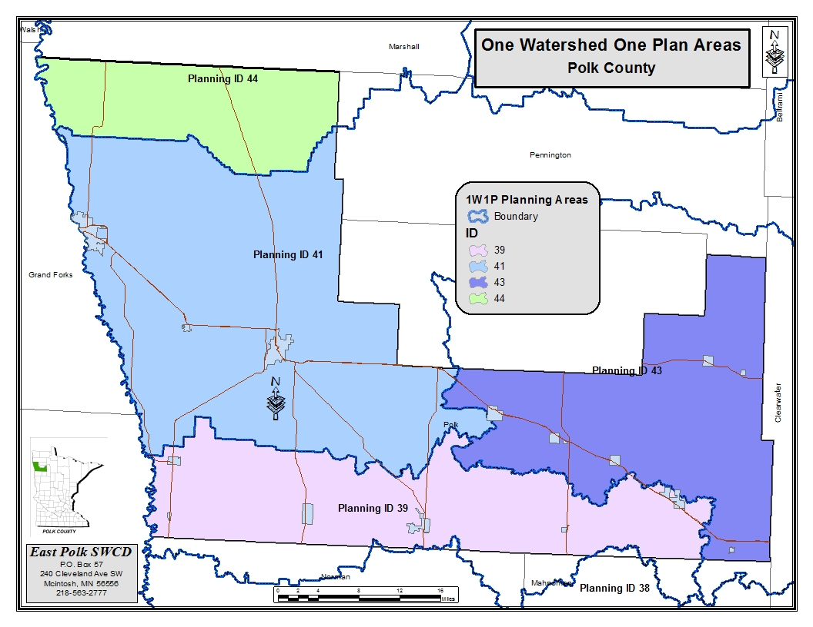

Grand Marais Creek Watershed

Refer to the One Watershed, One Plan (1W1P).

Lower Red Lake Watershed

Refer to the One Watershed, One Plan (1W1P).

Clearwater Watershed

The subwatershed is located in parts of the Lake-Washed Till Plain and Moraine physiographic area of the RLWD. The surficial geology of the area consists of mainly glacial tills to the south, peat to the northeast, lake-washed till to the northwest and sand to the southwest. The glacial till deposits consist of sandy, clay-silt loam containing fine to medium gravel with a scattering of boulders. The peat deposits are generally only a few feet thick, accompanied by the poor drainage and the water table at or near the land surface. Sand deposits are described as being very-fine to fine and commonly less than 20 feet thick. The lake-washed till deposits have a composition similar to the glacial till and are overlain in many local low areas by thin deposits of clay, silt, sand and peat. In the southern section of the subwatershed, just north of Bagley (and other small regions to the north), deposits of sand and gravel from outwash and ice contact features are present. The deposits consist of fine sand to medium gravel, with thicknesses ranging from a few feet to almost 100 feet. Local topography is generally hilly, with improved drainage over other areas in the watershed.

Glacial sediment aquifers in the region provide moderate amounts of groundwater. Suitable yields of 5 gpm or more for domestic use can be found in sand lenses within the till. These lenses are often localized and yields can vary and may accommodate municipal or industrial uses. Outwash and ice-contact sand and gravel aquifers are the best source in the watershed for alarge groundwater supply. Yields can reach several hundred gpm. The areal extent of the aquifer is fairly large, and water quality is adequate for municipal, industrial, domestic and irrigation use. Hardness is generally greater than 180 mg/l, and iron content may be high. Paleozoic sediments consisting of shale and limestone are discontinuous and underlie the glacial sediments along the western side of the subwatershed. Precambrian crystalline rocks underlie glacial sediments in most of the watershed. The fractured surface of crystalline rocks may provide an adequate supply of groundwater for localized domestic use but are not a good commercial or municipal source of groundwater.

Sand Hill River Watershed

The following information has been taken from the Sand Hill River Watershed District Watershed Management Plan. The Sand Hill River basin consists of glacial lake deposits, lake shore deposits, till and a small amount of ice-contact deposits overlying the bedrock. Bedrock in the east part of the basin consists of Precambrian, undifferentiated igneous, and metamorphic rock. Bedrock in the west part of the basin consists of a small band of Cretaceous, fine-grained sandstone and shell. Clay and silt lake deposits dominate the Lake Agassiz plain bordering the Red River. A transition zone between the lake plain and the glacial moraine areas is formed by lake shore deposits, delta sand, and gravel.

There are two aquifer systems of note within the SHRWD, a deep aquifer and a shallow aquifer.
The deep aquifer is the Cretaceous aquifer. Depths to the aquifer are approximately between 200-600 feet below mean sea level. The shallow aquifer is a glacial drift aquifer, and it is distributed through the SHRWD. As little as 20 feet or less of till overlie some of these areas. The amount and type of material overlying an aquifer is important because it largely determines recharge characteristic, the potential for contamination, and the degree of interaction with surface waters. Glacial drift aquifers within the SHRWD may be surficial and unconfined, meaning an impervious layer above the aquifer is absent and the water table is in equilibrium with the atmosphere. Alternatively, glacial drift aquifers may be buried. Buried aquifers are typically confined by an impermeable layer of material above them, less susceptible to potential contamination and at a pressure greater than atmospheric. Buried aquifers are rare within the District.

The shape of glacial drift aquifers within the District is typically long and narrow, oriented north and south along a beach ridge. Aquifer thickness varies from 10 to 50 feet and potential yields range from 10 to 500 gallons per minute. The flow direction of both deep and shallow aquifers is generally towards the west-northwest to the Red River.

Irrigation Use

Irrigation for crop production is a minor concern in Polk County. There are few agricultural users within the SHRW that draw water for irrigation purposes. A natural tributary to the Red River west of Nielsville has been impounded with a dam to create a reservoir for irrigation. In the northeastern part of the county irrigation is used for the cultivation of wild rice paddies. In the central portion of the county irrigation is used for the production of row crops.

Irrigation Water Use in Polk County in Millions of Gallons per Day, USGS Data, 2010

Groundwater | Surface Water
0.12 Mgal/d | 3.42 Mgal/d

Beach Ridge Deposits

Discontinuous beach ridge deposits of very fine- to medium-grained sand, with lenses of fine- to medium-grained gravel, are located throughout the Red River Basin. However, the horizontal and vertical extents of the beach ridges are highly variable. The beach ridge deposits range in length from one to tens of miles, and they range in width from a few hundred feet to several miles. The ridges can range in thickness from a few feet to 50 feet and may exceed 150 feet. Groundwater recharge and discharge rates of the beach ridge deposits throughout the Red River Basin are unknown because of the variability of particle size, sediment sorting, geographic distribution, and hydraulic connectivity of the ridges.

Quantity and quality of groundwater from the deposits vary greatly within the Red River Basin and within individual deposits because the beach ridge deposits are discontinuous and variable. The quantity of usable groundwater from the ridges generally increases to the south in the basin. Groundwater from the beach ridge deposits most commonly is used for domestic water supply and secondarily for small-scale sand and gravel mining operations. Theoretical well yields from the beach ridge deposits are unknown, USGS report, Ground-Water Availability fromSurficial Aquifers in the Red River of the North Basin, Minnesota (Reppe 2005)

Aquifer locations in the Red River Valley
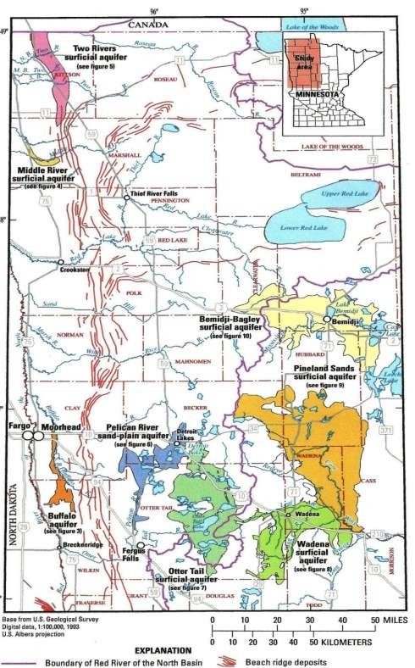

Source Water Protection

The Minnesota Department of Health has completed source water assessments for all the public water systems in the state, as required by the 1996 amendments to the Federal Safe Drinking Water Act. Any city over 1,000 people need to submit or complete a Water Supply Plan per the MN DNR rules. The following cities have had a MDH source water assessment and MN DNR appropriation water permit:

City of Nielsville – threeactive groundwater well – Low DWSMA Vulnerability
City of Climax – two active groundwater wells – Low DWSMA Vulnerability
City of Beltrami – two active groundwater wells – Low DWSMA Vulnerability
City of Fertile - two active groundwater wells – Moderate DWSMA Vulnerability
City of Fosston – three active groundwater wells – Low DWSMA Vulnerability
City of Crookston – fouractive groundwater wells – Moderate DWSMA Vulnerability
City of Winger – twoactive groundwater well – Low DWSMA Vulnerability
City of Erskine – two active groundwater wells – High DWSMA Vulnerability
City of McIntosh – two active groundwater wells – Low DWSMA Vulnerability

The water supply systems that are implementing a wellhead protection plan that has been approved by the Minnesota Department of Health under Minnesota Rules 4720 include the cities of Fertile, Nielsville, and Crookston. The water supply systems in the process of wellhead protection plan development as defined under Minnesota Rules Chapter 4720 are the communities of McIntosh, Climax, Beltrami, Winger, Erskine, and Fosston.

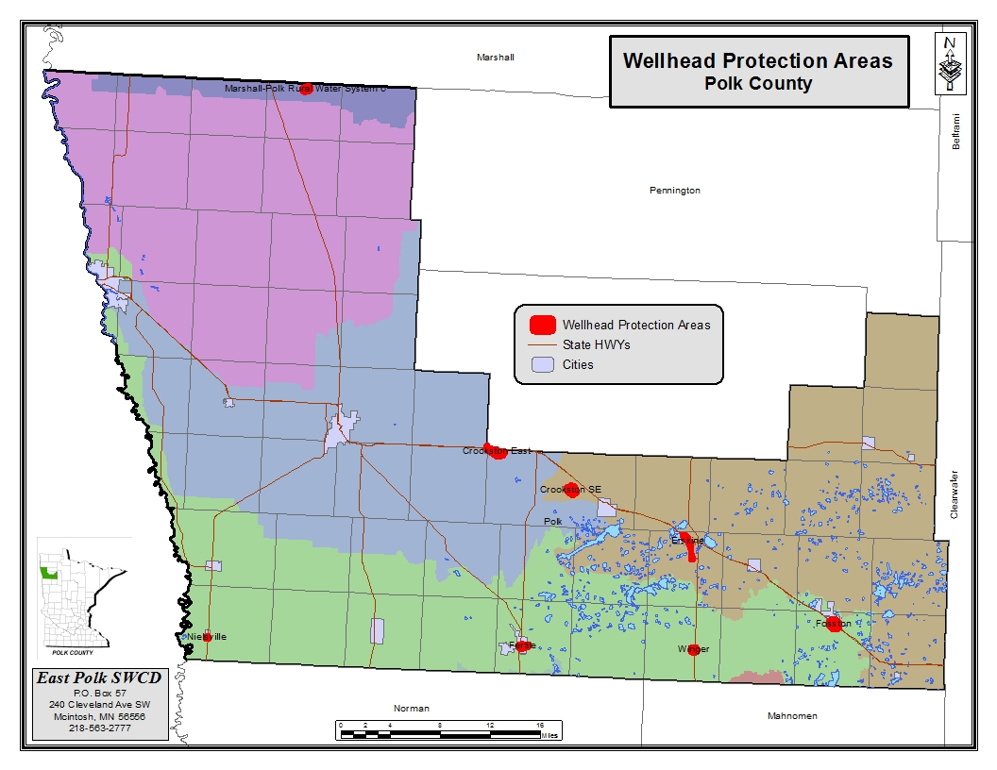

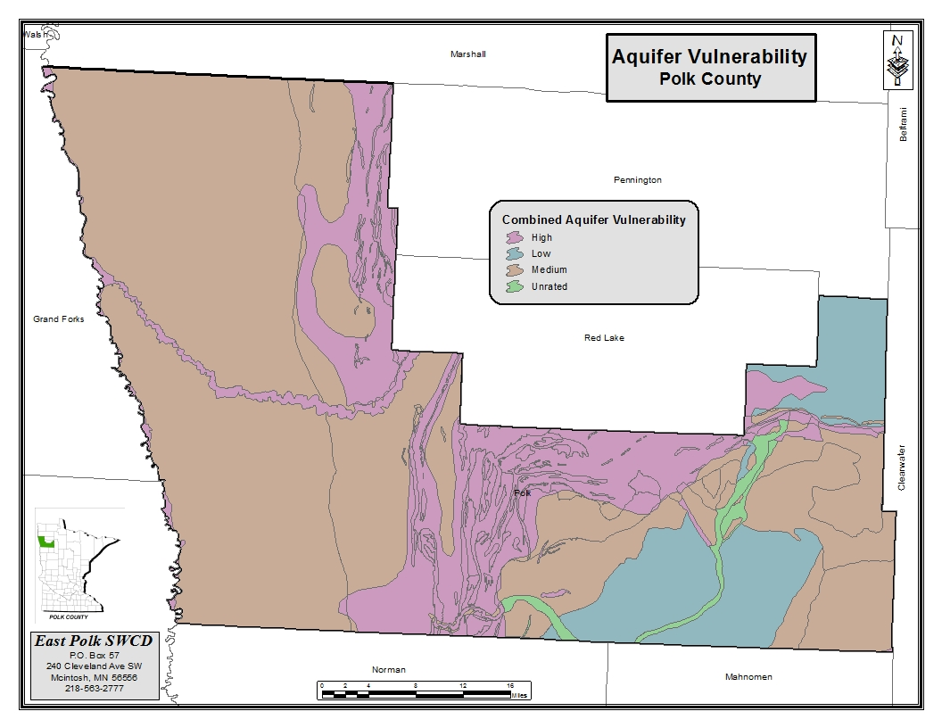

MN DNR Water Use Permit Appropriations

Permittee | Usename | Permit Volume (MGY) | Permit  GPM | Use 2016 (MG)
WINGER, CITY OF | Municipal Waterworks | 15.5 | 150 | 6.34
ERSKINE, CITY OF | Municipal Waterworks | 36 | 530 | 25.25
MCINTOSH, CITY OF | Municipal Waterworks | 24 | 225 | 18.4
CLIMAX, CITY OF | Municipal Waterworks | 15 | 320 | 15.4
FERTILE, CITY OF | Municipal Waterworks | 39 | 400 | 25.24
NIELSVILLE, CITY OF | Municipal Waterworks | 10 | 336 | 4.1
CROOKSTON, CITY OF | Municipal Waterworks | 500 |  | 208.13
CROOKSTON, CITY OF | Municipal Waterworks | 1750 |  | 112.98
BELTRAMI, CITY OF | Municipal Waterworks | 5 | 80 | 2.2
FOSSTON, CITY OF | Municipal Waterworks | 140 | 700 | 103.9

Polk County Priority Concern 2: Water Quantity

The Polk County Local Water Management Plan will focus on the quantity of water passing through the County and its associated watersheds by inventorying, assessing and evaluating the drainage infrastructure.

Due to the fluvial geomorphic characteristics of the Red River of the North Basin, Polk County is subject to frequent flooding. Some factors such as topography and increased precipitation are unmanageable, but other factors such as flood plain encroachment, channelization of waterways, land use practices and effective private drainage into public systems, are factors that can be assessed for Best Management Practices.

All of Polk County falls within the jurisdictional boundaries of three watershed Districts. With Watershed Districts being “special purpose” Districts and that special purpose:

103D.201 WATERSHED DISTRICT PURPOSE
“To conserve the natural resources of the state by land use planning, flood control, and other conservation projects by using sound scientific principles for the protection of the public health and welfare and the provident use of the natural resources, the establishment of watershed districts is authorized under this chapter.”

The most effective way to manage water is on a watershed perspective making it unattainable for an individual County to successfully implement a comprehensive water management agenda. It will likely be the Watershed Districts who will lead the major efforts to manage the water quantity issues impacting Polk County. They will however need the support and cooperation of Polk County and the West and East Polk SWCDs to accomplish its work in Polk County. Many
Watershed District water quantity control projects have been constructed in and outside of Polk County that have assisted in the reduction of flood related damages within the county. Please refer to the Long Rang Plans of the Red Lake, Sand Hill River, and the Middle-Snake-Tamarac Rivers Watershed District for more information on these and future efforts that will control the quantity of water flowing through Polk County.

The Following drainage assessments are taken from the Red Lake and Sand Hill River Watershed District plans.

Grand Marais Creek Watershed

Refer to the One Watershed, One Plan (1W1P).

Lower Red Lake Watershed

Refer to the One Watershed, One Plan (1W1P).

Clearwater River Watershed

Due to terrain, draining of wetlands for cropland and/or under-designed structures, the Clearwater River subwatershed experiences occasional flooding throughout the subwatershed. Spring flooding is almost an annual occurrence in this watershed. Damages associated with this type of flood are to public infrastructure, personal property, cropland and public resources (fisheries, wildlife, soils and water quality). Agricultural flooding was identified as the highest priority flooding issues.

Lakes are prominent and important resources in this watershed. In particular, a number of small lakes are found throughout the southern half of the watershed. These include a mix of recreational and natural environment lakes that provide seasonal and migratory habitat for a variety of species.

Wetland areas are scattered throughout the area. These wetland areas are considerably denser in the extreme northeastern portion of the subwatershed, especially within the Red Lake Reservation, where the original wetlands are intact. Many of the wetlands have been altered by farm drainage, and many wetlands have been drained for the purposes of agricultural production.

Sand Hill River Watershed

There are numerous public and private drainage systems in the SHRWD, specifically constructed since the early 1900’s, to provide agricultural drainage. The SHRWD has legal jurisdiction over many of these ditch systems, with the authority to approve proposed improvements to be made to the ditches. Several other legal ditch systems remain under the jurisdiction of Polk County. Most of these drainage systems are located in the lake plain geomorphic region, since this area is flat, has poorly drained soils, and lacks a natural drainage network. Without the drainage network, water would stagnate in the fields and drown crops. The ditch networks have improved the connection between areas that would otherwise not be hydrologically connected.

The need for and intensity of drainage differs to some degree between the eastern glacial moraine and the western glacial lake plain. The development of land for agriculture in the early 1900s modern agriculture would not be possible within the western portion of the District without improved drainage. This portion of the District lacked “natural” drainage because of its origin as the lake bed of Glacial Lake Agassiz. State and federal initiatives through the 1970s encouraged maximizing acreage for agricultural production. Landowners and others undertook drainage within the District’s eastern, glaciated moraine area in selected areas to address specific isolated drainage problems.

Minnesota Drainage Law (MSA 103E) provides a set of rules to administer and regulate drainage activity within the state. One of the District’s main responsibilities is to administer their state obligated responsibility under MSA 103E. These responsibilities are associated with both legal and private drainage systems. The legal system is administered jointly with the county or counties overlapping the watershed district. County ditches were originally under the jurisdictions of counties. MSA 103E specifies that ditch systems undergoing an improvement or redetermination of benefits process, or new systems must revert to the jurisdiction of the appropriate watershed district, if one exists. The county may also transfer jurisdiction of a ditch system without a project by resolution of the county board of commissioners. The SHRWD presently administers a number of miles of legal drainage systems, acquired either through petitions of new systems, improvements to existing systems, or the repair of existing systems under SHRWD jurisdiction. Landowner’s efforts to engage in private drainage projects (outside of the authority of MSA 103E), are subject to the SHRWD permit system (MSA 103D).

Flood Damage is another critical issue in the Red River Valley area and the SHRWD. Flooding causes a significant burden, particularly for the agricultural sector. Damage from flooding is most severe in the western portion of the SHRWD. Flooding results in financial damages as well as social and emotional damages that are more difficult to quantify. The majority of flood damages are agricultural in nature. However, Beltrami, Nielsville and Climax are also frequently threatened with flood damages. The SHRWD initiated projects to protect Beltrami and Nielville several years ago, which has been beneficial. Climax are currently in the process of being studied for flood damage reduction measures under existing MN DNR financing assistance. In general, the lake plain area of the SHRWD is prone to flooding due to the flat landscape and channels that have relatively low capacities for the amount of drainage coming to them. The water from the portions of the watershed contributing to the lake plain area of the SHRWD tends to release its runoff faster than the lake plain channels can carry it away. This is due to the capacity limitations of many of the Polk County legal ditch and natural channel systems in the lake plain. More recently the SHRWD has seen an increase in landlocked basin flooding in the beach ridge and moraine areas of the District.

Surface drainage through the construction of private and public drainage systems has historically been the primary means of providing suitable soil conditions for crop production. Soils within the Red River Valley were historically considered “too tight” for tile drainage, because the close spacing of tiles necessary for effective drainage. However, there is a growing trend of pattern drainage tiling within the Red River Valley. This change has come about due to several factors, including improved technology and equipment for tile installation, increase prices for agricultural commodities, increase crop yields from drained land, value of farm land, and enhanced farming operations from drained land. The effects of tiling on downstream water quality and quantity are being studied by various agencies, but remains basically unknown. Current thoughts are that quantity changes on peak rates of flow will not be significant from a downstream flooding perspective. However, persistent long term low flows may affect channel maintenance and land access opportunities.

Drainage System Management

With the County being the drainage authority on some public drainage systems and the individual Watershed Districts on others it will be vitally important to coordinate maintenance, repairs, and improvements to these systems. The Polk County Ag and Drainage department indicates that there are 830 miles of legal drainage systems they maintain. The Red Lake Watershed District is the drainage authority on 295 miles of ditches throughout their entire watershed jurisdiction. The Middle Snake Tamarac River Watershed District is the drainage authority on 108 miles of ditches throughout Polk County. No similar data available from the Sand Hill River Watershed District. Miles of ditches within Polk County that are required to have buffers:
RLWD – 105.15 miles
SHRWD – 80.46 miles
Wild Rice River Watershed District (WRRWD) – 1.58 miles
Polk County Public Ditches – 770.8 miles
Public Waterways (DNR Public Waters) – 551.83 miles

Reference to Basin Tech and Scientific Advisory Committee publication - Sept. 15, 2014 - http://www.rrbdin.org/wp-content/uploads/2014/10/BTSAC-BP3-Final-9-15-14a.pdf

The following assessment has been taken from the Red Lake River Watershed Farm to Stream Tile Drainage Water Quality Study, 2009.

Prior to this project, there were a lot of theories about how the increasing amount of tile drainage in the Red River Basin would affect water quality. However, there was a lack of actual water quality data from tile drainage within the basin. This study was designed to provide actual data from tile drainage in several different areas through-out the Red Lake Watershed District. In each area, tile drainage water quality has been compared with surface drainage water quality. The study also compares flow (sfc. v. tile) and different methods of tile drainage.

Generally, conventional agriculture tile drainage should have a positive impact on the problems of high turbidity, total suspended solids, and total phosphorus in the Red River Basin.
Unfortunately, there are “side effects” of high nitrate and conductivity levels. Minnesota scientists are researching possible methods for reducing these “side effects.”

The wild rice paddies were an exception in that the wild rice paddy main‐line tile water had all the water quality benefits of conventional agriculture tile, but without the high nitrate levels. Tile drainage for conventional agriculture has little benefit to water quality when the ground is frozen and the tile is not running (during spring runoff). The benefits are also lessoned when the ground is saturated enough for surface runoff to occur.

The existence of a grassed waterway appeared to moderate water quality.
Data analysis supports the hypotheses that were expressed at the beginning of the project. Peak flows generated from a surface drained field clearly exceed the peak flows from a tile drained field (tile and surface drainage included). The duration of flow from tile is much longer than the duration of flow from surface drainage. So, the total volume of drainage from a tiled field is clearly greater than the total volume of drainage from a field that lacks tile drainage.
- Tile drainage in the Red River Basin reduces peak flows from an individual field relative to surface drained fields during runoff events.
- Tile drainage in the Red River Basin increases the total volume of runoff in the long‐term relative to surface drained fields.
- Antecedent conditions have a significant role on the influence of tile drainage during a runoff event. A rainfall event will have a varying effect upon runoff due to varying levels of initial soil moisture, rainfall amount, rainfall intensity, and rainfall duration.
- These results pertain only to tile drainage systems with similar soils and topography in Red River Basin that do not have surface inlets.

There are plans to continue the monitoring efforts of this study, particularly the flow monitoring and runoff event sampling. Monitoring and research efforts should also be targeted at evaluating what happens to the concentrated discharges of nitrates after they enter a river system. Also, extra monitoring could be done in the lower Red River Valley, closer to the Red River where soils have higher clay content.

Priority Concern 3: Groundwater

Surface water quality is of primary concern for Polk County, but we will also be responsive to the need to monitor and protect our ground water resources. We will participate to our fullest capacity but state and federal agencies such as Minnesota Department of Health (MDH), and USGS will continue to be the primary source for groundwater protection and management.
Groundwater sensitivity to pollution of the shallow systems in the area was produced by the MN DNR, based upon the water table depths and soil textures. The beach ridge area has the highest sensitivity to pollution, followed by the glacial moraine area, and then the lake plain area.

Priority Concern 4: Management, Enhancement and Preservation of Natural Resources

Polk County is concerned with the preservation and enhancement of its natural resources. The geology of Polk County is divided into 3 distinct areas; the glacial-lake plain, glacial lake washed till plain and glacial moraine region. These major areas, because of their size, unique geographical features, and wide diversity of natural resources are of significant benefit to the area and citizens.
Polk County in cooperation with other local, state, and federal agencies will work to restore, enhance and protect these areas through programs and projects that accomplish this; cautious it is not done at the expense of the local economy.

Proper management and preservation of these unique ecosystems is a Priority Concern for Polk County because of the fragile balance that is needed to sustain the natural resources found in this area.

The Glacial Lake Agassiz Beach Ridge area in Polk County contains some of the largest tracts of native prairie in the state. These prairies are of high quality and include good examples of dry mesic and wet prairies. Saline soils are common in these areas and support unusual prairie types composed of species tolerant to elevated salt levels, including rare species such as; alkali cord grass (Spartina gracilis), northern gentian (Gentiana affinis), and Hall’s sedge (Carex halliana). There are several Minnesota listed rare plants found in the Glacial Lake Agassiz Beach Ridge
Area, including the federally threatened and state endangered western prairie fringed orchid
(Platanthera praeclara). The largest known populations of this species in the world are found in Polk County. Other state listed endangered species include; pale moonwort (Botrychium pallidum), Indian ricegrass (Oryzopsis hymenoides), and gray ragwort (Senecio canus).

Located within the Glacial Lake Agassiz Beach Ridge is the Glacial Ridge National Wildlife Refuge composed of 24,000 acres. It is the nation’s largest prairie and wetland restoration project. In addition to its biological importance, the restoration of Glacial Ridge should help improve water quality for the City of Crookston and reduce flooding in the Red River Valley. Habitat fragmentation and Invasion by exotic species (non-native plants and animals) are the most significant threats to the project’s native diversity. The property connects to other wildlife and recreational areas and, when the project is complete, The Nature Conservancy and its partners will have restored more than 8,000 acres of wetland and about 16,000 acres of Tallgrass Prairie. There will be nearly 20,000 acres enrolled into the federal Wetlands Reserve Program, which was turned over to the US Fish and Wildlife Service (USFWS) in 2004 and was designated as a national wildlife refuge.

Rydell National Wildlife Refuge located within the Glacial Moraine area. The Refuge was established in 1992 and composed of 2,100 acres hosting more than 7,800 visitors per year. The Refuge is a combination of maple/basswood/oak forest, wetlands, tallgrass prairie and bogs. The Refuge offers annual deer hunts for youth and disabled. Refuge objectives are to provide nesting, feeding and resting habitat for waterfowl and other migratory woodland and grassland birds, serve as a regional destination for environmental educational opportunities, provide woodland and prairie habitat for resident wildlife and to provide opportunities for wildlife observation and outdoor recreation.

The Vesedahl Wetland Mitigation Project is also located within the Glacial Moraine area. The Vesedahl project is a wetland restoration project in Polk County which will be used by MnDOT and BWSR to offset wetland impacts that cannot be mitigated on site for state, county, and township road projects in northwestern Minnesota. MnDOT has acquired approximately 1900 acres of farmland. The project will restore approximately 750 acres of land to its pre-agricultural wetland status while the remaining non-wetland acreage will be planted with native grasses. Once the restoration work is completed, control of this land will be transferred from MnDOT to the MnDNR and it will become a wildlife management area. The MN DNR operates 47 additional Wildlife Management Areas in Polk County.

There are large parcels of USFWS and MN DNR land scattered throughout the county that are open to the public to utilize. USFWS reports 13,314 acres of Waterfowl Production Areas in the county. There are 21 known calcareous fens identified on the Minnesota Department of Natural Resources List of Known Calcareous Fen Sites (June 30, 2001) located in Polk County. Calcareous seepage fens are numerously found in the Beach Ridge Area. This fen type is rare, with a precarious biology that makes them vulnerable to change.

Calcareous Fen Sites in Polk County
Site Name | Fen ID NO. | Township | Range | Section(s)
Chicog WMA East | 6403 | T148N | R45W | NWSWSE28,  SWNE33,  NENE33,
Chicog WMA West | 6405 | T148N | R45W | NE29, WSE20
Enerson WMA | 16306 | T149N | R40W | NENW17
Godfrey Prairie | 16268 | T148N | R44W | NWSE09, NE09
Gully 27 | 16326 | T150N | R39W | SWNE27
Gully 22 | 16303 | T150N | R39W | NE22, WSE22
Gully 23 | 16307 | T150N | R39W | SE23
Gully 25 | 16312 | T150N | R39W | NWNE25
Gully 30 | 35382 | T150N | R39W | NNE30,  NENW30,  SSE19
Kertsonville WMA | 6402 | T149N | R45W | SSESW16
Chester 24 | 35384 | T150N | R40W | SN24,  NNSW24,  NSE24
Chester 29 | 18396 | T150N | R40W | S29
Kittleson Creek Mire | 10149 | T147N | R44W | SS06, 0W07
Onstad WMA | 16270 | T147N | R45W | W01
Pankratz Prairie South | 245 | T149N | R45W | SWNE17
Pembina Trail: Crookston | 1226 | T149N | R44W | SSW19
Pembina Trail:  TNC | 17211 | T149N | R44W | ESWNW30
Thorson Prairie WMA South – a | 35142 | T148N | R45W | SE08
Thorson Prairie WMA South – b | 33545 | T148N | R45W | NE08
Thorson Prairie WMA South – c | 35143 | T148N | R45W | NWSE05
Thorson Prairie WMA South – d | 35144 | T148N | R45W | SWNE05

Conservation Reserve Program

One major concern is the large acreage of Conservation Reserve (CRP) program acres that are being taken out of grass and put into production. Many of these acres are in the prime habitat areas for sharp-tailed grouse and prairie chickens. Wild turkeys have also been introduced and are increasing in numbers. Some of these areas are also identified as MN DNR Deer Wintering areas.

CRP Expiration AC/YEAR (taken from the Conservation Reserve Program website (Total Acres, Continuous and General signup)

CRP  Expiration | Acres
FY2017 | 6,675.6
FY 2018 | 13,943.6
FY 2019 | 9,801.6
FY 2020 | 3,336.3
FY 2021 | 1,690.3
FY 2022 | 2,916.7
FY 2023 | 1,884.7
FY 2024 | 1,565.3
FY 2025 | 3,142.3
FY 2026 | 3,448.4
TOTAL | 48,404.8
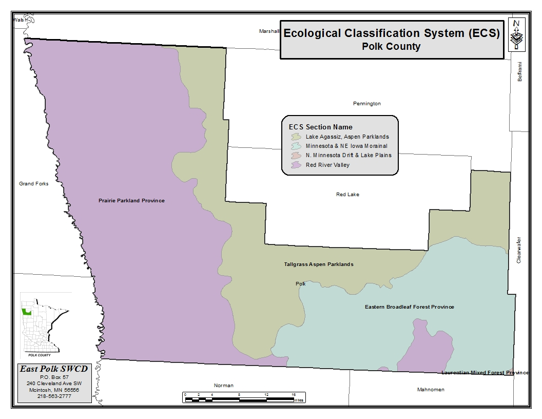

Ecological Regions of Polk County

The Minnesota Department of Natural Resources (MnDNR) and the U.S. Forest Service have developed an
Ecological Classification System (ECS) for ecological mapping and landscape classification in Minnesota following the National Hierarchical Framework of Ecological Units. Ecological land classifications are used to identify, describe, and map progressively smaller areas of land with increasingly uniform ecological features. The system uses associations of biotic and environmental factors, including climate, geology, topography, soils, hydrology, and vegetation. There are eight levels of ECS units in the United States. Map units for six of these levels occur in
Minnesota: Provinces, Sections, Subsections, Land Type Associations, Land Types, and Land Type Phases. Ecological subsections in Polk County include the Aspen Parklands, Red River Prairie, and Hardwood Hills subsections.

Species in greatest conservation need (SGCN) are defined as native animals whose populations are rare, declining, or vulnerable to decline and are below levels desirable to ensure their long term health and stability. Minnesota’s State Wildlife Action Plan (SWAP) identifies conservation needs for species of concern, including threatened and endangered wildlife and other wildlife species. Minnesota’s SWAP titled, “Tomorrow’s Habitat for the Wild and Rare” is a strategic plan focused on managing Minnesota’s populations of “species in greatest conservation need.” In Minnesota, in 2005, 292 species meet the definition of species in greatest conservation need (SGCN). These species include mammals, birds, reptiles, amphibians, fishes, insects, and mollusks and represents about one-quarter of the nearly 1,200 animal species in Minnesota that were assessed for this project. Minnesota has update their SGCN list in 2015 with a total of 346 SGCN including species form all major animal taxonomic groups.

Minnesota’s SWAP identifies specific key habitats to be conserved and enhanced in each of Minnesota’s 25 ecological subsections (see http://www.dnr.state.mn.us/ecs/index.html). It also describes key habitats relative to the ecological subsection, focusing on the important components of the habitats, both in terms of habitat quality and features important to SGCN.

Aspen Parkland Subsection Overview

The Aspen Parklands Subsection, located in northwestern Minnesota, is a mix of lacustrine plain and shoreline (beach) ridges formed by Glacial Lake Agassiz, with extensive forested peatlands to the east and tallgrass prairie to the west. The subsection is the southern end of a much larger province that stretches north and west into Canada and serves as the transition zone between the prairie and forest areas. The large Roseau and Red Rivers are in this subsection, and flooding is common due to the level topography. Deep lakes are rare. This subsection contains large complexes of wetlands, aspen and brush prairie with dry prairie on beach ridges.

There are 85 Species in Greatest Conservation Need (SGCN) known or predicted to occur within the Aspen Parklands. These SGCN include 30 species that are federal or state endangered, threatened, or of special concern. Gray wolves, sharp-tailed grouse, sandhill cranes, eared grebes, northern harriers, marbled godwits, American bitterns, Franklin’s gulls, Assiniboia skipper, great gray owls and moose make this subsection unique. It is also a major migratory stopover and breeding area for waterfowl. For more information on the Aspen Parkland Subsection or Species in Greatest Conservation Need and their key habitats refer to the “Tomorrow’s Habitat for the Wild and Rare” a strategic plan focused on managing Minnesota’s populations of “species in greatest Conservation need.”

Red River Prairie Subsection Overview

The Red River of the North forms the western boundary of the Red River Prairie Subsection and Minnesota. The former range limit of what was once tallgrass prairie forms the eastern boundary. Wet prairies were an important habitat in this subsection. The dominant landform is the large, flat, lake plain of Glacial Lake Agassiz, and associated landforms including beach ridges and sand dunes. Rich soils deposited from Glacial Lake Agassiz make this subsection highly desirable for agriculture. The Agassiz beach ridges include a significant proportion of the state’s remaining prairie acres, half of which are protected in preserves. Most of the remainder of the subsection has been drained using tile and ditching for row crop production. Less than 1 percent of former prairie remains, and remnant patches are often too small to be fully functional, due to the altered surrounding landscape. Some prairie remnants that are not protected in preserves are enrolled in conservation programs, but many have no formal protection and are subject to further agricultural development or mining for construction aggregates. Dams and channelization disrupt aquatic connectivity and degrade habitat along rivers.

There are 83 Species in Greatest Conservation Need (SGCN) known or predicted to occur within the Red River Prairie. These SGCN include 36 species that are federal or state endangered, threatened, or of special concern. Scattered remnant tracts of native prairie and riparian woodlands in the Red River Prairie are home to a surprising variety of wildlife. Some of the most pristine and extensive prairie tracts remaining in the state are found here. Featured wildlife include greater prairie chickens, marbled godwits, loggerhead shrikes, poweshiek skippers, northern pocket gophers and northern grasshopper mice. Lake sturgeon and black sandshells are found in the Red River. For more information on the Red River Prairie Subsection or Species in Greatest Conservation Need and their key habitats refer to the “Tomorrow’s Habitat for the Wild and Rare” a strategic plan focused on managing Minnesota’s populations of “species in greatest Conservation need.”

Hardwood Hills Subsection Overview

The Hardwood Hills Subsection runs through the heart of the Mississippi River flyway and central Minnesota. The Continental Divide splits this subsection; rivers to the north flow to Hudson Bay, and rivers to the south, to the Mississippi. The subsection contains numerous lakes, more than 400 greater than 160 acres and many smaller lakes. Wetlands, prairie potholes, and kettle lakes exist throughout the area. Before settlement by people of European descent, vegetation included maple-basswood forests interspersed with oak savanna, tallgrass prairie, and oak forest. Currently much of this subsection is farmed. While many wetlands have been drained, many potholes remain and provide habitat for waterfowl and shorebirds. Important areas of forest and prairie exist throughout the subsection, but they are small and fragmented. About 15 percent of the subsection is forested. Other significant land uses are tourism and outdoor recreation, especially around lakes. Increased lakeshore development and wetland loss are conservation concerns in this subsection.

There are 85 Species in Greatest Conservation Need (SGCN) known or predicted to occur within the Hardwood Hills. These SGCN include 28 species that are federal or state endangered, threatened, or of special concern. This subsection is a fascinating, wetland rich transition zone between prairies and forest, intermingled with hundreds of lakes. There is a mix of wildlife, including trumpeter swans, prairie chickens, sandhill cranes, western grebes, great egrets, great blue herons, Forster’s terns, bald eagles, creek heel splitters, and least darters. This is also a major migratory corridor for forest birds and waterfowl. For more information on the Hardwood Hills Subsection or Species in Greatest Conservation Need and their key habitats refer to the
“Tomorrow’s Habitat for the Wild and Rare” a strategic plan focused on managing Minnesota’s populations of “species in greatest Conservation need.”

Biodiversity Significance

The DNR’s Natural Heritage and Nongame Research Program, in collaboration with the Minnesota County Biological Survey (MCBS) identifies, describes and maps rare and high quality native plant communities in the Natural Heritage Information System (NHIS). Polk County has a unique diversity of rare species that the state listed endangered, threatened or special concern.

Rare Species found in Polk County

A Caddisfly | Limnephilus secludens | insect | none | endangered
A Caddisfly | Anabolia ozburni | insect | none | special concern
A Jumping Spider | Pelegrina arizonensis | spider | none | special concern
A Triaenode Caddisfly | Triaenodes flavescens | insect | none | special concern
Annual Skeletonweed | Shinnersoseris rostrata | vascular plant | none | threatened
Assiniboia Skipper | Hesperia assiniboia | insect | none | endangered
Baird's Sparrow | Ammodramus bairdii | bird | none | endangered
Beach Heather | Hudsonia tomentosa | vascular plant | none | threatened
Beaked Spikerush | Eleocharis rostellata | vascular plant | none | threatened
Black Sandshell | Ligumia recta | mussel | none | special concern
Blanketflower | Gaillardia aristata | vascular plant | none | special concern
Blunt Sedge | Carex obtusata | vascular plant | none | special concern
Burrowing Owl | Athene cunicularia | bird | none | endangered
Chestnut-collared Longspur | Calcarius ornatus | bird | none | endangered
Clustered Broomrape | Orobanche fasciculata | vascular plant | none | threatened
Creek Heelsplitter | Lasmigona compressa | mussel | none | special concern
Creeping Juniper | Juniperus horizontalis | vascular plant | none | special concern
Dakota Skipper | Hesperia dacotae | insect | threatened | endangered
Drummond's Campion | Silene drummondii ssp. drummondii | vascular plant | none | special concern
Eastern Spotted Skunk | Spilogale putorius | mammal | none | threatened
Felwort | Gentianella amarella | vascular plant | none | special concern
Few-flowered Spikerush | Eleocharis quinqueflora | vascular plant | none | special concern
Fluted-shell | Lasmigona costata | mussel | none | threatened
Franklin's Gull | Leucophaeus pipixcan | bird | none | special concern
Ghost Tiger Beetle | Cicindela lepida | insect | none | threatened
Goblin Fern | Botrychium mormo | vascular plant | none | threatened
Gray Ragwort | Packera cana | vascular plant | none | endangered
Great Plains Toad | Anaxyrus cognatus | amphibian | none | special concern
Greater Prairie-chicken | Tympanuchus cupido | bird | none | special concern
Hair-like Beak Rush | Rhynchospora capillacea | vascular plant | none | threatened
Hall's Sedge | Carex hallii | vascular plant | none | special concern
Handsome Sedge | Carex formosa | vascular plant | none | endangered
Indian Ricegrass | Achnatherum hymenoides | vascular plant | none | endangered
Lake Sturgeon | Acipenser fulvescens | fish | none | special concern
Lark Sparrow | Chondestes grammacus | bird | none | special concern
Least Weasel | Mustela nivalis | mammal | none | special concern
Loggerhead Shrike | Lanius ludovicianus | bird | none | endangered
Louisiana Broomrape | Orobanche ludoviciana var. ludoviciana | vascular plant | none | threatened
Marbled Godwit | Limosa fedoa | bird | none | special concern
McCalla's Willow | Salix maccalliana | vascular plant | none | special concern
Mudpuppy | Necturus maculosus | amphibian | none | special concern
Nelson's Sparrow | Ammodramus nelsoni | bird | none | special concern
Northern Gentian | Gentiana affinis | vascular plant | none | special concern
Northern Single-spike Sedge | Carex scirpoidea | vascular plant | none | special concern
Pale Moonwort | Botrychium pallidum | vascular plant | none | special concern
Plains Pocket Mouse | Perognathus flavescens | mammal | none | special concern
Plains Reedgrass | Calamagrostis montanensis | vascular plant | none | special concern
Poweshiek Skipperling | Oarisma poweshiek | insect | endangered | endangered
Prairie Moonwort | Botrychium campestre | vascular plant | none | special concern
Prairie Vole | Microtus ochrogaster | mammal | none | special concern
Ram's Head Orchid | Cypripedium arietinum | vascular plant | none | threatened
Regal Fritillary | Speyeria idalia | insect | none | special concern
Sandy Tiger Beetle | Cicindela limbata nympha | insect | none | endangered
Sea Naiad | Najas marina | vascular plant | none | special concern
Short Ray Fleabane | Erigeron lonchophyllus | vascular plant | none | threatened
Short-eared Owl | Asio flammeus | bird | none | special concern
Small White Lady's-slipper | Cypripedium candidum | vascular plant | none | special concern
Small-leaved Pussytoes | Antennaria parvifolia | vascular plant | none | special concern
Spike Oat | Avenula hookeri | vascular plant | none | special concern
Spiral Ditchgrass | Ruppia cirrhosa | vascular plant | none | special concern
Sprague's Pipit | Anthus spragueii | bird | none | endangered
St. Lawrence Grapefern | Botrychium rugulosum | vascular plant | none | special concern
Sterile Sedge | Carex sterilis | vascular plant | none | threatened
Trumpeter Swan | Cygnus buccinator | bird | none | special concern
Twig Rush | Cladium mariscoides | vascular plant | none | special concern
Western Prairie Fringed Orchid | Platanthera praeclara | vascular plant | threatened | endangered
White Adder's Mouth | Malaxis monophyllos var. brachypoda | vascular plant | none | special concern
Whorled Nutrush | Scleria verticillata | vascular plant | none | threatened
Wilson's Phalarope | Phalaropus tricolor | bird | none | threatened
Yellow Rail | Coturnicops noveboracensis | bird | none | special concern

Habitat Quality
The following Potential Quality Habitat map and Environmental Benefit Index map of Polk County will be used to identify areas of potential high quality wildlife habitat and greatest conservation benefits.

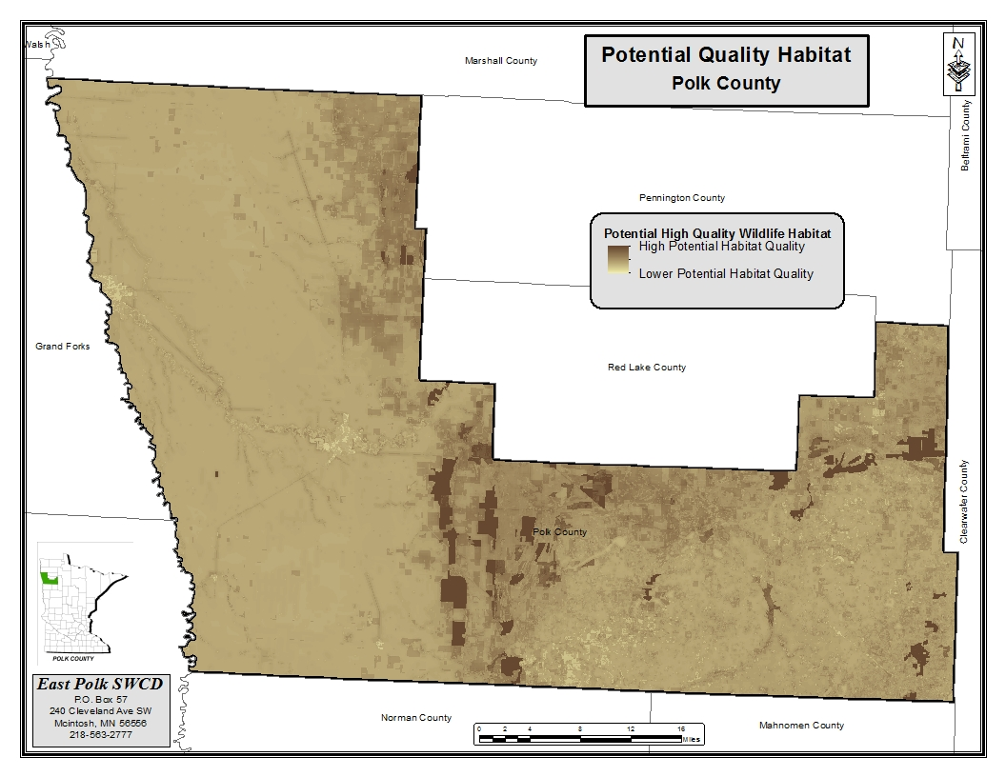

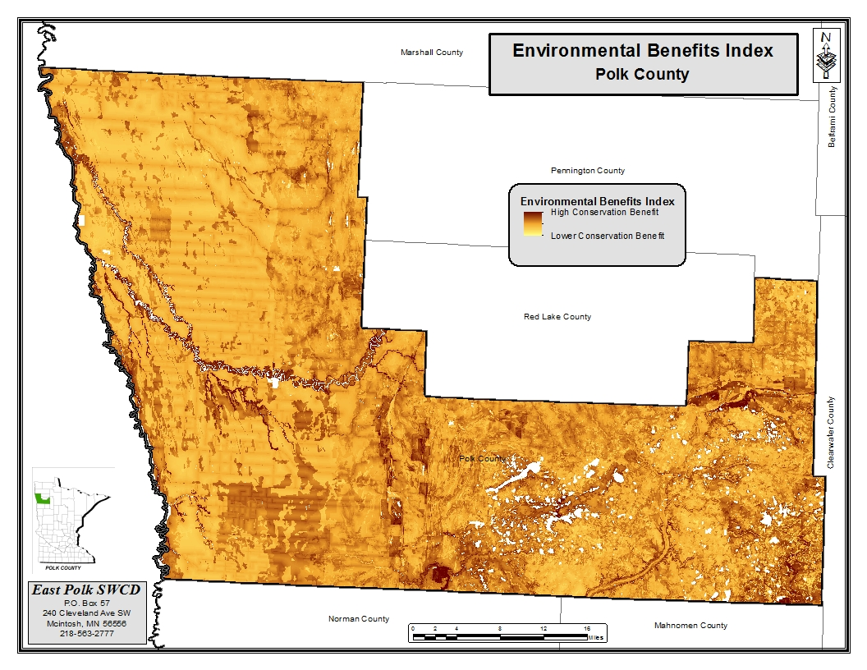

Exotic and Invasive Species Management

Polk County Local Water Management Plan will identify any new or yet to date undiscovered exotic and invasive species for prevention and management practices.

Terrestrial Invasive Species

Noxious weeds have and are becoming prolific in areas of Polk County. Canada, plumeless thistle, spotted knapweed and leafy spurge, for example are very successful at establishing themselves within the county. Wild parsnip is starting to appear in the southern part of the County.

Polk County Cooperative Weed Management Area

Chaired by Polk County Agricultural and Drainage Inspector, Jody Beauchane, agencies including the Minnesota Department of Natural Resources, , East and West
Polk County Soil and Water Conservation Districts, U.S. Fish and Wildlife Service, Minnesota
Extension, Farm Service Agency, The Nature Conservancy, and Minnesota Department of
Transportation have joined to form the Polk County Cooperative Weed Management Area (PCCWMA). The purpose of the PCCWMA is to work cooperatively to reduce the economic and environmental impacts that invasive plant species have on lands in the County. Representatives from these agencies are focusing on cooperative partnerships with policies, funding opportunities and time committed to reduce invasive weed species in Polk County. The overall objectives are on public education and mapping and control of invasive species with the specific goal to prevent, reduce and eliminate weeds through the use of chemical, mechanical and biological efforts to achieve success.

Formation of the Polk County Cooperative Weed Management Area (PCCWMA), including the development of a Purpose Statement and the drafting of a Memorandum of Understanding was initiated in 2008. Meetings were held to discuss what each agency was doing in regards to invasive weed management, how collaboration would benefit each agency and the benefits in working more cooperatively to promote control of invasive species. The PCCWMA established Euphorbia esula (leafy spurge), Centaurea stoebe (spotted knapweed), thistle species, and Typha spp. (cattails) as priority species. Additionally, secondary plants of concern for the county include Linaria vulgaris (common toadflax), Tanacetum vulgare (common tansy), Vicia cracca
(cow vetch), Coronilla varia (crown vetch), Chrysanthemum leucanthemum (oxeye daisy), Daucus carota (Queen Ann’s Lace), Pastinaca sativa (wild parsnip), Butomus umbellatus (flowering rush), Lythrum salicaria (purple lossestrife), Pastinaca sativa (wild parsnip), and Hieracium aurantiacum (Orange Hawkweed).

The Polk County Ag and Drainage Inspector reports noxious weed acreages controlled by Polk County along county and state roads have increased for the sixth year in a row. In 2008, the increase is largely due to a $12,000 grant received from the U.S. Fish and Wildlife that allowed Polk County to go beyond its normal budgeted amount. The grant was used to identify, map, and control non-native invasive plant species with an herbicide that leaves a residual behind to control any new noxious weed seeds that could germinate after an area was initially treated. In 2016 more than 2,268 acres of invasive noxious weeds along county and state roads within Polk County were treated, which increased from the 1,537 acres treated in 2015.

Locations of Invasive Species in East Polk County

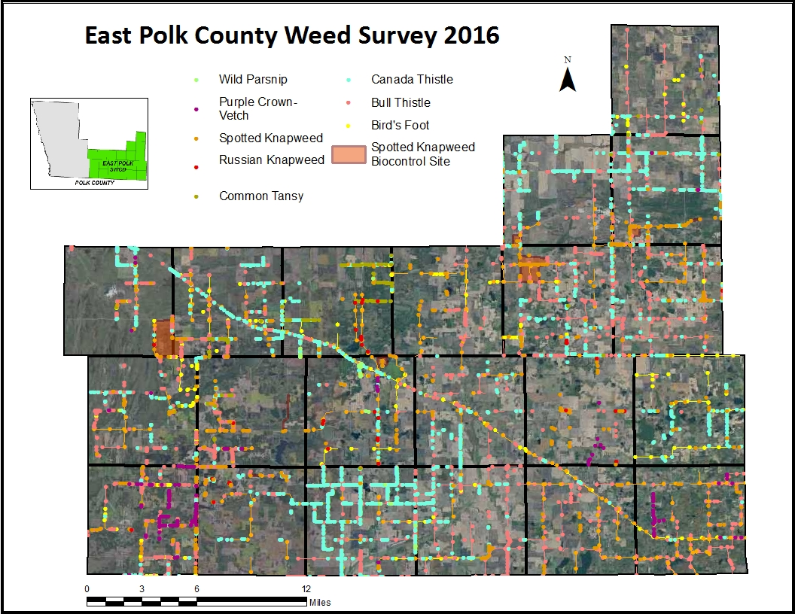

Aquatic Invasive Species

Polk County created an Aquatic Invasive Species (AIS) taskforce in 2015. Money was appropriated by the State of Minnesota for AIS prevention efforts in 2014 and beyond, and the taskforce was formed in order to help control the spread of AIS. Polk County received $24,932 in 2014, $55,187 in 2016, and is scheduled to receive $65,563 in 2017 and beyond. The AIS Taskforce has established an AIS plan to help guide the use of the funding in order to have the biggest impact on helping prevent and control the spread of AIS in Polk County.

The spread of AIS (aquatic invasive species) must be controlled because of the threat to our economy, recreational opportunities and fish and wildlife habitats. Once established, invasive species can rarely be eliminated. Currently one lake in Polk County has been identified as being infested with Eurasian Water Milfoil (Myriophyllum spicatum), Union Lake. Curly Leaf Pondweed (Potamogeten crispus) was found in Whitefish Lake in 1998 as part of a fishery survey, and is also present in Union Lake. Purple loosestrife (Lythrum salicaria) is found scattered throughout the County in wetlands and lakes. Zebra mussels.are now present in the Red River of the North. Starry Stonewort (Nitellopsis obtusa) is located nearby Beltrami County and is a major concern. The Chinese Mystery Snail (Cipangopaludina chinensis malleata) and the Faucet Snail (Bithynia tentaculate) have also been found in neighboring counties.
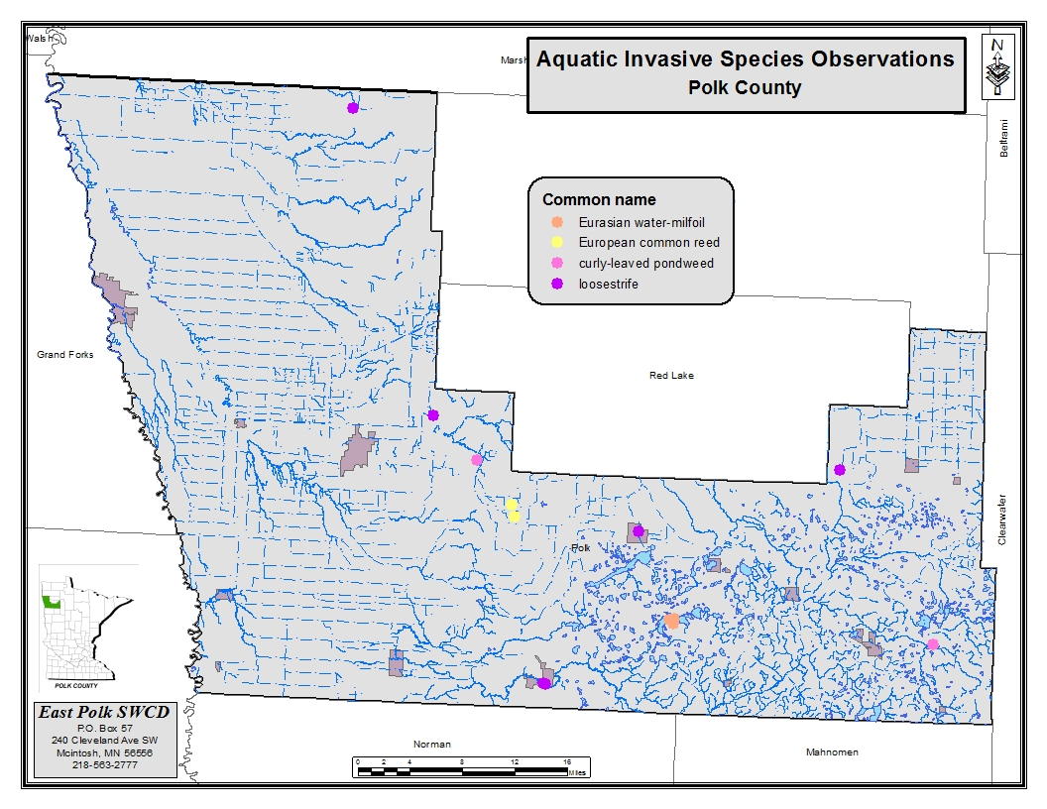

The major goals of the AIS taskforce have been to focus on education and public outreach, inspections and enforcement, special projects, and emergency response. The AIS taskforce hired two seasonal AIS technicians in 2016 and hired three AIS technicians in 2017. The major focus of the AIS technicians to conduct watercraft inspections within Polk County. In 2017 Polk County also purchased two I-LIDS camera systems to help monitor and prevent the spread of AIS at the Union Lake Public Water Access and at the Maple Lake East Shore Public Water Access.

III. Goals and Objectives

Priority Concern #1: Water Quality of Surface Waters of Polk County

The Polk County Local Water Management Plan will focus on protection and enhancement of surface water quality. Specific areas of focus will be:
Lake Region in the eastern part of the county, with specific focus on the human impacts.
- Increases in development around smaller, non-recreational lakes and larger wetland complexes should be assessed to determine if adverse impacts have affected the water quality of these smaller bodies of water.
- For nearly all of the lakes in this ecoregion phosphorus is the limiting factor. Major management efforts related to water quality are directed at limiting the amount of phosphorus loading into the lakes.
- Sediment loading has also become a major concern to the water quality of the lakes. Proper land use management and implementation of Best Management Practices needs to be analyzed and addressed.
Surface water in the western part of the county.

o The cities of East Grand Forks and Grand Forks receives its public water supply from the Red Lake River.
o The Red Lake River is impaired for turbidity and management efforts should focus on sediment loading into the Red Lake River and its tributaries.
- In addition to the above mentions specific areas of concern for Polk County, The County Board, Watershed Districts and SWCD’s will actively pursue efforts to address surface water quality concerns within the county.
- Although surface water is of primary concern for Polk County we will be responsive to the need to monitor and protect our groundwater resources. We will participate to our fullest capacity but state and federal agencies such as Minnesota Department of Health (MDH), Department of Natural Resources(DNR), Minnesota Pollution Control Agency(MPCA), Minnesota Department of Agriculture(MDA), and USGS will need to be the primary source for groundwater protection and management.

Goal: Improve the water quality of rivers and streams from the point they enter Polk County. Our goal is to attain/maintain a fishable/swimmable status of all lakes in the county, with the overall goal for all waters in Polk County to meet or exceed state water quality standards.

To meet this goal Polk County has formed a Water Resource Advisory Committee for those having the authority/interest in water quality to work together to achieve the goal for all waters of Polk County to meet or exceed state water quality standards, and will meet on a quarterly basis.

The County participated in the Sand Hill River Watershed Restoration and Protection Project (WRAP), the Red Lake River 1W1P, and will continue to participate the Red Lake River and Clearwater WRAPs as well as upcoming One Watershed One Plans (IWIP). Once complete, priority will be given to areas identified as a result of the WRAP and /or 1W1P process. The county will also participate in upcoming intensive watershed-wide monitoring studies scheduled to be completed in the future. Additional priority areas will be determined upon based on outcomes of future studies.

Major Watershed Restoration and Protection Studies

Watershed | Intensive Monitoring Start Year
Sand Hill River Watershed | 2011
Red Lake River Watershed | 2012
Grand Marais Creek Watershed | 2013
Snake River Watershed | 2013
Clearwater RiverWatershed | 2014

Until additional targeting efforts are applied the following have been identified as the county’s priority project areas based on a collaborative approach to water quality issues, readiness of projects, and willingness of project stakeholders. These and other future projects will be further defined and identified in the SWCD annual planning process.

Priority Areas:
- Projects identified in the Sand Hill River Watershed include the upper reaches of the Sand Hill Watershed
- Erosion of a Watershed Ditch west of the Fertile Airport

- Environmental Learning Center stream bank erosion project, and ditch systems that drain within 1 mile of a river or a county ditch system. Other potential projects include the
- Maple Lake Diversion Clean Water project
- areas within 1 mile of a well head protection area
- the sealing of unused and unsealed wells
- educate, market and install Ag BMPs based with whole farm planning
- Priorities around the lakes region include educating shoreland owners on lakescaping, working with new developments on natural environmental lakes
- and lakeshed assessments on Union, Sarah and Maple Lake and wetland retention to improve water quality entering Lake Sarah.
- The following watersheds have completed Watershed Restoration and Protection (WRAP) projects; Sand Hill River, Red Lake, Grand Marias Creek. The SWCD will be actively involved in these processes for watersheds currently underway and for those to be assessed in the future.
- Assist landowners to achieve full compliance related to the Minnesota Buffer Law.

Objective A: Identify areas of agricultural land use, especially in those areas with sensitive ground water and surface water resources for the installation of erosion and sediment control practices to reduce sedimentation into rivers, lakes, and wetlands with priority given to land with
a Land Management Plan. Pursue funds to do land management plans to accelerate implementation on needed areas with priority to source water protection. SWCD will help facilitate implemtation of the Buffer Law. County and Watershed Districts will enforce the Buffer Law.

Surface Water

- Action: Install BMP’s to address the resource needs such as grassed waterways, sediment control basins, side inlet pipes, minimum tillage or no-till.
Action: Develop a cost share program, which may supplement existing programs.

- Action: Provide financial support by seeking grant, Ag BMP loans, or working with agency/ special group partners (example such as NRCS, Deer Hunters Assoc, Ducks Unlimited, Pheasants Forever, and Turkey Federation).
- Action: Target areas for land retirement programs into RIM, CRP, WRP, walk-in- lands, wetland banking, or other programs available.
Action: Apply targeting tool to identify priority project areas (PTMapp or HSPF models).

- Action: Pursue and promote the restoration of wetlands, particularly large wetlands that have been drained or farmed-through. Ditches can be plugged, but sediment should also be removed from the wetlands for a full restoration. Work with the Detroit Lake USFWS Wetlands Office when and where possible. A lack of base flow has been identified as a stressor for many of the biological and low dissolved oxygen impairments in the Red Lake River, Clearwater River, and Grand Marais Creek watersheds.
- Action: Work with the USFWS to complete projects that can simultaneously benefit water quality and habitat.
- Action: Reduce pollutant loads to Cameron Lake. Explore options for restoration of the lake.
- Action: Provide technical assistance to establish buffer, conservation
- Action: Conduct sub subsurface sewage treatment system (SSTS) inventory and upgrades as needed on priority lakes: Maple, Union and Sarah with the potential to expand to other recreation and natural environment lakes

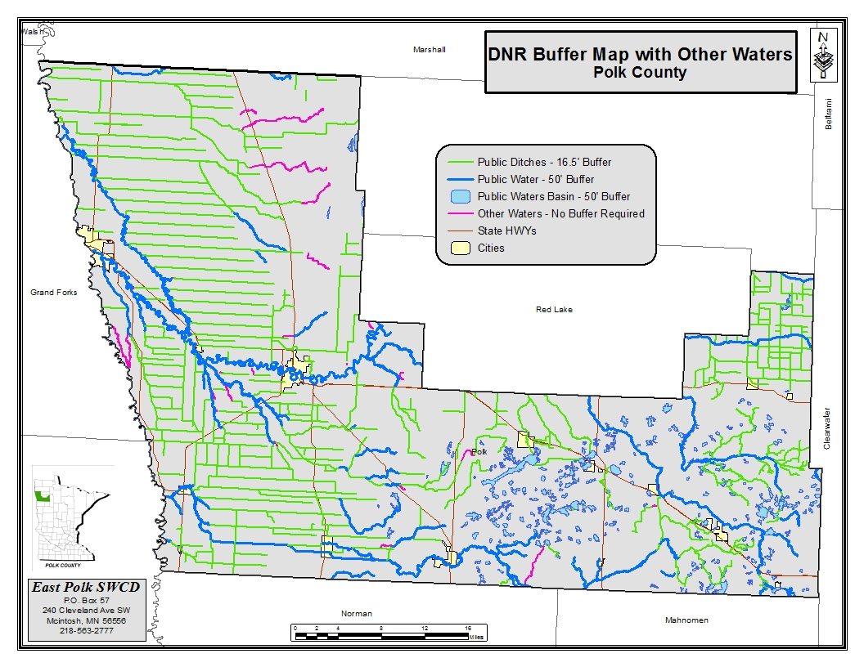

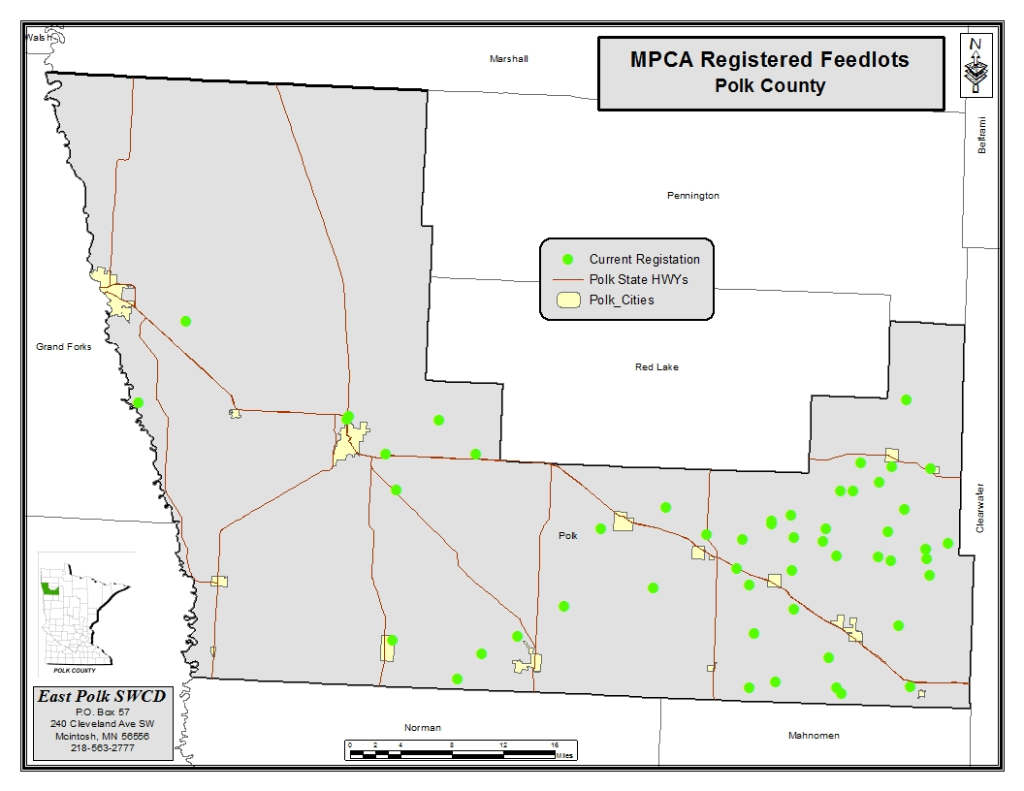

Ground Water

Action: Provide financial support to seal priority wells. Priority will be given to those meeting the State Cost Share priority guidelines, and/or have the potential to impact aquifers.

Objective B: Maintain and assess the water quality of rivers, and lakes.

Action: Continue to support the Red River Basin River Watch Program.
Action: Continue participation in the Citizen Stream Monitoring Program.
Action: Continue participation in the Lake Level Program on designated lakes.
Action: Continue MNDNR observation well readings.
Action: Continue citizens’ rainfall monitoring program. Action: Set up lake monitoring programs.
Action: Assist in implementing the Lake Improvement Districts lake plans.
Action: Implement the Watershed District plans.
Action: Implement and update the County Comprehensive Plan

Objective C: Continue to assist in the development of Watershed Restoration and Protection Project (WRAP) including TMDL’s for waters listed as impaired and Protection Plans for surface waters not impaired.

  - Action: Use resources to assist with and confirm listed waters on the TMDL impaired list.
Action: Develop a water quality monitoring program.

Action: Pursue grants and funding opportunities that will support the county’s surface water protection and improvement efforts.
  - Action: Once TMDL Implementation Plans are developed, high prioritize their implementation.
  - Action: Assist Watershed Restoration and Protection Strategies as they are completed, and assist with implementing the objectives.

Objective D: Promote and educate the citizens of Polk County about the wise use of our natural resources as it pertains to water quality.

  - Action: Participate at the Polk County fair with educational displays.
  - Action: Participate in presentations to schools, River Watch, agency meetings, and other educational events.
Action: Put out timely news releases and newsletters. Action: Conduct tours and demonstrations.

Action: Pursue grant funding for educational workshops for Buffer Law implementation, Lakescaping, etc.
Action: Hold a lakescaping workshop for the Maple/Union/Sarah area.

Objective E: Polk County has 77 feedlots that are registered. Many of these feedlots are located next to rivers, lakes or wetlands that may have the potential to impact water quality. Polk County has a approved MPCA County Feedlot Program Delegation Agreement Work Plan

Action: Conduct site visits and inspection as required in the County Feedlot Plan by the Polk County Feedlot Officers,.

Action: Provide landowners information on feedlot registration, permitting, regulations, and rule requirements.
Action: Work with feedlot operators to ensure compliance with program rules using education, technical assistance and enforcement when necessary.

Action: Seek grants or cost share for financial assistance to correct issue with priority given to riparian lots, and high priority to those on impaired waters.

- Objective F: Management of the Inner Emergency Response Area and Outer Source Water Management Areas. The inner and outer source water management areas primarily encompass the Red Lake River Watershed.

- Action: The East Grand Forks inner and outer surface water assessment areas will be prioritized to:
  - Improve surface water quality
  - Reduce turbidity and TSS levels
  - Reduce runoff, soil erosion, and sedimentation
  - Install riparian buffers along streams and ditches
  - Support land use controls and decisions that result in surface water protection.
  - Inventory and inspect SSTS.
  - Perform maintenance or upgrades of SSTS.
  - Promote education of proper septic maintenance
  - Support farming best management practices for nutrient reduction.
  - Promote feedlot inspection compliance
  - Habitat, Riparian, erosion and stormwater control projects.
  - Target areas for land retirement programs into RIM and CRP
  - Utilize Source Water Assessment Areas to assess needs and changes in land use (zoning and development ordinances, and enrollment in conservation programs) to protect surface water resources.
  - Install BMP’s to address the resource needs such as grassed waterways, sediment control basins, side inlet pipes, minimum tillage or no-till.
  - Seek funding to provide financial incentives or cost share for the implementation of BMP’s including cover crops, conservation tillage, nutrient management, forest stewardship, establishment of perennial vegetation and other protective measures in identified priority areas.
  - Continue promotion and collection of household hazardous wastes.

Potential Wind and Water Erosion Risk

The following maps will be referred to provide the county with baseline information for prioritization of efforts when addressing water concerns related to sediment and turbidity.
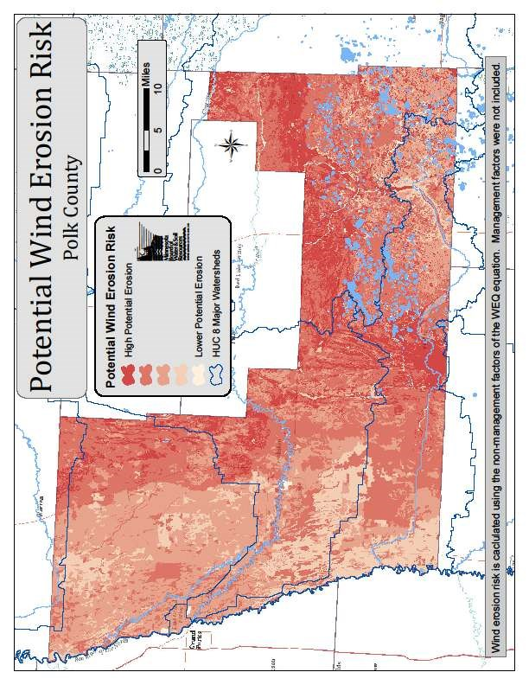

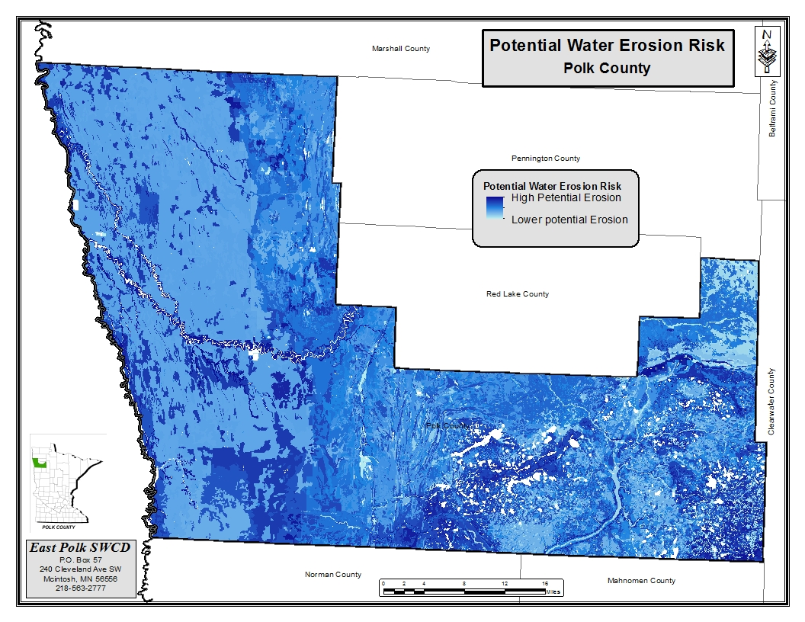

Priority Concern #2: Flood Damage Reduction/Water Quantity

Due to the fluvial geomorphic characteristics of the Red River of the North Basin, Polk County is subject to frequent flooding. Some factors such as topography and increase precipitation are unmanageable, but other factors such as flood plain encroachment, channelization of waterways, land use practices and effective private drainage into public systems, are factors that can be assessed for Best Management Practices.

Polk County Local Water Management Plan will focus on the quantity of water passing through the County and its associated watersheds by inventorying, assessing and evaluating the drainage infrastructure.

Goal 1:
Manage waters in Polk County in a manner that reduces flood damages within the County as well as the Red River Basin. Goals that have been established and will be recognized by Polk County are:

1)The Red River Basin Commission 20% Flow Reduction Strategy which indicate a 35% peak flow reduction on the Sand Hill River at Climax and a 35% peak flow reduction on the Red Lake River at Crookston. To meet these goals Polk County will need to coordinate its efforts with other counties and watershed districts to attain these peak flow reduction in the watersheds shared with Polk County.

2) The Flood Damage Reduction Work Group Mediation Agreement which include but not limited to:

Prevent damage to farm structures, homes, and communities.
- Promote the construction of farmstead ring dikes built to a minimum of 2 feet of freeboard over the flood of record, or 1 foot above the administrative 100-year flood, whichever is greater.
- Promote the construction of community setback levees and floodwalls built to the flood of record plus uncertainty (3 feet) or the 100-year flood plus uncertainty, whichever is greater.
- Promote the acquisition and permanent removal of flood-prone structures and establishment of greenways within the 100-year flood plain.
- Accelerate flood insurance studies, flood plain remapping and hydraulic/hydrologic studies in poorly defined or unmapped areas.
- Accelerate comprehensive watershed and systems approaches to basin management.
- Discourage the development of structures within the 100-year flood plain, with the exception of those approved in a community’s flood plain ordinances.

3) Reduce damage to farmland by:
- Providing protection against a ten-year summer storm event for intensively farmed agricultural land;
- Maintaining existing levels of flood protection when consistent with a comprehensive watershed management plan; and
- Providing a higher level of protection, e.g., 25-year event, when feasible at a minimal incremental cost.

Until additional targeting efforts are applied the following have been identified as the county’s priority project areas based on a collaborative approach to water quantity issues, readiness of projects, and willingness of project stakeholders. These and other future projects will be further defined and identified in the SWCD annual planning process.

Priority Areas: validate that all ditch systems are functioning properly with adequate culvert size, and proper BMP’s associated with that ditch system, be it a private, county or watershed ditch. Make sure that absentee landowners are maintaining the natural water courses so water movement isn’t impeded. Address water impoundments or any wetland improvements or dikes that hold water back so it does not alter the drainage system or change the water table so it will have an adverse affect on neighboring property, multi-purpose drainage assessments, and wetland restoration through the state banking program to hold back water.

1) Objective A: Ensure that county, township, watershed and private ditch systems adequately address the drainage needed to support agriculture without negatively impacting flooding, water quality and other natural resources, as well as economic impacts to the infrastructure of Polk County.

Action: Establish design standards based on current technological information for the repair, maintenance, improvement, and establishment of agricultural drainage systems.

Action: Determine if ditch systems are of adequate size.

Action: Identify needed BMP’s such as buffer strips and side inlet pipes.
Action: Enforce Buffer Law with required buffers or approved alternative practices
Action: Assess and modify, if needed, Polk County ditch rules and ordinances.
Action: Assess and modify, if needed Polk County ditch and culvert permitting.
Action: Assess adequacy of the drainage infrastructure.
Action: Conduct a culvert inventory.
Action: Identify and map private ditch systems to better understand water movement within the ditch system and county.

Action: Work with Watershed Districts on proper permitting for tiling on private land. Action: Address the need for beaver control in public and private ditch systems. Action: Implement new technologies in ditch and drainage systems and maintenance as they come available.
  - Seek funding for 2-stage ditch design for ditches that are scheduled/proposed for maintenance/cleaning/improvement.

2) Objective B: Identify key areas within the County that are prone to flooding and implement proper actions to address flood prevention.

Action: Use targeting tools to prioritize.

Action: Establish BMP’s that will reduce and/or slow down water movement through the County without adding to flooding.
Action: Identify site for water retention through land retirement programs such as the RIM/WRE or Agricultural Wetland Banking programs.

Action: Carry out goals and objectives in the Red Lake River 1W1P, Sand Hill River Watershed Plan, Middle-Snake-Tamarac Watershed Plan, the Red Lake Watershed Plan, and other state/local plans..

Action: Seek funding to assist landowners in flooded areas of the County; this could include MN Recover funds, emergency funding and FEMA funding.

Priority Concern #3: Groundwater

Objective A: Protect drinking water supply management areas (DWSMAs) to maintain, enhance and improve the quality of public and private drinking water supplies
Action: Provide financial support to seal priority wells. Priority will be given to those meeting the State Cost Share priority guidelines, and/or have the potential to impact aquifers.

- Action: Provide technical assistance to public water suppliers developing and implementing wellhead or source water protection plans.
- Action: Conduct unused, unsealed well inventory
- Action: Provide a variety of education on both public wellhead protection areas and the protection and management of private wells and well areas to city residents, farms and businesses regarding specific actions they can take to protect drinking water.
- Action: Conduct sub subsurface sewage treatment system (SSTS) inventory and upgrades as needed for vulnerable Drinking Water Supply Management Areas (DWSMAs)
- Action: Encourage landowners to conduct proper septic system maintenance at a minimum of every three years.
- Action: Utilize Wellhead Protection Plans to assess needs and changes in land use (zoning and development ordinances, and enrollment in conservation programs) to protect groundwater resources.
- Action: Seek funding to provide financial incentives or cost share for the implementation of BMP’s including cover crops, conservation tillage, nutrient management, forest stewardship, establishment of perennial vegetation and other protective measures in identified priority areas.
- Action: Continue promotion and collection of household hazardous wastes.
- Action: Identify vulnerable wellhead protection areas as priority areas for BMP incentive programs
- Action: Target vulnerable wellhead protection areas for land retirement programs into RIM and CRP.
- Action: Encourage and assist LGU’s in developing ordinances to limit land uses that threaten groundwater quality and quantity.
- Action: Participate in the development of a county geologic atlas (in the event one will be developed).
- Inventory gravel pits via GIS, permit review and phone interviews with landowners and/or aggregate representatives to determine the reclamation status of gravel pits throughout the county.
- Hold one public outreach event to educate/inform owners about the appropriate methods of reclaiming/restoring a gravel pit
- Action: Relocate or change the design of proposed storm water infiltration projects in high vulnerability DWSMAs

Objective B: Efficient use of groundwater resources for agricultural irrigation

- Action: Increase local awareness of available resources and technology for soil moisture monitoring and management of irrigated land and encourage their utilization.
- Partners: SWCD, NRCS, MDA
- Action 2. Work with landowners and producers to track and maintain planting, weather and irrigation data throughout the growing season to evaluate crop water use and scheduling of water applications.
- Action 3: Encourage water conservation through use of low-pressure irrigation systems to conserve groundwater in the county.

Priority Concern #4: Preservation and Enhancement of Polk County Natural Resources

Polk County is concerned with the preservation and enhancement of its natural resources. The geology of Polk County is divided into 3 distinct areas; the glacial-lake plain, glacial lake washed till plain and glacial moraine region. These major areas, because of their size, unique geographical features, and wide diversity of natural resources are of significant benefit to the area and citizens.
Polk County in cooperation with other local, state, and federal agencies will work to restore, enhance and protect these areas through programs and projects.

Goal: Participate in the restoration, conservation, and protection of key areas providing unique ecological values and recreational opportunities.

Until additional targeting efforts are applied the following have been identified as the county’s priority project areas based on a collaborative approach to restore, protect and enhance natural areas, readiness of projects, and willingness of project stakeholders. These and other future projects will be further defined and identified in the annual planning process.

Priority Areas: Conservation Reserve Program (CRP) acres that will be expiring in upcoming years which are located in the “high conservation potential” areas identified on the EBI map located on page 61. Areas that protect or restore rare natural features as identified in the Minnesota County Biological Survey (MCBS). Areas that require buffers based on the Buffer Law. Priority will also be given to those areas on which a land management plan has been developed to ensure proper conservation and habitat goals are met.

Objective A: Identify, restore, and protect grassland, wetland, and woodland habitats and key natural areas with multiple benefits to Polk County and its Citizens.

  - Action: Seek funding opportunities with existing or future land retirement or easement programs, with cooperating partners.
  - Action: Minimize land use impacts of potential land use changes by the installation of BMP’s.

Objective B: Recognize areas that are unique to the County such as native prairie sites in the glacial beach ridge areas, and wetland areas of the lake region. Utilize Minnesota County Biological Survey (MCBS) Areas of Biodiversity Significance, native plant communities, and key habitats as a resource to identifying appropriate sites.

  - Action: Seek funding opportunities with existing or future land retirement or easement programs, with cooperating partners.
  - Action: Minimize land use impacts of potential land use changes by the installation of BMP’s.
Action: Work with state, federal, and non-profit agencies/organizations on acquisition of strategic parcels.

Objective C: Protect and identify areas of threatened or endangered species

Action: Promote education on the species that are threatened or endangered.

Action: Minimize land use impacts of potential land use changes by the installation of BMP’s.
Objective D: Preserve high quality wetlands within Polk County for their best functional values.

  - Action: Identify wetlands that are of high value for banking credits, easements, flood storage, and wildlife.
  - Action: Offer cost share and other incentives to landowners to participate in restoration of wetlands.
  - Action: Assist with development of Agricultural Wetland Banking program.

Objective E: Preserve and enhance water quality by enforcing the Buffer Law
- Action: Assist landowner with establishment
- Action: Assist landowners with technical designs of alternative practices
- Action: Enforce non complicance of the Buffer Law

Polk County Local Water Management Plan will identify any new or yet to date undiscovered exotic and invasive plant or animal species for prevention and management practices.

Goal: Reduce invasive species impacts within Polk County.

Until additional targeting efforts are applied the following have been identified as the county’s priority project areas based on a collaborative approach to invasive species impacts, readiness of projects, and willingness of project stakeholders. These and other future projects will be further defined and identified in the SWCD annual planning process.

The Polk County AIS Taskforce will continue to meet and focus on preventing and/or limiting the spread of AIS within Polk County.

Priority Areas: Address invasive species along road right-of-ways, private landowner’s property, and local state and federal lands, aiming to prevent the spread of terrestrial invasive species. Address aquatic invasive species threats to area lakes and rivers. Monitor infestation of Eurasian Water Milfoil in Union Lake and other AIS. Monitor infestation of Zebra Mussels on the Red River of the North.

Terrestrial Invasive Species

Objective A: Control terrestrial invasive species by prevention, reduction and elimination.

Action: Map new sites and species occurrence.

Action: Conduct public education on the invasive species by public meeting, mailings, news releases and newsletters
Action: Work with township boards on township road weed management.

Action: Seek funding though cooperating partners and grants.

Objective B: Continue support of the Polk County Cooperative Weed Management Area.

Action: Have a central clearinghouse to compile all data collected.

Action: Continue to have meetings to keep the PCCWM group active. Action: Keep the public informed of the PCCWM group activities.

Aquatic Invasive Species
Objective D: Control aquatic invasive species by prevention, reduction and elimination by utilizing the AIS Taskforce.

Action: Educate staff and lake associations on aquatic invasive species threats.

Action: Educate public on reducing aquatic invasive species threats.
Action: Identify and map aquatic invasive species within county and regional threats.
Action: Continue the AISprevention plan for Polk County to help prevent or limit the spread of aquatic invasive species.
- Action: Hire seasonal AIS Technicians to perform watercreaft inspections.
- Action: Explore the benefit/need of decontamination units within Polk County,

Reference Documents and Website Locations

Middle Tamarack Snake Watershed District 10 Year Plan
http://mstrwd.org/about/10-year-plan/

Minnesota Department of Natural Resources, 2006. Tomorrow’s Habitat for the Wild and Rare: An Action Plan for Minnesota Wildlife, Comprehensive Wildlife Conservation Strategy. Division of Ecological Services, Minnesota Department of Natural Resources.

Minnesota Department of Natural Resources, Lake Finder Website http://www.dnr.state.mn.us/lakefind/index.html

Minnesota Department of Natural Resources, Rare Species Guide http://www.dnr.state.mn.us/rsg/index.html

Minnesota Department of Natural Resources List of Known Calcareous Fen Sites (June 30, 2001)

Minnesota Department of Natural Resources, Invasive Species in Minnesota, http://www.dnr.state.mn.us/invasives/index.html

Minnesota Prairie Conservation Plan
http://www.dnr.state.mn.us/prairieplan/index.html

MPCA Red River Basin Water Quality Plan, 1999
http://www.pca.state.mn.us/water/basins/redriver/wqplan/index.html

Minnesota Pollution Control Agency, Impaired Waters and TMDLs, www.pca.state.mn.us/water/tmdl/index.html

NRCS Website, Watershed Overview
http://www.mn.nrcs.usda.gov/technical/rwa/Assessments

Red Lake River One Watershed One Plan
http://westpolkswcd.com/1w1p.html

Red Lake River Watershed Farm to Stream Tile Drainage Water Quality Study Final Report, Revision 3 - March 20, 2009
http://www.redlakewatershed.org/projects

Red Lake Watershed District 10-Year Comprehensive Plan, April 2006 http://www.redlakewatershed.org/planupdate

Sand Hill River Watershed Management Plan, May 13, 2011

Summary of Regional Assessment Locations
By Danni Halvorson, IWI
- Heiskary, Steven, and S. McCollor. 1993. Selected Water Quality Characteristics of
Minimally Impacted Streams from Minnesota’s Seven Ecoregions, Addendum to: Descriptive Characteristics of the Seven Ecoregions in Minnesota. Minnesota Pollution Control Agency.
- Fandrei, G., S.A. Heiskary, and S. McCollor. 1988. Descriptive Characteristics of the Seven Ecoregions in Minnesota. Minnesota Pollution Control Agency.
- Minnesota Pollution Control Agency. 2010. Guidance Manual for Assessing the Quality of Minnesota Surface Waters for Determination of Impairment: 305(b) Report and 303(d) List.

U.S. Geological Survey, Estimated Use of Water in the United States in 2005, By Joan F.
Kenny, Nancy L. Barber, Susan S. Hutson, Kristin S. Linsey, John K. Lovelace, and Molly A. Maupin

U.S. Geological Survey, Ground-Water Availability from Surficial Aquifers in the Red River of the North Basin, Minnesota (Reppe 2005).

U.S. Geological Survey, Water-Resources Investigation Report 95-4201, 1996.

Cover Photograph courtesy of Ben Sullivan, July 7, 2011.

IV. Implementation Schedule
Fundamental goals and objectives can be generalized, project’s budgets will be further refined as the projects develop.

Priority Concern # 1
Goal: Improve the water quality of rivers and streams from the point they enter Polk County. Our goal is to attain/maintain a fishable/swimmable status of all lakes in the county, with the overall goal for all waters in Polk County to meet or exceed state water quality standards.

Objective A: Identify areas of agricultural land use, especially in those areas with sensitive ground water and surface water resources for the installation of erosion and sediment control practices to reduce sedimentation into rivers, lakes, and wetlands with priority given to land with a Land Management Plan. Pursue funds to do land management plans to accelerate implementation on needed areas with priority to source water protection.

Action | Schedule | Lead Agency | Partnerships | Budget | Watershed
Install BMP’s to address the resource needs | Ongoing | SWCD/NRCS | Watershed Districts | Unknown | All
Develop a cost share program | Ongoing | SWCD/NRCS | BWSR | Unknown | All
Provide technical assistance | Ongoing | SWCD/NRCS | Landowners, Watershed  Districts | $30,000/ year | All
Provide financial support by seeking grants | Ongoing | SWCD | Watershed Districts,  BWSR, Other | Unknown | All
Target areas for land retirement programs | Ongoing | SWCD/NRCS | Watershed Districts,  BWSR | Unknown | All
Apply targeting tool to identify priority project areas | Ongoing | SWCD | Watershed Districts,  BWSR, NRCS | Unknown | All
Pursue and promote restoration of wetlands | Ongoing | SWCD | BWSR, Watershed Districts, MNDNR, | Unknown | All
Work with USFWS on projects that benefit water quality and habitat | Ongoing | SWCD | County, Watershed Districts, MNDNR | Unknown | All
Reduce pollutant loads into Cameron Lake, explore restoration opportunities | Ongoing | County/MPCA | SWCD, RLWD, MNDNR, City of Erskine | Unknown
Conduct SSTS inventory & upgrades | Ongoing | County Environmental Services | SWCD | Unknown | All
Provide financial support to seal priority wells | Ongoing | SWCD/NRCS | BWSR | $5,000/ year | All

Objective B: Maintain and assess the water quality of rivers, lakes, and groundwater resources.

Action | Schedule | Lead Agency | Partnerships | Budget | Watershed
Utilize monitoring data to establish an attainable range for water quality | Ongoing | MPCA | Watershed Districts, SWCD, River Watch, MNDNR | Unknown | All
Continue to support the Red River Basin River Watch Program | Ongoing | River Watch (IWI, RLWD) | Watershed Districts | $1,000/year | All
Continue participation in the Citizen Stream Monitoring Program | Ongoing | SWCD | MPCA, Watershed  Districts | $2,000/year | RLWD SHRWD
Continue taking water elevation readings on designated lakes | Ongoing | SWCD | Watersheds | $2,000/year | RLWD SHRWD
Continue MNDNR observation well readings | Ongoing | SWCD | MNDNR | $200/year | RLWD
Continue citizens’rainfall monitoring program | Ongoing | SWCD | MNDNR, Citizens | $500/year | All
Set up/continue lake monitoring programs | Ongoing | SWCD | County, SWCD, MPCA MN DNR Shallow Lakes Program | $10,000/year | All
Implement the Lake Improvement  Districts lake plans | Ongoing | Lake  Improvement  District | MPCA, County, SWCD,  Watershed Districts,  MNDNR | $100/year | RLWD SHRWD
Implement the Watershed District plans | Ongoing | Watershed  Districts | County, Watershed  Districts, MPCA, Lake  Imp. Dist.., SWCD | $100,000/year | All
Implement and update the County Comprehensive Water Plan | Ongoing | County, SWCD | Watershed Districts, MPCA, Lake Imp. District, MNDNR | Unknown | All

Objective C: Assist in the development of Watershed Restoration and Protection Project (WRAP) including TMDL’s for waters listed as impaired and Protection Plans for surface waters not impaired.

Action | Schedule | Lead Agency | Partnerships | Budget | Watershed
Use resources to assist with and confirm listed waters on the TMDL impaired list | Ongoing | MPCA,  Watershed  Districts | SWCD, MNDNR, USFWS, MDH, MDA | $2,000/year | All
Develop a water quality monitoring program | Ongoing | Watershed  Districts, MPCA | SWCD | $1,000/year | All
Pursue grants and funding opportunities that will support the county’s surface water protection and improvement efforts | Ongoing | SWCD | Watershed Districts, County, MNDNR | $6,000/year | All
Prioritize implementation of the TMDL Implementation Plans | Ongoing | Watershed Districts, MPCA | SWCD, County | Unknown | All
Implement TMDL Implementation Plan and WRAPs Projects | Ongoing | Watershed Districts, MPCA | SWCD, County, MNDNR | Unknown | All

Objective D: Promote and educate the citizens of Polk County about the wise use of our natural resources as it pertains to water quality.

Action | Schedule | Lead Agency | Partnerships | Budget | Watershed
Participate at the Polk County fair with educational displays | Ongoing | SWCD | County,Watershed Districts, MNDNR, River Watch (IWI) | $100/ year | All
Participate in presentations to schools, River Watch, agency meetings, educational events | Ongoing | SWCD | River Watch (IWI), County,  Watershed Districts,  MNDNR, USFWS | $1,500/year | All
Put out timely news releases and newsletters | Ongoing | SWCD | River Watch (IWI), County,  Watershed Districts,  MNDNR, USFWS | $1,000/year | All
Conduct tours & demonstrations | Ongoing | SWCD | River Watch (IWI), County,  Watershed Districts,  MNDNR, USFWS | $1,000/year | All
Pursue grants for educational workshops for buffer implementation, lakescaping, etc | Ongoing | SWCD | County, Watershed Districts | Unknown | All
Hold lakescaping workshop for Union/Lake Sarah/Maple | Ongoing | SWCD | County, Watershed Districts, MNDNR, Lake Imp. Dist. | Unknown | All

Objective E: Polk County has 77 feedlots that are registered. Many of these feedlots are located next to rivers, lakes or wetlands that may have the potential to impact water quality. Polk County has an approved MPCA County Feedlot Program Delegation Agreement Work Plan.

Action | Schedule | Lead Agency | Partnerships | Budget | Watershed
Conduct site visits and inspection as required in the MPCA County Feedlot Program Delegation Agreement Work Plan. | Ongoing | SWCD | MPCA, County, MNDNR | $7,500/year | All
Provide landowners information on feedlot registration, permitting, regulations, and rule requirements | Ongoing | SWCD | MPCA U of M Extension, County, MDA | $7,000/year | All
Provide educational and technical information | Ongoing | SWCD | MPCA U of M Extension, County, MDA | $1,000/year | All
Seek grants or cost share for financial assistance | Ongoing | SWCD | MPCA, MDA | Unknown | All

Objective F: Management of the Inner Emergency Response Area and Outer Source Water Management areas. The inner and outer source water management areas primarily encompass the Red Lake River Watershed.

Action | Schedule | Lead Agency | Partnerships | Budget | Watershed
Prioritize the East Grand Forks inner and outer surface water assessment areas. | Ongoing | City of East Grand Forks | W. Polk SWCD, MDH, MPCA, BWSR, RLWD | Unknown | Red Lake Watershed

Priority Concern #2

Goal: Manage waters in Polk County in a manner that reduces flood damages within the County as well as the Red River Basin. Goals that have been established and will be recognized by Polk County are:

1) The Red River Basin Commission 20% Flow Reduction Strategy which indicate a 35% peak flow reduction on the Sand Hill River at Climax and a 35% peak flow reduction on the Red Lake River at Crookston. To meet these goals Polk County will need to coordinate its efforts with other counties and watershed districts to attain these peak flow reduction in the watersheds shared with Polk County.

2) The Flood Damage Reduction Work Group Mediation Agreement which include but not limited to:

Prevent damage to farm structures, homes, and communities.
- Promote the construction of farmstead ring dikes built to a minimum of 2 feet of freeboard over the flood of record, or 1 foot above the administrative 100-year flood, whichever is greater.
- Promote the construction of community setback levees and floodwalls built to the flood of record plus uncertainty (3 feet) or the 100-year flood plus uncertainty, whichever is greater.
- Promote the acquisition and permanent removal of flood-prone structures and establishment of greenways within the 100-year flood plain.
- Accelerate flood insurance studies, flood plain remapping and hydraulic/hydrologic studies in poorly defined or unmapped areas.
- Accelerate comprehensive watershed and systems approaches to basin management.
- Discourage the development of structures within the 100-year flood plain, with the exception of those approved in a community’s flood plain ordinances.
3. Reduce damage to farmland by:
- Providing protection against a ten-year summer storm event for intensively farmed agricultural land;
- Maintaining existing levels of flood protection when consistent with a comprehensive watershed management plan; and
- Providing a higher level of protection, e.g., 25-year event, when feasible at a minimal incremental cost.

Objective A: Ensure that county, township, watershed and private ditch systems adequately address the drainage needed to support agriculture without negatively impacting water quality and other natural resources, as well as economic impacts to the infrastructure of Polk County.

Action | Schedule | Lead Agency | Partnerships | Budget | Watershed
Establish design standards for the repair, maintenance, improvement, and establishment of agricultural drainage systems | 3 years | Watershed  Districts | Polk County Drainage Authority | $1000/ year | All
Determine if ditch systems are of adequate size | 5 years | Watershed  Districts | Polk County Drainage Authority | $500/year | All
Identify needed BMP’s | 5 years | SWCD | Watershed Districts, MNDNR | $500/year | All
Assess and modify, if needed, Polk County ditch rules and ordinances | 5 years | County | Watershed Districts | $500/year | All
Assess and modify, if needed Polk County ditch and culvert permitting | 3 years | County,  Watershed Distr. | Townships | $500/year | All
Assess adequacy of the drainage infrastructure | 3 years | County,  Watershed Distr. | Townships | $500/year | All
Conduct a culvert inventory | 5 years | Watershed Dist. | SWCD | $50,000/year | All
Identify and map private ditch systems to better understand water movement within the ditch system and county | 5 years | SWCD | Townships, Landowners | $50,000/year | All
Work with Watershed Districts on proper permitting for tiling on private land | 3 years | Watershed  Districts | SWCD | $500/year | All
Address the need for beaver control in public and private ditch systems | Ongoing | Townships | SWCD, Watershed  Districts, County, MNDNR | $500/year | All
Implementation of new technologies in ditch and drainage systems and maintenance as they come available. | Ongoing | Watershed  Districts, SWCD | County | Unknown | All
Seek funding for 2-stage ditch design for on ditches proposed for maintenance/cleaning/improvement | Ongoing | Watersheds, County | SWCD, BWSR | Unknown | All

Objective B: Identify key areas within the County that are prone to flooding and implement proper actions to address flood prevention.

Action | Schedule | Lead Agency | Partnerships | Budget | Watershed
Establishment of BMP’s that will reduce and/or slow down water movement through the County | Ongoing | SWCD | NRCS, Watershed Districts, MNDNR, BWSR | $5,000/year | All
Identify site for water retention through land retirement programs such as the RIM/WRP or Agricultural Wetland Banking programs | Ongoing | SWCD | BWSR, NRCS, Watershed  Districts, MNDNR | $25,000/year | All
Carry out goals and objectives in Watershed District plans and 1W1P. | Ongoing | Watershed  Districts | SWCD | Unknown | All
Seek funding to assist landowners in flooded areas of the County; this could include MN Recover funds, emergency funding and FEMA funding | Ongoing | SWCD | BWSR, NRCS, Watershed  Districts, MNDNR | $5,000/year | All

Priority Concern #3: Groundwater

Goal: Protect drinking water supply management areas (DWSMAs) to maintain, enhance and improve the quality of public and private drinking water supplies
Objective A: Protect drinking water supply management areas (DWSMAs) to maintain, enhance and improve the quality of public and private drinking water supplies.
Action | Schedule | Lead Agency | Partnerships | Budget | Watershed
Provide financial support to seal priority wells. | Ongoing | SWCDs, County | MPCA, MDH, BWSR | Unknown | All
Provide technical assistance to public water suppliers developing and implementing wellhead or source water protection plans | Ongoing | MDH | SWCD, BWSR, County | Unknown | All
Conduct unused well inventory | Ongoing | SWCD | MDH, MPCA, County | Unknown | All
Education on public wellhead protection areas and protection and management of private wells to the public | Ongoing | MDH | SWCD, County, MPCA | Unknown | All
Conduct sub-surface sewage treatment system (SSTS) inventory | Ongoing | County | MDH, MPCA, SWCD | Unknown | All
Encourage landowners to perform proper septic system maintenance every 3 years. | Ongoing | County | MDH, MPCA, SWCD | Unknown | All
Utilize Wellhead Protection Plans to assess needs and changes in land use to protect groundwater resources. | Ongoing | SWCD, County | MDH, MPCA, NRCS, MNDNR, Watershed Districts, Cities, BWSR | Unknown | All
Seek funding to provide financial incentives or cost share for the implementation of BMP’s | Ongoing | SWCD | Watershed Districts, County, Cities, BWSR | Unknown | All
Continue promotion and collection of household hazardous wastes | Ongoing | County | Cities, Townships | Unknown | All
Identify vulnerable wellhead protection areas as priority areas for BMP incentive programs | Ongoing | SWCD | County, NRCS, Watershed Districts | Unknown | All
Target vulnerable wellhead protection areas for land retirement programs | Ongoing | SWCD | MNDNR, County, BWSR | Unknown | All
Encourage and assist LGU’s in developing ordinances to limit land uses that threaten groundwater. | Ongoing | MDH | MPCA, SWCD, County | Unknown | All
Participate in the development of a county geologic atlas | Ongoing | County | MDH, IWI, USGS, MNDNR, SWCD, Watershed Districts | Unknown | All
Inventory gravel pits to determine the reclamation status of gravel pits throughout the county | Ongoing | County | MNDNR, SWCD, Townships | Unknown | All
Hold public outreach event to educate the public on reclaiming and restoring gravel pits | Ongoing | County | MNDNR, SWCD, Townships, NRCS | Unknown | All
Relocate or redesign proposed storm water infiltration project in high vulnerability DWSMAs | Ongoing | MPCA, MDH | County, Cities, Townships | Unknown | All

Objective B: Efficient use of groundwater resources for agricultural irrigation

Increase local awareness of resources and technology for soil moisture monitoring and management | Ongoing | MDH | SWCD, NRCS, MDA, MNDNR | Unknown | All
Work with landowners to track and maintain planting, weather and irrigation data throughout growing season | Ongoing | MDH | SWCD, NRCS, MDA, MNDNR | Unknown | All
Encourage water conservation through use of low-pressure irrigation systems to conserve groundwater | Ongoing | MNDNR | MDH, MDA, NRCS, SWCD | Unknown | All

Priority Concern #4

Goal: Participate in the restoration, conservation, and protection of key areas providing unique ecological values and recreational opportunities and reduce invasive species impact in the county.

Objective A: Identify, restore, and protect grassland, wetland, and woodland habitats and key natural areas with multiple benefits to Polk County and its Citizens.

Action | Schedule | Lead Agency | Partnerships | Budget | Watershed
Seek funding opportunities with existing or future land retirement or  easement programs, with cooperating partners | Ongoing | SWCD | NRCS, Working Lands Initiative Local Technical Team (LTT), MNDNR, USFWS, TNC | $25,000/year | All
Minimize land use impacts of potential land use changes by the installation of BMP’s | Ongoing | SWCD0 | NRCS, Watershed  Districts, MNDNR | $20,000/year | All
Management of existing public land and acquisition of strategic parcels | Ongoing | DNR/USFWS/TNC | LTT, conservation clubs, MNDNR, USFWS, TNC | Unknown | All

Objective B: Recognize areas that are unique to the County such as native prairie sites in the glacial beach ridge areas, and wetland areas of the lake region. Utilize Minnesota County Biological Survey (MCBS) Areas of Biodiversity Significance, native plant communities, and key habitats as a resource to identifying appropriate sites.

Action | Schedule | Lead Agency | Partnerships | Budget | Watershed
Seek funding opportunities with existing or future land retirement or  easement programs, with cooperating partners | Ongoing | SWCD | NRCS, MNDNR, USFWS, TNC | $20,000/year | All
Minimize land use impacts of potential land use changes by the installation of BMP’s | Ongoing | SWCD | NRCS, Watershed Districts, MNDNR | $15,000/year | All
Work with state, federal, and non-profit agencies/organizations on acquisition of strategic parcels | Ongoing | SWCD | MNDNR, USFWS, NRCS, Nature Conservancy | Unknown | All

Objective C: Protect and identify areas of threatened or endangered species.

Action | Schedule | Lead Agency | Partnerships | Budget | Watershed
Promote education on the species that are threatened or endangered | Ongoing | SWCD | MNDNR, USFWS, County, TNC | $4,000/year | All
Minimize land use impacts of potential land use changes by the installation of BMP’s | Ongoing | SWCD | MNDNR, USFWS, Lake  Improvement Associations, County | $15,000/year | All

Objective D: Preserve high quality wetlands within Polk County for their best functional values.

Action | Schedule | Lead Agency | Partnerships | Budget | Watershed
Identify wetlands that are of high value for banking, easements , flood storage, and wildlife. | Ongoing | SWCD | MNDNR, USFWS, TNC | Unknown | All
Offer cost share and other incentives to landowners to participate in wetland restoration | Ongoing | SWCD | MNDNR, USFWS, BWSR, NRCS | Unknown | All
Assist with development of Ag Wetland Bank sites | Ongoing | SWCD | NRCS, BWSR | Unknown | All

Objective E: Preserve and enhance water quality by enforcing the Minnesota Buffer Law.

Action | Schedule | Lead Agency | Partnerships | Budget | Watershed
Assist landowners with establishment of buffers and/or alternative practices | Ongoing | SWCD | NRCS, FSA | Unknown | All
Enforce buffer law for areas that are non-compliant with the buffer law | Ongoing | County | SWCD, BWSR | Unknown | All

Terrestrial Invasive Species

Objective A: Control invasive species by prevention, reduction and elimination.

Action | Schedule | Lead Agency | Partnerships | Budget | Watershed
Map know sites and species occurrence | Ongoing | County | Polk Co. Cooperative Weed Management Group, MNDNR, SWCD | $15,000/year | All
Conduct public education on the invasive species by public meeting, mailings, news releases and newsletters | Ongoing | SWCD | Polk Co. Cooperative Weed Management Group, MNDNR | $1,000/year | All
Seek funding though cooperating partners and grants | Ongoing | SWCD | Polk Co. Cooperative Weed Management Group, MNDNR | $500/year | All

Objective B: Continue support of the Polk County Cooperative Weed Management Area

Action | Schedule | Lead Agency | Partnerships | Budget | Watershed
Have a central clearinghouse to compile all data collected | Ongoing | County | Polk Co. Cooperative Weed Management Group, MNDNR, SWCD | $30,000/year | All
Continue to have meetings to keep the PCCWM group active | Ongoing | County | Polk Co. Cooperative Weed Management Group, MNDNR , SWCD | $600/year | All
Keep the public informed of the PCCWM group activities | Ongoing | County | Polk Co. Cooperative Weed Management Group, MNDNR, SWCD | $300/year | All

Aquatic Invasive Species

Objective A: Control aquatic invasive species by prevention, reduction and elimination by utilizing the AIS Taskforce.

Action | Schedule | Lead Agency | Partnerships | Budget | Watershed
Education and Public Awareness outreach on AIS threats | Ongoing | County, DNR | Polk Co. AIS Taskforce, MNDNR | $10,000/year | All
Explore cost and feasibility of purchasing decontamination units for Polk County | Ongoing | County | Polk Co. AIS Taskforce | $20,000/year | All
Identify and map aquatic invasive species within county and regional threats | Ongoing | County | Polk Co, AIS Taskforce | $5,000 | All
Continue the AIS prevention plan for Polk County | Ongoing | County | Polk Co. AIS Taskforce | $5,000 | All
Hire seasonal AIS technician to perform watercraft inspections and provide education | Ongoing | County | Polk Co. AIS Taskforce, Lake Improvement Districts | $30,000/year | All
Provide funding for local units of government or lake improvement districts to conduct special projects to limit or control the spread of AIS | Ongoing | County | Polk Co. AIS Taskforce, Lake Improvement Districts | $10,000/year | All

V. Ongoing Activities

Polk County Local Water Plan
Administration | Ongoing | SWCD | County | $23,916/yr

Polk County Local Water Management Program - Monitoring
Activity/Initiative | Schedule | Lead Agency | Partner Agency | Budget | Watershed District
DNR Lake Levels | 7 per year | East Polk SWCD | MNDNR | $2,000 | All
DNR Observation Well Measurements | 8 per year | East Polk SWCD | MN DNR | $160 | RLWD
Stream Readings | 7 per year | East Polk SWCD | MPCA, MNDNR, RLWD, Riverwatch (IWI) | $3,000 | All
Rainfall Monitoring | 8 per year | East Polk SWCD West Polk SWCD | MNDNR | $400 | All
Nitrate Testing Clinic | Yearly | East Polk SWCD | MN Dept. of Ag, MN Ext. | $360 | All
Polk County Local Water Management Program - Education
Northwest Water Festival | 2 events per year | East Polk SWCD West Polk SWCD | Area 1 SWCD’s | $900 | All
Area 1 Envirothon | 2 events per year | East Polk SWCD West Polk SWCD | Area 1 SWCD’s | $900 | All
Polk County Fair Booth Participation | Yearly | East Polk SWCD West Polk SWCD | Watershed Districts,  County, MNDNR,  USFWS, River Watch (IWI) | $400 | All
Tree Newsletter | Yearly | East Polk SWCD West Polk SWCD | None | $1,200 | All
UMC Class Presentations | 2 per year | East Polk SWCD West Polk SWCD | Not Applicable | $800 | Not Applicable
River Watch Presentations | - per year  - per year | East Polk SWCD West Polk SWCD | Not Applicable | $1,000 | All
Newsletters (Lake Leader, Landowner, Polk County Feedlot Newsletter) | 2 per year (both) | East Polk SWCD West Polk SWCD | None | $4,000 | All
Rydell 7th Grade Youth Tour | Yearly | East Polk SWCD | None | $300 | Not Applicable
Arbor Day Presentations | Yearly | West Polk SWCD | Not Applicable | $500 | Not Applicable
Cooperative Weed  Management Education | Yearly | East Polk SWCD | Township Boards, County Weed Inspector | $6,000 | All

Polk County Feedlot Program
Activity/Initiative | Schedule | Lead Agency | Partner Agency | Budget | Watershed District
Administration | Ongoing | SWCD | MPCA, County | $7,500 | All
Feedlot Inspection | Ongoing | East Polk SWCD West Polk SWCD | MPCA | $2,500 | All
Feedlot Permitting | Ongoing | East Polk SWCD West Polk SWCD | MPCA, Polk County  Environmental Services | $250 | All
Feedlot Registration | Ongoing | East Polk SWCD West Polk SWCD | MPCA, Polk County  Environmental Services | $1,000 | All
Feedlot Staff Training | Ongoing | East Polk SWCD West Polk SWCD | MPCA, Polk County  Environmental Services | $2,000 | All
Feedlot Owner Assistance | Ongoing | East Polk SWCD West Polk SWCD | MPCA, Polk County  Environmental Services | $5,000 | All
Feedlot Administration | Ongoing | East Polk SWCD West Polk SWCD | MPCA, Polk County  Environmental Services | $2,000 | All
Wetland Conservation Act Program
Activity/Initiative | Schedule | Lead Agency | Partner Agency | Budget | Watershed District
WCA Program  Administration | Ongoing | SWCD | BWSR | $43,282/year | All
District Tree Program
Activity/Initiative | Schedule | Lead Agency | Partner Agency | Budget | Watershed District
Hand Plant Tree Sales | Ongoing | East Polk SWCD West Polk SWCD | NRCS, Landowners | $22,500/year | All
District Tree Planting Services | Yearly (Spring) | East Polk SWCD West Polk SWCD | NRCS | $5,000/year | All
District Tree Maintenance Services | Ongoing | West Polk SWCD | NRCS | $1,000/year | All
Shoreland Ordinance
Activity/Initiative | Schedule | Lead Agency | Partner Agency | Budget | Watershed District
DNR Shoreland Management | Ongoing | County Environmental Services | SWCD, MNDNR | $6,798 | All
SSTS
Activity/Initiative | Schedule | Lead Agency | Partner Agency | Budget | Watershed District
SSTS Sewage Treatment Ordinance | Ongoing | County Environmental Services | MPCA, SWCD, BWSR | $9,931 | All
Low-Income SSTS Fixup Program | Ongoing | County Environmental Services | MPCA, BWSR | $20,945 | All

Appendix A

Common Abbreviations
ACOE – Army Corps of Engineers
AIS – Aquatic Invasive Species
BMP – Best Management Practice
BWSR – Board of Soil and Water Resources
CLWP – Comprehensive Local Water Plan
CRP – Conservation Reserve Program
DNR – Department of Natural Resources
FDR – Flood Damage Reduction
IWI – International Waters Institute
LGU – Local Government Unit
MDA – Minnesota Department of Agriculture
MPCA – Minnesota Pollution Control Agency
NRGG – Natural Resources Block Grant
NRCS – Natural Resources Conservation Service
RIM – Reinvest in Minnesota
RLWD – Red Lake Watershed District
SHRWD – Sand Hill River Watershed District
SWCD – Soil and Water Conservation District
TMDL – Total Maximum Daily Load
TSS – Total Suspended Solids
WCA – Wetland Conservation Act
WRP – Wetland Reserve Program
WD – Watershed District
WRAC – Water Resources Advisory Committee
1W1P – One Watershed, One Plan
WRAPs – Watershed Restoration and Protection Strategies

Appendix B
