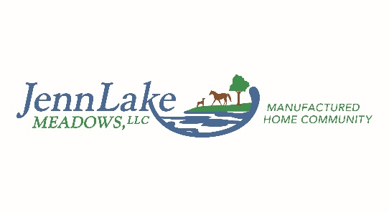
185 JennLake Drive
Starkville, MS 39759
662-324-1001
jennlake662@gmail.com
www.jennlakemeadows.com

JennLake Meadows Tree Policy Rules Amendment

Effective April 27, 2026
THE FOLLOWING IS AN AMENDMENT TO CLARIFY AND UPDATE THE JENNLAKE MEADOWS POLICY ON ALL TREES ON THE ENTIRE PROPERTY
- There are thousands of trees at JennLake Meadows. This is a blessing in that it adds to the attractiveness of the property and provides natural shade and noise buffering. But it's also a curse because, well, trees occasionally fall.
- The rules are clear that JennLake is not responsible or liable for any damage caused by any tree or shrub that is considered to be on any specific LOT.
- The rules regarding trees considered to be on the general property, and not part of a specific lot, have always been grey areas. This rule amendment will clarify the policy and replace any other documentation regarding property trees.
- JennLake Meadows is never, under any circumstances, liable or responsible for any damage caused by any tree on the property, ever. There are just too many trees to be able to practically ensure that none pose a hazard, and trees are too unpredictable.
- There is no such thing as “comprehensive” insurance for a business like JennLake Meadows. There is only “liability” insurance. Property Management Liability Insurance protects property managers against lawsuits and claims arising from management services. This insurance covers legal defense costs, settlements, and judgments resulting from covered claims. If somebody slips and falls walking to the office and hires a lawyer, our liability insurance would kick in for that. If somebody was injured by a dog on the property and felt that our off-leash policy was responsible for creating a condition that meant a dog injury was foreseeable, our liability insurance would kick in for that. If somebody went swimming in the pond and drowned is another example. If somebody got bitten by a snake walking around the pond and sued over it. If somebody felt they did not get approved for a lease but somebody else with the same application credentials did get approved. You get the idea. IF A TREE WERE TO FALL ONTO SOMEONE’S HOME, OR OTHER PROPERTY, OR worst-case scenario injures a person as a result of falling, that may be a case where liability insurance would be involved.
- In general, trees falling are considered an Act of God with no liability attached. If a tree falling caused damage to personal property or injury to a person, an assessment would be made as to whether JennLake Meadows could have reasonably known any given tree posed an imminent danger. There are hundreds of large trees along the tree-lines at the back of many, but not all, residential lots. It is not feasible to 1) clear cut all the trees to remove any fall hazards or 2) have prior knowledge of a potentially dangerous tree.
- That said, JennLake Meadows absolutely wants everyone to be safe and all personal property to be safe. We strongly encourage homeowners to proactively keep an eye on large trees that might cause damage if they fell. Homeowners who are significantly concerned about the possibility of a tree falling should only purchase homes where no trees are nearby.
- If an owner feels that a tree poses an imminent threat, they should notify JennLake management preferably by email. JennLake will coordinate having a professional, bonded tree service company look at it and provide a recommendation as to whether the tree is dangerous and should be proactively removed. If the recommendation is for removal, then most likely the tree will need to be removed either quickly or relatively soon depending on the immediate risk.
- Removing large trees in tight residential areas can be very tricky and expensive to do properly. Often there will be some damage to lots or fencing to gain access to be able to remove the tree. Often large heavy cranes are necessary to remove the trees, especially behind the lots with homes on either side of them. All damage caused by the act of removing a tree is the full responsibility of the homeowner to repair back to the original condition, except for the driveway. Any damage done to a driveway will be repaired by JennLake Meadows.
- If any homeowner ever wants to remove any tree at JennLake they feel endangers their lot, JennLake will always approve the removal, at homeowner expense, as long as it is done safely. Depending on the location and situation, JennLake may require the homeowner to use a licensed, bonded professional tree service company with appropriate equipment and skills to safely remove the tree and minimize property damage.
- If JennLake management feels that a tree poses an imminent risk of falling and causing property damage or injury, they may REQUIRE the homeowner to remove the tree. In these instances, JennLake will pay half the cost of the tree removal. The homeowner is still responsible for any damage to property resulting from removing the tree. Leasing land that your home is installed on is very different from renting an apartment. Homeowners are responsible for ALL things related to their lots, and this includes threats from ANY trees including property trees that are not located directly on a residential lot.
- To be clear – once a tree falls, or a portion of a tree falls, or a branch falls, for any reason, anywhere onto a residential lot or personal property, JennLake Meadows is not responsible at all for it. JennLake Meadows is not responsible for any liability associated with damage or injury. The homeowner will have to coordinate the cleanup using an approved contractor or by themselves and make any repairs to damaged property back to the original condition before the damage occurred. If JennLake has resources available we may be able to assist with the cleanup but this should not be assumed.

Homeowner Signature: _______________________

