Caregiver Survey for the
Program of Comprehensive Assistance for Family Caregivers (PCAFC)

PAPER WORK REDUCTION ACT INFORMATION: This information is collected according to the clearance requirements of section 3507 of the Paper Work Reduction Act of 1995. No persons are required to respond to a collection of information unless it displays a valid Office of Management and Budget (OMB) control number. The valid OMB control number for this information collection is xxxx. The time required to complete this information collection is estimated to average 10 minutes per response, including the time to review instructions, search existing data resources, gather the data needed, and complete and review the information collection. The information requested on this survey will be used to help VA improve the caregiver support program. A response to this survey is voluntary.

VETERANS HEALTH ADMINISTRATION
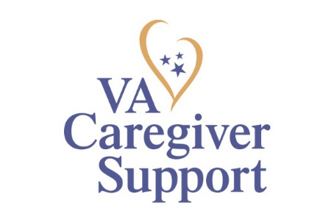 CAREGIVER SURVEY
Welcome to the Caregiver Survey for the Department of Veterans Affairs (VA) Program of Comprehensive Assistance for Family Caregivers (PCAFC).
(The program is also known as the “Caregiver Support Program”, “VA Stipend Program” or “Family Caregiver Program”).

The survey asks about Caregiver awareness, utilization, and satisfaction regarding PCAFC. Even if you are not a current participant in PCAFC your feedback about your experience with this program is important. This survey takes about 10 minutes to complete, depending on your experience in the program.

We are eager to hear about your personal experiences with the program. Your participation is voluntary, but we hope you will choose to participate. If you decide not to participate or not to answer some questions, your VA benefits or other benefits to which you are entitled will not be affected.

This survey is confidential. VA will protect your identity and answers to the fullest extent allowed under law, and will not share your individual responses with VA staff. Also, no information you provide will be released to the general public in a way that can be traced back to you.

Questions or concerns? For questions about completing the survey, please call the Survey Information Line toll free at 1-xxx-xxx-xxxx Monday through Friday, 8:00 a.m. until 8:00 p.m. Eastern time. For questions about healthcare services at the VA please contact the Health Resource Center toll free at 1-xxx-xxx-xxxx (xxxx) Monday through Friday, 8:00 a.m. until 8:00 p.m. Eastern time.

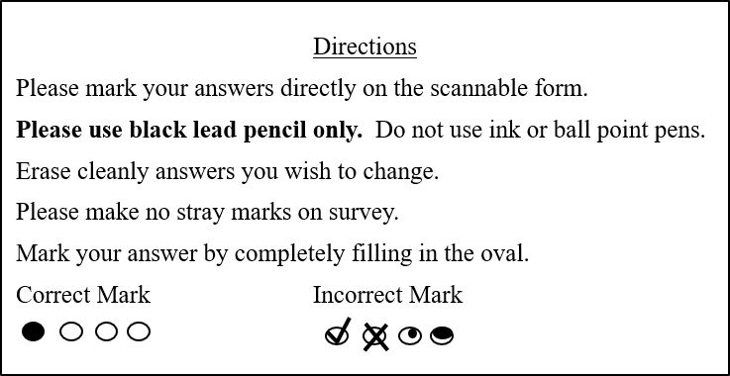
SECTION A: PCAFC Participation Status
Q1. Are you currently enrolled in PCAFC as a Caregiver?
- Yes (PLEASE GO TO Q1a)
- No (PLEASE GO TO Q1b)

Q1a. How long have you been a Caregiver in PCAFC? Please select one response.
- 3-6 months
- 7-12 months
- 13-18 months
- 19-23 months
- 2-3 years
- 4-5 years
- 5 years or longer

Q1b. How long were you a Caregiver in PCAFC? Please select one response.
- 3-6 months
- 7-12 months
- 13-18 months
- 19-23 months
- 2-3 years
- 4-5 years
- 5 years or longer

SECTION B: PCAFC Services
Q2. Are you aware of the following PCAFC services? Please select all services you have heard about:
  - Building Better Caregivers ™
  - Caregiver Support Line
  - Caregiver Support Line Education Calls
  - Civilian Health and Medical Program of the Department of Veterans Affairs (CHAMPVA)
  - Mental Health services/counseling for you
  - Peer Support Mentoring Program
  - Reimbursement for travel and lodging expenses when going with the Veteran to medical appointments, procedures or in-patient stays at your VA Medical Center
  - Resources for Enhancing All Caregivers Health (REACH) VA
  - Respite Care
  - Self-Care Classes (Managing Stress, Problem Solving/Effective Communication, Taking Care of Yourself)
  - Stipend
  - Telephone Support Group Sessions for Caregivers
  - I am not aware of any of the services listed above

Q3. Whether or not you have received this service, how would you rate the importance of each of the following services based on your needs?

PCAFC Service | Not Important  At All | Not Very Important | Neutral | Important | Very Important | Don’t Know How Important
Building Better Caregivers ™
Caregiver Support Line |  |  |  |  | d | d
Caregiver Support Line Education Calls
Civilian Health and Medical Program of the Department of Veterans Affairs (CHAMPVA)
Mental Health services/ counseling for you | D | D | D | D | D | D
Peer Support Mentoring Program
Reimbursement for travel and lodging expenses when going with the Veteran to medical appointments, procedures or in-patient stays at your VA Medical Center
Resources for Enhancing All Caregivers Health (REACH) VA
Respite Care
Self-Care Classes (Managing Stress, Problem Solving/Effective Communication, Taking Care of Yourself)
Stipend
Telephone Support Group Sessions for Caregivers

Q4. How satisfied are you with each of the following PCAFC services? If you have not received a service, please select “Did not receive this service.”

PCAFC Service | Very Dissatisfied | Dissatisfied | Neutral | Satisfied | Very Satisfied | Did not receive this service
Building Better Caregivers ™
Caregiver Support Line |  |  |  |  | d | d
Caregiver Support Line Education Calls
Civilian Health and Medical Program of the Department of Veterans Affairs (CHAMPVA)
Mental Health services/ counseling for you | D | D | D | D | D | D
Peer Support Mentoring Program
Reimbursement for travel and lodging expenses when going with the Veteran to medical appointments, procedures or in-patient stays at your VA Medical Center
Resources for Enhancing All Caregivers Health (REACH) VA
Respite Care
Self-Care Classes (Managing Stress, Problem Solving/Effective Communication, Taking Care of Yourself)
Stipend
Telephone Support Group Sessions for Caregivers

SECTION C: Caregiver Support Coordinator
Every VA medical center has at least one Caregiver Support Coordinator. This person may have helped you with the PCAFC application process or assisted in referring you to additional resources and services.

Q5. As a Caregiver, how helpful was it to have a Caregiver Support Coordinator as a designated person you could contact for assistance?
- Not helpful at all (PLEASE GO TO Q5a)
- Not very helpful (PLEASE GO TO Q5a)
- Neutral (PLEASE GO TO Q6)
- Helpful (PLEASE GO TO Q6)
- Very helpful (PLEASE GO TO Q6)
- Was not aware of the Caregiver Support Coordinator (PLEASE GO TO Q6)

5a. Which of the following explains why the Caregiver Support Coordinator was not helpful? Select all that apply.
- The Caregiver Support Coordinator was not responsive to my requests
- The Caregiver Support Coordinator did not follow-up with me
- The Caregiver Support Coordinator did not clearly communicate with me
- The Caregiver Support Coordinator could not provide the information I needed
- The Caregiver Support Coordinator was not familiar with my Veteran’s specific health needs
- Other, please specify_________________

Q6. How well were you updated on your application status during the application process?
- Not at all
- Not very well
- Neutral
- Well
- Very well
- Don’t remember

Q7. As a Caregiver in PCAFC, you assume specific responsibilities. How well did the Caregiver Support Coordinator explain the following responsibilities to you as a Caregiver entering PCAFC?
Caregiver Responsibility | Not at All | Not Very Well | Neutral | Well | Very Well
Your overall responsibility to:
a. Work closely with the Veteran’s treatment team to encourage and support the Veteran achieving maximum independence.
b. Promptly inform the Veteran's doctor and Caregiver Support Coordinator of any changes to the Veteran's physical or mental health.
c. Demonstrate flexibility in scheduling home visits. Be physically present and participate during home visits and monitoring required by the Program of Comprehensive Assistance for Family Caregivers.
Your responsibility to promptly inform the Caregiver Support Coordinator:
d. If you are no longer willing or able to serve as the Veteran's Primary Family Caregiver.
e. If you are or the Veteran is admitted to a hospital, long term care facility, rehabilitation facility, residential treatment program, or incarcerated.
f. If your address, telephone number or other contact information changes.
g. If your Veteran’s address changes.
If enrolled in the Civilian Health and Medical Program of VA (CHAMPVA), your responsibility to inform the Caregiver Support Coordinator: (IF NOT ENROLLED IN CHAMPVA, PLEASE GO TO Q8)
h. If you get health care coverage, such as a commercial health insurance plan, Medicare, Medicaid, or a Workers’ Compensation law or plan.
i. If you become eligible for TRICARE.

SECTION D: PCAFC Staff Support
Q8. How often have you encountered issues caused by lack of communication or miscommunication between PCAFC staff and your VA health care providers?
- Never
- Rarely
- Sometimes
- Most of the time
- Always

Q9. How often do/did you feel that you were treated with respect by the PCAFC team?
- Never
- Rarely
- Sometimes
- Most of the time
- Always

Q10. Other than financial support, what do/did you identify as your primary need as a Caregiver? Please select one response.
- Connections with other caregivers
- Education/training to be a better caregiver
- Physical help with caregiving
- Self-care
- Supportive counseling
- Time away from caregiving
- Other, please specify___________________________

Q11. How well does/did PCAFC help you meet the primary need you identified above?
- Not at all
- Not very well
- Neutral
- Well
- Very well

Q12. Did/do contacts (home visits, telephone calls, tele-health visits) with PCAFC staff lead to additional or new VA services or resources for you or the Veteran?
- Yes (PLEASE GO TO Q12a)
- No (PLEASE GO TO Q13)

Q12a. Which of the following new or additional services or resources were received as a result of your participation in the PCAFC? Select all that apply.
- Adaptive equipment for the Veteran (examples: grab bars, wheelchair, cane)
- Aide and Attendance from the Veterans Benefits Administration for the Veteran
- Home Based Primary Care
- Home Improvements and Structural Alterations (HISA) Grant from the Veterans Benefits Administration for the Veteran
- Homemaker/Home Health Aide
- Veteran Directed-Home and Community Based Services
- Referral to community agency for support
- Other, please specify _________________________________

Q13. Overall, how satisfied are/were you with PCAFC?
- Very dissatisfied (PLEASE GO TO Q13a)
- Dissatisfied (PLEASE GO TO Q13a)
- Neutral (THANK YOU FOR COMPLETING THE SURVEY)
- Satisfied (THANK YOU FOR COMPLETING THE SURVEY)
- Very satisfied (THANK YOU FOR COMPLETING THE SURVEY)

13a. Which of the following explains why you are/were not satisfied? Select all that apply.
- The application decision process was too lengthy
- The clinical appeals process was confusing
- My Caregiver Support Coordinator was not helpful
- The education services provided to the Caregivers were not helpful
- There was a lack of follow-up services
- There was a lack of personalized communications (e.g., phone calls, in-person meetings, etc.)
- Poor customer service from VA staff
- There was a lack of useful information about the program
- The VA doctors had no knowledge about PCAFC and did not understand my role as the Veteran’s Caregiver
- Other, please specify_________________

THANK YOU FOR COMPLETING THE SURVEY.

