Second Sunday in Lent
Sunday, February 25, 2024
9:30 am

Introduction
The second covenant in this year’s Lenten readings is the one made with Abraham and Sarah: God’s promise to make them the ancestors of many, with whom God will remain in everlasting covenant. Paul says this promise comes to all who share Abraham’s faith in the God who brings life into being where there was no life. We receive this baptismal promise of resurrection life in faith. Sarah and Abraham receive new names as a sign of the covenant, and we too get new identities in baptism, as we put on Christ.

Prelude
Improvisation on Munich

+ Gathering +

Welcome & Announcements

Ringing of the bell The congregation may stand.

Confession & Forgiveness
God of all mercy and consolation, come to the help of your people, turning us from our sin to live for you alone. Give us the power of your Holy Spirit that we may confess our sin, receive your forgiveness, and grow into the fullness of Jesus Christ, our Savior and Lord.
Amen.
Let us confess our sin in the presence of God and of one another.

Most merciful God,
we confess that we are captive to sin and cannot free ourselves.
We have sinned against you in thought, word, and deed,
by what we have done and by what we have left undone.
We have not loved you with our whole heart; we have not loved our neighbors as ourselves.
For the sake of your Son, Jesus Christ, have mercy on us.
Forgive us, renew us, and lead us,
so that we may delight in your will and walk in your ways,
to the glory of your holy name. Amen.

God, who is rich in mercy,
loved us even when we were dead in sin,
and made us alive together with Christ.
By grace you have been saved.
In the name of ☩ Jesus Christ, your sins are forgiven.
Almighty God strengthen you with power through the Holy Spirit,
that Christ may live in your hearts through faith. Amen.
Gathering Hymn O Word of God Incarnate (ELW 514)
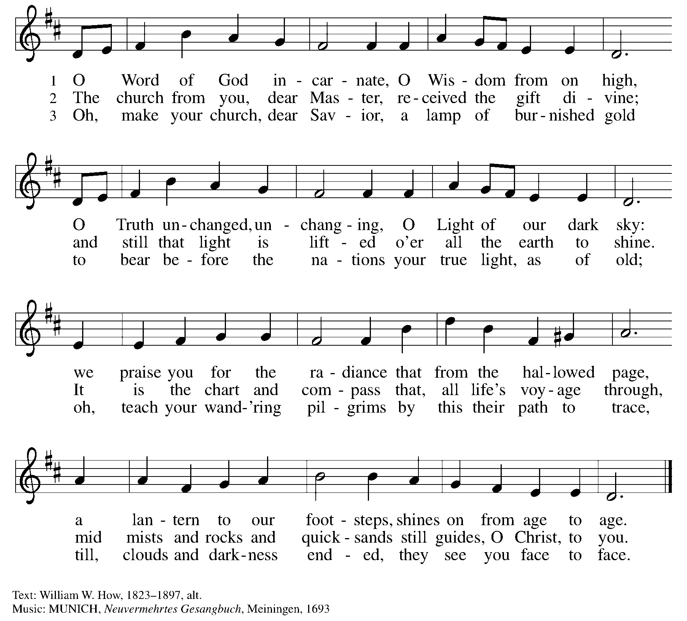

Greeting
The grace of our Lord Jesus Christ, the love of God,
and the communion of the Holy Spirit be with you all.
And also with you.

Kyrie

Prayer of the Day
Let us pray together,
O God, by the passion of your blessed Son you made an instrument of shameful death to be for us the means of life. Grant us so to glory in the cross of Christ that we may gladly suffer shame and loss for the sake of your Son, Jesus Christ, our Savior and Lord, who lives and reigns with you and the Holy Spirit, one God, now and forever.
Amen.

The congregation may be seated.

+ Word +

Reading I Genesis 17:1-7, 15-16
A reading from Genesis.

¹When Abram was ninety-nine years old, the Lord appeared to Abram, and said to him, “I am God Almighty; walk before me, and be blameless. ²And I will make my covenant between me and you, and will make you exceedingly numerous.” ³Then Abram fell on his face; and God said to him, ⁴“As for me, this is my covenant with you: You shall be the ancestor of a multitude of nations. ⁵No longer shall your name be Abram, but your name shall be Abraham; for I have made you the ancestor of a multitude of nations. ⁶I will make you exceedingly fruitful; and I will make nations of you, and kings shall come from you. ⁷I will establish my covenant between me and you, and your offspring after you throughout their generations, for an everlasting covenant, to be God to you and to your offspring after you.”
¹⁵God said to Abraham, “As for Sarai your wife, you shall not call her Sarai, but Sarah shall be her name. ¹⁶I will bless her, and moreover I will give you a son by her. I will bless her, and she shall give rise to nations; kings of peoples shall come from her.”

Word of God, word of life. Thanks be to God.

Psalm Psalm 22:23-31

The congregation sings the refrain and the verses in bold.

Psalm Refrain

Psalm Tone

²³You who fear the Lord, give praise! All you of Jacob’s | line, give glory.
Stand in awe of the Lord, all you off- | spring of Israel.
²⁴For the Lord does not despise nor abhor the poor in their poverty; neither is the Lord’s face hid- | den from them;
but when they cry out, | the Lord hears them.
²⁵From you comes my praise in the | great assembly;
I will perform my vows in the sight of those who | fear the Lord.
²⁶The poor shall eat | and be satisfied,
Let those who seek the Lord give praise! May your hearts | live forever! Refrain
²⁷All the ends of the earth shall remember and turn | to the Lord;
all the families of nations shall bow | before God.
²⁸For dominion belongs | to the Lord,
who rules o- | ver the nations.
²⁹Indeed, all who sleep in the earth shall bow | down in worship;
all who go down to the dust, though they be dead, shall kneel be- | fore the Lord.
³⁰Their descendants shall | serve the Lord,
whom they shall proclaim to genera- | tions to come.
³¹They shall proclaim God’s deliverance to a people | yet unborn,
saying to them, “The | Lord has acted!” Refrain

Reading II Romans 4:13-25
A reading from Romans.

¹³The promise that he would inherit the world did not come to Abraham or to his descendants through the law but through the righteousness of faith. ¹⁴If it is the adherents of the law who are to be the heirs, faith is null and the promise is void. ¹⁵For the law brings wrath; but where there is no law, neither is there violation.
¹⁶For this reason it depends on faith, in order that the promise may rest on grace and be guaranteed to all his descendants, not only to the adherents of the law but also to those who share the faith of Abraham (for he is the father of all of us, ¹⁷as it is written, “I have made you the father of many nations”)—in the presence of the God in whom he believed, who gives life to the dead and calls into existence the things that do not exist. ¹⁸Hoping against hope, he believed that he would become “the father of many nations,” according to what was said, “So numerous shall your descendants be.” ¹⁹He did not weaken in faith when he considered his own body, which was already as good as dead (for he was about a hundred years old), or when he considered the barrenness of Sarah’s womb. ²⁰No distrust made him waver concerning the promise of God, but he grew strong in his faith as he gave glory to God, ²¹being fully convinced that God was able to do what he had promised. ²²Therefore his faith “was reckoned to him as righteousness.” ²³Now the words, “it was reckoned to him,” were written not for his sake alone, ²⁴but for ours also. It will be reckoned to us who believe in him who raised Jesus our Lord from the dead, ²⁵who was handed over to death for our trespasses and was raised for our justification.

Word of God, word of life.
Thanks be to God.

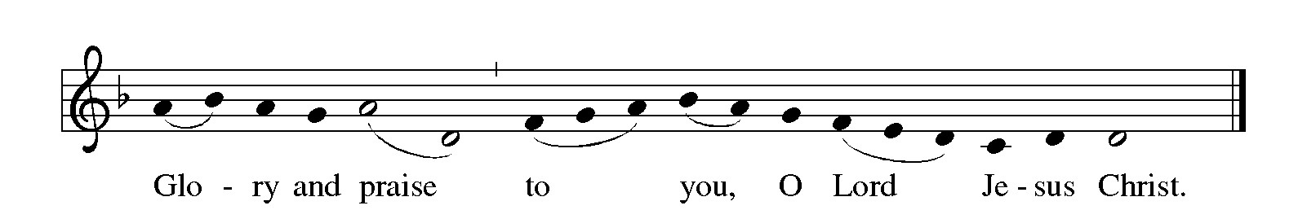
Gospel Acclamation The congregation may stand.

Gospel Mark 8:31-38
The holy gospel according to Mark.
Glory to you, O Lord.

³¹[Jesus] began to teach them that the Son of Man must undergo great suffering, and be rejected by the elders, the chief priests, and the scribes, and be killed, and after three days rise again.³²He said all this quite openly. And Peter took him aside and began to rebuke him. ³³But turning and looking at his disciples, he rebuked Peter and said, “Get behind me, Satan! For you are setting your mind not on divine things but on human things.”
³⁴He called the crowd with his disciples, and said to them, “If any want to become my followers, let them deny themselves and take up their cross and follow me. ³⁵For those who want to save their life will lose it, and those who lose their life for my sake, and for the sake of the gospel, will save it. ³⁶For what will it profit them to gain the whole world and forfeit their life? ³⁷Indeed, what can they give in return for their life? ³⁸Those who are ashamed of me and of my words in this adulterous and sinful generation, of them the Son of Man will also be ashamed when he comes in the glory of his Father with the holy angels.”

The gospel of the Lord.
Praise to you, O Christ.

Sermon The congregation may be seated.
Vicar Alex Linn

Hymn of the Day The congregation may be stand.
All My Hope on God Is Founded (ELW 757)

The Apostles’ Creed
Let us confess our faith in the words of the Apostles’ Creed:

I believe in God, the Father almighty,
creator of heaven and earth.
I believe in Jesus Christ, God’s only Son, our Lord,
who was conceived by the Holy Spirit,
born of the virgin Mary,
suffered under Pontius Pilate,
was crucified, died, and was buried;
he descended to the dead.
On the third day he rose again;
he ascended into heaven,
he is seated at the right hand of the Father,
and he will come to judge the living and the dead.

I believe in the Holy Spirit,
the holy catholic church, the communion of saints,
the forgiveness of sins, the resurrection of the body,
and the life everlasting. Amen.

Prayers of Intersession
Holding onto God’s Promise to reconcile all things, let us pray for the world God loves. You are invited to pray through standing, kneeling, or sitting. Let us pray,
Pause

As we journey through the 40 days, guide us to seek new missions for the church. Pray for the work of God’s people… pause
Hear us, O God,
Your mercy is great.

Through the wilderness of this earth, you have called us to discipleship.
Pray for God’s creation… pause
Hear us, O God,
Your mercy is great.

We live together in our own towns, yet we are a people of your divine dominion. Pray for our communities… pause
Hear us, O God,
Your mercy is great.

O God, we often fail to see your image in one another causing us to fall into sins of racism, sexism, hate, and all that we do to separate us from each other. Pray for transformation… pause
Hear us, O God,
Your mercy is great.

For those who heart in mind, body, spirit, we pray for your hand. Pray for the healing of one another… pause
Hear us, O God,
Your mercy is great.

People of God, for what else shall we pray this day? Pray for what you wish to share today… pause
Hear us, O God,
Your mercy is great.

Trusting God who raises us out of death, we give thanks for the people who have gone before us into your embrace. Pray for our beloved dead… pause
Hear us, O God,
Your mercy is great.

Into your hands we commend all for whom we pray, trusting in your mercy through our Lord Jesus Christ.
Amen.

The Peace
The peace of Christ be with you all.
And also with you.

You are invited to share a sign of peace with one another (wave, handshake, hug, etc.), honoring the personal boundaries of all. Those online may unmute and verbally share the peace.

The congregation may be seated.

+ Meal +

Offertory
We give thanks for your ongoing support of the ministry of
St. John’s! Gifts may be placed in the offering plate, made
in the Vanco Mobile app, or given online by scanning the
QR code. Thank you for your generosity!

Offertory Anthem
In My Heart (Spiritual arr. by Alan Bullard)

Lord, help me be a Christian in my heart,
Lord, help me be more loving in my heart,
Lord, help me be more prayerful in my heart,
Lord, help me be more like Jesus in my heart!

Offertory Verse The congregation may stand.
Create in Me A Clean Heart
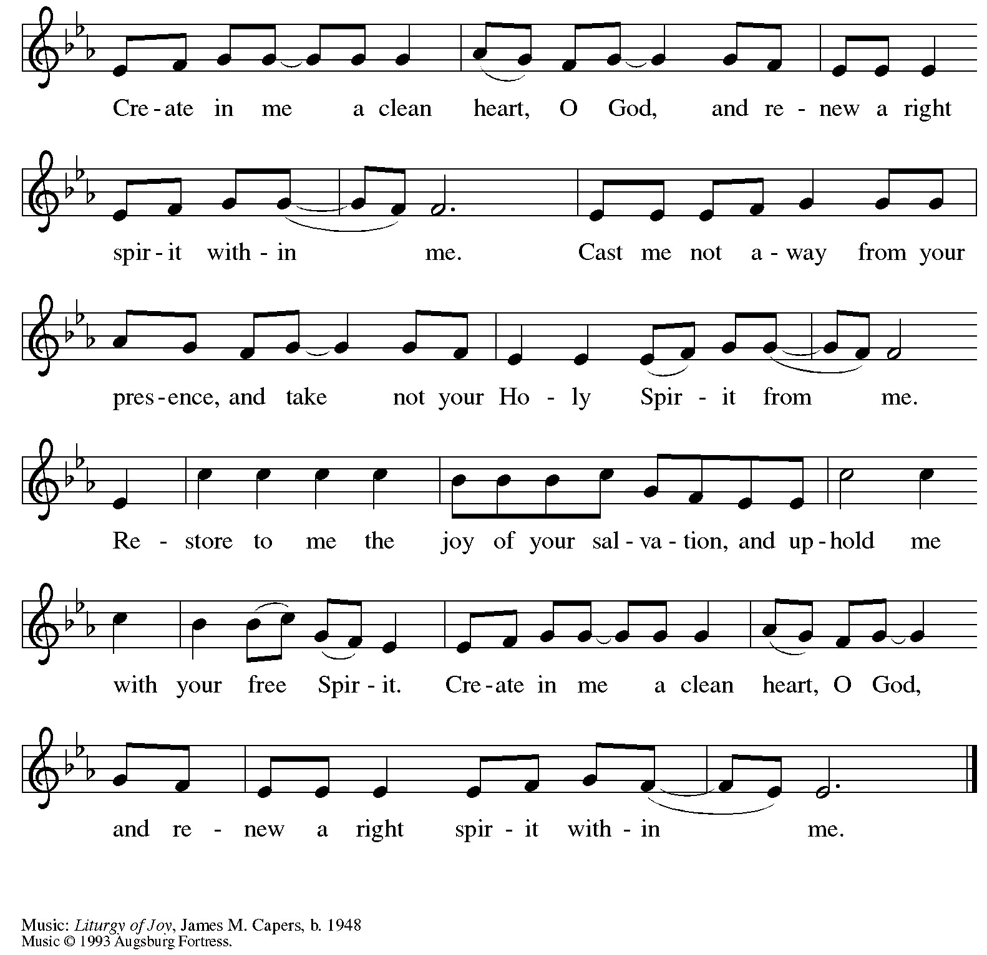

Offertory Prayer
Let us pray together.
Jesus, you are the bread of life
and the host of this meal.
Bless these gifts that we have gathered
that all people may know your goodness.
Feed us not only with this holy food
but with hunger for justice and peace.
We pray this in your name.
Amen.

Dialogue
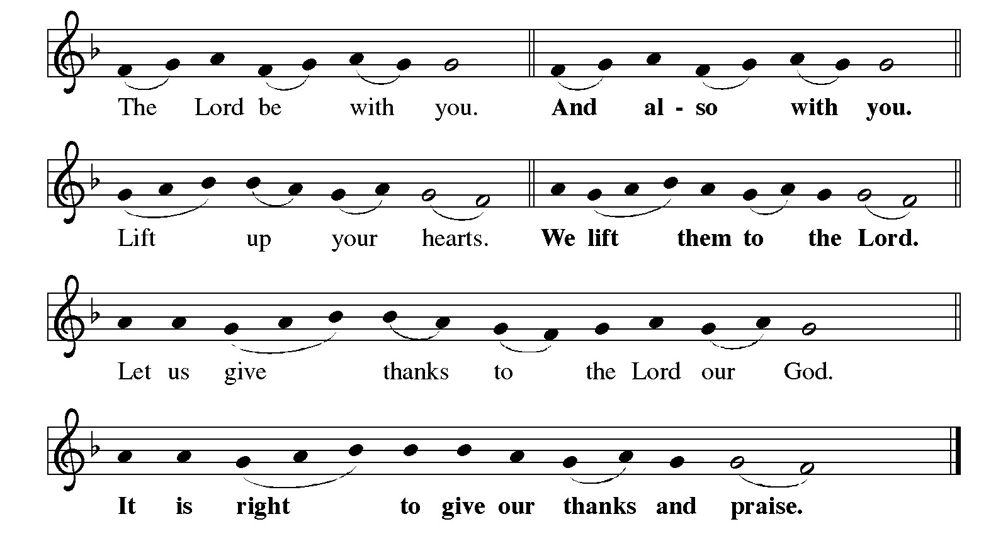

Preface
“… we praise your name and join their un-ending hymn:”

Holy, Holy, Holy
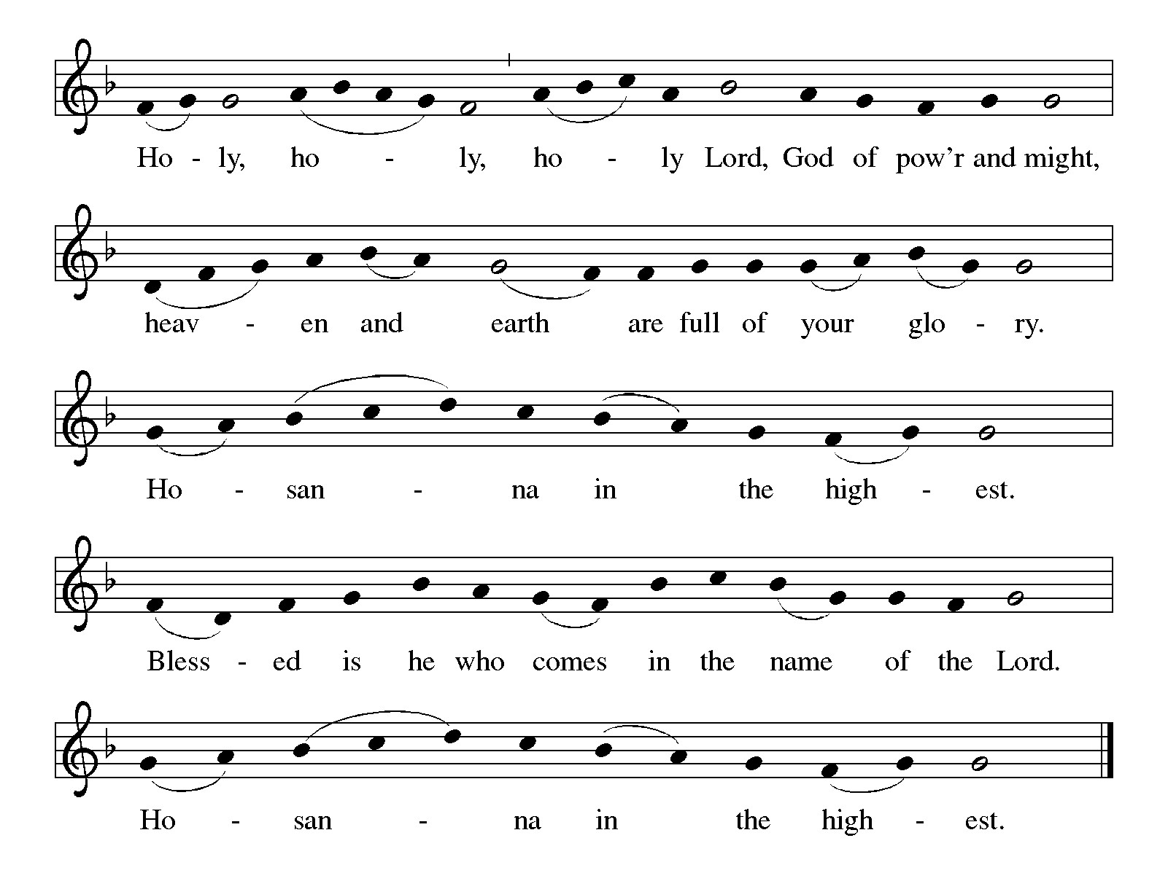

Words of Institution
We give you thanks, heavenly God,
through Jesus Christ, your beloved Son,
whom you sent in this the end of the ages
to save and redeem us and to proclaim to us your will.

He is your Word, inseparable from you,
through whom you created all things,
and in whom you take delight.
He is your Word, sent from heaven to a mother’s womb.

He there took on our nature and our lot
and was shown forth as your Son,
born of the Holy Spirit and of the Blessed Mary.
He, our Lord Jesus, fulfilled all your will
and won for you a holy people;
stretching out his hands in suffering
in order to free from suffering those who trust you.

He is the one who, handed over to a death he freely accepted,
in order to destroy death, to break the bonds of the evil one,
to crush hell underfoot, to give light to the world,
to establish a new covenant shown forth in the his resurrection,
taking bread and giving thanks to you, said:
Take and eat; this is my body, given for you.
Do this for the remembrance of me.

In the same way he took the cup, gave thanks,
and gave it for all to drink, saying:
This cup is the new covenant in my blood,
shed for you and for all people for the forgiveness of sin.
Do this for the remembrance of me.

Remembering, then, his death and resurrection,
we take this bread and cup,
giving you thanks that you have made us worthy
to stand before you and to serve you as your holy people.
Send your Spirit upon these gifts of your church;
gather into one all who share this bread and wine;
fill us with your Holy Spirit to establish our faith in truth,
that we may praise and glorify you through your Son Jesus Christ;
through whom all glory and honor are yours, almighty God,
with the Holy Spirit, in your holy church, both now and forever.
Amen.

Lord’s Prayer
Gathered into one by the Holy Spirit, let us pray as Jesus taught us in the many and varied languages we hold dear…

Our God in heaven, hallowed be your name,
your kingdom come, your will be done, on earth as in heaven.
Give us today our daily bread.
Forgive us our sins as we forgive those who sin against us.
Save us from the time of trial and deliver us from evil.
For the kingdom, the power, and the glory are yours,
now and forever. Amen.

Invitation
Taste and see that the Lord is good. Come, for Christ first welcomed us.

Communion The congregation may be seated.
All are welcome to commune at Christ’s table without exception! If you are online, serve yourself or those worshipping with you by saying, “The body of Christ, given for you,” and, “The blood of Christ, shed for you.” If you are communing in person, please proceed down the center aisle at the direction of an usher. You may receive bread or request a gluten-free wafer. A glass of wine (dark colored) will be placed on the table for you, or you may request grape juice (light colored). After drinking, please place your empty glass in the basket before returning to your seat via the side aisle. If you would prefer to receive only a blessing, you may cross your arms across your chest to indicate this preference. If you would like to receive communion in your seat, please inform an usher, and the sacrament will be brought to you.

Lamb of God
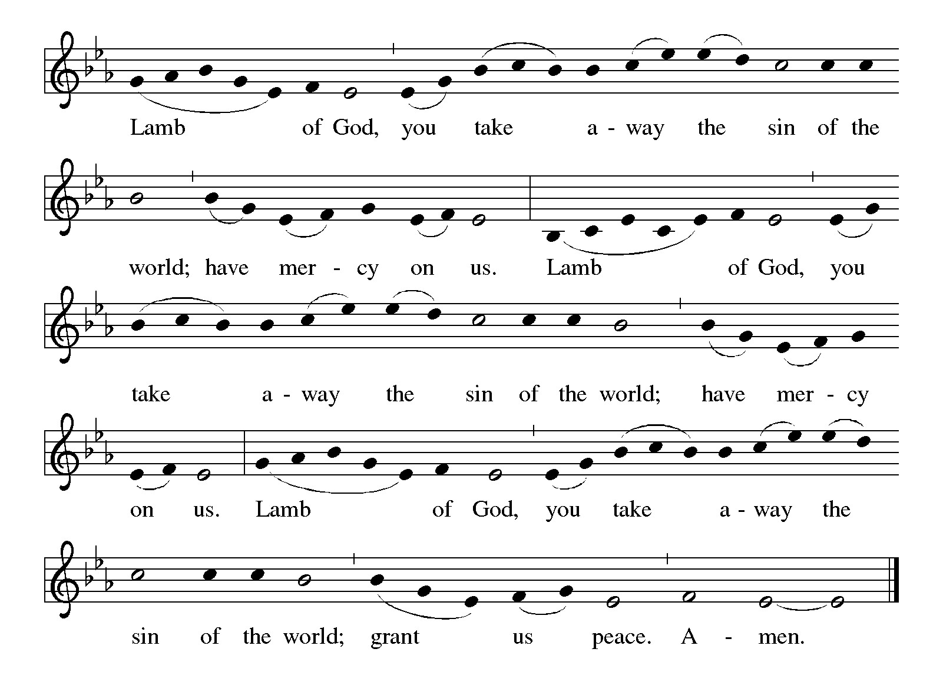

Communion Hymn
Tree of Life and Awesome Mystery (ELW 334 verses 1, 2, 3 + Lent 2)
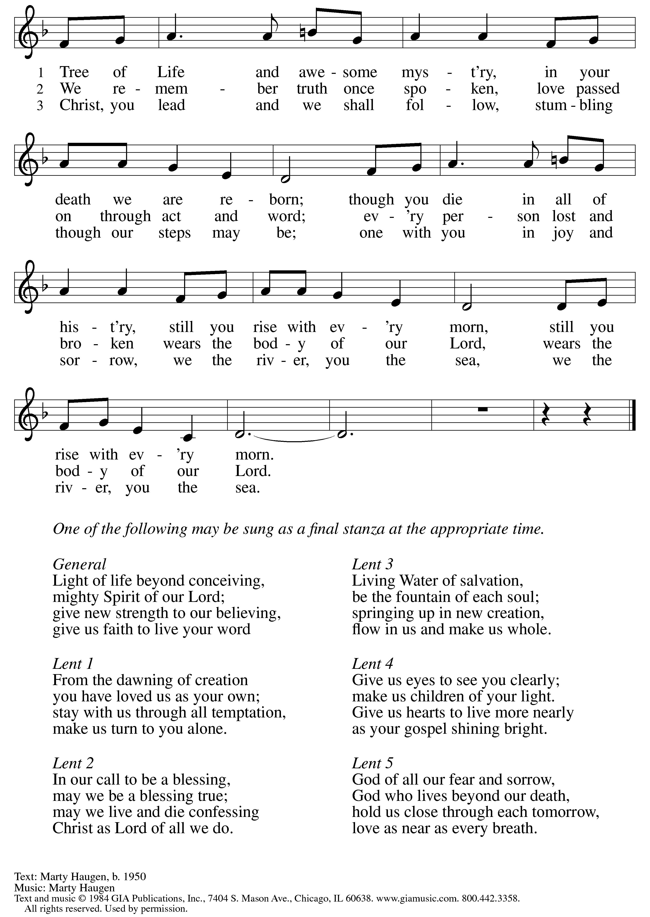

Prayer after Communion The congregation may stand.
Let us pray together.
Generous God,
At this table we have tasted your immeasurable grace.
As grains of wheat are gathered into one bread,
now make us one loaf to feed the world;
in the name of Jesus, Bread of Life.
Amen.

+ Sending +

Benediction
God bless you and keep you,
shower you with mercy,
fill you with good courage,
and give + you peace.
Amen

Recessional Hymn Jesus, Keep Me Near the Cross (ELW 335)
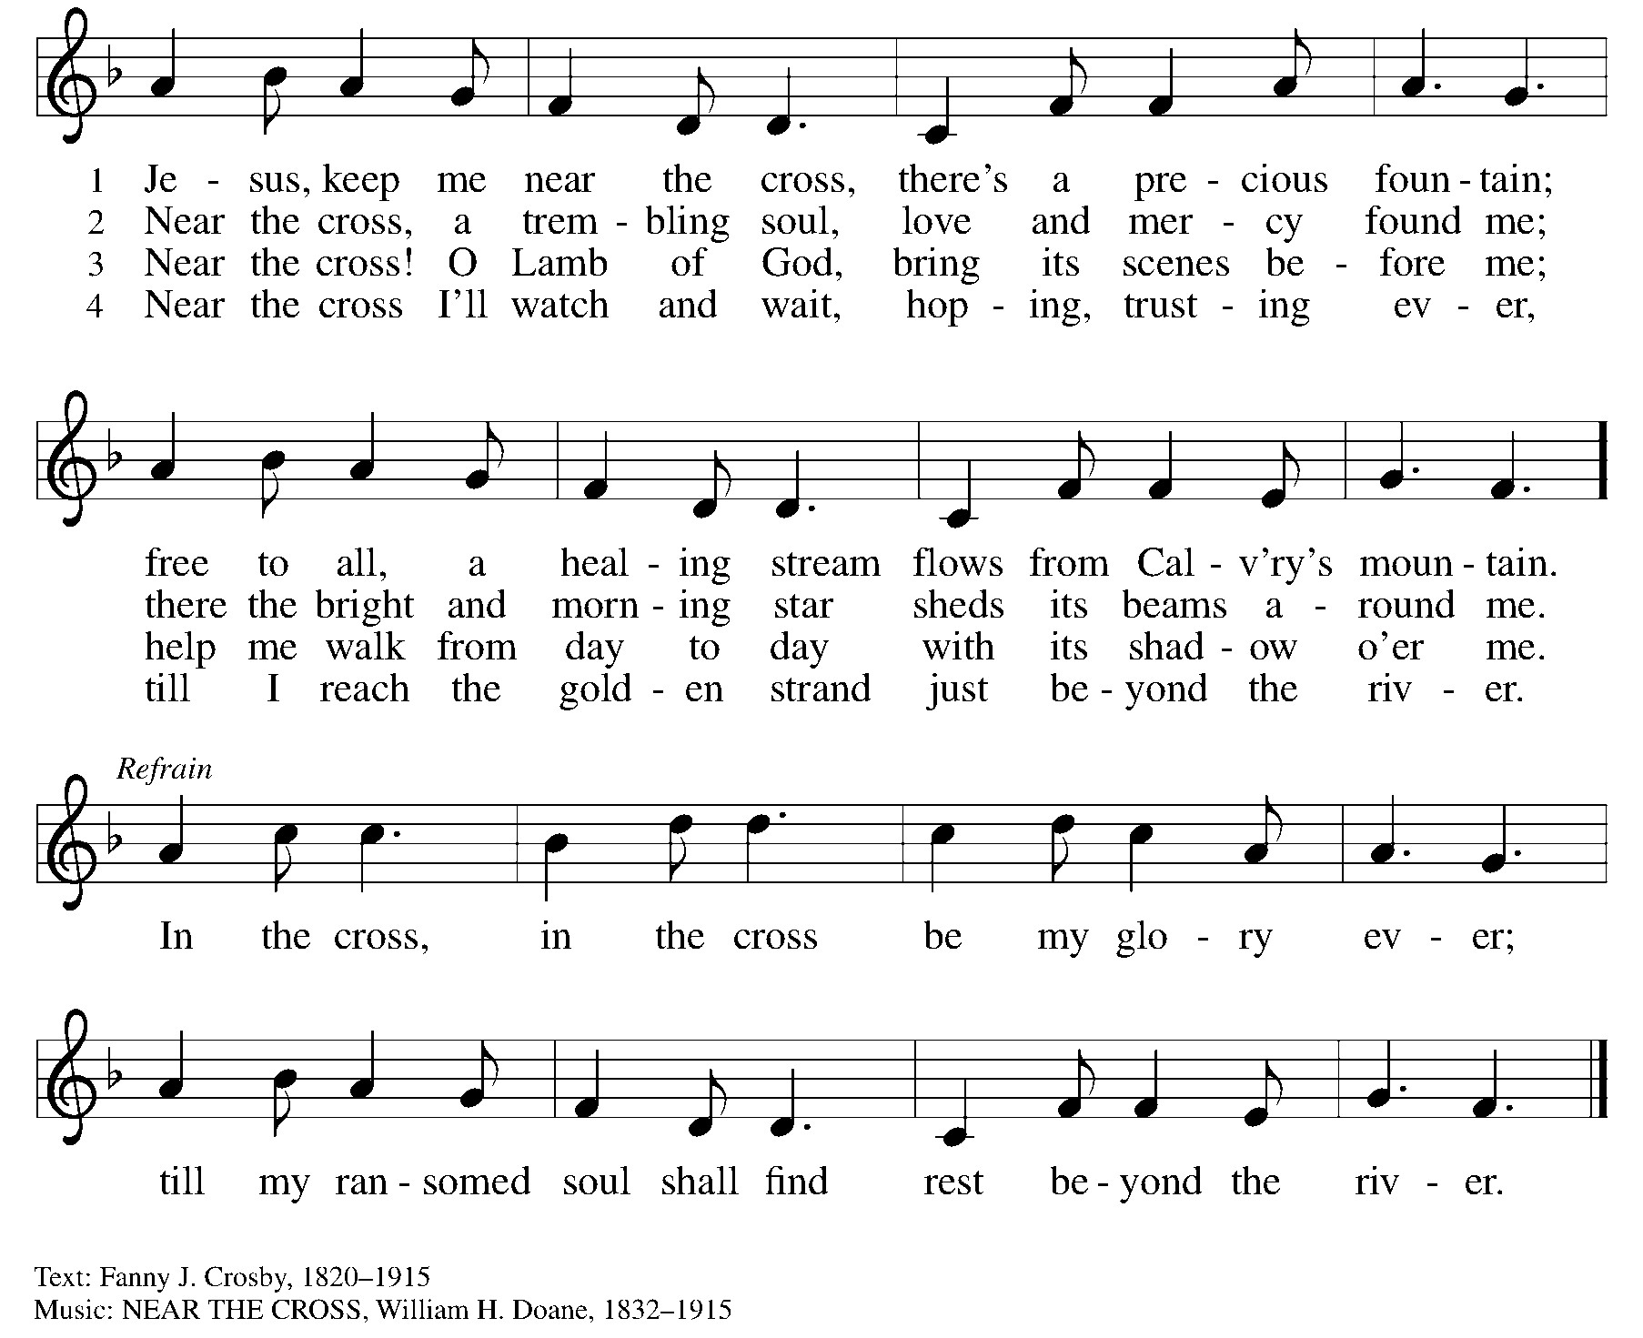

Dismissal
Go in peace to love and serve the Lord.
Thanks be to God.

Postlude
Obangiji by Fela Sowande

Worship materials adapted this day from multiple ecumenical partners and The Evangelical Lutheran Church in America (2023).
- SundaysandSeasons.com. Copyright 2013, Augsburg Fortress. All rights reserved. Reprinted by permission under Augsburg Fortress Liturgies Annual License #3706.
- Other music reprinted by permission under CCLI Annual License #11282942.
- Scripture readings from the NRS

Serving Today
Interim: | Vicar Alex Linn
Director of Music:  Cantor:  Assisting Minister:  Reader:  Ushers: | Luke Duroc-Danner  Audrey Neace  Alan Swanson  Mae Loesel  Jason Shutters
Announcements

Family Promise
Our Family Promise host week begins today and goes through Saturday, March 2. We are still in need of people to provide dinners and visit with the families in the evenings, to be an overnight host, and to provide snacks and breakfast & lunch items. Sign-up sheets are on the table in the gathering area. You can also call Jan in the church office to sign up. Thank you!

Our Lenten Journey Continues
Lenten Suppers and worship, Wednesdays from 6-7 pm
This year for Midweek Lenten worship, we will use parts of the "Unfailing Light" liturgy by Marty Haugen and Susan Briehl, and our devotional discussion prompts will follow the disciple Peter as a wonderful accompaniment to the Lent lectionary cycle on Sunday. Join us! Join us Wednesday 2/28!

Family Bowling Event on March 3
Children and families of St. John's are invited to go bowling as we strike up some fun Sunday afternoon March 3 from 3 to 4pm at the Wilmette Bowling Center. See Jason Shutters if you have any questions.

Tuesday Bible Study
Bible study meets on Tuesday mornings, 11am-12:00pm. with Vicar Alex Linn. Everyone is welcome to attend.

Take Care Packages for Migrant Families:
We are now a drop-off spot for donations! The Village is now partnering with SaLT to create "Take Care Packages" which are designed to assist migrants arriving via bus from Texas to our area while they await transfer to the Chicago Processing Center. These packages are a tangible expression of our community's care for others. Learn more about what you can donate and about SaLT: Service and Learning Together using the links in your e-news.

In Our Prayers

- Buckley Crist  - Family & friends of Peter Knobel, who died 1/13/24  - Dottye Wolf, sister of Margye Smith  - Rena Leinberger, cancer diagnosis 11/12/23  - Family and Friends of Hing You Tam Siu, mother-in-law of Jim Dossa, who passed away  - Family & friends of Viola Gonder, mother of Craig Gonder, who died 8/7/23  - Congratulations to Dano Johnson & Emily Mock, who were married June 17, 2023  - Family & friends of Richard Rusz, who died 6/6/23  - Family & friends of Karen Daugherty, aunt of Erin Rasmussen, who died 5/8/23  - Family & friends of Joan Schinler, who died 5/5/23  - Sarah Rink, hospitalized after a fall 3/8/23  - Family & friends of Ruby Winter, who died 1/10/23  - Steve Morrison, son of Tom & Judy Morrison, recovering from back surgery 1/1/23  - Family & friends of Marge Bennett, loved one of Kristen Danielsen, who died 11/17/22 | - Margaux Tauszig, granddaughter of Wolf Peddinghaus  - Natalie Domchenko & Hilaire Sainson, sister of Olga Domchenko and sister’s husband, in need of healing  - Karen Brunn, daughter of Dave & Lyn Brunn, recovering from spinal cord injury  - Mindy Davis, seeking permanent housing, 2/23/22  - Lorraine Beutelspacher, moved to new home in Arizona 2/3/23

Notes on Today’s Music

Alan Bullard (b. 1947) is a British composer. Born in London, Bullard studied with Herbert Howells at the Royal College of Music, and at Nottingham University. He enjoyed a successful career in music education; for many years he was Head of Composition at Colchester Institute, and is currently an examiner for ABRSM. The majority of his career has been dedicated to editing, arranging, and composing music for all levels of choirs as well as instrumental works for a flexible array of ensembles. He has also worked extensively with ABRSM to create a large body of pedagogical work for many instrumental collections to build musical skills, and has described the challenge of composing a Grade 1 piece to be one of the most exciting musical challenges.

Chief Olufela Obafunmilayo "Fela" Sowande (1905-1987) was a Nigerian musician and composer who is considered the father of modern Nigerian art music. Born to Emmanuel Sowande, a priest and pioneer of Nigerian church music, he sang in the Cathedral Choir and studied music in Lagos. During this time, he began blending local Yoruba music with European church music as well as jazz and highlife music. In 1934, he went to London to study music where he worked as a theatre organist for the BBC and played in a piano duo with Fats Waller. He returned to Nigeria in 1952 to lead the Nigerian Broadcasting Service before moving to teach at Howard University in Washington, D.C. in 1968.

