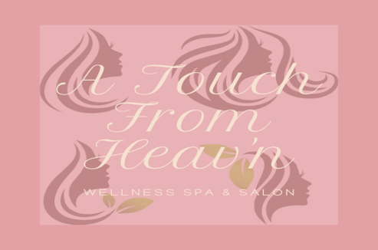
A Touch from Heav’n Wellness Suite
Product List
Please refer to the Website for pricing as introduction prices have changed effective 2/23/2020 and for more comprehensive product list. @ www.atouchfromheavn.com
Butter Blends
Lotion Blends
Scrubs
Body Balms
Lip Scrubs
Lip Balms
Body Wash
Massage Oil

**Base for blends are Coconut Oil, Almond Oil, Jojoba Oil, Argan & Aloe Vera

Essential Oil Blends Butters & Lotions

- CoCo Blend Body Butter
- Lavender Plush Body Butter
- Vanilla Cream Body Butter
- Bergamot Flow Body Butter
- Hemp & Mint Body Butter
- Muscle Ease Body Butter (Caoipa, Hemp & Mint)
- Verbena Blossom Butter
- Exhilaration Lotion (Lemongrass, Vitamin E)
- Vanilla Cherry Blossom Lotion
- Sweet Orange Sensation Lotion
- Soothe Lotion (Lavender & Eucalyptus)
- Restore Lotion (Frankincense/Myrrha/Lavender)

Women’s Health Blends

- A Women’s Touch (Love Spell Blend Oils)
- Loving Me (Passion Blend Essential Oils)
- Beautiful (Beautiful Blend Essential Oils)
- Worthy (Twilight Blend Essential Oil)
- Breathe (Island Blend Essential Oil)
- Plush (Baby Powder Blend)
- Ylang Lang Hormonal Blend

Scrubs

- Lip Scrub ** Other Flavors Available
- Lemon Verbena Body
- Crème-De-Le Crème (Vanilla/Oatmeal/Shea) Body
- Peppermint Foot Scrub

Body Wash/Soaps

- Lavender & Eucalyptus
- Almond CoCo
- Eucalyptus & Frankincense
- Geranium
- Lavender Bar

Massage Oils
- Vanilla Delight
- Mango Spice
- Mint Butter

Children Blends

- Butterscotch Butter Blends
- Coconut Butter Blends
- Blueberry Butter Blends

