# We

**Welcome to the Event Hire Brochure 2021**

**We specialise in provision and installation of equipment for a huge range of events including:**

## Business Seminars and Conference Packages

## Audio Visual Equipment, Bespoke Staging Décor and Set Manufacture

## Smart Presentation Screens/TV, Projectors and Screens

## PA Systems & Portable Sound Equipment

## Loudspeakers, Amplifiers, Mixing desks, Microphones, Lighting Units Smoke Machines, Stage Effects

## Party Packages

## Gazebos, Karaoke kit, Wine Chillers, Chill Boxes, Fans, Air Conditioning Units, Parasols & Garden Umbrellas, Lighting & Speaker stands, Rigging & Trussing, Outdoor & Architectural Lighting

## Outdoor Events

Large and small Generators, Gazebos, Small Party Marquees, Dance Floors, Heaters, Bar Furniture, Balloon Kits, Professional outdoor PA units.

**PLUS - A MASSIVE range and stock of Tables, Chairs and Furniture for every occasion**

FB Smaller Like us on Facebook and get news of special offers and the latest kit

**Most of our kit is designed for ease of transport and operation, with the following guideline symbols:**

 Equipment is heavy or large and may require a van to transport or delivery by Event Hire staff

Semi-portable equipment can be easily collected and transported by car. Some items may weigh more than 20kgs.

Equipment may/will require technical knowledge or Event Hire staff to assist or set up - we are here to help.

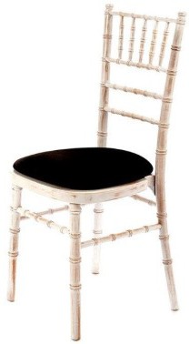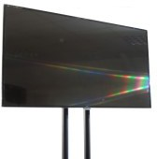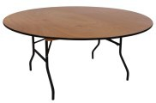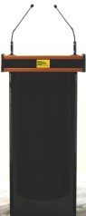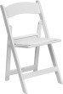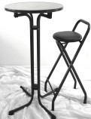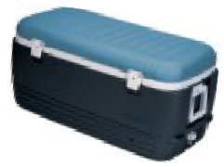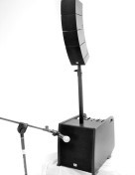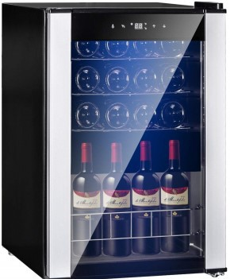

**All Rates quoted are for *one day hire* unless otherwise shown.**

**Two day / weekend / weekly or longer term rates available on request.**

# Audio Visual & Business

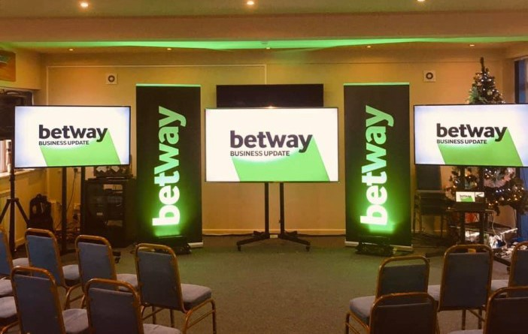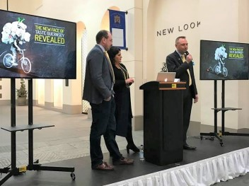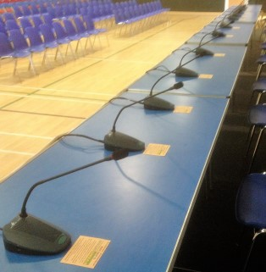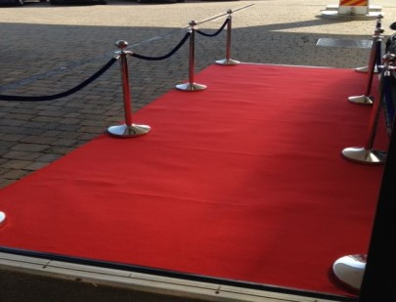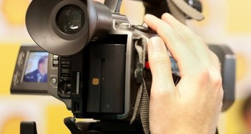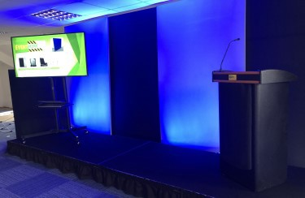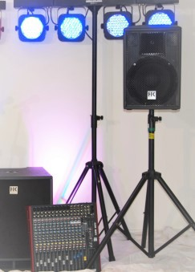

From a simple Microphone and loudspeaker to a bespoke Display & Stage Set with

Hi-Tech Audio-Visual Presentation & Lighting, Large Screen TV’s / Monitors, Conference Facilities; we can provide what *YOU* need to make your event technically successful.

* **All necessary leads and instructions** are supplied with grab-and-go equipment hires, or we offer a full delivery, rigging and technician attendance service should you prefer.
* **Digital Video and Audio recording facilities** can be provided to record or relay your event, along with full editing suite capability.
* **We also do a range of furniture, lighting and hospitality equipment—see other sections.**

***Please note - any equipment offering Bluetooth or Wi-Fi facility will require the appropriate infrastructure at your venue.***

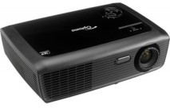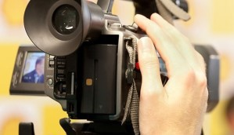



|  |  |  |
| --- | --- | --- |
| **Tripod Screen**  **AVL 71 £22.00**  1.8m x 1.8m screen (6ft x 6ft) Front projection surface Square format    **Tabletop projector**  **AVL 7 £22.00**  2.4 lumen, VGA input with HDMI adaptor Ideal for ‘in-house’ seminars and training.  **Video Cameras**  A selection of Semi-  Pro Camerasare available to record  or relay your event.  *Please contact our Hire Technician to discuss* | Most items are suitable for you to call and collect from our Bouet Hire Shop, conveniently situated near the Longstore, St. Peter Port.  If you need items delivered, set-up and collected, please ask.  *Delivery is chargeable****.*** | |
| **The Perfect Small to Medium Business Presentation / Lecture / Training Set-up; An Audio Visual Meeting Kit in a really cost-effective package.**  **MTG 14 £320.00**   * **Smart lectern -** a work surface for your laptop or tablet; concealed lights for your notes; built in USB charge point and 240v outlet for laptop **2 fixed mics and a radio mic.** * **2 Loudspeakers**; * **2 x 52” Presentation Smart screens** with HDMI, VGA, USB, RGB, inputs or Wi-Fi, on stands * **1 x Lightweight stage deck 1m x 2m** with valence.   **Perfect for meetings of up to 120 people**  *Add to your package with other items from our brochure for larger venues.You can increase the PA system power or microphones, screens up to 75”, back-drop sets, lighting; . . .whatever you want!* | |

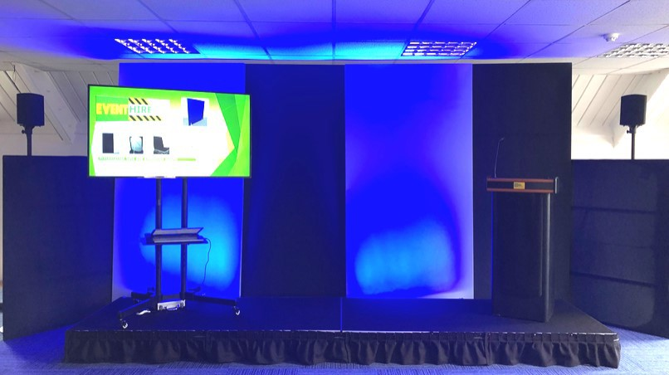

## Business Meeting and Presentation Sets

We have an extremely versatile range of equipment that can create a back-drop and stage set

for most small to medium Business Seminars, Conferences, Educational Lectures, In-house Presentations, Promotions, etc. with a wide selection of lighting and A/V options.

*You can see layout ideas, other sets styles and displays for corporate meeting equipment in our brand new Business Suite on the first floor of our Hire Store.*

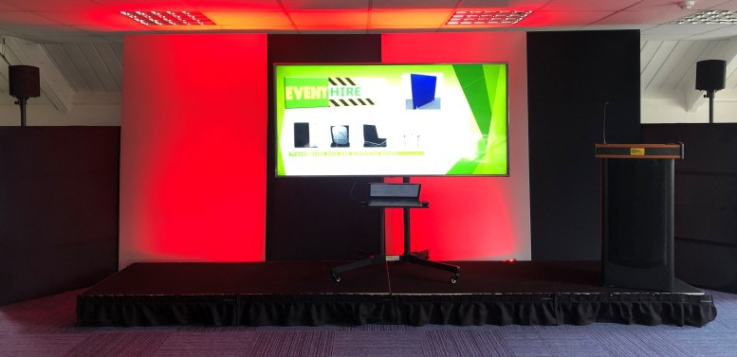

**SET 01**

**Basic Presentation**

from £150 delivered and rigged

**Stage flats in Black or Silver fabric** which takes on a ‘Chameleon’ nature when lit, allowing multiple colour surfaces. Various sizes and layouts are possible; including surrounding presentation screen[s].

**A carpeted lightweight stage and valance**. Options for 75” or 52” Smart TVs; a Lectern which has a desk for a Laptop (with power socket and USB charging facility), Lapel radio mic or fixed mics and a suitable audio system, plus set lighting to enhance or colour-brand the set or add logos and spotlight the presenter.

*Perfect to focus your audience on keynote speeches and stage presentations*

**Your logo or presentation message can be reproduced onto the stage flats.**

This is a modular systemand can be adapted for almost any area or venue —please discuss your requirements with us and let us create a simple, cost effective and impressive Set for your presentations.

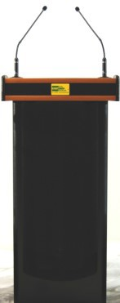



|  |  |  |
| --- | --- | --- |
| **Professional**  **presentation**  **lectern**  **AVL 70**  **£80.00**  Integral Audio System,  Desk for Laptop, with reading lights, 240v outlet and USB point, twin microphones, Audio input from Laptop/tablet. Built in loudspeakers.  Ideal, self-contained Unit. | **AVL74 75” £250**  **AVL73 52” £130**  **Professional Presentation screens**  Digital SMART screen with HDMI, VGA, USB, RGB and S-Video in and Wi-Fi options, remote control.  Built in loudspeakers/audio out. Supplied with presentation stand. | **Conferencing delegate PA Kit**  **PA 121— P.O.A.**  Ideal for Small Conferences or Public Meetings—each delegate has a microphone and monitor speaker to hear other delegates.  Can interface with PA systems, radio mics, audio recorder, etc  Ask for further details. |
|  |  |  |
| **MTG 12 £100.00**  **Small Business / Lecture Audio Kit** Lectern c/w Lapel radio mic, dual fixed lectern mics, 2 speakers.  Ideal for office/boardroom/Staff  meetings. Shelf & facilities for Laptop with notes light, built in USB charge points and 240v outlet for laptop.  Add to your package with other items from our Brochure | **STG-03 £28.00**  Aluminium Pro Stage Units 2.4m x 1.2m surface area at  200mm/400mm/600mm height.  Sturdy, heavy duty units.  **STG04— £4.00**  Stage Steps to access the higher stages. Safety rails also available. | **STG 01 £22 each**  2m x 1m lightweight stage  **STG 02 £17 each**  1m x 1m lightweight stage Charcoal carpet top.  200mm fixed height supplied with  a Black valance Simple self-assembly,  Key & instructions included or we can deliver and set them up  for you. |

**Audio Visual - Individual Items; mix and match to create your own presentation kit**

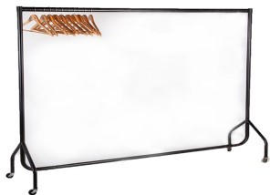

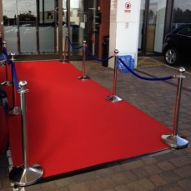

|  |  |  |
| --- | --- | --- |
| **SET32 £22.00**  Office Dividers / Exhibition Boards 1.8m x 1.8m (6ft x 6ft)  Blue pin board can accept pin or  ‘Velcro’ fixing. Self standing.  *Clip on lights available.* | **SET33 £32.00**  Folding Display Exhibition Board  Versatile; so simple to set up and  very effective. Various sizes / colours. Ask for details. *Clip on lights available.* | **Frameset Panels**  **SET34 £30.00 each**  **2.4m x 1.2m** (8’ x 4’ )  **Set 35 £22 each**  **1.2m x 1.5m** (4ft x 4ft 9”)  Free-standing supplied with brace + stage weight. Choice of  Black or Silver Face. Silver is ideal for lighting effects, it has Chame- leon like qualities and enhances most colours shone on to it.  Easily rigged. |
| **SET36 £6.00**  Frameset stage weight 10kgs Available to hire separately to support your own Props or  **PTY 13 £15.00**  **Coat Rack + Wooden Hangers** Portable coat rack with 50 wooden coat hangers. Dismantles for  transport, on castors for ease of movement. | **AVL 75 £5.00 /set** | **Digital**  **Video Facilities** |
| **Polished Chrome Poles & Rope**  (One set = 2 posts and one rope as shown) | We have semi-pro Digital Video and Audio facilities available to record your event — be it a  Seminar, Conference, Ceremony, **Whatever the event, please ask for details.**  Full editing & duplicating service. |
| **Red or Blue ropes** available to create grand entrance-ways or use as crowd separators | *This service has been popular at*  *Funerals and other Ceremonies, where relatives & friends cannot attend but wish to have a*  *recording of the proceedings.* |

**Sound & Lighting**

There are so many options available in the market today please contact us with your requirements and tell us what you are hoping to achieve.

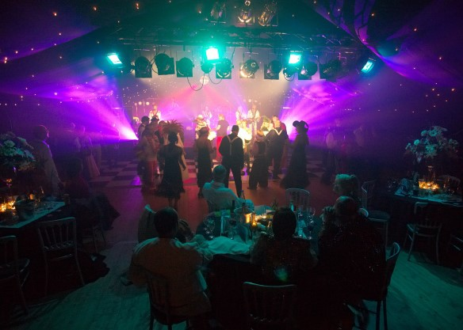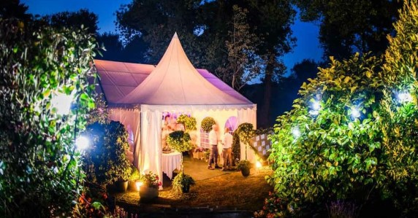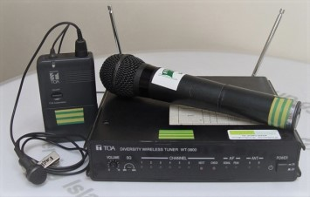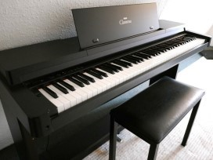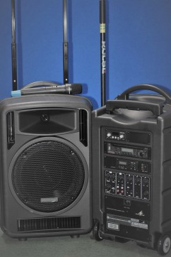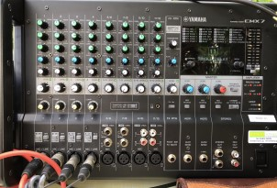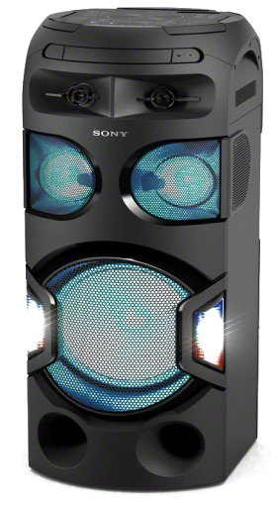

We can advise on equipment needed based on location and size of event.

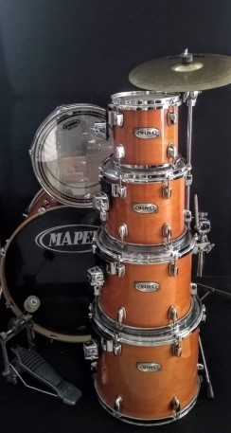

**We supply instructions and all necessary leads and cables with equipment hires**

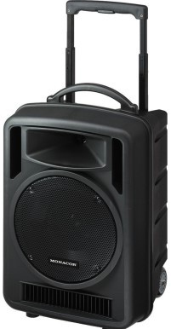

|  |  |
| --- | --- |
| **The Buskers PA**  **PA 101 £55.00**  **one unit**  **PA 101P £110**  **per pair**  **Portable PA covering from 30 to 50 people (1 unit)**  Ideal for street musicians, parties, meetings, etc. Powerful small PA system with built in CD Player,  Bluetooth connectivity. Mains or battery powered.  Comes with 1 x Radio Microphone and stand. Easily transported in car and simple to set up.  2 or more Units can be linked wirelessly.  Battery or mains powered. | **PA 102 £65.00 1 unit PA102P £130 Stereo Pair**  **Portable Mains powered PA**  **for 50—150 people (with Stereo 2 units)**  Powerful PA system with Bluetooth & USB link; Built in mixer & effects unit. Crystal clear output for parties, acoustic bands and solo / duo artists, speeches or just good quality background music. 1 Wired microphone supplied or add radio  microphones as an optional extra.  *Really easy to use!* |
| **PAPK 1A £75.00**  Small Party Package  Mains or battery portable PA c/w Bluetooth for Smart Phone connectivity.  1 Radio microphone. Built in CD player.  Twin box of 16 Retro disco Lights, sound activated  *Perfect for children’s parties of up to 30*  *Easy to transport and set up* | **PAPK 1B £110.00**  Medium Party Package  2 Mains or battery portable PA units c/w Bluetooth for Smart Phone connectivity,  1 Radio microphone and a CD player  2 boxes of Retro disco Lights , sound activated  *Perfect for children’s parties of up to 70 Easy to transport and set up* |

*All packages can be ‘mixed n matched’ with other options from our brochure. Call in to see the Demonstration Zone*

**Party Packages All come with the necessary leads to simply plug and play**

|  |  |
| --- | --- |
| **PA 101ER £45.00 (main unit)**  **PA 101 EX Passive Extension Speaker £15.00**  Similar to the Busker [PA101]  Ideal for street musicians, parties, meetings, etc.  CD Player & USB input.  With 1 x Radio Microphone and stand.  Easily transported in car and simple to set up.  2 or more Units can be linked.  Mains or battery operated (up to 4hrs on battery) | **AUD-1 £105.00**  Audio Package for Crystal Clear sound reproduction in medium sized rooms and public meetings  2 x Bose 402 Loudspeakers & Stands  Powered Mixing Desk with optional inputs for music source or radio mics. Supplied with 2 wired  Microphones. May require Technical assistance to setup - full instructions given.  *For larger rooms you could add 2 more speakers for only £20* |
| **AUD-2 £140.00**  Large Audio Package for speeches, acoustic / small Bands & Solo / Duo Entertainers  4 x Bose 802 Loudspeakers Powered Mixing Desk 1.4kw Amp power  1 wired & 1 Radio Microphone For larger Rooms—up to 200 people  May require Technical assistance to setup -  full instructions given | With A&H ZED12FX  mixer + 1kW power  Amplifier  **AUD-3 £175.00**  High Power, Full Spec Audio Package for Bands 4 x Bose 802 Loudspeakers  Allan & Heath Mixing Desk + Powerful Amplifier  4 wired vocal Microphones  2 wired Instrument Microphones  All cables and stands  (Stage shown not included)  For larger Rooms—up to 300 people  May require Technical assistance to setup -  full instructions given |

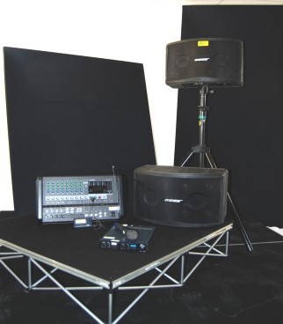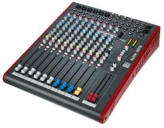

9



#### Packages - All come with the necessary leads to simply plug and play

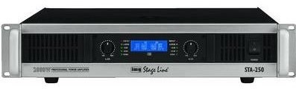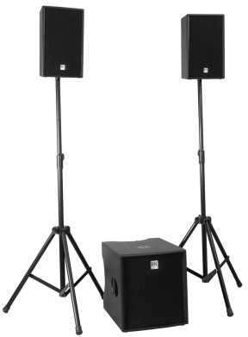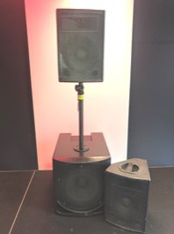

|  |  |
| --- | --- |
| **NEW IN STOCK**    **PAK412 £45.00 Each PAK412P—£90.00 Pair**  **350W RMS, mains powered Monitors/PA Cabs.**  12” loudspeaker with horn , inputs for Mic or line with pre-set EQ options. An ideal monitor unit or  stand-alone medium PA system. | ← **PAHK 1 £90.00 HK-LUCAS 2kW**  **System**  1200 watt 18” sub woofer and two 400 watt Mid/ High Satellites.  A BIG punchy sound c/w stands.  Note: Either LUCAS system requires an audio mixer  **PAHK 2 £70.00** →  **MINI LUCAS** 900W System  600W sub woofer + two 150W  Mid/High Satellites.  Great sound in a simple package.  c/w stands. |
| **KAR 01**  **£80.00**  **SONY DJ**  **Party and Karaoke Machine**  The **ULTIMATE**  interactive party music player with built in lighting  effects. Massively Versatile.  *GREAT FUN !!*  1 x wired Mic (supplied) and 1 x extra line input.  Built in DVD/CD/USB/SD Card Player and Bluetooth. Karaoke facility requires free Sony Music Centre App for iPhone (available on line)  *Try it in store; you’ll love it,* ***you’ll want it !*** | **STA 250 £20.00**  **STA 250 Stageline Stereo Amplifier**  1KW per channel    **Citronic CXP350 £15.00**  **700W Stereo Amplifier**  **MLT 01 £20.00**  **30m stage multi-core**  **24 sends + 4 returns**  **All XLR connectors.** |

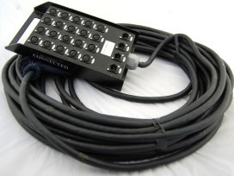**All items come with instructions and the necessary leads to simply plug and play**



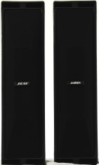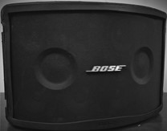

|  |  |  |
| --- | --- | --- |
| **Powerful Mixing** | **MXD 02 £50.00**  **Allen & Heath ZED16FX**  Pro Mixing Desk  10 mics 3 line. On board FX.  **MXD 03 £45.00**  **Allen & Heath ZED12FX**  As above unit but only 6 mic and 3 line channels + FX  *Industry Standard Mixers for Conferences, Bands, etc. (Requires Amplifier+PA).* | ← 402’s  c/w Tripods stands  802’s ↓  **PA 402**  **£30 per**  **Pair**  **PA 802 £40 per Pair**  **Professional Loudspeakers**  THE trade standard professional loudspeakers for outstanding speech and music reproduction  Both models can be mixed and  matched for large events  Add a powered mixing desk or an amplifier and mixer combination  i.e. MXD 01, 02, 03 and STA250 |
|  |
| **MXD 01 £50.00** |
| **Yamaha** 2 x 710 watts Powered 12 channel stereo mixing desk: On board digital effects unit and monitor and auxiliary channels.  Inputs: 4 x universal (mic/line) and 4 mic, plus 2 x stereo. |
| A great ‘work-horse’ for small bands or solo musicians.  Easily transported in your car. |
|  | **BEH AMP 60 £25.00**  **Behringer V-Tone GMX212**  Guitar Amplifier  2 channel. 2 x 12” full range Speakers. Digital Valve Effect Built in multi effects + tuner  Supplied with FX Pedal |  |
| **PA PAS 80 £40 per Pair**  **Behringer Passive Loudspeakers** | **BEH AMP 70 £25.00**  **Behringer UltraBass BXL900A** |
| 300W RMS handling each  15” bass woofer & Mid + Horn  Speakon connectors  *Beefy Speakers for powerful music reproduction* | Bass Combo Amplifier  12” Bass Driver  7 band EQ |

**Audio Systems & Components**

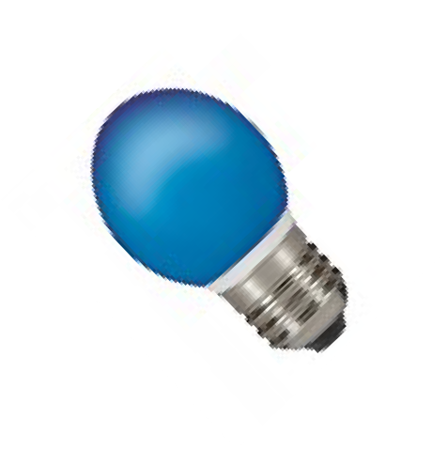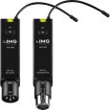

|  |  |  |
| --- | --- | --- |
|  | **BKL 01 £75.00**  **Digital CVP360 Clavinova Piano** | **PA 442 £ Various**  **We stock a wide Range of audio accessories & Processors**  Di Boxes, Mic/Line Splitters, Attenuators, Wi-Fi Links,  Alice Mic/ Line mixer with limiter, USB Interfaces. We have a lot of these little ‘problem solvers’—Let us help and advise you if you need these special products for your  event and audio work.  UHF Plug-In Radio system—perfect to link amps to speakers wirelessly → |
| **DRM01 £65.00**  **Mapex ‘M’ Series Drum Set** | 88 key, weighted hammer  action keyboard; |
| 6 Piece Professional Drums | very authentic Piano sound & |
| c/w stands & Cymbals | feel. c/w Stool. |
| All flight cased.  Ask for full Spec. | Built in Sound System |
| **PA 266 From £6.00 Each**  **Wired Microphones**  Professional Microphones  **Shure SM58 vocal Mics £6.00**  **Shure 545 Instrument Mics £7.00 Beta Kick Drum Mic £8.00**  **Beta Instrument Mic £8.00**  All includes XLR mic cable.  Various Stands available—see  accessories pages. | **RDM304—£28.00**  **DualToa UHF with**  **2 Hand-held or Tiepin mic**  Reliable, versatile.    **RDM305—£18.00**  **Toa Single UHF System with Hand-held mic** | **Spares — Production, Manufacture & Sales**  We stock a massive range of pre-made cables, leads, lamps, connectors, bulk cable, plugs, Accessories and many obscure ‘techie’ items - just ask!  We also manufacture special cables to order.  Items can be designed & fabricated in our well equipped workshops. |

|  |  |  |
| --- | --- | --- |
| **NEW IN STOCK . . Introducing the very latest**  ***DIGITAL Radio Microphone Technology***  **\*Digital technology eliminates interference from other systems such as private radios, paging and wi-fi systems, utility companies etc. Its unique encryption ensures only your broadcast is allowed through the receiver and broadcast via the PA system.**  **More importantly, others cannot listen in to your speech or event as scanners or other radio- mic systems cannot receive and decode the unique digital encryption. Totally secure.**  **\*Digital technology gives crisp, clear audio and ultra-reliable radio transmission over distances up to 100m (Average range dependent on structural factors).**  **\*Available in either a Dual system or a Quad system, or both can be used together for up to 6 units, (which is our current stock) although the encryption regime means you can have up to 32 microphones operating on the system at any one time.**  **\*All receivers can be used with a choice of transmitter microphones to suit YOUR application and comfort: Hand held (great for interviews), tie-pin (for presentations or filming), discrete ’ear-hanger’ sets (brilliant for on-stage presenters requiring constant voice levels)**  **or aerobic headset (robust, for sports or arena activities) available.**  **Please let us know YOUR application so we can advise you on the best system for you.** | | |
| Discrete ear-hanger  Mic set. Flesh coloured -  ideal for presentations.  Tie-Pin Mic  Hand-held Mic  Aerobic headset |  |  |
| **RDM 307—£90.00** | **RDM 306—£50.00** |
| **Quad Digital** | **Dual Digital** |
| **Radio Mic System** | **Radio Mic system** |
| **4 receivers in a single case.** | **2 Receivers in a single case.** |
| **Available with any of the** | **Available with any of the** |
| **Transmitter options listed on** | **Transmitter options listed on** |
| **the left (included in the price)** | **the left (included in the price)** |

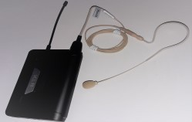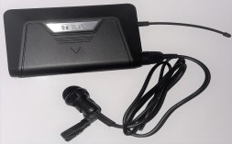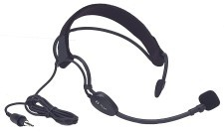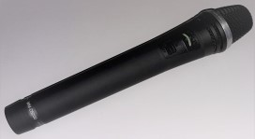

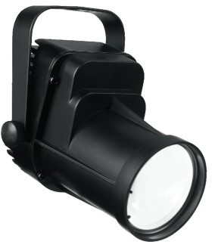

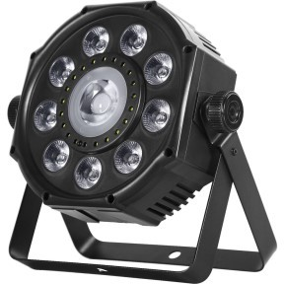

|  |  |  |
| --- | --- | --- |
| **LX 7660 £25.00**  Wash 100  LED Effects Wash **MOVING HEAD** Powerful, dazzling Party unit activated by sound-to-light.  Or can be DMX controlled.  Weight: 5.7 kg  ***All these lighting effects can be manu*** | **LX 7740 £20.00**  Wash 42  LED Effect Mini Wash  **MOVING HEAD**  Strong performance with  highest luminous efficiency, small dimensions Ideally suited for use at parties. Weight: 5.7 kg  Sound to Light or DMX control    ***ally or DMX programmed or simply*** | **LX 6410 £12.00**  LED 10 spot  LED spotlight, small design with extra high luminous  intensity.  3 primary colours (red, green and blue) plus white.  Weight: 570 g  Sound to Light or DMX control |
| ***operated as stand-alone units activat***  **LX 3780 £8.00**  LED36 Spot  1 bright white Mini LED, 3 W, for highest luminous efficiency.  Very Narrow Pin-Spot—perfect for product highlighting.  Weight: 350 g | ***ed by sound or to pre-set patterns*** | **LX 7750 £55.00**  FX Bar Set  Light bar with an RG laser (class 2M laser), 2 x rotating LED derby,  2 x LED spotlight and  4 x integrated white LED strobe Weight: 11 kg  *A Really impressive, simple to use lighting rig.*  ***The Party Favourite!*** |
|  |
| **LX 8360 £18.00**  LED Floor Can |
| Powerful multi effect floor light RGBW LEDs with strobe option. Auto / Sound to Light Operation or DMX control  Weight: 1.65 kg |
|  |

***Call in to our Shop Demonstration Room to select your ideal lights.***

#### Party & Event Lighting—Individual Items to Mix and Match for a great Party!



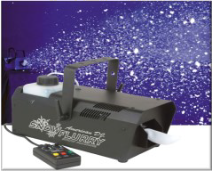

|  |  |  |
| --- | --- | --- |
| ***Call in to our Shop De***  **LX 7751 £36.00**  4-way Light bar  4 x LED Parcan lights, great for Bands / Stage light  Programmable functions with footswitch control | ***monstration Room to select***  **LX 5577 £20.00 Each**  LED Light Baton  Powerful 900mm LED stage and wall baton for adding colour to Stages, walls and ceiling.  Manual or auto operation or can be DMX controlled | ***your ideal lights.***      **LX 5566 £25.00 Each**  **LED Architectural lighting**  High power colour wash lighting to add colour to walls and ceilings or even whole buildings!  Interior or Exterior Use.  Self contained, pre-programmable  or DMX Control |
|  | **SN01 £36.00**    **BUB01 £36.00**  **Effects Machines**  professional **Party Snow** and  **Bubble machines**  Water based fluid Supplied with 1Ltr of fluid (Extra available on request)  **Ask in store for details** | ***A MUST HAVE with any LIGHTING EFFECT; Smoke***  ***or Haze really brings out the lighting & colours***    **SMK 011 £20.00 HAZE1 £45.00**  Professional stage haze & smoke machines  Water based light or dense  smoke fluid available  Can be safely used with most smoke detection alarm systems.  Supplied with 1Ltr of fluid |
| **PTY 11 £60.00** |
| **3m x 6m Star Cloth** |
| Brilliant party or Stage backdrop complete with controller that makes the stars twinkle and  shine. Can free-stand on its own frame or hang in your venue with suitable fixings, very simply. |
| Great to cover walls or blank out windows at a venue |
|  |

**Party & Event Lighting**

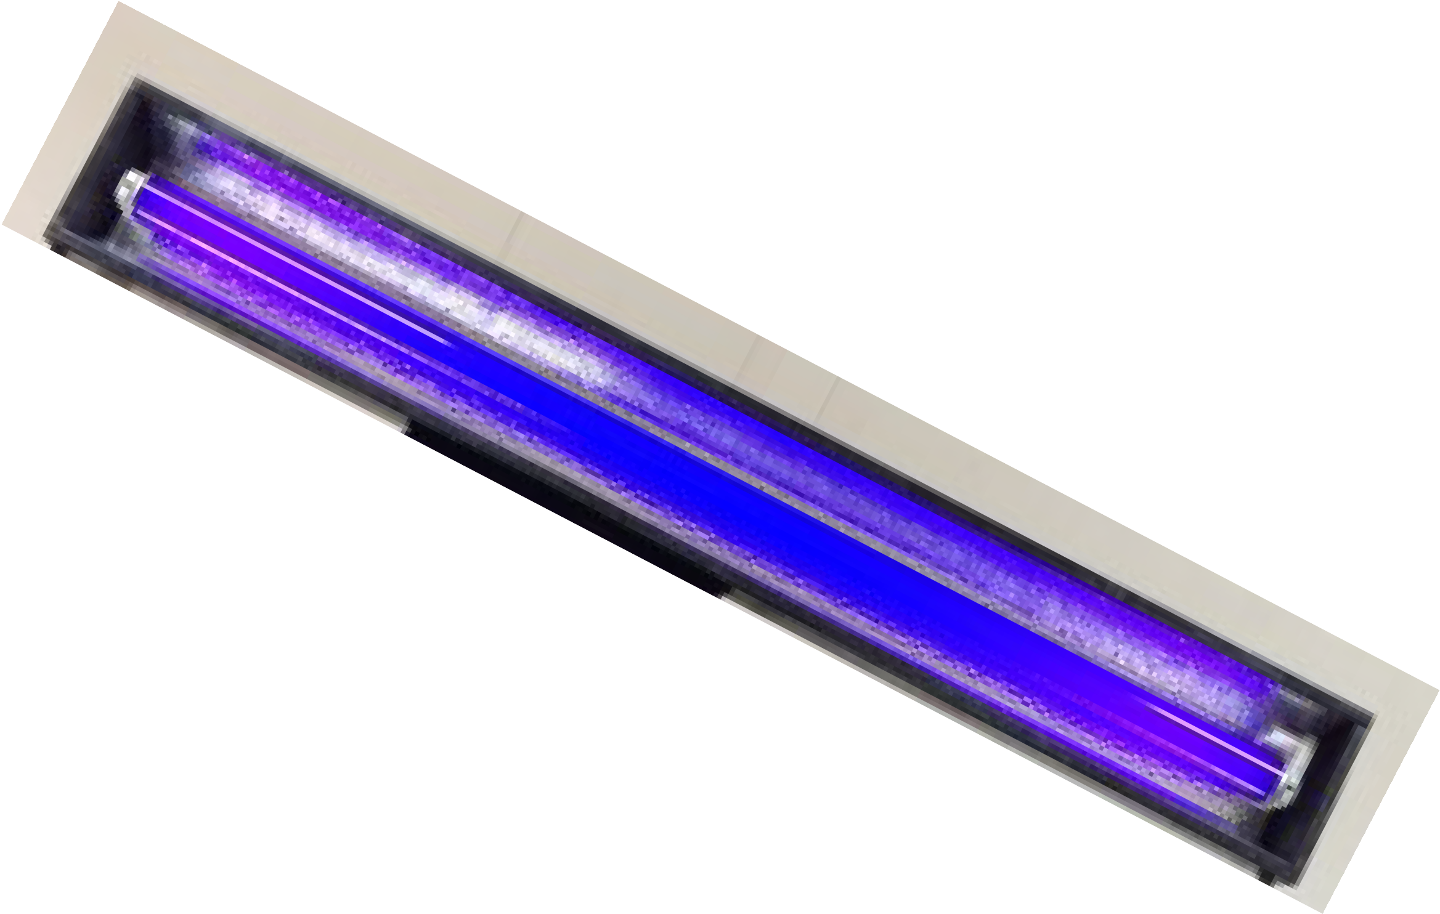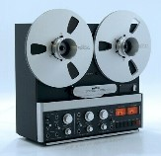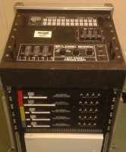

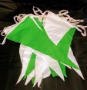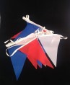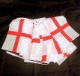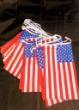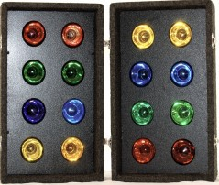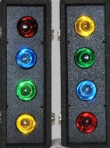

|  |  |  |
| --- | --- | --- |
| **RETRO 35 £ various**  *Various Retro Items—which many people still need every now and then. We’ve got them!*  Dual **Cassette** Player/ Recorder **CD** Players and **Vinyl Turn-Tables**, **Mini Disc** Players,  **Media** players, Graphic Equalizers **Reel to Reel Tape**  **machines** | **RETRO 36 from £8 -£18**  Various Lighting Items & Lasers Projection Disco Lights with  Built in gobo patterns.  If **70’s + 80’s parties** are your thing—this is for you.  Call in to view the range in our  showroom | **RETRO 37 BUNTING**  **from**  **£6.00**  Per 10m  Various Bunting Designs.  Create that outdoor and indoor party atmosphere ! We also stock large national Flags—please ask.  **LIGHTING EFFECTS CONTROLLERS & DIMMERS**  We have a wide range of Control gear for lighting; discuss what you need with us |
| **RETRO**  **LX 5590 £22.00**  **LX 5592 £15.00**  Retro Disco Lights  8 & 16 Traditional high brightness flashing coloured lamps—sound to light operated.  *Great for children's parties—so simple and effective.* | **LXFX 012 £30.00 Each**  Large silk flame effects unit **1m high** simulated silk flame A stunning effect, Ideal for Stage or Party ! | **RETRO**  **UV 02 £12.00 Each**  **Ultra Violet Black light**  strip light  A MUST for Halloween parties  and 70’s Discos    **FLD 01 £6.00**  Clip on 65w Exhibition/bar light |

***Call in to our Shop Demonstration Room to select your ideal lights.***

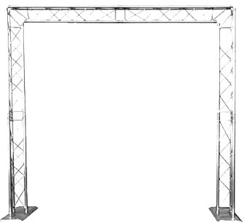

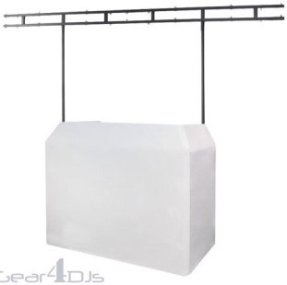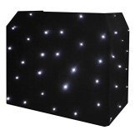

|  |  |  |
| --- | --- | --- |
| **STD 2461 £4.00 Each**  **Loudspeaker & Lighting Stands**  Robust professional heavy duty stands adjustable height with safety drop-arrest pins. | **STD 2462 £4.00 Each**  Various Microphone Stands  Robust professional heavy duty microphone stands, adjustable height, various base styles.  Table top, straight and boom types also available | **STD 103 £12.00 Each**  Wind up Stands  Robust professional heavy duty stands; adjustable height with safety drop-arrest pins.  Sizes up to 5m high.  Range of top brackets & Fittings |
| ***Call in to our Shop Demonst***  ***ideal lights and*** | ***ration Room to select your accessories.*** | **NEW IN STOCK**  **DJB01**  **DJ-Booth**  **£55.00**  Ultra lightweight, aluminium DJ Booth system with shelf for gear.  White (great with lighting!) or black stretch covers.  *Lighting Bar optional -*  **DJB02 Light Bar £25.00**  *Packs up into a carry bag for easy transport.* |
| **RGG312**  **£125.00** |  |
| **Trilite Truss Arch**  Truss Arch — 5m height and 3m wide—or can be 3m high and 5m wide. Other formats / sizes available—a very versatile frame system.  Perfect for sports and outdoor events,  Entrance arches or big lighting rigs. Free standing but may require bracing depending on load. | **STD 2463 From £55.00**  Heavy Duty Winch operated  **Trilite Truss Bridge**  Lighting Truss bridge— adjustable to 5m height. Perfect to mount all your lighting kit on.  Freestanding. |

#### Audio & Lighting Stands and Accessories



**Furniture & Party Section**

We have OVER 3,000 items of Furniture in stock; all supplied cleaned and ready for use (and it should be returned likewise!) Our stock range is constantly being updated to ensure the BEST, LATEST styles for your party.

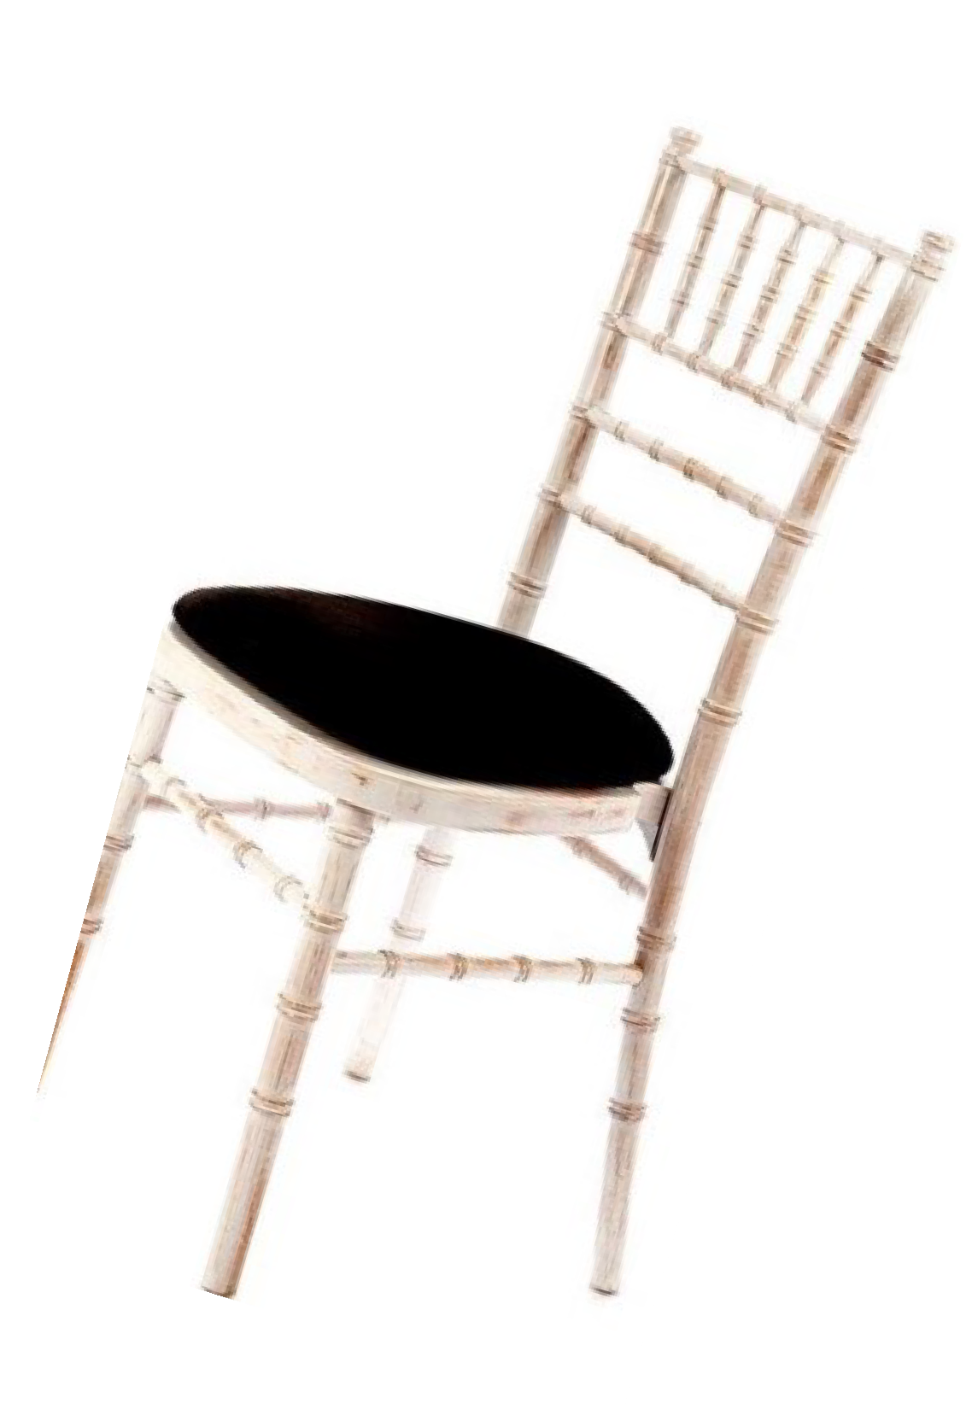

Check out our **Facebook** pages to see all the new kit as it comes in.

##### As with all of this brochure — if you don’t

**see exactly what you want, please talk to us.**

**If we haven’t got it, we may know someone**

**who has; We always try to be helpful!**

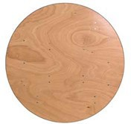

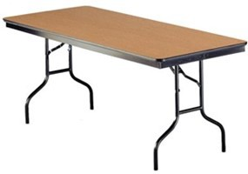

|  |  |  |
| --- | --- | --- |
| Round  Tables    **TBL 20 6ft £7.50 Each**  **Seats 10-12 persons**  **TBL 21 5ft £6.00 Each**  **Seats 8-10 persons**  Wooden Banqueting Table With traditional folding legs. | **TBL 27 £9.00 Each**  **8ft Oval Table**  **seats 12 to 14 people**  Great for the ‘top table’  Folding legs | **TBL 22 £5.00 Each**  **4ft (1.2m) Wooden Top Banqueting Table** Traditional folding legs  **TBL 26 £4.00 Each**  **3ft round Cake Table**—choice of  folding or rigid legs. |
| **Don’t forge**  **— a**  **TBL 23 £6.00 Each**  **6ft X 2ft 6” (1.8m x .79m)**  Wooden Top Trestle Table  Traditional folding leg table  Ideal for catering stations, Bars, party events, quiz nights, old school feasts, Banquets, etc. | **t the table cloths ! Linen or pap sk us for more information and pr**    **TBL 24 £5.50 Each**  **4ft x 2ft 6” (1.8m x .79m)**  Wooden Top Trestle Table  traditional folding table Ideal for catering stations, party  events, quiz nights etc. | **er available ices.**    **TBL 25 £5.00 Each**  **5ft (1.52m) x 2ft 6” (.79m) Trestle ’D’ End folding table**  Can be used with 4ft or 6ft Trestles  to make a large round-ended table |

**Furniture—Tables** *All our furniture is supplied clean and ready useable.* ***Table linen*** *is available, please ask*

*.*



|  |  |  |
| --- | --- | --- |
| **CHR 330 £2.10 Each**  **White Resin Folding Chair**  Choice of white or black seat pad  Ideal chair for use on lawns or level grass surfaces, or indoors.  Classic wedding ceremony chair. | **CHR100 £1.00 Each**  **‘Samsonite’ Folding Chair**  Traditional folding chair for indoor or outdoor use. Burgundy seat and back.  Can be linked into rows to satisfy Building Regulations. | **CHR 348 £1.75 Each**  **Red Padded Folding Chair**  Comfortable; ideal for marquee,  conference and event seating.  Can be linked into rows to satisfy Building Regulations. |
| **CHR 150 £2.85 Each**  **Stacking Banqueting Chair**  Comfortable, thickly upholstered formal chair. Charcoal finish, Gold frame.  Ideal for meetings or dining.  Can be linked into rows to satisfy Building Regulations. | **CHR 263 £3.55 Each**  **Chiavari Chair**  Our Premium Banqueting limewashed ladderback chair with black cushioned seat pads. (Other colours may be available) 40cm wide  *For indoor use on hard or wood floor*  *surfaces or fully floored Marquees only. NOT Grass.* | **PTC 02 £1.45 Each**  Stacking High Backed Patio Chair  Bright white plastic outdoor chair for all outdoor or indoor events  Matching Tables available in  Patio sets. See page 21 |

**Furniture — Chairs; our range is constantly updating styles and colours. If you don’t see**

**what YOU want, please ask.**

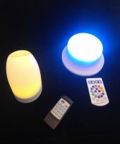

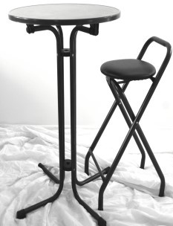

|  |  |  |
| --- | --- | --- |
| **PSR 02**  **Poseur Tables & Chairs**    **Table £10:75 Chair £3.00 Gossamer Cover £4.00**  **‘Linburg’ Poseur Tables & Chairs**  Optional lights available to illuminate under the Gossamer cover. | **PSL100**  **£7.00 each**  **(Tables & Covers Extra)**    **Poseur Table Lights**  **LED colour lamps**  **For covered ‘Linburg’ Poseur and other tables**  Static or changing colours -  *Stunning * Chic* | **PSR-01 £10.75**  **Aluminium Poseur Table**  Bright finish, Chic high table. Can also be fitted with BLACK or WHITE Gossamer Covers and optional PSL100 LED lighting under the covers.  *Matching chairs available Please ask.* |
| **PAT 03 £15.50 Set**  **4ft resin table and**  **6 High backed plastic chairs**  Umbrellas available—see page 25 | **DNC01 £ POA**  *Black & White Vinyl Dance Floor*  Available in various sizes up to 6m x 7m  May require underlay if laid on grass or in a Marquee.  Price depends on size.  NOT suitable for outside use. | **DNC02 £ POA**  *Traditional Parquet Dance Floor*  Available in various sizes up to 12m x 10m  May require underlay if on grass or in a Marquee.  Price depends on size.  NOT suitable for outside use. |

**Furniture For Bars, Patios, Casual & Party Events**

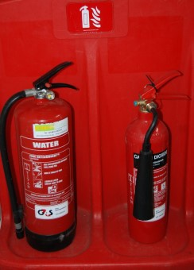

**More Party Items**

**All those little things you forget you may**

**need at a Party! (but we’re here to remind you)**

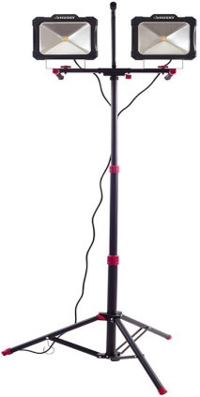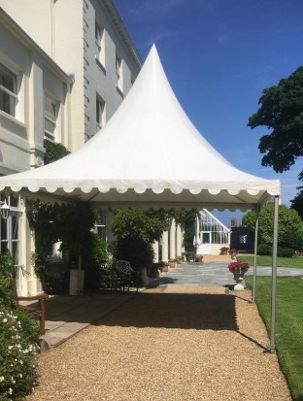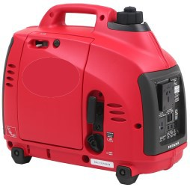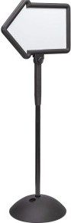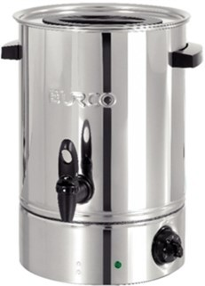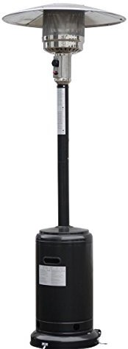

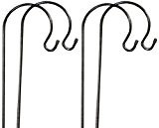

|  |  |  |
| --- | --- | --- |
| **RETRO MIRROR BALL**    **MIR01 £26.00**  **40cm Diam. Includes motor** *The original Disco and Ballroom lighting effect*  Various suspension systems available depending on your venue.  Let us advise you on the ideal spot- lights to make this really effective. | **FEST 25 £5 Per 10m**  **White or Ice Blue fairy lights**  **FEST 24 £12 Per 10m**  **White globe mini festoons**    **FEST 23 £15.00 Per 10m**  Festival style low voltage LED globe festoon lights; multi-coloured or white lamps available.  *ALL light strings are low voltage*  *supplied with transformer.* | **LX14 £20.00 Each**  Brass Chandelier lighting units in *warm white* for indoor events, parties etc.  Can be dimmed.  Various sizes / number of arms.  Candle lamps available. |
| **FESC 26 £3.00 Each**  Shepherd Garden Crooks 2m For hanging festoon lighting  And LED lanterns, plants or bunting.  Spikes in to soil / lawns.  **SGN01 £7.00**  Event Directional Signs on sturdy baseplates A must at outdoor  events.  Dry marker board  *Customised Signwriting available.* | **FLD01 From £5.00 Each**  Halogen and LED Floodlights for site or indoor use. Ensure your guests can see safely outside your venue or car park area. Some units are wireless (battery) supplied with  chargers others are mains powered.  Various sizes and power.  *We can also supply* ***LIGHTING***  ***TOWERS*** *for large areas.* | **FLD01B £30.00 Each**  Powerful LED Floodlights  for site or outdoor use. Ensure your guests can see safely outside your venue or car park area and steps.  240v mains powered. |

|  |  |  |
| --- | --- | --- |
| **CHL 004 £80.00**  Portable Air Conditioning Unit Designed for cooling areas up to 30m3 Various Models available  We also supply De-Humidifiers  please ask for details. | **CHL 001 £45.00**  28 bottle* Under-Counter Drinks Chiller.  Cooler Fridge with Glass Door.  * capacity depends on bottle size and stacking. 240v 4 Amp | **URN 01 £20.00**  Portable Water Boiler  20 Litre capacity with thermostatic control Piping hot water on tap!  240v 3kW (13amp) |
| **Gen25 From £295.00** |  | **CHL 02 £195 - 2 Day Hire Catering Chiller Trailers**  Mobile walk in chiller units for all catering events—Keep wines, beers, soft drinks, food items chilled for as long as required. Great for outdoor garden parties, weddings, sporting events etc.  ***Delivery and collection extra*** |
| **Multi Phase Generators** | **CHL 004 £18.00** |
| Super Silent Generators to power up your parties.  230V and 415V Road tow units  **Delivery and collection extra. Full range of distribution and safety kit available. Expert Advice.** | **Day Cool Boxes**  Quick-access hatch lets you access contents without letting the cold air escape.  Holds 2 Litre bottles upright and  45 x 330ml drink cans |
|  | Colours / style may vary |
|  |  |

#### Party Items

|  |  |  |
| --- | --- | --- |
| **MQE 005 from £80.00**  (Dry Hire— easy self erect)  **Commercial Grade Gazebo**  (not a ’cheap’ lightweight unit)  **3m x 3m £80 3m x 4.5m £100** Pop Up structure with zipped door and 4 walls. Ideal for garden parties, fetes, Markets stalls, etc.  Easy & quick to install Packs into transportable bag  Ballast weights or grass stakes.  **Delivery & Rig service available.** |  |  |
|  | **HTR 55 £65.00** |
| **FRN 91 £11.00 Each** | **Plus £30 per Gas canister** |
| Garden Parasols Freestanding & adjustable  Bases require filling with water | Patio Gas Heater with integral and adjustable push and turn  ignition switch which lets you  control the heat output ranging  from 5kW to 13kW. |
| Perfect for garden parties and other outdoor events | *1 canister can run up to 10 hours*. (Gas consumption depends on heat level setting) |

**MQE009 5mx5m**

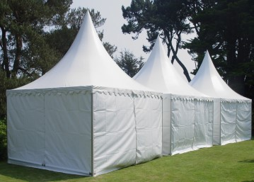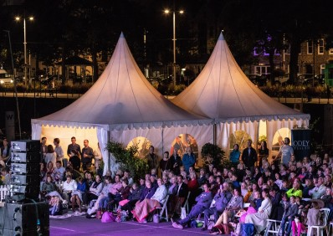

**from £501.40**

**MQE 007 4mx4m**

**from £420.00**

**Premium Range Chinese Hats**

**MQE 008 5mx3m**

**from £430.00**



Available with Georgian windows or plain wall options, or can be entirely open all round— just as a canopy.

*Optional Lining, Lighting, matting, etc. available.*

Perfect for garden parties and other outdoor events. Please contact our Hire Shop or Marquee Department

for full details and prices.



|  |  |  |
| --- | --- | --- |
|  | **HTR 57 £15.00**  Electric Fan Heater  240v 2Kw electric fan heater for  small marquees & rooms etc. Please ask for advice on use. | **FNC 01 £12.00 each**  White resin Picket fence panels  Freestanding and Interlocking 2.1m x 1m high |
| **HTR 56 £210.00** |
| **plus D&C, install + fuel** |
| **55Kw diesel powered fan heater** for marquees, hangars, warehouses & large rooms etc. Comes complete with ducting—meaning the heater stays OUTSIDE the venue and only  clean, warm air comes in. |
| *Building Regs prohibit the use of*  *direct fired heaters in buildings.* |
| Please ask for advice on the best  unit for your job and its use. |
| Can also feed cool air if required |
| **PTY 10 £49.00**  **Helium Balloon Kits**  Comprising 58 balloons, ribbons & disposable helium tank.  Price increase due 6.20 |  | **Gen1 £55.00**  Portable Generators  1.2KVA 230V Inverter  For small appliances up to 1000 watts.  *Event Services are the Generator Hire Specialists—we can advise you what you will need to power your event reliably and safely.* |
| **EXT 001 £18** |
| Fire Extinguisher Set |
| 1 x water |
| 1 x CO2 |
| On a regulation fire stand. |
| A Recommended Extra for any |
| party or BBQ ! |

#### More Essentials for a Great Party

**Venue Décor / Night Clubs**

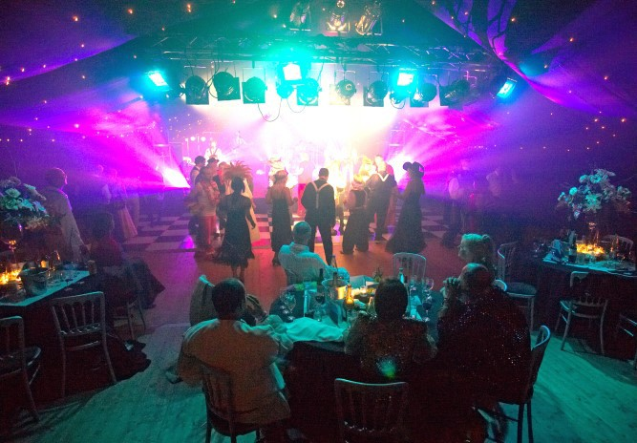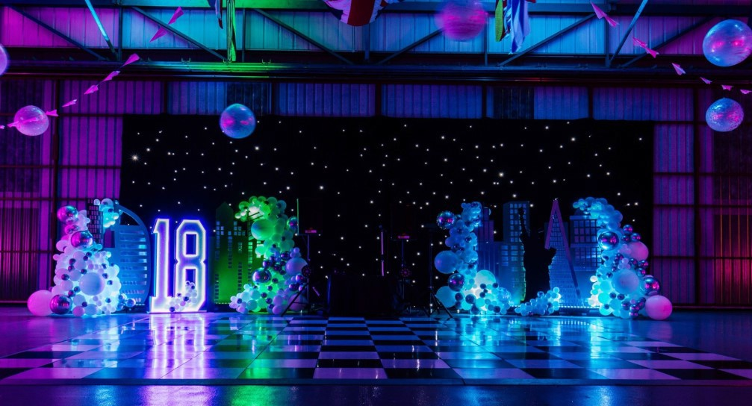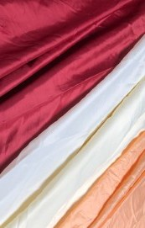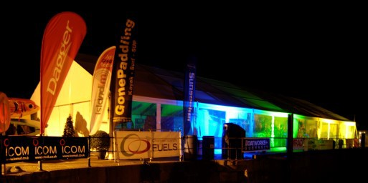

Installed almost anywhere

#### Architectural Lighting

A great effect for Buildings, Marquees or any exterior surface

Hangar Parties - Décor, lighting Dance floors

**LNG 12 £ Various**

**Room Dressing / Marquee Lining / Architectural Lighting**

We stock a range of room linings, trimmings and decor to create Event Venues in halls,

garages, sheds, marquees, conservatories, community centres, warehouses etc.

Linings in White, Black (including heavy duty blackout curtains and Starcloths), plus a range of colours including Red, Green, Peach, Burgundy, Blue and seasonal specials.

*Call to arrange a site visit to see what can be done at your party venue.*

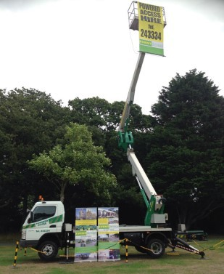

|  |  |  |
| --- | --- | --- |
| **Temporary Power**  **Event Group** has the Island’s largest, most reliable range of generators for events, standby power and  emergencies. Sets available from 20KVA to 100 KVA and more!  Road Tow and skid mount sets. Along with a massive stock of  **Electrical Distribution + Safety Kit**  *Whatever your power needs—call the experienced experts.* | **Event Services** started in 1976 providing PA systems for events— *and we proudly still do!*  **Public Address Caravans For all outdoor events**  All come complete and self- contained with an appropriate sound system for your event and  venue; Radio & wired microphones, cd player, connection for iPhones etc. Seating and work bench.  Powered by either fitted batteries or from 240v mains if available. | **Access Plant**  **Cherry Pickers** ranging from 13m 4WD units to 27m  Building inspections & repairs, Property maintenance,  Gutter cleaning, Tree surgery, Hedge cutting, Chimney work, Floodlamp replacing, Advertising banners & signs erecting, *Cheaper than scaffold for those odd jobs—quick and safe.*  ***Qualified, Experienced Operators*** |
|  | **Trailers**  We have a selection of **Trailers for hire**, including a ramp-tail 3 ton **Plant Low-Loader** and several other lighter, general purpose trailers. Self drive hire (Insurance conditions apply) or we can supply trailer with tow vehicle and experienced driver.  All units are braked, light and road legal. | **Premium Quality Clearspan Marquees**  What ever your event—we have Marquees and all the facilities you will need, for any occasion.  Garden Parties, Weddings, Corporate events, Official Functions,  Celebrations, whatever  —we can do it!  **Call 711717 to discuss YOUR Marquee event.** |
| **Flatbed Truck and HIAB** |
| Truck has a tilt ’n’ slide recovery bed with winch. Ideal for vehicle, cabins, plant transportation & Boat engines! *Versatile Remote Controlled HiAB lifting up to 8 tons.* |
| We can arrange escorted outrider services for Loads over 8ft (2.4m) wide  or overlength. |
| Specialists in moving ‘odd’ loads |
| **Also - Operated Fork Lift Hire** |

**Event Services & Plant Limited — Plant & Access Division Tel: 01481 243334**

**Event Hire** is located at Jamaica Hall, Le Bouet, St Peter Port GY1 2AZ and is part of the **Event Group** which is registered as **Event Services & Plant Limited**, Events House, Braye Road, Vale, Guernsey GY3 5PB.

Hours of business are usually: **Monday to Friday 09:00—17:30, Saturday 09:00 to 12:00 (Seasonal variations may occur)**. **Event Hire** is a party hire and business meeting equipment supplier whose aim is to ensure YOUR function is successful. With hundreds of items in stock that can be hired as part of a package or as individual units, **Event Hire** can supply nearly all of your needs from one source. An online brochure is available for relaxed browsing. Order from home or office or you can visit our unique shop **at Jamaica Hall** to see the range and

demonstrations of the hire stock, discuss your requirements with our in-house technicians. Please order by PHONE, email, POST or in PERSON. Do NOT use Facebook messaging.

* **Terms:** All hire and services are rendered according to our Standard Terms of Business, a full copy of which is available on our website and also printed on the reverse of all invoices. Here are some of the more pertinent:
* Title to said equipment shall remain with Event Hire. Hirer has examined said equipment prior to signing this agreement and agrees that the same is the correct equipment ordered by Hirer and is in good order, condition and repair. The Hirer agrees to return said equipment to Event Hire (unless otherwise stated prior to the signing of agreement) **on or before 10.00am** on the day after the end of the Hire Period in the same good order, condition and repair, and to pay Event Hire the rental therein at the rate provided. The rental day shall commence on the day the equipment is delivered/ collected to/by Hirer and shall continue until said equipment is returned. Hirer agrees to pay additional

period rental if said equipment is not returned before 10.00hrs.

* All goods hired from Event Hire must be paid for in full on collection or delivery unless the hirer has a credit account agreement with Event Services & Plant limited. A deposit will be required on all hires, refundable on the timely and proper return of the equipment.
* Note that to keep our stock ‘fresh’ and up to date, some items of hire may differ to that described in our online and printed brochures. You will be advised of this at the time of hire, and can be assured that replacements or alternatives will be at least as good or suitable as the product illustrated. Colours may also vary from the catalogues.
* Longer hires periods are available for all equipment: please ask for details.
* A charge of **£32.00 each way** will be levied for all **Event Hire** deliveries and collections of goods *
* ***Prices & specifications subject to change without notice.*** Although quoted and confirmed bookings are price-assured.

Most equipment is simple to set up with colour coded cables and connections; comes with detailed instructions and guidance / safety notes; are easy to operate, but some items [marked] we recommended that our staff demonstrate or deliver and set up.

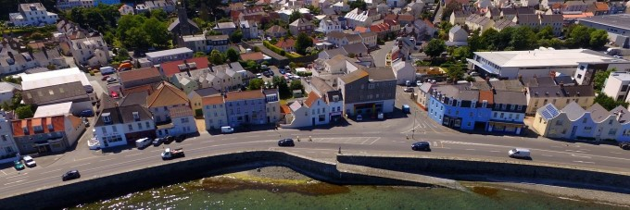

**←JAMAICA HALL**

Co-Op

St. George’s Esplanade

To Admiral Park→

**Jamaica Hall** is situated just inland from the Longstore Co-Op Locale, adjacent to the Jamaica Inn. There is a parking and un/loading area outside our door.

Please watch for pedestrians as our car park is bordered by a public pavement.

Explanation of symbols on products:

Equipment is heavy or large and may require a van to transport or delivery by Event Hire recommended. Some large items or bulk quantities may be held at our Braye Road stores; you will be advised on booking.

Semi portable equipment; can be easily collected and transported by average car. Some items may weigh more than 20kgs.

If in doubt please ask. Loading assistance is available at Jamaica Hall

 Equipment may/will require technical knowledge or Event staff to assist or set up; we’re here to help.

*Standard Delivery or Collection charge is currently £32 each way, ‘door to door’ - this can vary depending on the load, access, timing and if any rigging or setting up is involved. This charge is variable on large orders! However LABOUR to pack or collect items is chargeable. Please have hire goods ready to collect to avoid this charge.

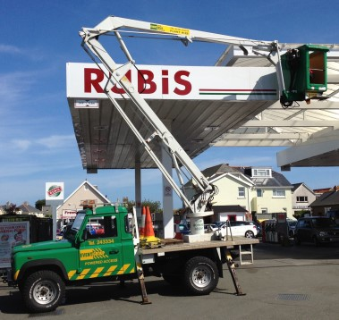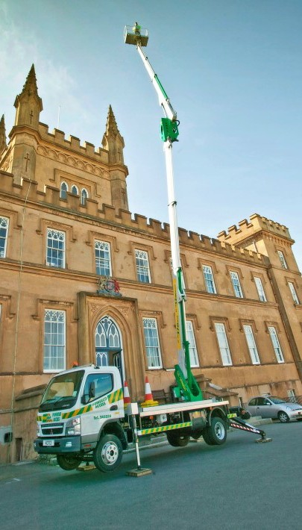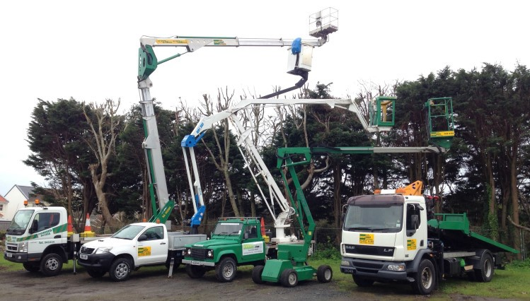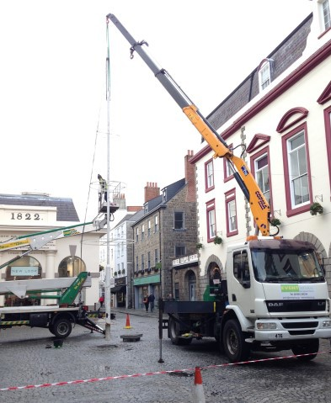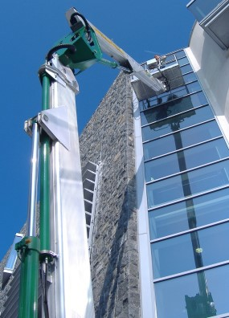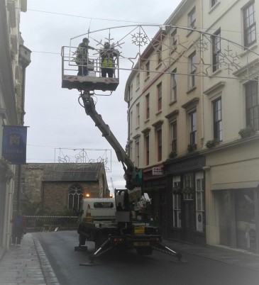



**EVENT GROUP** has the largest and finest range of specialist Access Equipment available in the Island, with highly trained, experienced operators to access any difficult job or transport that ‘odd’ load.

*Whatever you need to access or move, discuss it with us.*

‘Cherry Pickers’ from 12m to 27m range; all fully certified and insured. Some models are on 4 wheel drive vehicles for accessing those difficult areas. One machine is self- propelled and only 1.6m wide meaning it can access almost anywhere—indoors or out.

Units are available by the hour, with an operator. Ideal for accessing those high jobs in complete safety without the need for scaffolding or dodgy ladders!

Photo; Chris George