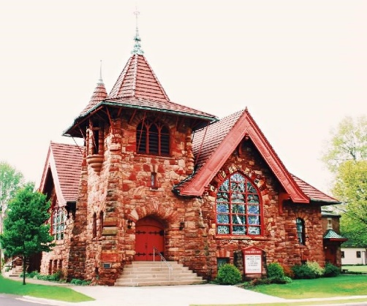

**First Presbyterian Church, Napoleon, Ohio**

**Job Description:**

First Presbyterian Church of Napoleon, Ohio is seeking a part time pastor to lead our community of faithful believers to live out our Biblically based faith, embody love and compassion within the church, and extend these values into the broader community. The pastor will empower the congregation by instilling enthusiasm through transformative leadership. This will help us to live out our mission and vision to actively share our faith, nurture and guide new believers, integrate newcomers into our congregational community, honor and praise God through worship, and serve the community through various ministries. The candidate should have a clear vision and passion for: the spiritual growth of Christ followers, community outreach, supporting the needs and growth of Napoleon FPC members and their families, and creating a welcoming and engaging culture for families who are new to the church.

**General Responsibilities**:

* Oversee the worship services and faithfully preach and teach the Word of God
* Provide pastoral care, creating personal connections and offering support to individual members in times of need, crisis, or celebration
* Meet regularly with the Elders to facilitate the work of the church and perform other pastoral duties according to the Book of Order

**Proficiencies:**

* Utilize qualities and abilities akin to those of a church planter
* Engage young individuals and families
* Connect effectively with younger generations

**Qualifications:**

* + Passionately embody God’s Word and live out the gospel in daily life
  + Fully understand and support the doctrine of First Presbyterian Church
  + Ordained minister, commissioned lay pastor, or equivalent education

Although initially part-time, this position holds the potential to transition into a full-time role. We offer a competitive salary and benefits package tailored to the candidate's qualifications, education, and experience. Please send your resume, letter of intent, and statement of faith to [NapoleonPNC@gmail.com](mailto:NapoleonPNC@gmail.com).