Antioch Retreat 2026
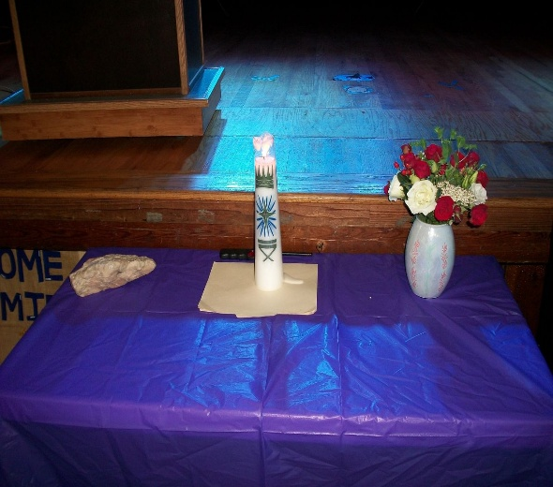 | 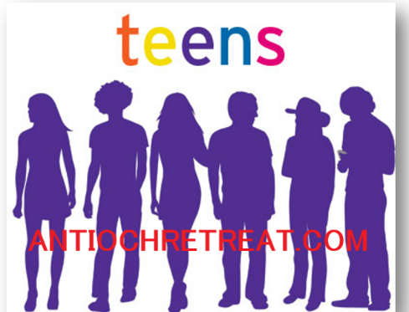 | 
Come a Rock and Leave a Rose! | Age 13 to21  Teens and Young Adults | ^^^ SCAN ME ^^^
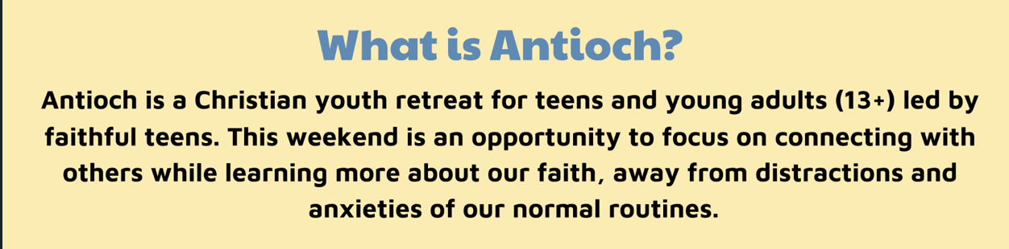
Where?  Mary Help of Christians Center  6400 E Chelesa St.  Tampa Fl 33610 | When?  March 13th  thru 15th  2026 | How Much?  $80.00  (Scholarships available) No One denied for financial reasons!
Where Can I sign up?
www.antiochretreat.com (scan code above)
antiochtampa@gmail.com
Steve (813)404-9658

