Easter application 2024

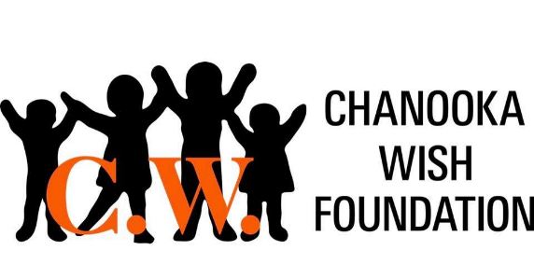

CW use only
Family Name: Click or tap here to enter text.
Family Phone Number Click or tap here to enter text.
House Address: click or tap here to enter text.
Easter Basket Request:
Child Name | Age | Gender
Click or tap here to enter text. | Click or tap here to enter text. | Click or tap here to enter text.
Click or tap here to enter text. | Click or tap here to enter text. | Click or tap here to enter text.
Click or tap here to enter text. | Click or tap here to enter text. | Click or tap here to enter text.
Click or tap here to enter text. | Click or tap here to enter text. | Click or tap here to enter text.
Application available to families in need. Need to have filled out the main application in order to apply to CW’s Easter program. If you fill it out at start of school year you do not need to do again. (Aug. 2023) Contact us for more information: 815-412-5130, Carolyn@chanookawf.org

Due by March 15th, 2024
Submit to Carolyn@chanookawf.org
Mail to: 25900 McEvilly Rd Minooka, IL 60447

