# Chicken Dak Bungalow with Basanti Pulao

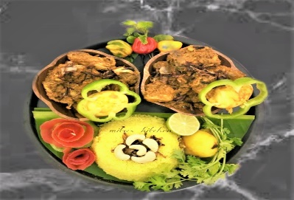

**Chicken Dak Bungalow** has its roots in the British era. During the British raj in India, Dak Bungalows were built as rest houses and used for providing lodging facilities to Government officials and sometimes for other travelers. During their stay in the bungalow khansamah (steward) used to prepare meals with the local fresh produce in country style cooking and this recipe is one of those. It’s a simple and hearty Chicken Curry which goes very well with Basanti Pulao but one can have this with Rotis too.

This is a great recipe to make when you don't have much time to continually sautee the chicken which most of the other recipes require. The Marinade must be made with a balanced amount of spices as the perfect Chicken Dak Bungalow must not have overpowering flavors of anything other than Coriander powder. I always serve it with some freshly added coriander leaves as that is how they served it in the tea estate bungalows.

## Ingredients

* Chicken- 800g with bone (medium sized pieces)
* Egg- 4 (hard boiled)
* Potato- 2 (medium sized)
* Onion- 2 large (thinly sliced)
* Green chillies- 4 (slitted)
* Turmeric powder- ½ tsp
* Red chilli powder/Kashmiri mirch powder- ¾ tsp (adjust according your tolerance)
* Sugar- ½ tsp
* Salt
* Mustard oil- ½ cup
* Garam masala powder- ¼ tsp
* Fresh coriander leaves- 1 tsp (chopped)

## To marinate

* Yogurt- 150g (whisked)
* Ginger paste- 1 tbsp
* Garlic paste- 1 tbsp
* Lemon juice- 1 tbsp
* Coriander powder- 1 tbsp

## For tempering

* Green cardamoms- 4-5 (roughly crushed)
* Cinnamon- Three 1” pieces
* Black peppercorn- 1/2 tsp (roughly crushed)
* Cloves- 4-5
* Bay leaf- 2
* Whole dry red chillies- 2

## Method

* Peel the potatoes and cut into halves, wash and keep aside.
* Add everything in a bowl mentioned for ‘marinate’ with the freshly washed pieces of chicken. Mix well; keep aside for 3-4 hours.
* Mix some turmeric powder and salt with boiled eggs, keep aside.
* Heat oil in a deep-frying pan/ kadai, add boiled eggs and fry on medium heat until golden in color. Remove and keep aside.
* Next to add the potatoes, fry them until golden, remove and keep aide.
* In the remaining oil temper with the ingredients mentioned ‘for tempering’. Add onion, sauté on medium heat until light brown; next to add green chillies, turmeric powder and kashmiri mirch powder. Mix well; now add the marinated chicken and potatoes into this. Mix, cover and cook on low heat. Stir in between. Add salt along with ½ cup of hot water when the chicken is half cooked. Mix well, cover and cook further. When the chicken is almost done add sugar and garam masala powder. Mix gently and simmer until thoroughly cooked. Add fried eggs and garnish with coriander leaves. Your delectable **Chicken Dak Bungalow** is ready to serve.
* *Enjoy this hot with* ***Basanti Pulao***

# Basanti Pulao

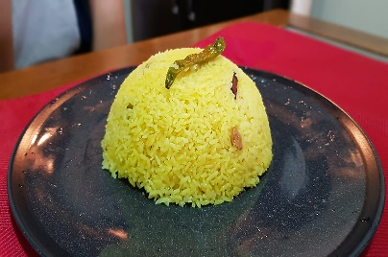

## Ingredients

* 2½ cups long grain Gobindo bhog rice
* 1 tablespoon saffron strands
* 1/2 cup warm milk
* 1 tablespoon sugar
* 2 tablespoon ginger paste
* Pinch of salt
* 6-7 small cardamom
* 6-7 cloves
* 2 bay leaves
* 1/2 cup chopped cashews and raisins
* Green chilies
* 5 cups warm water
* Pure Ghee

## Method

* Wash the rice, and drain out excess water.
* Leave out on kitchen towel for 30 minutes to soak out the excess water.
* In the meantime, soak the saffron strands in the warm milk
* In a deep bottom pan heat ghee, fry cashew nut & raisins till the nuts turn brownish, strain from the pan.
* Temper the ghee with cinnamon stick, green cardamom, black cardamom, clove & bay leaves.
* Add rice & start frying the rice around 5 mints. in low flame.
* Now add sugar, salt to taste and green chilies.
* Add saffron soaked milk & few drops of yellow food color.
* Add fried nuts & raisins.
* Now add the double amount of warm water.
* Cover the pan with lead & cook for minutes.
* After 10 minutes open the lead & give the pulao a light stir.
* *Enjoy this hot with* ***Chicken Dak Bungalow***



## MITA PODDAR