**Mini Mango Cheese Cupcake Recipe (No Bake)**

***-Recipe By Mouli Datta***

**“Mini Mango Cheese Cupcake”** is one of the most popular of trending dessert in the world. They are truly the best way to celebrate mangoes in summer. Sweet, slightly tart, creamy. It is simple, it's fast & it tastes yummy. This will be really delicious. Trust me, this will surely satisfy your taste buds. Perfect dessert for the summer!



**Servings:** 12 **Prep Time:** 20 mins **Freezing Time:** 3 hrs. 30 mins

**Ingredients:**

**For the Base**

Digestive Biscuits, 20 pcs

Butter, 1/3 cup

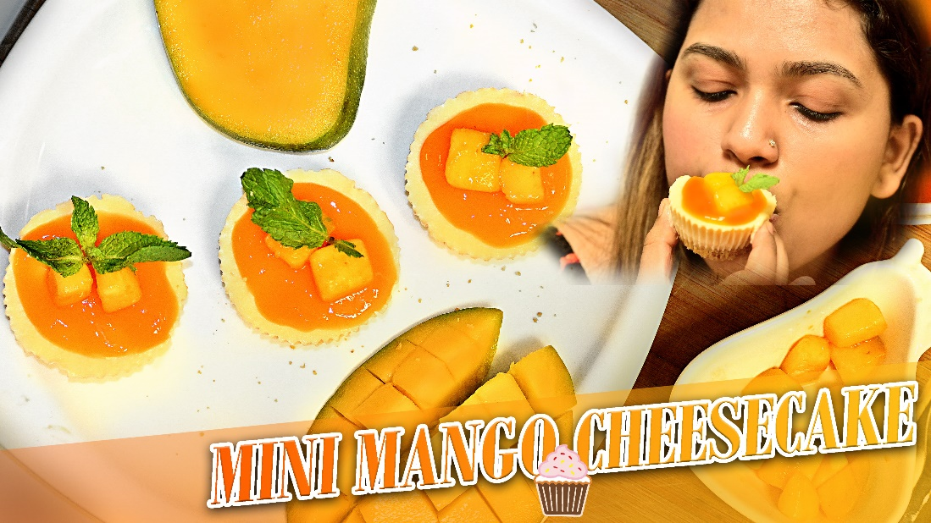**For the Filling**

Cream Cheese, 2 tbsp

Yogurt, 1 cup

Icing Sugar, 1/2 cup

Mango Puree, 1 cup

Lime Juice, 1 tbsp

Whipping Cream, 1/2 cup

**For Topping**

Mango Puree (more)

Cubed Mango (some)

Fresh Mint leaves (some)

### 

### Equipment

Hand Mixer

Blender

Muffin Pan

Rolling Pin

### Instructions

### The Base

1. Place digestive biscuits in a Ziplock bag & using a rolling pin, bash them until you get fine crumbs.
2. Place in a bowl together with butter and mix well.
3. Prepare 12 muffin liners in two muffin pans. Set aside.
4. Divide evenly into 12 muffin liners & using the back of a glass, press to compact. Place in the freezer for 40 mins.

#### **The Mango**

5. Peel mangoes, take out the meat and place in a blender.

6. Add lime juice & blend until smooth.

1. Separate 1 cup aside for the filling.

#### **The Filling**

8. Place cream cheese and yogurt in a bowl. Mix everything well.

9. Now add in mango puree & icing sugar and mix well. Set aside.

10. Using a hand mixer & whisk until fluffy.

11. Add previously made whipped cream into cream cheese mango mixture & whisk. Gently fold everything to combine.

12. Using an ice-cream scoop, fill all the muffin cups. Use a butter knife to smooth out the top. Shake the muffin pan to help the filling settle in.

13. Place in the freezer for 3 hrs. or until they are firm.

**How To Serve**

14. Remove the muffin liners and transfer to a serving plate.

15. Spoon some mango puree on top followed by cubed mango & some fresh mint.

