***Shahi Egg Korma***

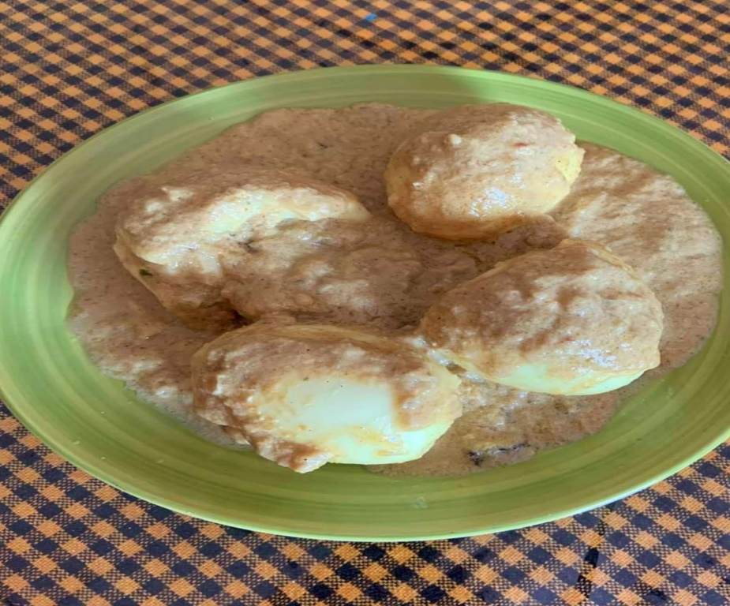

**Ingredients:**

* **4 eggs**
* **1 big size Onion (chopped)**
* **2 Onion Paste**
* **1 tablespoon Ginger paste**
* **1 tablespoon Garlic paste**
* **2 Bay Leaves**
* **½” Cinnamon**
* **2 Cardamoms**
* **6-7 white Peppers**
* **½ teaspoon red Chilli Powder**
* **½ teaspoon Cumin Powder**
* **½ teaspoon Coriander Powder**
* **10 Cashew nuts**
* **1 teaspoon Garam masala**
* **Salt (as required)**
* **1 teaspoon Sugar**
* **½ cup liquid Milk**
* **3 tablespoon Ghee**
* **4 tablespoon White Oil**

**Preparation-**

* **To prepare a delicious Shahi Egg Korma, I have taken frying pan then added 2 tablespoon white oil along with chopped onion, then we have to fry until it becomes deep brown colour.**
* **Now we need to fry the egg with salt and slight red chilli powder.**
* **Then we have to add 2 tablespoon White Oil along with 3 tablespoon Ghee. Then we will wait to heat around 30 sec of time. Then we mixed Bay leaves, Cinnamon, White Peppers, and Cardamoms. The we will wait for frying until it gets good smell.**
* **Then we have to add Onion Paste, Garlic paste, Ginger Paste, Red Chilli Powder, Cumin Powder and Coriander Powder. After that we need to stir it for 2-3 minutes. Then we have to add cashew nut paste and stir it very well on low flame for a minute.**
* **Now mixed the Eggs and stir it with all spice, with added Milk. Then we have to cook in a very low flame around 2-3 minutes.**
* **Now it’s almost ready. Finally, we need to add 1 teaspoon Ghee and Garam Masala.**
* **Now we need to sprinkle some Onion Barista and the Korma to make it’s ready to serve.**
* **It will be more delicious if you serve the korma with Pulao/Roti/Paratha (as per your choice).**

**Recipe by: - Papri Chowdhury**