**Why countries don’t have purple on their flags**

Purple was the color of royalty and was historically associated with roman emperors.

The reason was to put in simpler terms “very expensive”. There was one dye in particular “Tyrion dye” that was deeply coveted. So, flags that have been used for a long time in their battle standards can be traced back thousands of years to places like India, China and the Roman Empire. However, during the medieval period in Europe those banners, saint flags and royal standards slowly took root of becoming easily identifiable symbols.

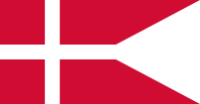

Denmark England

You would think kings who are trying to become better against each other would have picked purple for their colors, but it was (again) very expensive. So, none of the older European states have made use of purple as a national color to spend on wars except the papacy and cardinals and the pope wore purple robes.



Now Europeans have been trying for centuries by dying red cloth blue. Most flags even after the empires and kingdoms still couldn’t afford purple and most countries don’t want it because they were tired of the Catholicism

But when Spain (A Catholic Nation) overthrew its monarchy (1931)… they adopted a flag with a purple color.

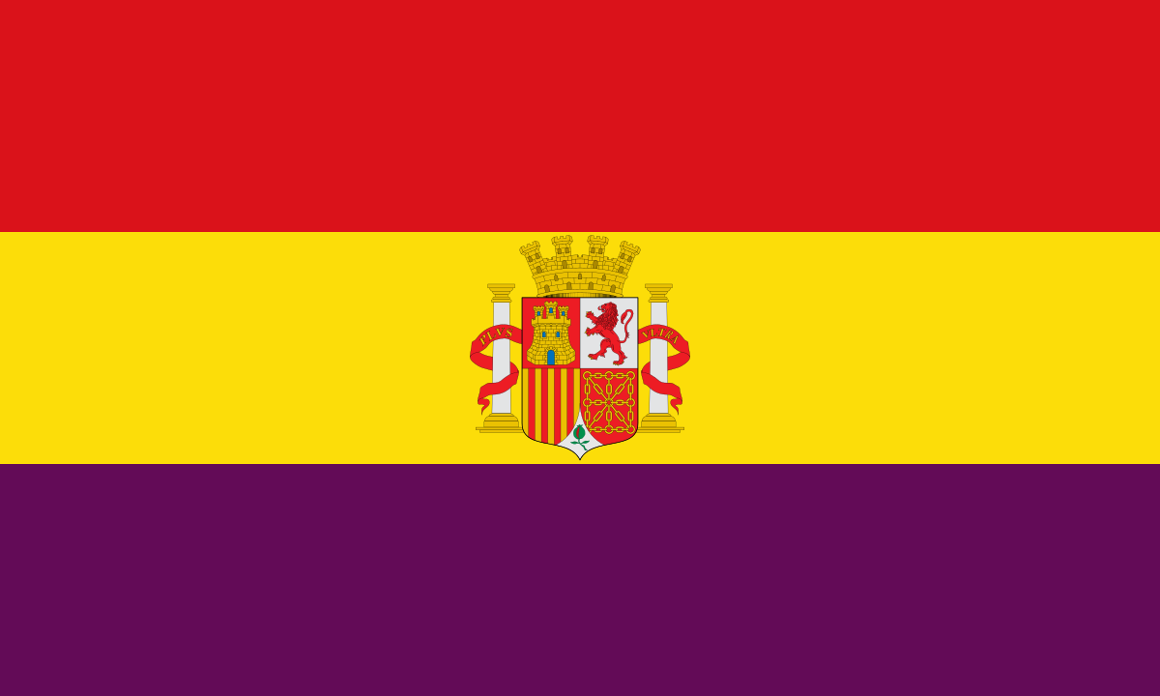

Modern Flags with ***Synthetic*** Purple:

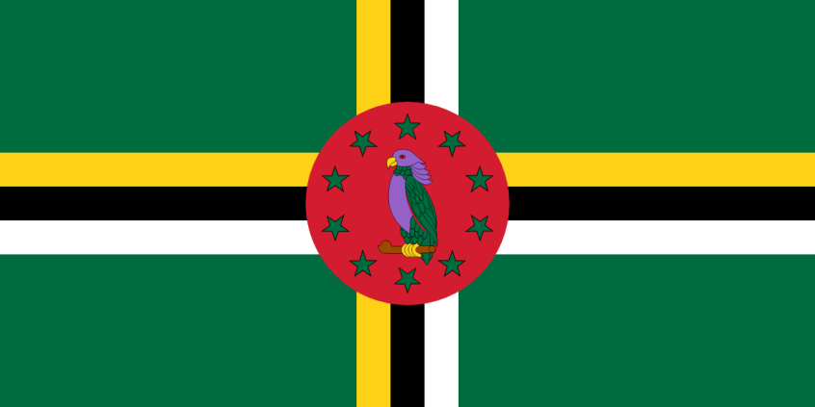Dominica

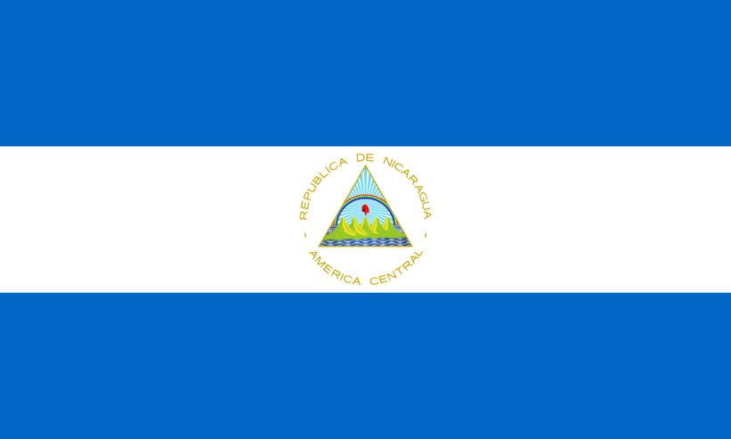

Nicaragua