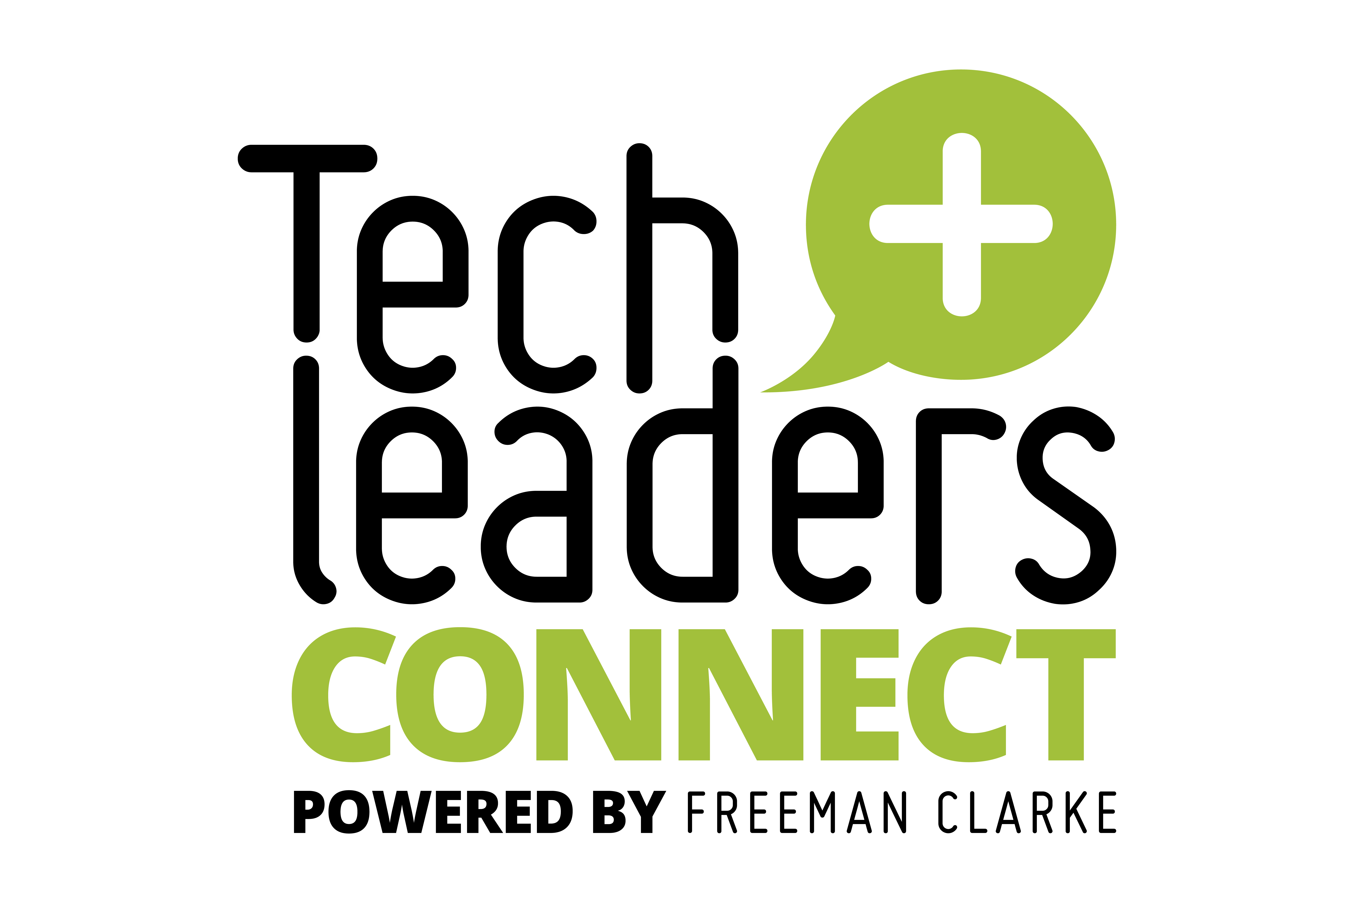

**Is data the lifeblood of the business?**

Tech Leaders Connect Dinner co-hosted by BCN

**Chasing Pirates: Using data both within and without the company:**

* Data is often siloed with very little interaction between silos let along with external data
  + Ownership is a concern
  + If the data’s wrong who is responsible for correcting it? Who knows what the correct data actually is? How do we know it’s wrong in the first place?
* Too much business-critical data is held only in spreadsheets. It’s something like as much as 70%
  + Jim Alampi used to talk about barriers to growth and he specifically mentioned the business systems and how they were used as being a barrier to growth. This is the same for data and data storage too.
* Too often, data is excluded from the tech debt discussion. It’s assumed to be just about the systems, but the tech debt in the data can be significant
* Quality data will drive value in to the business, the big question though is how do you know what quality data looks like and who is the arbiter?
  + It can’t be the CIO/CTO, but often we’re seen as the custodians, but in reality just like with systems there are data stakeholders and owners. They need to stand up and be counted.
  + Social Media platforms have been known to purposely pollute their data so it cannot be used outside of their environment.
* Major concerns around unstructured data, particularly the control of what is in that unstructured data. FoI or an legal Information Request when it comes to unstructured data is quite a scary thought.

**Pipe-Lines and Explosions: Using data in new ways:**

* Data is useful historically and indeed, auditors look for patterns of data – history is important in case things change
* Regulators use it to also check for bias in the auditors
* Developing a data retention policy is s a good idea, but hard to enforce
* Inconsistency even in gov agencies (inc ICO) so how are private businesses going to get it right?
* There’s a huge amount of duplicate data around, the problem is how to find it, correlate it and understand which of the duplicate data items is the one that needs to be kept
* And, a growing problem with Shadow Data, not just Shadow IT. This also directly contributes to the Shadow AI issue.
* Any sort of data management is ham-strung if you don’t understand what the data is in the first place. You shouldn’t delete something unless you understand what the data actually is and the consequences.

**Athletes: Health and wellbeing data and its use**

* When it comes to storing data about individuals, their health, wellbeing and personal data, it becomes a lot more difficult.
* Systesm sould be secure by design/secure by default
* Different generations have different views when it comes to the amount they care about sharing their personal data. Recent generations appear far more open to sharing than older generations.
* There needs to be regulation when it comes to this kind of data
  + Should we be worried about the NHS selling anonymised health data to American companies? Possibly?
* Corporates, for the most part, have a different attitude towards data. Start-ups often very happy to share data whereas corporates not so much.
  + Corporates appear very happy to use their employee data against them though.
  + Using systems to monitor people working from home
  + Office desk occupancy, etc.
  + Worrying trend about monitoring of workers
    - Amazon probably have the most wide-ranging monitoring and have massive amounts of data on individuals
* Corporations can be seen to be uncaring and unknowing, but switched on for data
* Data can be used to care about people, but at the same time data can be used against you

**Other discussion comments:**

Who owns the data? Surely the CEO should be stepping up and acting as the main stakeholder?

* CIO needs to become a product owner
* Prototyping in the business helps use data quickly. And low-code/no-code enables departments to develop their own systems (is that concerning!)
* Innovation doesn’t come from the CFO – those reporting lines are out of date
* Data should be enabling a more successful CEO
* Decisions with what to do about data need to come from the users rather than the tech team

CIO/CTO is still a muddled concept – what exactly are our responsibilities

* Great CIOs don’t necessarily come from a tech background