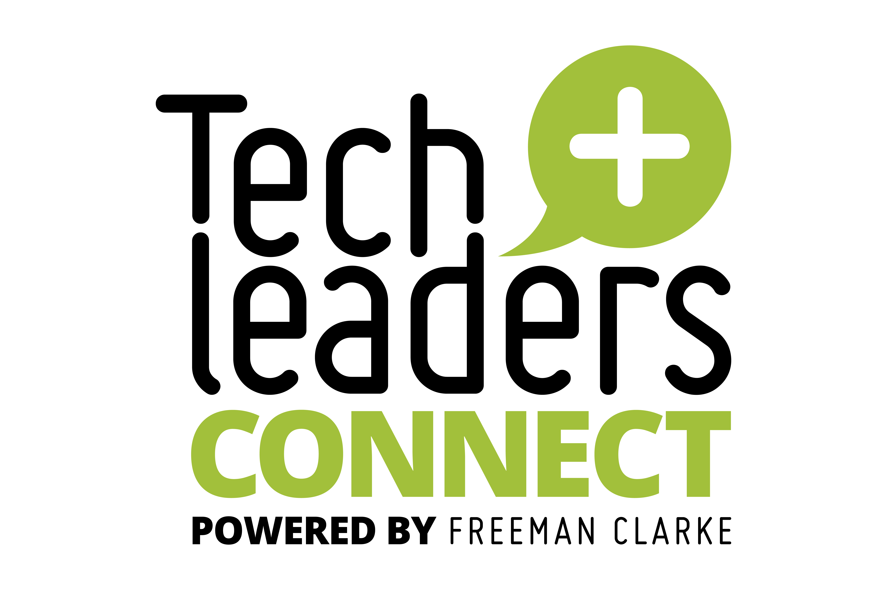

**Data isn’t just a resource; it’s a risk,  
a catalyst, and a culture problem**

Tech Leaders Connect Dinner co-hosted by BCN

**Data might not be shared for very good reasons – countries holding on to (perceived) critical data or people just not knowing it existed.**

* Sometimes departments don’t know that another department could benefit from their data so it’s not shared. So not locked away, just not widely known about.
  + Spreadsheets are terrible for this. Spreadsheets are usually/often personal and stored locally so data and analysis gets no further.
* Integrated systems helps, as does a centralised data warehouse/data lake, but needs someone to have the idea to set it up in the first place. This is a role for IT leadership
* Frequently not really understood about the value of data
  + Certainly very little understanding of opportunities to sell on data – that’s not something that occurs to most businesses.
* CEOs still often making decisions with half the information
* CEOs still frequently don’t know the state of their business on a day-to-day basis

**In addition, data literacy is a problem within business.**

* Being able to think about and come up with use-cases for data is not a skill many have
* Often up to the CIO/CTO to provide the art of the possible to kick things off.
* Starting with a blank sheet of paper is problematic – need something to review/build on/criticise
* This includes the view of joining disparate sets of data together in order to produce something of greater value.
* There has to be a clear Return on Investment or Return on Aggravation otherwise it’s never going to get board level approval. Often MVPs or small demonstrative models are needed to show what a difference can be made. CIOs/CTOs shouldn’t be afraid of running these and demo’ing the advantages to the business in order to kick-start the process.

**Too often individuals at board level are arguing about their reports which show different things, sometimes even if they’re using the same data.**

**That’s why data governance is becoming a thing even in smaller companies.**

* Worth considering a data governance capability.
* Or at least having someone responsible for data at board level even if it’s not a full time job
* Consistency of reporting methods which leads to consistency of reports and thus better business decision.
* Definition of single sources of truth along with centralised validation of data
  + Reduce the opportunities to enter data in unvalidated ways (e.g. typing anything in to a field)
* Business needs to be able to define what good looks like with data, e.g. what is the right contents for a specific data item, e.g. a data dictionary.
* Creating Responsible Owners for company data develops an environment where data quality is more likely to be maintained.

**Quality of data is also probably part of the data governance remit.**

* However it’s again more about facilitation than it is about defining it. The business need to be the ones engaging with it and working to improve the quality of their data.
* This is where demonstrating real-life problems is effective; if you can demonstrate the consequences of having bad data, then there’s more likely to be a drive to improve the quality.
* Important to have a definition of what data quality actually is too.

**It is often an iterative process of improvement:**

* Spot people who are frustrated and help them out, or guide them in the right direction and then they become champions
* Often need to tighten up on data as well so that it becomes more meaningful, e.g. don’t have 26 statuses for a sale, just have 5 and make them meaningful.
* Spot where same jobs are delivering different levels of productivity. Use data to find out why, demonstrate to the board.
* Creating an environment that encourages people to be innovative with data and see their results quickly. Needs to be lo-code/no-code so they can do it themselves without resorting to the IT function for help/delivery.
* Move towards a load-once method with validation; clear systems of record where the data can only be entered accurately even if there’s very little interest in entering it correctly.
  + Need to demonstrate that by entering accurate data, it makes their lives/jobs easier.
* If it’s difficult to enter data – it’s not convenient, then this makes it hard to create a high quality data set for a business. People will avoid doing it!

**This is not an IT project. Although frequently it will be assumed by the business as a whole to be the case.**

* CEO really needs to be the owner of data, in order to do that the CEO needs to be “taught” to understand the value. That may be through an initiative, run by IT, to show the benefit. Once those benefits are understood by the CEO, it’s much easier for them to champion.
* The CEO needs to understand the “why”

**It’s no good just telling people that they should value data, you need to show them the actual value to the business.**

* Illustrate it in big ways – big graphics of useful information on big board
* Sales: Leagues, customer inbound progress, etc.
* Gamification certainly helps
* Make sure it’s clear who has the real value in the data and thus an interest in maintaining the quality of that data both at input and later on down the line. Or at least put in place stick/carrot in the right places to ensure that those interacting with the data have a good reasons to maintain the data quality.
* The CIO/CTO needs to be a facilitator and the spark, but not the main data stakeholder.
* It’s quite likely that without having data at the heart of a business, the company will experience “Competition Fade”, e.g. they gradually slip backwards in competing with other companies in their sector. It won’t happen quickly, but it will happen.
* We also need to consider how generations coming in to business are going to interact with data. TikTok generation interact with data in a completely different way.
* AI is a way to open the conversation. Many (most?) CEOs are interested in how AI might be able to make a difference to their business, the data/process story can hang off the back of it.

The CIO/IT function has company wide views of the business data within the company. That’s a privileged position.

* It is thus becoming more important for a CIO/CTO to report to the CEO.
* Certainly the role is growing in importance whereas the CFO is going backwards (with their role far more likely to end up in AI than the CIO/CTO role)
* Reporting in to other board members can mean important messages are lost in translation.
* The CIO/CTO also has to provide translation between the senior leadership team and the rest of the IT function.
* IT is now a people business. The tech bit is the easy bit. The idea of the traditional IT function stuck away in the basement, working in the dark, eating pizza being rude to internal customers is long gone. We now need a team that’s high EQ and capable of interacting with the business at all levels.

Data Debt is an issue, particularly with unstructured data.

* The cost and effort to resolve often outweighs the benefit of doing anything about it
* AI can be used to help here though to review unstructured data and surface issues far faster than doing it by hand
* However, given it’s never clear what type of data exists in the unstructured data set providing an AI with access to it could mean that data never meant to be shared (and potentially private) could end up being released to a audience it was never meant for.
* Some prefer to use the term Toxic Tech rather than Technical debt because it has more impact when talking to the rest of the business.
* Often easier to concentrate on data loss prevention rather than try and address the mountain of unstructured data.
* BUT make sure that going forward, things are confidential by design. This is similar to the development of systems that are secure by design, secure by default.
* The problems really come about when there’s a Subject Access Request or a Freedom of Information request. These can mean a heavy load on IT functions to surface the data because much of it will be unstructured.

Security of data remains a big red flag. Given that to be useful to the business, it has to be unencrypted at some point, this can provide opportunities for data to be exfiltrated from the business.

* As previously outlined, confidential by design, secure by design, secure by default are important elements of securing company data.
  + Frequently we encounter data secured by a wing and a prayer which is rather scary.
* Doesn’t reduce the need to keep an eye on people who may be interested in taking data to a competitor
* Trust is important and it needs to be earned.
* Use of cloud systems can push the ownership of security back out to the department rather than it being owned by IT.
  + HR own a cloud based HR system, they will also own the admin rights for it, not IT
* Need to consider the impact of outsourcing, particularly overseas outsourcing.
  + Where is the data stored? Who’s accessing it? Could it be exfiltrated by the outsourcer. Tends to be less interest in caring for the data as it’s not their company’s data.

Suggested that there are three things to discuss when talking data:

* A business needs to care about data, understand the value of data, thrive and differentiate through data
* A business needs to care about the process; is what we’re doing the right thing?
  + Joining the data and the process and reviewing them together is important.
  + Frequently processes are in people’s heads or were developed in an emergency by someone who’s now left.
* A business needs to have a Chief Prompt Officer/Champion to make AI come to life. It could be one person or many.