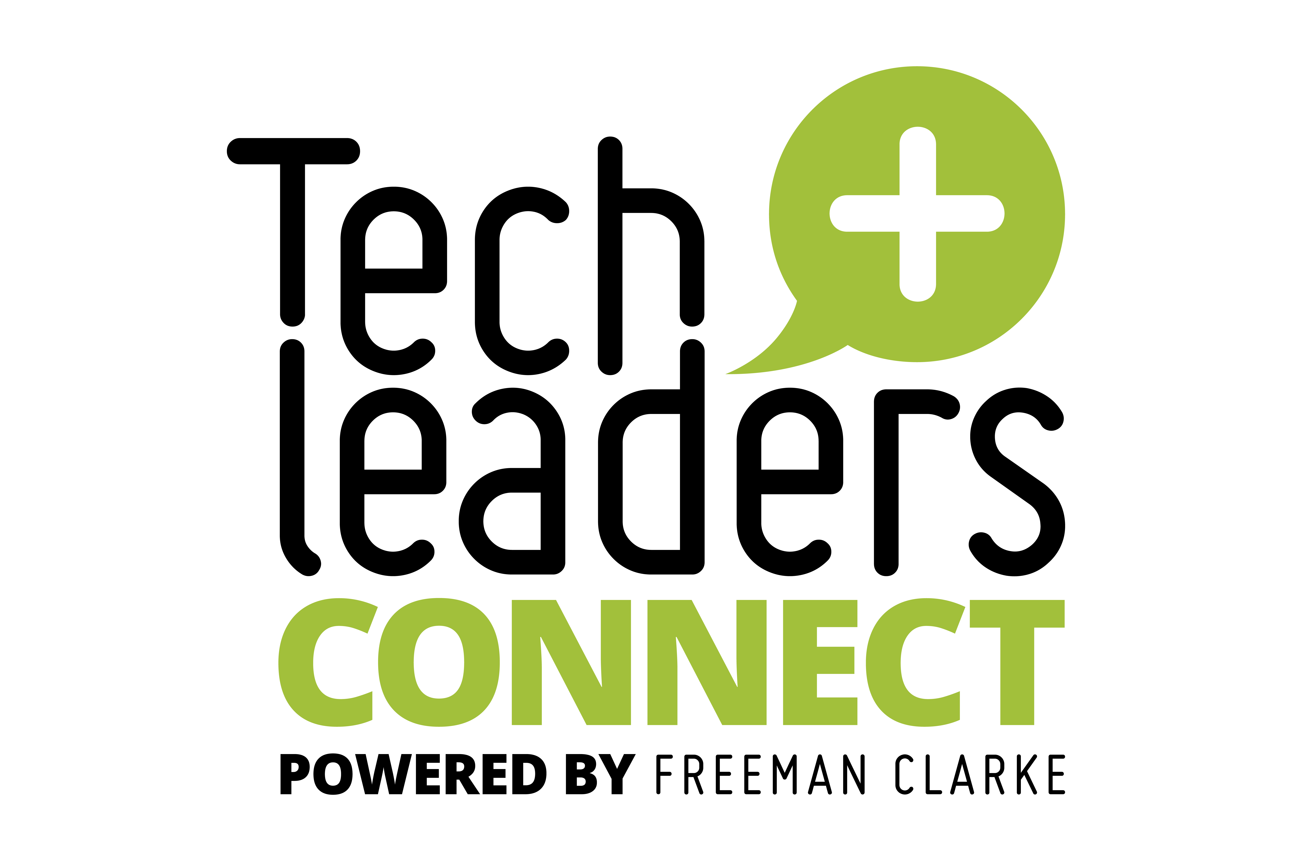

**Cracking the Productivity Code**

Tech Leaders Connect Dinner co-hosted by Workday

**What are the productivity barriers that your organisations are experiencing right now when it comes to enhancing productivity:**

* It’s important to find productivity gains that deliver measurable impact, otherwise it’s pointless.
  + Is it about quality of life for the employee or something else? Surely, it’s got to be quality of life.
* And what are the benefits; should be able to do more for less
* Home working can drive up productivity, but at the expense of collaboration. Bringing people back in to the office drivers up collaboration, but at the expense of productivity – quite role specific though
* Good office products
* Finding ways of improving customer satisfaction – introduction of agentic customer services agents to enhance the customer experience and enable the customer services team to work on more complicated issues.
  + But customers don’t like talking to an AI agent, still quite easily spotted
* Important to convert higher levels of productivity in to reinvestment although it’s acknowledge that for some companies higher levels of productivity will result in reduced headcount
* Runners/Repeaters/Strangers
  + Runners: 99 Flake
  + Repeaters: Ice Lolly in the freezer
  + Stranger: Wants a Triple whip with flake and a witches hat (yes that’s a real thing)
  + I found this online: <https://wholesalewisdom.substack.com/p/what-are-runners-repeaters-and-strangers>
* The number of meetings is a productivity issue in itself. Often down to culture
  + Tech Incident with 250 people on the call!
  + No Meeting Friday has worked, but no chance of growing beyond Friday

**When it comes to productivity we can**’**t escape the topic of AI. What are your organisations**’ **tangible experiences with AI-drive productivity gains?**

* Co-Pilot – Keen to be utilised, but after a short while was not perceived as useful – had a lot of distrust.
* Co-Pilot – used for summarising emails sent out of hours – worked well.
* One Co’s Marketing function ended up concluding that it was a waste of time
* ChatGPT far more likely to be adopted in the long run that Co-Pilot.
* Microsoft is too expensive
* Gemini: HR using it to help with coaching on difficult conversations. However, had to use it on personal devices only.

**Productivity is intrinsically linked to skills. Given the increasing integration of AI, what proactive strategies are you employing for reskilling, upskilling, or redefining roles within your workforce to ensure a smooth transition, maximise the benefits of AI and mitigate potential negative impacts? How are IT leaders themselves evolving their skills and leadership to navigate this evolving landscape?**

* Identifying the skills needed going forward first
  + Horizontal skills, not vertical skills
  + Critical thinking, etc
* Roles change -> Jobs that we don’t even know about yet
* Need to address anxiety
  + 5-10 years trust will be in AI (natural because much of workforce will have grown up with it), but not the case at the moment
* Increased amount of sharing of roles
* One attendee saw their adult child get advice from Gemini when buying a flat; wouldn’t have ever thought about doing that themselves.
* Emotional Intelligence is still key
* Future skill: How do you ask and how do you adapt the prompt?
* Trust in AI will be incredibly important, but right now we know it lies
* We need to have adaptability and a willingness to learn
* The human touch is important
* Enhancing Engagement in areas they don’t know about

**Beyond specific technologies like AI, what fundamental shifts in IT strategy, architecture or operational models have you found to be most impactful in enabling sustained productivity improvements across the wider business?**

* Still uncertainty about exactly what the role of the senior IT Leaders is, what the definitions of CIO, CTO, CDO, etc actually are. Whether CIO is more senior than CTO, etc.
* CTOs found in start-ups, CIOs found more in corporates.
* Traditionally different, perhaps not so going forward.
* CIO/CTO is a critical role within the executive team.
* Developing relationships is key
* Helping the business make decisions, not just having people come to you and ask IT to do things. Now going out in to the business and finding stuff
  + Can’t be reactionary, need to be strategic
* The next generation don’t seem to want the responsibility. If they’ve not done it before, then they don’t feel confident picking things up to lead/manage.