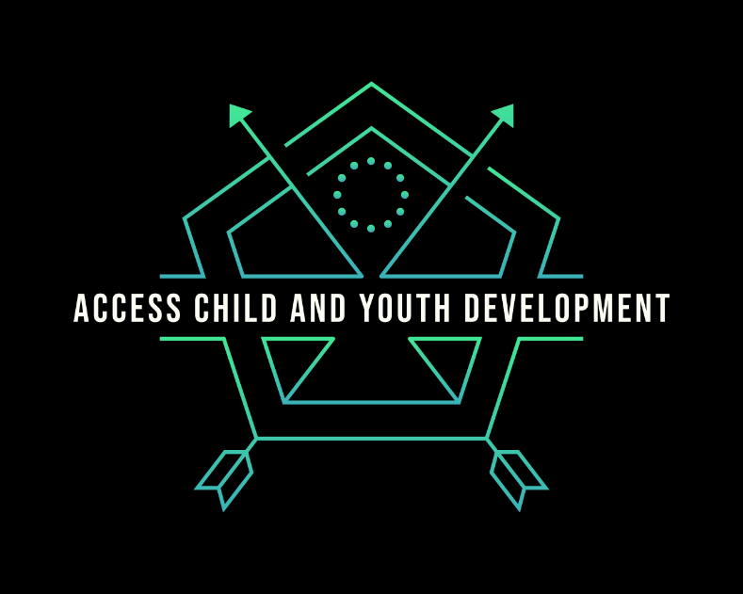
Access Child and Youth Development
YOUTH LEADERSHIP PROGRAM INFORMATION PACKAGE
Access Child and Youth Development Ltd.’s., goal is to create tomorrow’s leaders through training programs, long-term mentoring and real-life experience. An incredible 20-week program designed for youth, aimed to inspire and create a future generation of leaders. One of our key purposes is to give individuals the opportunity to engage in short-term humanitarian trips, where students will serve those living in overlooked communities while building bridges across cultural, racial and socio-economic divides. These kinds of experiences are what fosters a new sense of global understanding and awareness. The footprint we leave behind should be gentle. An humanitarian outreach program can be a powerful, life-changing experience that broadens your perspective, gives you better direction, teaches you new skills, and rejuvenates your body and mind.
Component 1 - Personal Leadership and Development: (week 1 - 8)
Students develop an awareness of the principles and practices of leadership and develop, implement and assess a personal leadership plan. We will be developing leadership skills which include vision casting, goal setting, mental health training, bullying strategies, team building, decision making, conflict management, and time management. Students will also be encouraged to learn about diverse abilities, healthy relationships, boundaries, and the real-life tough stuff. We will also begin our personal and group fundraising initiatives. Opportunities and suggestions may include:
Fundraise with a lunchtime cook-off.
- Host an online yard sale.
- Use social media to fundraise.
- Fundraise and match donations.
- Fundraise with a bake sale.
- Fundraise with a sporting tournament.
- Lego Nights
- Paint Nights
- Petting Zoo
- Carnation Sale on Valentine's Day
- Candy Grams
- Santa Pictures
- Santa Pet Pictures
- Golf Tournaments
- Hockey Puck Shot – Donations used at prizes.
- Pumpkin Carving Contest – Donations used as prizes
- Pie in the Face Toss
- Guess the Jellybeans
- Art Auction
- Cakewalk
- Car Wash
- Movie Night
- Community Yard Sale
- Craft Show
- Dunk Tank
- Garden and Plant Sale
- Karaoke Night
- Pancake Breakfast
- Pool Party
- Silent Auction
- Dinner Party Auction
- Chili Cook-Off
- Bake-Off
- Walk for a Cause
- Fun Run
- Pizza Day
- Texas Donut Day
Time commitment: There will be one evening meeting per week. Attendance is strongly encouraged; individuals will be required to have a minimum attendance of 80% to participate in overseas outreach.
Component 2 - Teamwork and Community Connections: (week 9 - 15)
Component 2 will be broken down into teamwork and communication, fundraising and sponsorship and public speaking. Students will continue with preparations for overseas outreach. This is also the phase when we start giving back and supporting our community. Designed by our students, we will contribute our skills and talents to educate, empower and energize our schools and local communities. We will be volunteering at a variety of facilities, giving a hand wherever we are needed. Some locations may include:
- Airdrie Boys and Girls Club
- Airdrie Food Bank
- Community Links Events
- Boo in the Park
- Bethany Care Society
- Connecting Care Hospitality Aide
- Cedarwood Station
- Project Sunshine
- Airdrie Public Library
- EJ Animal Rescue
- Calgary Mustard Seed
- AARCS – Calgary
- Youth Central
- Grow Calgary
- Cerebral Palsy Association of Alberta
- Women’s Centre of Calgary
- YMCA
- YWCA
- Inn from the cold
- Wood Home
- Hull Services
- The Children’s Cottage
- The Ronald McDonald House
- Louise Dean School
- Elizabeth House – Calgary
- Habitat for Humanity
- Meals on Wheels
Giving back to the community is an important aspect of leadership as it gives a great perspective on how to make a positive impact in someone else's life.
Time commitment: Group meetings one evening per week will continue. There will also be 2-4 group connection days to prepare for oversea outreach. Attendance is strongly encouraged; individuals will be required to have a minimum attendance record of 80% to participate in overseas outreach.
Component 3 – Outreach: week 17 (7-10 days)
The Overseas Outreach Project will take place in Montego Bay, Jamaica and will allow students to apply what they have learned, using their newly obtained leadership skills to serve others. In this component, students will gain knowledge of diverse cultures, cross-cultural communication and the dynamics of privilege and oppression. Opportunities for service may include street feeding, orphanage care, painting primary schools, participating in homes for hope, hosting soccer camps, etc. Every evening there will be time for reflection and sharing. Students will be encouraged to journal and document their experiences, thoughts and feelings.
*We will do our best to schedule our outreach during schools breaks and will avoid mandatory high school exams.
Component 4 - Debriefing and Presentation: (week 18 – 20)
Taking time to debrief with students will increase the value of their experience, helping to stretch what they have learned beyond their travels. Students will learn to utilize tools of reflection and feedback, making meaning of these experiences, furthering their understanding of their own leadership practice. During the final three weeks of the Leadership and Community Outreach Program, students will create a visual display/presentation of their experience, sharing new perspectives with their peers, especially. From first-hand life experience, these students will have the knowledge and understanding to resolve problems and implement sustainable solutions.
Time commitment: There will be two remaining group meetings and a presentation evening for family members and future teams.

The Finer Details
Our package includes flights, food, accommodation, ground transportation, a $200 admin fee to support the project costs and the Access Leadership team at home and your destination.
Volunteer projects usually involve some physical activity, and long days. Participants should be in good physical health to join a team!
International travel always has some level of danger. All team members participate at their own risk. Prior to departure, you will be asked to fill out a personal health form and submit a liability waiver. Participants under the age of 18 must have a parent or guardian fill out a separate liability waiver well before departure. Access Chid and Youth Development Ltd., holds group insurance policies, but additional coverage may be required.
You will need a current passport valid for six months past your travel dates. To ensure you get your passport well ahead of your departure date, allow 20 weeks for your passport application to be processed (new or renewal).
Frequently Asked Questions
How often is the Youth Leadership Program offered?
Our programs are offered twice per year, see below for program options.

- September 2022 - January 2023
- February 2023 - June 2023
- September 2023 - January 2024
- February 2024 - June 2024
Is there a maximum number of youths allowed to participate?
Yes! In order to keep our group size personal, we are limiting our participants to 16 youth and 4 supervisors.
What if I have already graduated high school? Can I still join the program?
Absolutely! Our programs are designed for youth ages 15 - 20 but we will make acceptations case by case. Please email us for more information.
How much does the outreach cost?
Each student would be financially responsible for their own outreach costs; however, fundraising opportunities will be made available to assist with these expenses.

Fee breakdown will be based on the total number of participants per program and will include group flight rates, insurance, medical coverage, transportation, meals and accommodations.

An approximate estimate currently sits at
$950 for flights and insurance
($700 - $1000) $100 per day for transportation and accommodations (including three meals, housing, host fees)
$200 for administration and program fees.
Is my youth guaranteed to go on the outreach if we sign up?
It is our goal for all participants to be welcome on the outreach, however, if unforeseen circumstances jeopardize the health or safety of our youth and volunteers, your family will receive a refund of any fees collected and may apply to another program at a later date.
Are you looking for parent volunteers?
Yes! However, we are limited to a maximum of 3 parent volunteers. Preferences will go to parents with experience working with youth. Current police check with the vulnerable sector check will be required prior to the program start date. All volunteers must also be first aid trained and be willing to complete a Plan-to-Protect online course.
Volunteers will be required to participate in meetings and will be responsible for paying their way for outreach costs.
Where in Jamaica will my youth be staying?
Reading, Long Hill, Montego Bay, Jamaica.
Youth With a Mission (YWAM) Montego Bay has graciously agreed to host our teams. It is a secured campus with student dorm-type accommodations. Not only will our teams be hosted by YWAM, but they will also be the ones connecting our team with volunteer facilities and outreach. YWAM buses will also be our essential means of transportation and will be providing all our meals and lodging needs. Having locals’ partner with us creates one more sense of security, it also gives our team extra opportunities to build lifelong connections!

For a video summary of the campus in Jamaica, please visit https://www.ywamjamaica.org/accomodation
How do I apply?
Please send an email to accesschildandyouth@gmail.com with the subject: Application - (YOUR NAME). We will send you a registration package and short questionnaire. Once your application is received, we will set up a meet and greet for a proper, in person introduction. All applications must be submitted and approved at least one month prior to the program start date.
If you have other questions or want more information before registering, contact us at accesschildandyouth@gmail.com and we will be happy to provide answers.

