**Anterior Cruciate Ligament (ACL) Injury**

**Background**

The anterior cruciate ligament (ACL) is important for both anterior-posterior and rotational stability in the knee. The ACL is most commonly torn during a non-contact pivoting mechanism, and ACL injuries may be associated with meniscal tears, cartilage injury and injury to other ligaments. 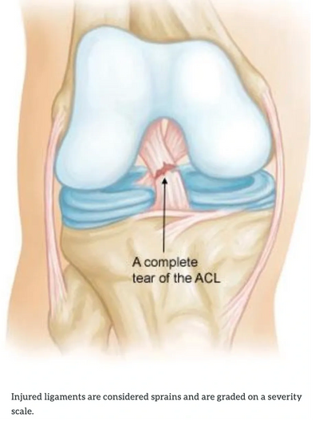

ACL injuries are one of the most common conditions treated by sports surgeons. In my experience, ACL injuries may be overlooked in the urgent care or emergency room setting because x-rays are typically normal and physical exam is often inaccurate after an acute injury. If you injured your knee acutely, experience significant knee swelling, and have any sensation of instability/giving way of your knee, particularly with twisting and pivoting, then an ACL injury should be considered.

**Management**

In cases of partial ACL tear with a stable knee exam, or complete tears in patients with lower athletic demands, non-operative management may be considered. Non-operative treatment does *not*mean “no treatment”, and significant rehabilitation guided by a skilled physical therapist, and bracing may be necessary. 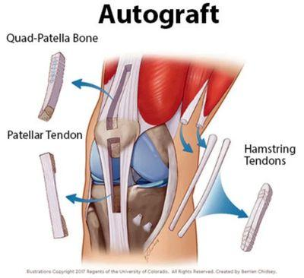

Complete tears of the ACL in active patients and athletes are typically treated surgically to restore stability of the knee, prevent future meniscal and cartilage injury and restore active lifestyle and function. The standard of care for surgical treatment of ACL tears is ACL reconstruction, where a tissue graft (typically from your own knee, sometimes from a cadaver) is used to reconstruct the structure and function of the ACL. In some cases, ACL repair may be considered. There are various graft options, and no one-size-fits-all approach in my hands. This will be discussed in detail at your visit.

Unfortunately, it is possible to re-tear your ACL even after a successful and technically well-done surgery. If this is the case, surgical revision may be offered. Revision surgery may require a more extensive diagnostic workup, and may require multiple surgeries (i.e. staged procedures).

**Recovery and Prognosis**

Most patients are able to ultimately return to sports, some at very high levels, after ACL injury and reconstruction. Typically return to competition or high risk sports occurs at 9-12 months minimum after surgery, and depends on progress with physical therapy. It is critical to allow adequate time for graft healing and incorporation, and also to regain full strength, agility and muscle coordination prior to return. This will minimize the chance of re-injury in the future.

**Andrew Zogby, MD**

Orthopaedic Surgeon, Sports Medicine Specialist

332 Santa Fe Drive, Suite 110

Encinitas, CA 92024

(760) 943-6700

For further information, visit:

<https://orthoinfo.aaos.org/en/diseases--conditions/anterior-cruciate-ligament-acl-injuries/>

<https://acltear.info/>