**Proximal Humerus Fractures**

Andrew Zogby, MD

Orthopaedic Surgeon, Sports Medicine Specialist

332 Santa Fe Drive, Suite 110

Encinitas, CA 92024

azogby@coreorthopaedic.com

(760) 943-6700

* **Background**
  + The proximal humerus is an important part of your shoulder joint that contains the humeral head articular cartilage, greater and lesser tuberosities (where your rotator cuff attaches) and other important attachment sites for tendons and the shoulder capsule.
  + The proximal humerus like other bones is susceptible to osteopenia/osteoporosis, similar to the hip, and is prone to fracture during a fall or trauma to the shoulder. Younger patients with good bone quality also sometimes sustain proximal humerus fractures by higher energy trauma or during a shoulder dislocation.
  + Proximal humerus fractures are suspected after a fall onto the shoulder, and diagnosis is confirmed by x-rays and sometimes a CT scan.
  + 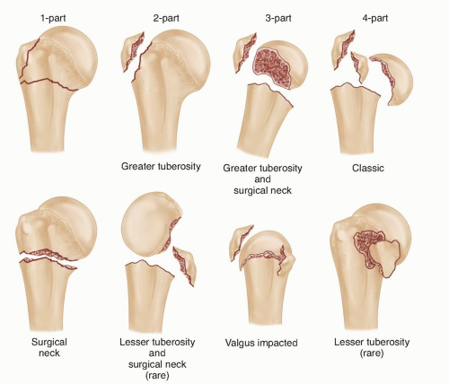
    - Image credit <https://musculoskeletalkey.com/open-reduction-and-internal-fixation-of-proximal-humerus-fractures-3/>
* **Management** 
  + Many proximal humerus fractures can be managed non-surgically. This involves a rest period in a sling for several weeks to allow the bone to heal and stabilize, followed by gradual progression of range of motion and strengthening, typically guided by a physical therapist.
  + Patients with certain fracture patterns with severe displacement may do better with surgical management. In younger patients with good bone quality, this typically involves open reduction and internal fixation of the fracture with plates and screws. In older patients and/or those with poor bone quality, a shoulder replacement (reverse total shoulder arthroplasty; image below) may be indicated, as attempted repair of the fracture in these situations is very likely to fail and lead to poor outcome.

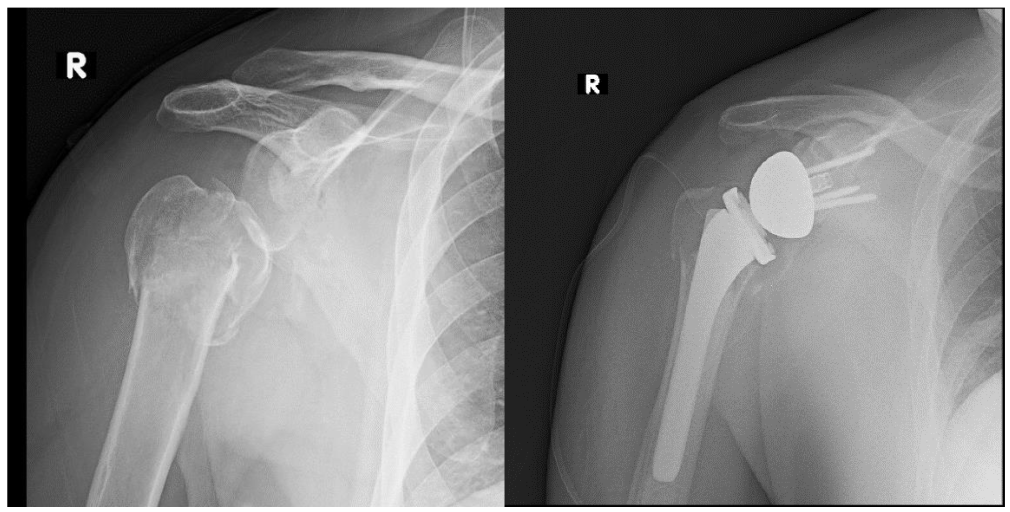

* Image credit Larose G, Virk MS. The Evolution of Reverse Total Shoulder Arthroplasty and Its Current Use in the Treatment of Proximal Humerus Fractures in the Older Population. Journal of Clinical Medicine. 2022; 11(19):5832. <https://doi.org/10.3390/jcm11195832>
* **Recovery and Prognosis** 
  + With both non-surgical and surgical treatment, recovery from proximal humerus fractures can be prolonged and challenging. Patients often lose some degree of range of motion and function long term, but once the fracture is healed and rehabilitation is complete, there are no long term restrictions.
  + If a reverse total shoulder arthroplasty is performed, the long term goal is a pain-free shoulder with functional range of motion, typically forward elevation above 90 degrees and ability to use your arm for normal daily activities.
  + Most patients are fully recovered from proximal humerus fractures by 6 months after injury/surgery; however, there still may be fine tuning for another several months depending on goals and activity level.