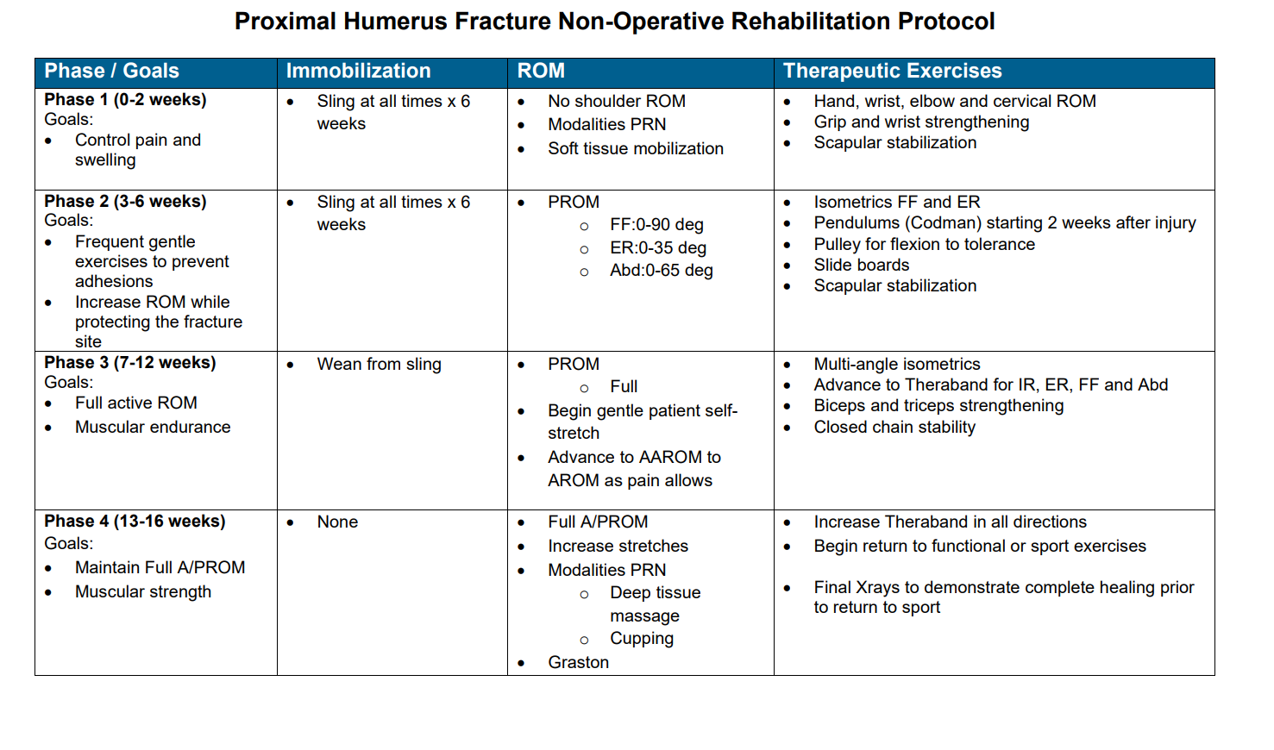

*Protocol Adapted from Twin Cities Orthopedics Physical Therapy Protocols*

*Ref: https://www.tcomn.com/wp-content/uploads/2016/07/Proximal-Humerus-Fracture-Non-Operative.pdf*