

**Andrew Zogby, MD**

Orthopaedic Surgeon, Sports Medicine Specialist

332 Santa Fe Drive, Suite 110

Encinitas, CA 92024

(760) 943-6700

**PHYSICAL THERAPY PROTOCOL: Clavicle ORIF (advance patient slowly)**

G 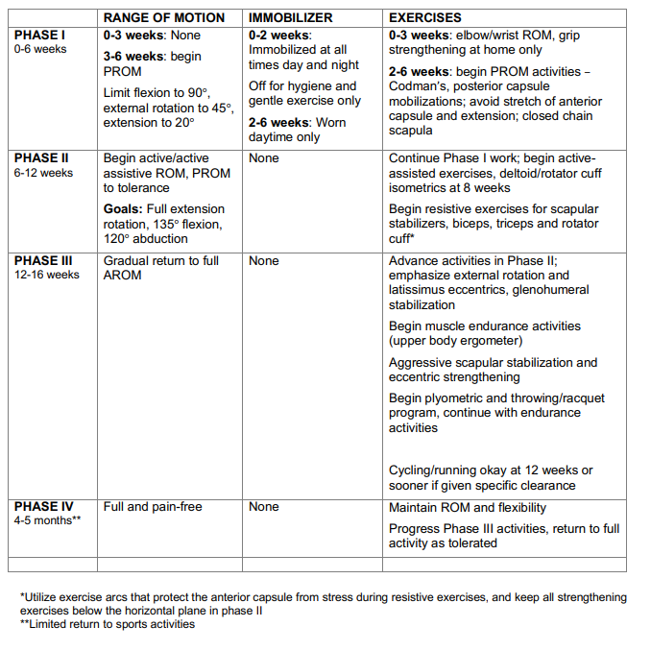

*Protocol obtained courtesy of Dr. Brian Cole, MD; Midwest Orthopaedics At RUSH;https://www.briancolemd.com/wp-content/themes/ypo-theme/pdf/clavicle-orif.pdf*