**NOVEMBER NEWSLETTER**

**WELCOME TO THE WINTER NEWSLETTER**

Just a reminder that photographs and information will be posted on our **Facebook page** (St Mary’s Pre School-Playgroup). Webb page: St Mary’s pre school .co.uk

If you have any questions or queries, please do not hesitate to speak to Auntie Gwendy, our pre-school Supervisor.

**All financial queries must made be to, Debbie Williams, who only works Monday for pre-school.**

**CHESTER ZOO VISIT:**

We have been successful in obtaining 10 free Zoo entry tickets for the Flying Start children. We will be attending the zoo on Monday 2nd December. Please complete the attached permission form and return to Gwendy by 21st November 2024

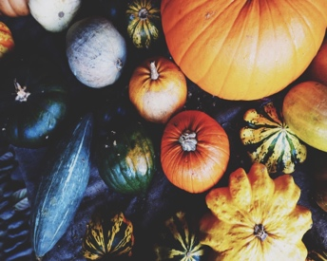

**Opening Times**

**Monday - Thursday**

9.15 am - 3.00pm

Please ensure you pick you child up ON TIME. If you are going to be late, please contact Gwendy

Changing Bags: Please ensure there are enough nappies, wipes and nappy sacks for the whole day. If there are no spare clothes in your child’s bag and they require changing, we will send your child home

As the cold weather is starting to make an appearance can you please ensure your child has a coat and wellingtons for outdoor play. Please put their name in both.

**Banana Bens Visit:**

Whilst the younger children are visiting Chester Zoo Debbie & Cath will take the nursery children to Banana Bens for the afternoon, please complete the permission form and return to Gwendy by 21st November 2024

Child Absence:

If your child is not attending St Mary’s due to sickness, holidays etc please inform Gwendy A.S.A.P. 07711 210403, this includes all children who are collected from St Mary’s School

Please DO NOT PHONE Debbie

**Early Education:**

**If your child turns 3 before 31st December 2024 your child is entitled to 10 hours free childcare at St Mary’s pre-school. Please see Gwendy for further details and application forms.**

**If your child turns 3 before 31st March 2024, please see Gwendy for further details**

Christmas closure Dates:

Close 3pm on 18.12.24

Reopen 9.15am on 06.01.25