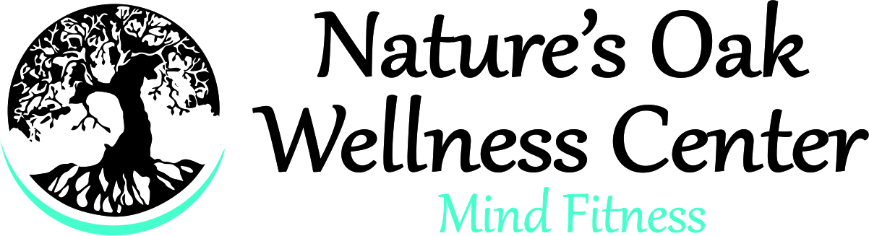 NATURE’S OAK, LLC WAIVER OF LIABILITY
I, __________________________________________________ on behalf of myself or the minor
child listen below, do hereby acknowledge that I am a _________________________________ of Nature’s Oak LLC, a Florida company, and voluntarily wish to participate in activities while at Nature’s Oak such as wood working, art, crafts, yoga, physical fitness or other chosen activities at my own risks. I am fully aware of the risks associated with physical activity (should I chose to engage in it) and will consult with my physician prior to participating. I voluntarily assume full responsibility for any risks of loss, property damage or personal injury that may be sustained by me/us while on the property. I am fully aware that my behavior must be respectful to others and appropriately engage in said activities. Should I have in issue or concern pertaining to an activity or other member, I agree to discuss it with the activity facilitator and/or the director, Dr. Susan Posada in attempt to resolve the issue. At any time, Nature’s Oak, LLC has the right to tell me to leave this property and not return at its discretion.
I, on behalf of myself, my personal representatives and my heirs, as well as the minor(s) listed below, hereby voluntarily agree to release, waive, discharge, hold harmless, defend and indemnity Nature’s Oak, and its officers, directors, members employees and agents from any and all claims, actions or losses for bodily injury, property damage, wrongful death, loss of services or otherwise which may arise out of my/our participation in said activities. I specifically understand that I am releasing, discharging and waiving any claims or actions that I may have presently or in the future for the negligent acts or other conduct by the officers, directors, members, interest holders, employees of Nature’s Oak, LLC.
IN SIGNING THIS RELEASE, I ACKNOWLEDGE AND REPRESENT THAT I HAVE READ THE FOREGOING WAIVER OF LIABILITY, UNDERSTAND IT, AND SIGN IT VOLUNTARILY AS MY OWN FREE ACT AND DEED; NO ORAL REPRESENTATIONS, STATEMENTS, OR INDUCEMENTS, APART FROM THE FOREGOING WRITTEN AGREEMENT, HAVE BEEN MADE; I AM AT LEAST EIGHTEEN (18) YEARS OF AGE.
________________________________________ _________________________________
Signature Date

____________________________________ minors_________________________________
Printed Name

