HMI Techniques and Tools help people bring their physical, mental and emotional systems into balanced alignment with their heart’s intuitive guidance. This unfolds the path for becoming heart-empowered individuals who choose the way of love, which they demonstrate through compassionate care for the well-being of themselves, others and Planet Earth.  HMI research confirms our intuitive understanding of the heart with solid science and explains how the electromagnetic field radiating from the heart can affect those around us.  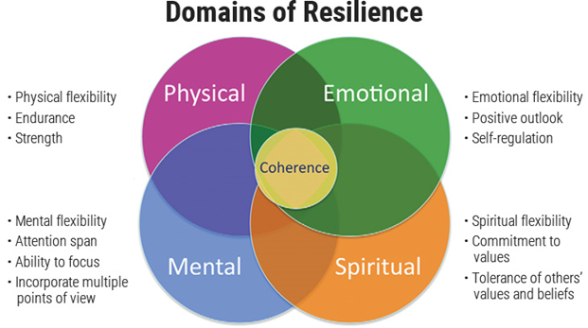 |  |  | HMI is committed to helping activate the heart of humanity. We believe that when we align and connect our hearts and minds and connect with others, we awaken the higher mental, emotional and spiritual capacities that frequently lie dormant. HMI aspires to always conduct our operations with passion, compassion and a heartfelt desire to transform lives. This is in keeping with our desire to help usher in an era of ever-expanding heart intelligence.  HMI research, training and technologies are aimed at guiding all of humanity toward realization of its full potential and to rely on the qualities of the heart in its role as caretaker of future generations and our planet.

