W/S Commission

23688 Adams Street

P.O. Box 189

Independence, WI 54747

Phone: 715.985.3055

Fax: 715.985.2530

Email: [indchall@triwest.net](mailto:indchall@triwest.net)

www.independencewi.org

#### DIRECTIONS

**23510 Cleveland Street City’s FOG Dumpster**

***Free of Charge & Available***

***to ALL City Residents.***

Following Directions Below: *Start* at City Hall (23688 Adams St.) and *End* at the City’s FOG Dumpster located at 23510 Cleveland Street.

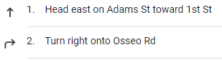

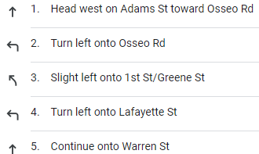

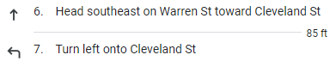

#### 

# City of

# Independence

# 

**Water & Sewer**

Phone: 715.985.3055

**Keep Kitchen & Toilet Drains Fat-Free**

Removal of FOG blockages in your home drain lines are ***EXPENSIVE*** and messy.

FOG in sewer lines increases maintenance of the City’s sewers, raising sewer rates for ALL customers.

***To reduce FOG problems at home:***

1. Cool cooking oil and grease in a plan and then transfer it to a disposable container and place it in the trash.
2. ***NEVER*** pour hot oil or grease into the trash or sink!!
3. Hot water will ***NOT*** make grease flow through sewer pipes. Eventually water cools and grease become solid again.
4. Scrape oil or grease from pots, pans, and plates prior to washing.
5. Handwashing dishes? Cold water congeals FOG, making buildup in pipes and sewers laterals less likely.
6. Dispose of old cosmetics, lotions, and other oily or greasy products in the trash.

*Ignoring these steps may result in FOG blockage in your plumbing. Resulting unsanitary sink and toilet backups or overflows could damage your home.*



**Fats, Oils, & Grease**

**Fats, Oils, and Grease (FOG)** enters the sanitary sewer through sinks, floor drains, dishwashers, and other kitchen equipment plumbed to the sanitary sewer. Over time, FOG and solid food waste entering drains cause blockages in plumbing and sanitary sewer lines. FOG build up along the walls of the pipes can lead to a sanitary sewer overflow inside your home, business, adjacent buildings, streets or the environment. These spills create a safety hazard that endanger public health and impact the health of our creeks.

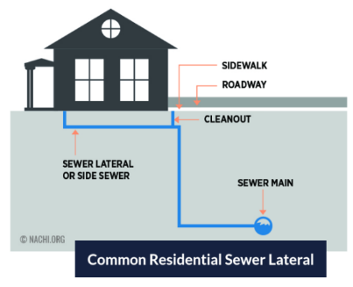

**What is FOG?**

Putting seemingly harmless fats, oils, and grease (FOG) down the kitchen drains causes real problems! Common cooking FOG includes:

* **Cooking Oil (olive, coconut, canola, vegetable oil (s), etc.**
* **Salad Dressings**
* **Bacon Grease/ Meat Fat**
* **Butter/ Shortening**
* **Gravy/ Sauces**
* **Dairy Products**

**How this Affects the City of Independence Residents**

If residents do not ***STOP*** putting fats, oils, & grease (FOG) into the city sewer drains; the city will be forced to replace the current sewer plant.

* Estimated cost of a ***NEW*** sewer plant is ***9 million dollars***.
* A significant increase to the current sewer rate would occur.
* That cost ***WOULD*** be added to the resident’s utility bill.

**How to Prevent Replacing the Sewer Plant?**

Help be a good neighbor and keep kitchen and toilet drains fat- free!!!

1. Remind neighbors, family, and/or friends how and where to dispose of their Fat, Oil, & Grease in the City of Independence.
2. Keeping the city sewer drains fat- free will help the city maintain the current sewer plant.
3. Call City Hall at (715) 985-3055 with questions, concerns, or directions on FOG dumpster disposal.
4. Follow directions attached and utilize the city’s fats, oils, and grease dumpster located 23510 Cleveland Street.

*This is a free of charge and available to all city residents!!*

ITEMS MUST BE SORTED, PACKAGED, BAGED, OR TIED.

YOU MUST PROVIDE YOUR OWN CONTAINERS.

ALL ITEMS MUST BE COMPLETELY CLEAN AND SEPARATED ACCORDING TO CATEGORIES.

#### Sewer System