City Trash Cans

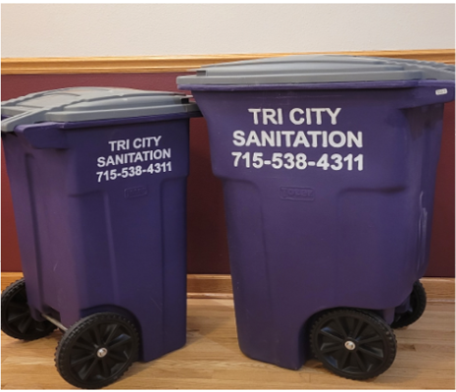

Reminder:

The Enforcement of the City Trash Can Ordinance will be in Effect Thursday, November 2nd, 2023 for the City of Independence.

Bags are no longer for Sale at the City Hall.

Every Household and Rental is REQUIRED to have a City Trash Can or the Allowed Exemption Aligned by November 1st.

If you have NOT ordered your City Trash Can already; you will be issued a $7.50 Small Trash Can. This charge will be included in the November water billing cycle.

You may stop into City Hall if you would like to adjust the size of your garbage can.

Cost of cans are $7.50 for a small and $12.50 for a large. Extra cans can be added if needed. Garbage billing is added to your monthly water and sewer billing.

Please contact City Hall for any further questions or concerns.

Thank You!

