Hoarding resources and tools
Compiled by Kay Jewels and Dominique Rouleau
Part of a collaboration with the Town of Winthrop

June 2019

Table of Contents
Part 1: Tools for First Responders 2
1. HOMES Multi-disciplinary Hoarding Risk Assessment 2
2. Clutter Image Rating System 2
3. Home Environment Index (HEI) 3
4. Sample Referral Form 3
5. Environmental Cleanliness and Clutter Scale 3
Part 2: Documentation tools 4
6. Sample Assessment Form and Clutter Interview 4
7. Hoarding Rating Scale 4
8. Saving Inventory – Revised Tool 5
9. The Structured Interview for Hoarding Disorder (SIHD 2.0) 5
Part 3: Hoarding Informed Assessment Tools 6
10. Hoarding Intervention Decision Tree 6
11. Sample Consent for Services and Service Plan 6
12. Stages of Change Questionnaire 7
13. UCLA Hoarding Severity Scale 7
Part 4: Measuring Changes Post-Intervention 7
14. Saving Cognitions Inventory (SCI) 7
15. Activities of Daily Living – Hoarding (ADL-H) 8
Part 5: Peer Support 8
16. Peer support groups and volunteers 8

This toolkit was compiled to help with the assessment, documentation and response planning in cases of hoarding or clinically impaired clutter amongst the residents of the town of Winthrop.

Part 1: Tools for First Responders

1. HOMES Multi-disciplinary Hoarding Risk Assessment
^{©Bratiotis, 2009}
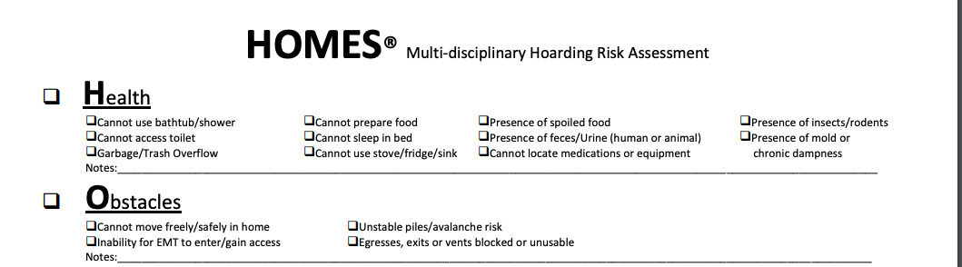

- The HOMES Assessment was developed in conjunction with the Massachusetts Statewide Steering Committee on Hoarding. It provides a structural measure through which the level of risk in a hoarded environment can be conceptualized.
- It is intended as an initial and brief assessment to aid in determining the nature and parameters of the hoarding problem and organizing a plan from which further action may be taken-- including immediate intervention, additional assessment or referral.
- HOMES can be used in a variety of ways, depending on needs and resources. It is recommended that a visual scan of the environment in combination with a conversation with the person(s) in the home be used to determine the effect of clutter/hoarding on Health, Obstacles, Mental Health, Endangerment and Structure in the setting.
- (available online here through Tufts University)

2. Clutter Image Rating System
^{©International OCD Foundation}
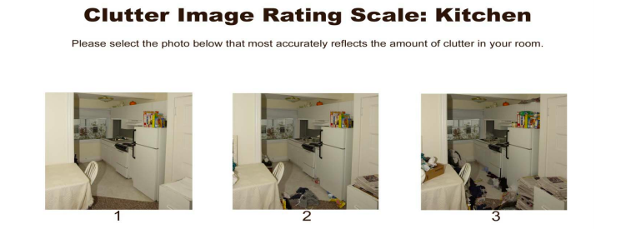

- This tool is designed to get an accurate sense of a clutter problem through a series of pictures of rooms in various stages of clutter – from completely clutter-free to very severely cluttered. First responders can pick out the picture in each sequence comes closest to the clutter in their own living room, kitchen, and bedroom.
- In general, clutter that reaches level 4 or higher impinges enough on people’s lives that it is encouraged for them to get help for their hoarding problem.
- (available online here)

3. Home Environment Index (HEI)
^{©Rasmussen et al. 2014}

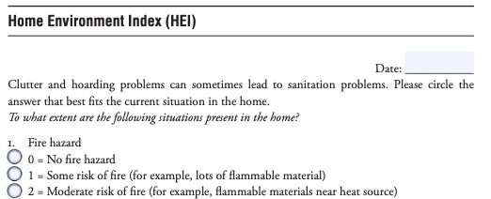

- The HEI tool was developed as a measure of squalor associated with hoarding.
- To score the HEI, sum the responses for all 15 items – a score of 2 or above on any question warrants attention.
- (available online here)

4. Sample Referral Form
^{©Hoarding Best Practices Guide}

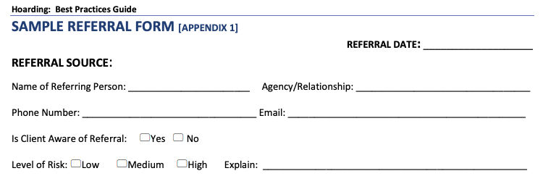
- The Hoarding: Best Practices Guide was developed by a Hoarding Best Practice Committee, which included members of the Greater Lynn Senior Services, Brookline Community Mental Health and other elder service providers.
- This 2-page form is part of a “Pre-Meeting/Referral Process,” which aims to gather as much information as possible over the phone from the referring person or the individual themselves. This is designed to help to plan an initial approach and to better understand the condition of the home and prepare for any precautions needed when entering the home.
- (full guide available online here, appendix 1: pages 25-26)

5. Environmental Cleanliness and Clutter Scale
^{©Graeme and Snowdon, 2012}
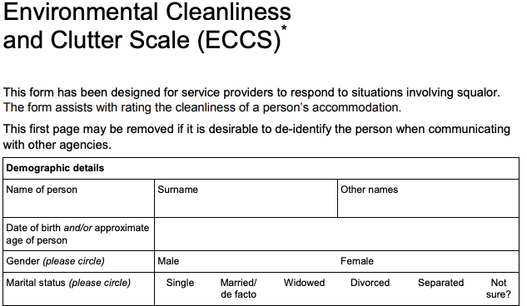

- This scale was developed to rate the degree and various aspects of uncleanliness will facilitate description and research in cases of severe domestic squalor.
- (available online here through the University of Wisconsin-Madison)

Part 2: Documentation tools

6. Sample Assessment Form and Clutter Interview
^{©Hoarding Best Practices Guide}

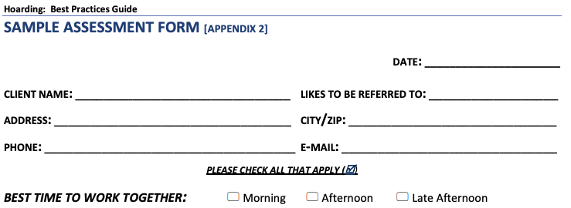

- Also developed by the Hoarding Best Practice Committee, these tools form part of the initial meeting and assessment phase. This might include open ended questions, the Clutter Image Rating scale, the Hoarding Interview, Activities of Daily Living Scale and general questions about what they are interested in learning and changing.
- (full guide available online here, appendix 2 and 3: pages 27-32)

7. Hoarding Rating Scale
^{©Tolin, Frost & Steketee, 2010}

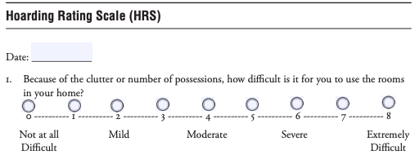

- The Hoarding Rating Score can be used to assess the severity of hoarding behaviors.
- Its 5 questions assess clutter, difficulty discarding, acquisition, distress and interference with a Likert scale of preferences (from “not difficult at all” to “Extremely difficult”). Each of the 5 dimensions can be assessed using cutoff scores and typical HRS scores.
- (available online here through Oxford Clinical Psychology)

8. Saving Inventory – Revised Tool
©Frost, Steketee & Grisham, 2004

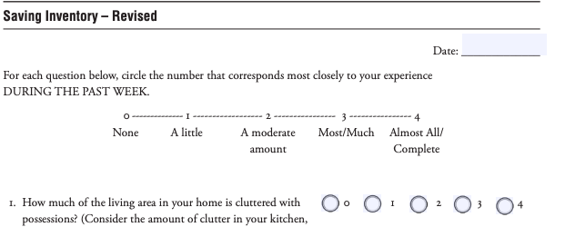

- This tool was developed to assess the saving practices and home clutter.
- It has a series of questions on clutter, difficulty discarding and excessive acquisition, all of which can be interpreted using cutoff scores and typical SI-R scores.
- (available online here through Oxford Clinical Psychology)

9. The Structured Interview for Hoarding Disorder (SIHD 2.0)
©Oxford Handbook of Hoarding and Acquiring

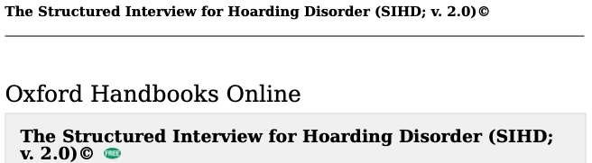

- The questions in the SIHD interview relate to each of the 6 criteria needed to evaluate the presence of hoarding disorder and its two specifiers. These questions appear in bold print and should be asked during the course of the interview, whereas the text in italics is present only to assist the rater.
- For a diagnosis of hoarding disorder all 6 criteria must be endorsed. If any of the criteria are not met, the diagnosis can be ruled out. The specifiers are only relevant for individuals endorsing all diagnostic criteria.
- (available online here through Oxford Handbooks Online)

Part 3: Hoarding Informed Assessment Tools

10. Hoarding Intervention Decision Tree
©Hoarding: Best Practices Guide
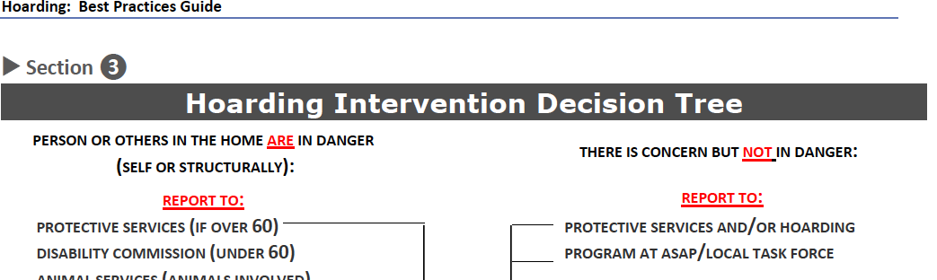

- The Hoarding Best Practices Committee formulated this decision tree to aid with understanding what approach to take based on the levels of insight, motivation, and dementia.
- (full guide available online here, Section 3, page 6)

11. Sample Consent for Services and Service Plan
©Hoarding: Best Practices Guide
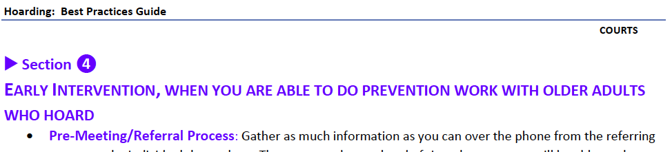
- This section of the Hoarding Best Practices Guide includes steps to plan and carry out an early intervention, including initiating the conversation about a service plan, a sample consent form and sample service plan form.
- (full guide available online here, Section 4 and appendices 4 and 5)

12. Stages of Change Questionnaire
© ?
Image
Description
Link

13. UCLA Hoarding Severity Scale
^{© Oxford Handbooks Online}
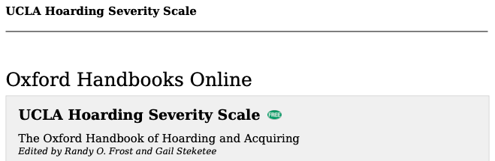
- The UCLA Hoarding Severity Scale (UHSS), is a semi-structured, clinician-administered rating scale that measures the severity of both the core symptoms of Hoarding Disorder (HD) and the associated features of indecisiveness, perfectionism, task prolongation, and procrastination, which are significantly associated with the diagnosis and impairment of HD.
- (available online here)

Part 4: Measuring Changes Post-Intervention

14. Saving Cognitions Inventory (SCI)
©Steketee, Frost & Kyrios, 2003
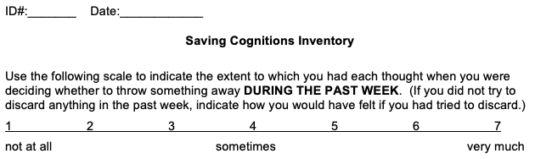

- The SCI is a tool that helps to assess saving cognition along 4 sub-scales: emotional attachment, control, responsibility and memory. The score on all 24 questions is added to generate a score.
- (available online here)

15. Activities of Daily Living – Hoarding (ADL-H)
© Steketee & Frost, Oxford University Press, 2014
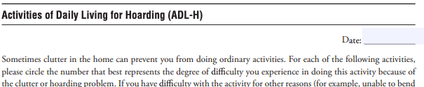

- This test is designed to assess the extent to which hoarding behaviors and clutter in the home interfere with the activities of daily living. Questions are structured around three areas: activities of daily living, living conditions, and safety issues. An average score in the range of 3 is likely to indicate substantial problems with functioning due to clutter.
- (available online here)

Part 5: Peer Support

16. Peer support groups and volunteers
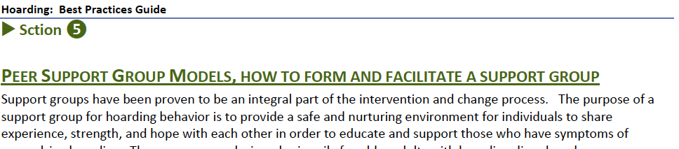

- This section of the Hoarding Best Practices Guide includes guidance on establishing a peer support group model, a sample volunteer outreach welcome message, and sample volunteer forms.
- (full guide available online here, Section 5 and appendix 7)

