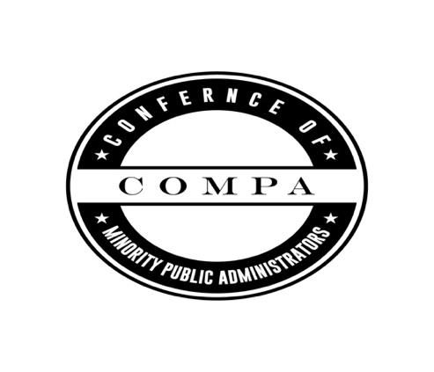
Conference of Minority Public Administrators (COMPA)
ANNUAL CONFERENCE REGISTRATION
CROWNE PLAZA ATLANTA SW PEACHTREE CITY
201 Aberdeen Parkway, Peachtree City, GA, 30269,

A special COMPA 2020 room rate is available: Crowne Plaza Hotel Atlanta SW-Peachtree City
201 Aberdeen Parkway * Peachtree City, GA 30269 * 770-4872666
Hotel rates : $112 per night; king/double occupancy and utilize the link below:
https://www.crowneplaza.com/redirect?path=hd&brandCode=CP&localeCode=en&regionCode=1&hotelCode=ATLPA&_PMID=99801505&GPC=I4Z&cn=no&viewfullsite=true

COMPLETE Registration below & mail with university check to:
Point University
c/o Dr. Kristie Roberts-Lewis
800 Commerce Dr.
Peachtree City, GA 30269

Registrant Information

Full Name: ___________________________________________________________________________________
Last Name First Name MI

Address: _____________________________________________________________________________________
Street Address Department/Unit#

_______________________ ____________________________________________________________________________________
City State

Email: _______________________________________________________________________________________

University/Organization:_________________________________________________________________________
Title
Student Y or N:________________________________________________________________________________

Registration Fees: Check Appropriate Box
_____Early Bird Registration thru January 15, 2020- $250
_____Regular Registration rate after January 15, 2020- $300
_____Student Registration rate- $160
Total Among enclosed $:______________________

For questions concerning registration please contact : compasecretary@gmail.com

