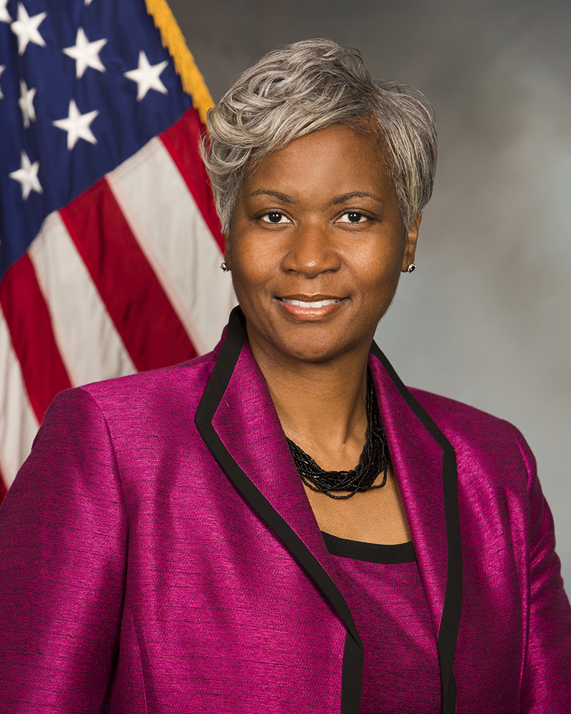

BIO

DR. CATHERINE FOSTER ROWELL

Dr. Catherine Foster Rowell is the Councilwoman for District 1 of the City of South Fulton and served as the first Mayor Pro Tem. Currently, she is employed with Fulton County Schools. She has also worked in the nonprofit sector and served as Executive Director of Operation PEACE; Senior Government Grants Manager for Families First; and Senior Program Director with Enterprise Community Partners. Additionally, she has held leadership roles in a number of public-sector consulting firms to include Beacon Analytics, the Bronner Group and MAXIMUS consulting firm. Dr. Foster Rowell is published and has served on numerous volunteer boards which include but are not limited to the Conference of Minority Public Administrators, National Forum for Black Public Administrators, and the National Coalition of 100 Black Women Metropolitan Atlanta Chapter. She holds bachelor degrees in Sociology and Social Work from Cleveland State University and a Masters of Public Administration and doctorate of Political Science from Clark Atlanta University.

Word Count :156

