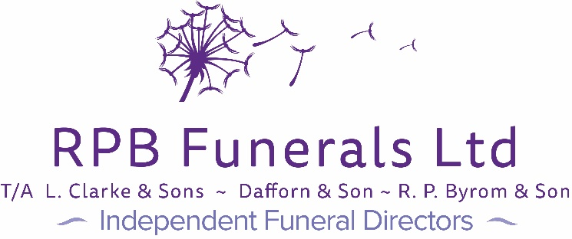

1 Caen Shopping Precinct

Caen Street

Braunton

N.Devon

EX33 1EE

Tel: 01271 813526  
Email: Clarke@rpbfunerals.co.uk

**Direct Cremations**

We can offer 2 different types of direct cremation packages, as we have found that no one service is the same for all. This is a service with no formal ceremony.

**Basic Direct Cremation £1,250**

• Collect deceased and bring into our care during office hours

• The cremation will take place at a Pure Cremation crematorium

• Simple plain coffin*

• Arrange all necessary paperwork

• No choice of service day and time

• No attending ceremony or viewing of the deceased

• We will inform you that the direct cremation has taken place

• The ashes will be ready to collect from us within 14 days and must be collected within 28 days of the service

Extras: Out of hours removal of deceased £75

**Basic Local Direct Cremation £1,450**

• As above but with the following differences

• The cremation will take place at the North Devon Crematorium

• We will care for the deceased until day of the funeral

• A suitable vehicle to transport coffin

• The ashes will be ready to collect from us within 14 days and must be collected within 28 days of the service

Extras: Out of hours removal of deceased £75

*All these services need to be paid BEFORE the service day if payment is not received the service may get postponed or charges will be increased in line with our price list.*

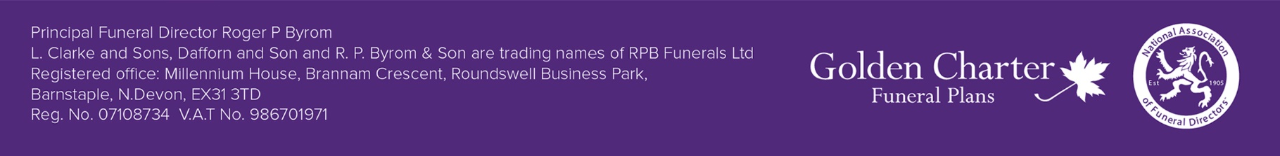*Coffin included is upto 22” wide and 6’2” long, an additional fee of £60 is due if a larger coffin is required.