BECKLEY DISCIPLES NEWS
First Christian Church
119 N. Fayette Street., P.O. Box 5556, Beckley, WV 25801
March-April 2022 Edition

Several years ago, after I dropped Keith off at a local medical laboratory to get his monthly labs drawn, I decided to swing through the McDonald’s drive-thru to get us cups of coffee. I weaved my way through the cars in the parking lot up to the drive-thru screens. You know the drill: repeat everything you want numerous times because the attendant can’t understand what you’re saying through their earpieces. I ordered Keith a chicken biscuit and then ordered our two small coffees (repeating how I wanted them “dressed “several times). The cost of the biscuit appeared on the screen and then the cost of the coffees. The transaction was almost complete. I was already tasting the creamy goodness of that cup o’ Joe when the attendant blurted out, “By the way, small coffees are free today!” Free??? My goodness, I had hit the jackpot – and first thing on a Monday morning, too! I couldn’t wait to tell Keith when he got back in the car that our coffees were free today. Now, this might not sound like that big of a deal to you, but I’ve never been the kind blessed with luck enough to win door prizes or drawings. And I carry my parents’ words always in my head, “If it sounds too good to be true, it probably is,” so, I don’t buy lottery tickets or jump at free vacation offers. Generations in my Scots/English/Irish background have worked hard and long for all they have owned and for every inch of ground gained. “Free” isn’t something I expect, and generally, isn’t something I am comfortable receiving.

Perhaps you can deduce then that grace isn’t an easy concept for me to wrap my head around. Giving up what your heart beats for, so others can receive what they have done little to deserve? “For God so loved the world that he gave his only Son, that whoever believes in him shall not perish, but have everlasting life.“ (John 3:16, NIV) In my mind, this sounds like the behavior of a lunatic! Why would God give up his child for me? How will I ever work hard enough or earn enough to repay what was lost with that kind of sacrifice? My work ethic pulsates with the notion that the best things come to those who are willing to roll up their sleeves and jump into the trenches to do the work required. The Scriptures tell me Jesus died to save me from the evil forces at work to destroy me and to sever my connection to God. They even say that God was complicit in the crucifixion – willingly giving over his Son, so nothing could ever come between me and his love. I understand from the writings in the New Testament there will never be anything I can do to earn love like that or to repay God for it. Specifically, the writer of Ephesians said, “For it is by grace you have been saved, through faith—and this is not from yourselves, it is the gift of God—not by works, so that no one can boast.”(Ephesians 2:8-9, NIV)The grace offered to me by God is plain and simply a free gift that I may either embrace or discard. Yes, it might sound too good to true, but Christians for centuries have been reporting that the gift of grace is real and that it has changed the trajectory of their lives.

During Holy Week each year, we remember and celebrate anew God’s freely given gift of grace through the acts of Jesus Christ. We journey again with Jesus into Jerusalem; into the Upper Room as he prepares to say goodbye to his disciples; to the Cross of Calvary as he lays down his life; and to the empty tomb as we become aware he has risen – annihilating death as man’s final and fiercest enemy. I don’t find Holy Week a comfortable journey because I’m offered yet again the free gift I’ve done nothing to deserve. I must grapple all over with a love so fierce nothing is considered too precious to set aside for me. Will I let that love transform me or will I run from it?

As a child, in my neck of the woods in North Carolina, Easter Sunday was anticipated and prepared for weeks in advance. Plans were made for family celebrations and new outfits were purchased to wear to church. Easter Sunday was literally a parade of flowers, gloves, hats, shined up black patent leather, immaculately tied ties, and pastel colors. Worship services were full of music, pageantry, and language so warm and well-formed it rolled around on the tongue like honey. It was a special day – a day like no other – and I looked forward to it every year. We dress Easter up less these days trying to make it more accessible to everyone. In so doing, I wonder if we have let go of much of the special nature of the day. It should still be a day like no other. We should come into God’s house expectantly waiting to confront again the free offer of God’s grace. You don’t have to show up in fancy, new clothes to hear the Good News or to celebrate it. God desires nothing more than a “date” with us to tell us again that nothing – especially death – can separate us from his enduring love. I pray to see you Easter Sunday. The lights will be on at First Christian and the doors open. We are preparing for the party. By the way, admission to our kingdom celebration is FREE. And the grace? Well, it’s overflowing the grounds! Come on out....you’ll see!

Serving the Risen King,

Pastor Sharon

And let us consider how to stir up one another to love and good works, not neglecting to meet together, as is the habit of some, but encouraging one another, and all the more as you see the Day drawing near. (Hebrews 10: 24-25, ESV)

Pastor Sharon will be in the church and/or church office Monday through Thursday and Sunday mornings. She can be reached in the church office at 304-252-8597. If you cannot reach her in the church office, try her cellphone at 540-233-2534. Fridays and Saturdays will be her days off, although she will still be available by phone on those days in the event of an emergency.
Sharon also communicates through text messages and e-mails. Her e-mail address is writingrev60@gmail.com. You may also leave her a message on the BeckleyDisciples Facebook page.
She does have a personal Facebook page, but makes it a policy to keep that page only for communication with family, close friends, and creative writing buddies outside the church she is serving.

The season of Lent begins on March 2nd with Ash Wednesday. Pastor Sharon will be dispensing ashes to anyone desiring them from 12:00-1:00 p.m. and 5:30-6:00 p.m. in our church chapel. Please come to the Prince Street glass doors and ring the doorbell to access the chapel.

Once inside the chapel, Pastor Sharon will read a short Scripture passage, pray with you, and place ashes in the sign of a cross on your forehead. All are welcome!

Holy Week Activities

Sunday, April 10th Palm Sunday Worship
Thursday, April 14th Maundy Thursday service at
7:00 p.m.
Sunday, April 17th Easter Sunday Worship –
Easter Cantata (tentatively) at
10:45 a.m.

Due to the drop in active COViD cases in our area, the following was decided at our most recent Church Board meeting:

*Masks will be required when entering the building and upon leaving after worship services or meetings. Masks may be removed upon being seating. Social distancing will continue to be recommended for safety’s sake. If COViD numbers surge again, the above may be readjusted.

9:00 a.m. live-streamed Sunday worship services will also be continued on the BeckleyDisciples Facebook page indefinitely. If you are not comfortable attending church in-person yet, the live stream services will continue to be a way to stay connected

Our ZOOM Bible Study dealing with the difficult words of Jesus is going well. We currently have participants in the study not only from FCC/Beckley, but from Virginia, South Carolina, North Carolina, and New Mexico (because of our live-streamed worship and hymn sings).

Stayed tuned for other Bible studies that will be offered during 2022. Study does assist in deepening our faith and walk with the Lord. Don’t miss an opportunity to join in!
“Lent affords us the opportunity to search the depths of our sin and experience the heights of God’s love.”
— Chuck Colson

PRAYER LIST

Our country
Members of the U.S. Military
Our Regional Minister, Rev. Thad Allen
Our President
Victims of terrorism, both foreign and domestic
Pastor Sharon and Keith Waters
Members of your church staff
School teachers, administrators, and staff
The people of Ukraine
Health care workers
Carolyn Bailey
Linda Hall
Amy Herrenkohl
Susan Bailey Hoskyns
Joey Di Piero
Kevin & Susan Fry
Roger Hutchens
Nancy Kittle
Betty & Jack McClung
Derek Ross
Jim & Pat Trader

Community Service and Outreach

Even though I am not leaving, and love my church, this is my last official article as Outreach Coordinator. We collected money this year to purchase the online shoeboxes from Samaritan’s Purse. We chose this option due to Covid. A total of 35 boxes were donated by our church. Certainly, this is a celebration that we touched 35 children’s lives and let them know even someone far away can care about them!

For many years now, our church has provided Christmas gifts for children at Mabscott Elementary. This year 10 angels received gifts from members of our congregation that otherwise would not have been possible. It is a worthwhile service to make Christmas a little merrier for students in need in our local community

I have always believed God led me to this congregation. I have stepped down from my employment position in the church, but I am still a member and will continue to serve here. I anticipate great things for our church and cannot wait to see where we are led.

Tammy Runion

Worship and Music

Hello Everyone,

I pray you have had a safe, warm, and healthy winter. Spring is just a few weeks away and our daylight hours are beginning to get longer. That brings a smile to my face! I will continue to pray for good health for everyone!

I hope you have enjoyed the music the choir continues to present each Sunday. I am still thankful for Susie Brock assuming the
duties as our accompanist. Please take the time to thank her for sharing her talents with us that we may continue singing praises to the Lord as she plays!

The choir is about to begin preparing music for Easter and I am looking forward to presenting a new Easter Cantata to our congregation. Easter Sunday is April 17th and the day will be here sooner than we realize. Please keep us in your
prayers as we prepare for the Easter celebration.

Our Black History month recognition in song really didn’t go as planned; however, I do hope you enjoyed the history that was presented of many of our African American spirituals.

Many of you have been giving me medicine bottles, as I am still collecting them for my sorority. I appreciate everyone donating to the cause. I am happy to report that I personally turned in 460 bottles that were collected from July thru January. THANK YOU SO MUCH FOR THE HELP! Keep them coming!

The choir is always thankful for your support and with prayer we will continue to sing praises to our Lord! Don’t forget to SMILE when you sing and rejoice in the words that these wonderful
lyricists have given us down through the years relating to the scriptures!

Be blessed KEEP SINGING!

Yvonne Seay
Director of Worship

Mission Project

Do you have empty prescription pill bottles around your house? The Delta Sigma Theta sorority is collection empty prescription bottles to send to an organization in Africa. This organization uses the bottles to disperse medicine to needy individuals. If you would like to contribute bottles, peel off the labels, and wash the bottles. Bring them on Sundays to Yvonne Seay or she also would be happy to pick them up if there is more than one bottle being contributed.

Greetings! I hope you and yours are doing well. We have some folks in our congregation who are in the midst of serious challenges—please remember them in your prayers.

We resumed in-person worship services on February 13th and we have been blessed with pretty good attendance. Now that the weather and COVID numbers appear to be turning in the right direction, I hope that the whole gang will be back soon!

Thank you for remembering the church with your generous contributions. As you know, we all must act to support our church, financially and otherwise.

On February 13th we recognized Tammy for her years of service as an employee of the church, and prior to that we sent her the love offering which was collected in her honor. If you haven’t had the chance to do so yet, please speak to her and let her know how much you have appreciated her efforts, and how glad you are that she and Garrett are still active members.

I hope to see you all soon!

John File, Chairperson
Church Board

Thank you so much for the love offering collected for me. It wasn’t necessary as I have always felt honored to serve God here! I appreciate the thoughts and gifts given. I have
always experienced love at our church.
--Tammy Runion

March birthdays

March 1 Pastor Sharon Waters
March 2 Paula Shrewsbury
March 4 Doug Korczyk
March 6 Tammy Runion
March 7 Casey Baber
March 16 Richard Vaughan
March 23 Susan Bailey Hoskins, Michael Zutaut
March 24 Ashley Tredway
March 27 Carolyn Clarke
March 31 Sandra Palen
March 31 Mike Runion

April birthdays

April 1 Rita Lowe
April 2 Jeff Leach
April 4 Kristin Canterbury
April 8 Paula Rogliano, Garrett Runion
April 9 Kara Gaigall Falcinella
April 12 Juanita Adams Bryant
April 13 Lanny Oakes
April 16 Chris Baber
April 22 John Welch
April 23 Sue Ann Baber
April 24 Carol Buklad
April 28 Charles Turner
April 29 Barbara Adkins

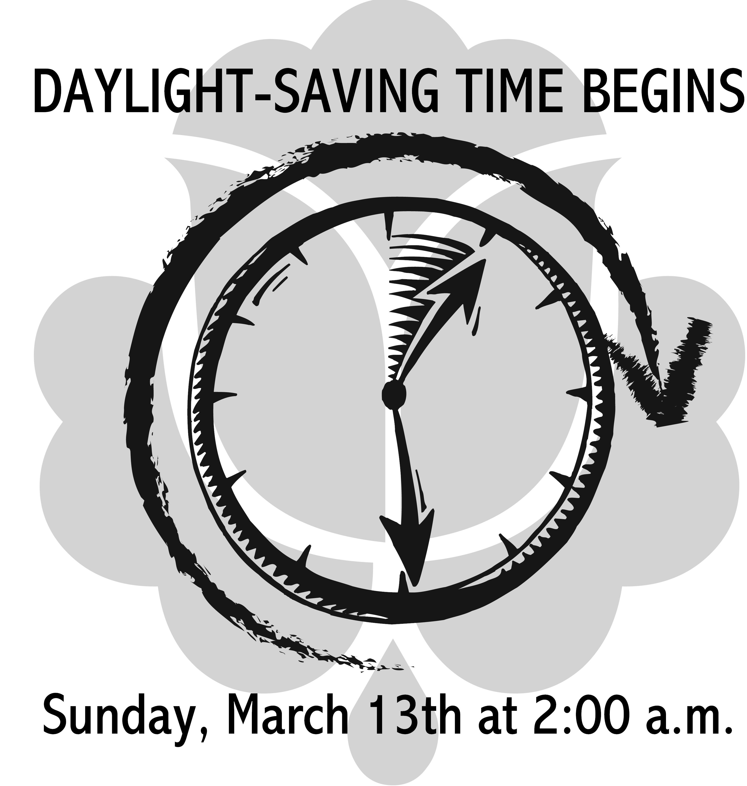

Our Sunday worship service time will return to 10:00 a.m. on Sunday, April 24th. Please mark this on your calendars.

Church Staff:

Rev. Sharon Waters, Senior Minister
Yvonne Seay, Director of Worship Susie Brock, Keyboardist
Barbara Adkins, Bookkeeper/Office Assistant
Bobby Sanders, Custodian
First Christian Church
(Disciples of Christ)
119 N. Fayette Street
P.O. Box 5556 Beckley, WV 25801

Phone: 304-252-8597
Web: beckleydisciples.org Email: fccbeckley@outlook.com Facebook@BeckleyDisciples

