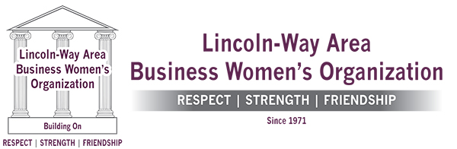

If you are interested in helping the Lincoln-Way Area Business Women’s Organization (“LWABWO”) donate scholarships to local high school seniors and women continuing their educations, please check one of the boxes below. Scholarship awards are handed out in June, 2022.

$1,000

Donor Name:

Donor Mailing Address:

Donor Email Address:

Donor Telephone Number:

$750

$500

$250

$100

$50

Other $_____________

Check may be made payable to LWABWO and mailed to P.O. Box 366 in New Lenox, IL, 60451. Any questions may be directed to lwabwo@gmail.com.

Your support of local women is truly appreciated.

