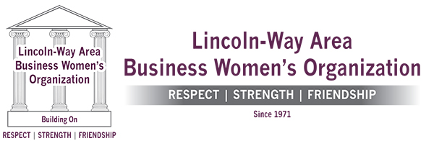

October 26, 2020

Mayor Timothy Baldermann
Village of New Lenox
One Veterans Parkway
New Lenox, IL 60451

Dear Mayor Baldermann:

The Lincoln-Way Area Business Women's Organization (“LWABWO”) is a 501c6 nonprofit club formed in the 1970's to support the interest and networking of area business women, as well as to extend opportunities to local women through education.

Our focus is to provide scholarship funds to graduating Lincoln-Way Community female high school seniors and adult women for the purpose of continuing their education. The number and size of the annual scholarship awards are based on the earnings of our yearly Holiday Christmas Auction. As a result of the earnings from the 2019 Auction, LWABWO was able to provide $1,000 scholarships to 17 Lincoln-Way residents which cannot be repeated without the support of local business sponsors.

Due to the COVID-19 Pandemic we will not be able to host our fabulous in-person auction. We are in great need for financial support to keep the scholarship tradition alive. For fifty years, LWABWO has donated scholarships and is hoping that you’ll help to keep the momentum going. As a volunteer-driven organization, your donation -- no matter how big or small -- will help local women benefit from a scholarship. Enclosed is a form to help facilitate your donation.

We appreciate your support in advance. Any questions may be directed to lwabwo@gmail.com. More information about LWABWO can be learned by visiting our website, www.LWABWO.org.

Thank You,

Nancy Dye, Member/Immediate Past President
Lincoln Way Area Business Women’s Organization

