2021 Crosswalk at Holy Trinity Memphis
- Printable Copy of Crosswalk Map, Photos, and Descriptions
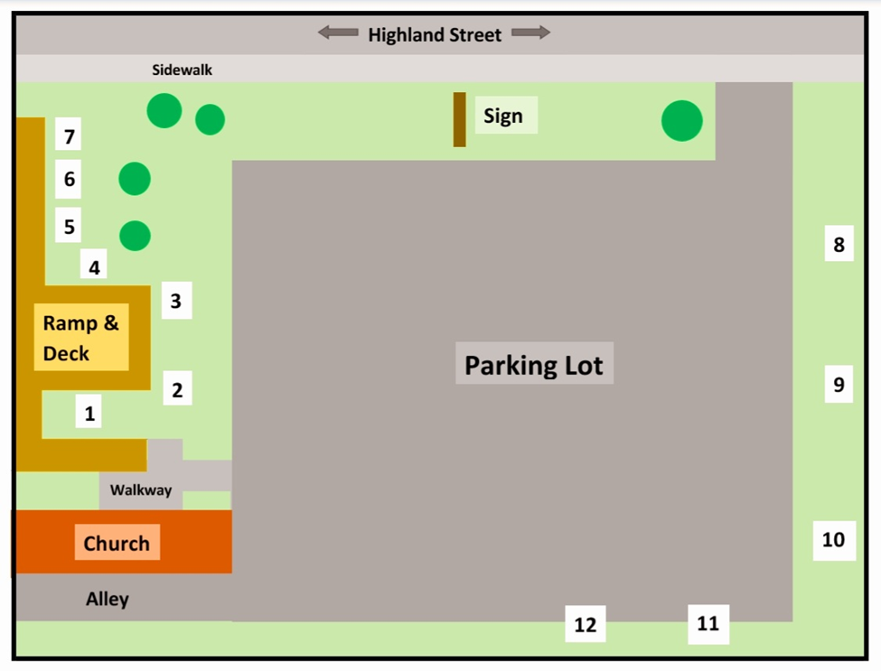
#1 The Barnes Family Cross
The first part of our cross is in memory of Tom Brundige, Uncle Tom to my kids. He was a true example of how happy someone can be with God in their heart. Just being around Tom made you feel good and loved. He showed my kids the true gift of God’s love and taught them so much about how to treat people. So, the front of our cross is flowers in honor of Tom’s love of nature and because, thanks to his example, my children will always know how to spread the seeds of God’s love!
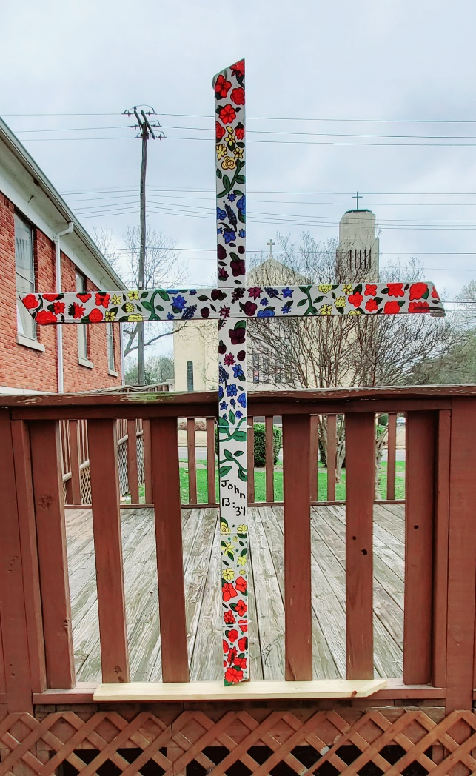
The rainbow colors in our cross are a thank you to the church family of Holy Trinity. Due to our support and love of the LGBT community, my family has recently had their faith questioned. God sent the wonderful folks of Trinity at the perfect time and helped us remember that we still have a place in God’s family. The verse is also to thank everyone at Trinity for the love they have shown us. Lastly, we wrapped the cross in hymns, because we always feel closest to God when singing, playing or listening to music.
Thank you,
Robert, Marie, Bethany, Crystal and Dawn Barnes
#2 The Vine Cross by Anonymous
JOHN 15:4-5 – “Abide in Me, and I in you. As the branch cannot bear fruit of itself, unless it abides in the vine, neither can you, unless you abide in Me. “I am the vine, you are the branches. He who abides in Me, and I in him, bears much fruit; for without Me you can do nothing.” In order to find myself, to embrace all of who I am and who God created me to be, I needed to learn that I can’t do it alone. For so long I tried to control everything in my life and the results where terrible. When I finally “let go and let God” everything changed. Letting God into my life has given me more than I could have ever imagined. Each day is a gift. I am not alone. I am worthy. My favorite song is the traditional Abide with Me. The words remind me that no matter what life throws at me I have the love, grace, and mercy of God protecting me, guiding me, inspiring me.

Abide with me; fast falls the eventide;
The darkness deepens; Lord, with me abide;
When other helpers fail and comforts flee,
Help of the helpless, oh, abide with me.

Swift to its close ebbs out life’s little day;
Earth’s joys grow dim, its glories pass away;
Change and decay in all around I see—
O Thou who changest not, abide with me.
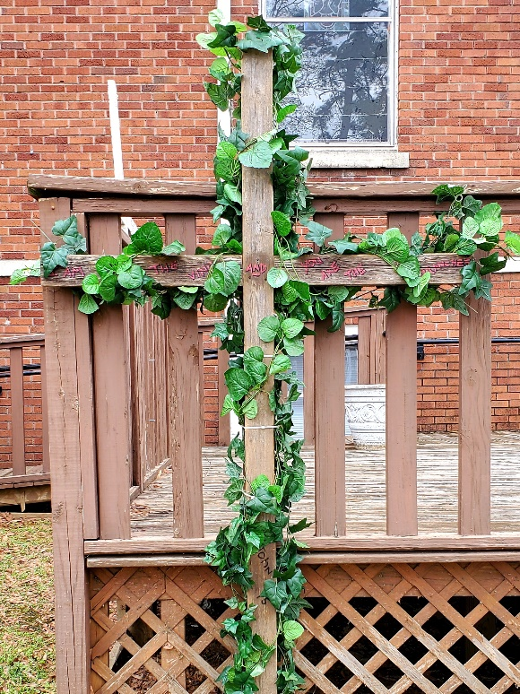
I need Thy presence every passing hour;
What but Thy grace can foil the tempter’s pow’r?
Who, like Thyself, my guide and stay can be?
Through cloud and sunshine, Lord, abide with me.

I fear no foe, with Thee at hand to bless;
Ills have no weight, and tears no bitterness;
Where is death’s sting? Where, grave, thy victory?
I triumph still, if Thou abide with me.

Hold Thou Thy cross before my closing eyes;
Shine through the gloom and point me to the skies;
Heav’n’s morning breaks, and earth’s vain shadows flee;
In life, in death, O Lord, abide with me.

#3 The Trans Cross by RVE
Trans rights are human rights! This cross is inspired by the Transgender Day of Remembrance. What is Transgender Day of Remembrance? Transgender Day of Remembrance (TDOR) was started in 1999 by transgender advocate Gwendolyn Ann Smith as a vigil to honor the memory of Rita Hester, a transgender woman who was killed in 1998. The vigil commemorated all the transgender people lost to violence since Rita Hester's death, and began an important tradition that has become the annual Transgender Day of Remembrance.
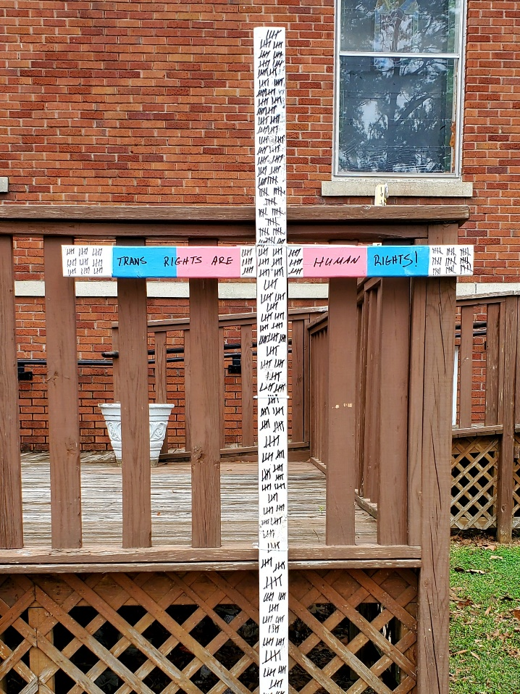
"Transgender Day of Remembrance seeks to highlight the losses we face due to anti-transgender bigotry and violence. I am no stranger to the need to fight for our rights, and the right to simply exist is first and foremost. With so many seeking to erase transgender people -- sometimes in the most brutal ways possible -- it is vitally important that those we lose are remembered, and that we continue to fight for justice." - Transgender Day of Remembrance founder Gwendolyn Ann Smith
I know that we are all made in the image of God. Transgender people are a unique and beautiful reflection of God. Their presence in our lives is a blessing, a holy gift, that needs to be protected and respected. Take the time to educate yourself about the Transgender Day of Remembrance and transgender rights. Become an advocate.
350 transgender people were killed in 2020, a figure that has risen since last 2019's total of 331. The annual global list is released for Transgender Day of Remembrance, held on November 20 each year. The list shows that in 2020 the average age of those killed was 31, with the youngest just 15. While a fifth (22%) of the transgender people murdered were killed inside their own house. The majority of the murders happened in Central and South America, totaling 287. Like last year, the most deaths in a single country happened in Brazil, totaling 43% of global deaths (152 people). Mexico was next with 57, while the United States sits in this report at 28. The hard facts are many transgender deaths are not recorded.
These numbers also do not include suicide. The numbers of which are far higher in the transgender population. The 2015 U.S. Transgender Survey (USTS), which is the largest survey of transgender people in the U.S. to date, found that 81.7 percent of respondents reported ever seriously thinking about suicide in their lifetimes, while 48.3 percent had done so in the past year. In regard to suicide attempts, 40.4 percent reported attempting suicide at some point in their lifetimes, and 7.3 percent reported attempting suicide in the past year.
As a society we need to do better. We need to advocate for all of God’s children. May it be so. Amen.
#4 The Beer Can Cross by Rob Van Ess
The prayer that traces the sides of this cross has saved my life.
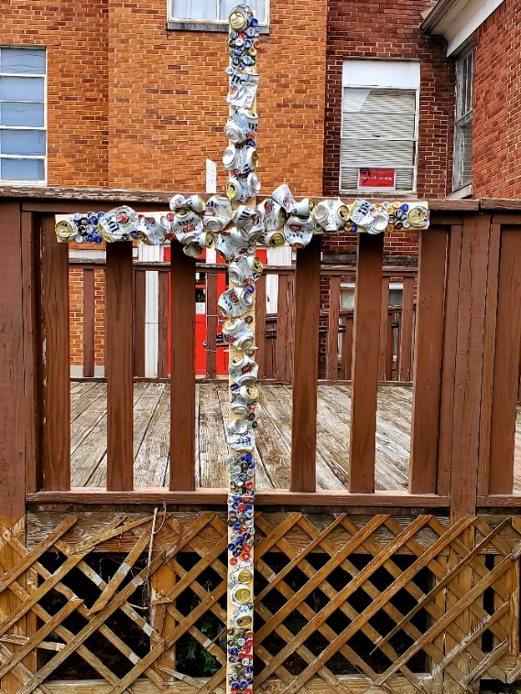
The Serenity Prayer:
"God, grant me the serenity
to accept the things I cannot change,
the courage to change the things I can,
and the wisdom to know the difference.
Amen."
It wasn't until much later I learned that many people added to this prayer:
"Living one day at a time,
enjoying one moment at a time,
accepting hardship as a pathway to peace,
taking as Jesus did,
this sinful world as it is,
not as I would have it,
trusting that You will make all things right,
if I surrender to Your will,
so that I may be reasonably happy in this life
and supremely happy with You forever in the next.
Amen.
When I took my first steps into sobriety many kind people took the time to teach me that in order to release myself from the power of alcohol in my life that I would need to surrender to a higher power. And not just surrender my drinking. Abstinence was not enough. I needed to surrender my will and my life over to the care of God. All that I was, all that I wanted to be. Everything my drinking meant to me. The lies I told myself. The terrible things I had done. The grief and suffering, the abject loneliness and hopelessness that drove me to madness. The beer cans and bottle caps on this cross represent everything I lI need to lay down at the cross.
Now I know that addicts and alcoholics are not special in this regard. Any of us, suffering an addiction or not, needs to surrender our will and our life over to the care of God, we all need to lay it all down at the cross, if we are going to experience what many in recovery refer to as "the promises of God."
1. If we are painstaking about this phase of our development, we will be amazed before we are halfway through.
2. We are going to know a new freedom and a new happiness.
3. We will not regret the past nor wish to shut the door on it.
4. We will comprehend the word serenity, and we will know peace.
5. No matter how far down the scale we have gone, we will see how our experience can benefit others.
6. That feeling of uselessness and self-pity will disappear.
7. We will lose interest in selfish things and gain interest in our fellows.
8. Self-seeking will slip away.
9. Our whole attitude and outlook upon life will change.
10. Fear of people and of economic insecurity will leave us.
11. We will intuitively know how to handle situations which used to baffle us.
12. We will suddenly realize that God is doing for us what we could not do for ourselves.
I have found this all to be true and I thank God every day for the gift of new life in Christ Jesus.
#5 The Ribbon Cross by Michael Purvis
We can find all kinds of symbolism throughout the bible – and as we research the various translations there is an array of words to describe the same thought process or meaning behind the message of the verse(s). Numbers 15: 38 – 39a (KJV), says “Speak unto the children of Israel, and bid them that they make them fringes in the borders of their garments throughout their generations, and that they put upon the fringe of the borders a ribband of blue: And it shall be unto you for a fringe, that ye may look upon it, and remember all the commandments of the Lord, and do them”. Rib-band in Hebrew is “pathiyl” which means twine; bound lace; line; and/or thread. For additional translations, ribband is a cord, ribbon or tassel – so with this, the design of the Ribbons of the Cross offers the following:

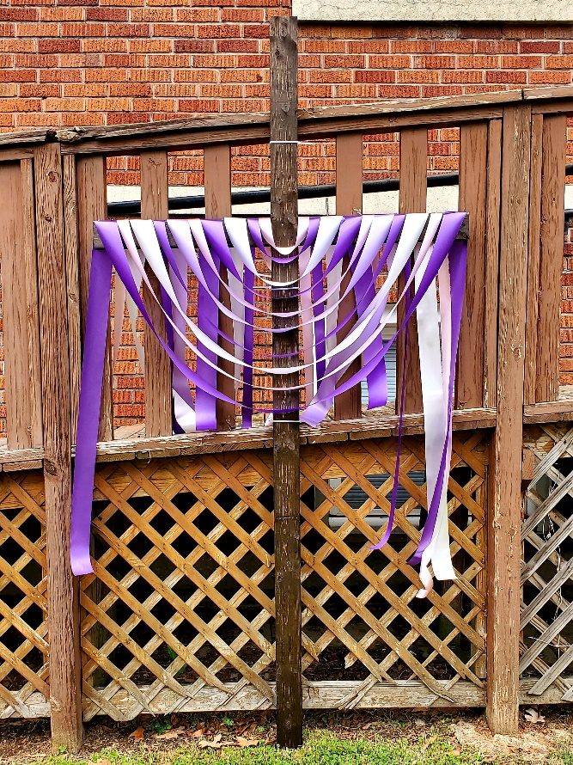
· Ribbons of Ministry – a ribbon is a symbol of awareness and support. In 1979 – 1981, a yellow ribbon was used to show support for the American’s held hostage by Iran and to remind others of their service to their country. In 1991 the New York HIV-awareness arts organization used a red ribbon for its’ boldness, passion, heart and love in the efforts to increase public awareness of HIV and to convey that HIV was relevant to everyone. The New York Times called 1992 The Year of the Ribbons. YOU are encouraged to find a ribbon, cord, tassel or yarn and set your self an awareness ribbon to minister to this world with your gifts and talents. A phone call to a neighbor, a wave to a by-passer, a kind word to the cashier, a letter to an old friend, words of encouragement through social media – sharing the love of Christ to encourage others on their life’s journey.

· Ribbons of Binding – “Bind us together, Lord, bind us together, with cords that cannot be broken”… In quilt making, most quilt-makers use a double fold binding where long strips of fabric are folded to create two layers. The extra layer is for durability and protections. Consider this – the Holy Spirit binds us together which is the first layer. However, each one of us makes up the second layer in this double folded binding. We must do our part through ministry. James 1:22 tells us to be doers of the word and not hearers only. Now, Easter people – what are you going to do thru the Holy Spirit with your fold of God’s ministry as we bind our journey together through Christ’s church?

· Ribbons Untied – not only do we bind our ribbons together through Christ and ministry, but we are also called to untie our ribbons. On our life’s journey, we tend to tie ourselves up; maybe we tie ourselves up in knots from worry or stress, maybe we tie ourselves to an idea of the perfect church or perfection in people; or maybe we tie ourselves to making ministry about self. Whatever is tying you from experiencing Holy Trinity’s extravagant grace, radical inclusion and relentless compassion, pray that Christ will untie your ribbons so thru Christ you can break chains, shake prisons and offer Christ through ministry!

#6 The Cradle to Grave Cross by Anonymous
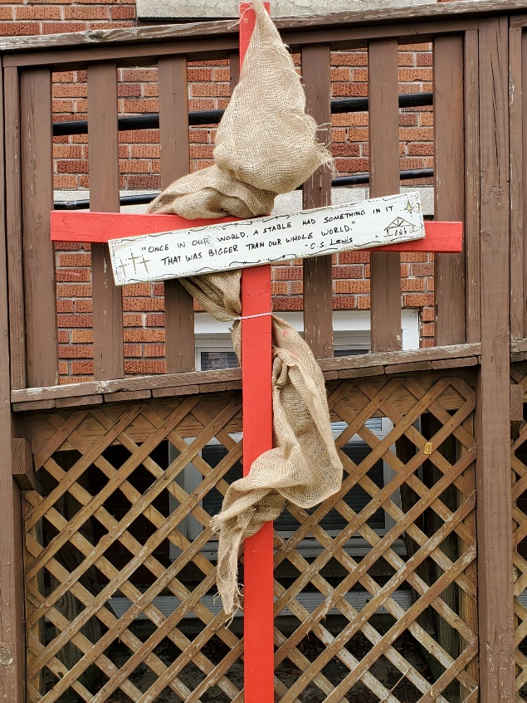
“Once in our world, a stable had something in it that was bigger than our whole world (C.S. Lewis)." This cross is red to represent the blood of Christ when he suffered and died on the cross. The burlap wrapped around this cross represents His humble birth in a manger, (swaddling clothes), and his resurrection, (his funeral shroud). This quote by C. S. Lewis reminds us that the journey from the crèche to the cross carries the gift of new life. The city of Bethlehem, (where Jesus was born), is only 6 miles SW of Jerusalem and Golgotha, (where Jesus was crucified). Wilfred L Winget poignantly observes: “Bethlehem is close to Calvary because humanity is far from God.” When I meditate on the life, death, and resurrection of Jesus I am inspired so very thankful for the gift that Jesus is to all of us today. "For God so loved the world that he gave his only Son, so that everyone who believes in him may not perish but may have eternal life.” – John 3:16

#7 (Has Not Been Installed)

#8 The Flower Cross by the Lofton Family
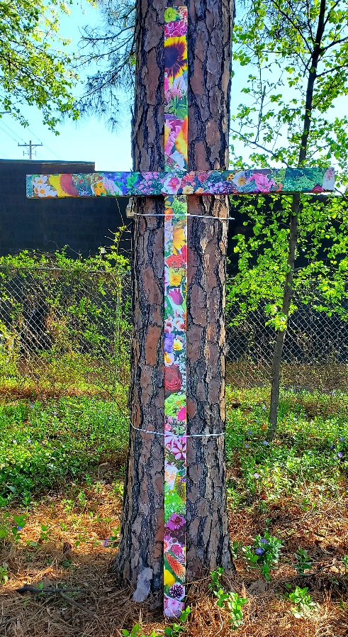
I woke up from a deep sleep, sat up, and said: "Our son's name is Atlas." I never had heard of the name nor had I ever seen it in any baby book. It jus came to me. The same moment came to me when it came time for an inspiration for the decorating of the cross. Jesus Christ created this beautiful earth... the trees... the flowers. So, his beauty in this earth and everything that he has given us is where I found my inspiration.

#9 The Old Rugger Cross by Alicia & Carrie Smith
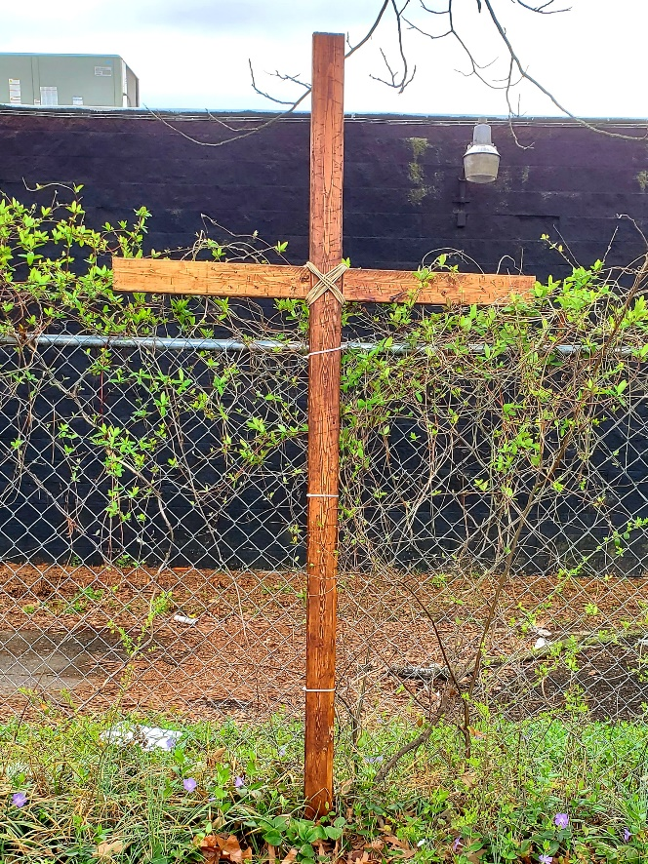
A moment 10,000 angels would have rushed at one command; yet He chose us. Choosing to say, “It is finished,” declaring the release of His spirit, saving us and allowing love to win always. The old rugged cross could not hold Him; freeing us from Friday to deliver us to Sunday of hope. When challenged with any thought, or question of Christ's love; I am reminded by a quote I saw: “The Man on the middle cross told me I can come.” We are signed, sealed and delivered; Jesus said from the Old Rugged Cross, we ALL could come. ALL are welcome, no matter where you are on your journey; His arms are open with LOVE ALWAYS. Tetelestai! (meaning, it is finished, paid in full, no adjustments or additions are necessary) YOU ARE LOVED!
#10 The Beautifully Made Cross by Nikki Morgan
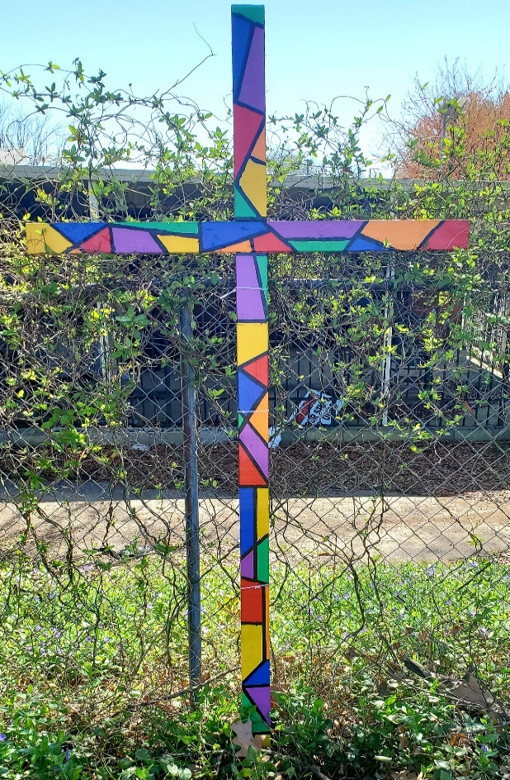
One of the fondest memories I have of church, both as a child and as an adult, is looking at the beautiful stained-glass windows that adorned each sanctuary. Delicate pieces of colored glass placed together to form intricate artwork that depicted some of the most important stories or people from the Bible. And when the light hit them just right, the views were simply spectacular! But without Christ at the center, they were simply pieces of broken, colored glass with jagged edges and no story to tell.
The same is true for Christians. Faith in the healing and spiritual power of our Lord, Jesus Christ is the solder that holds our broken pieces together and makes us whole. The edges are still imperfect, but God’s unending love for us allows our kaleidoscope of colors to come together to create a “beautifully made” piece of art that radiates love and hope.
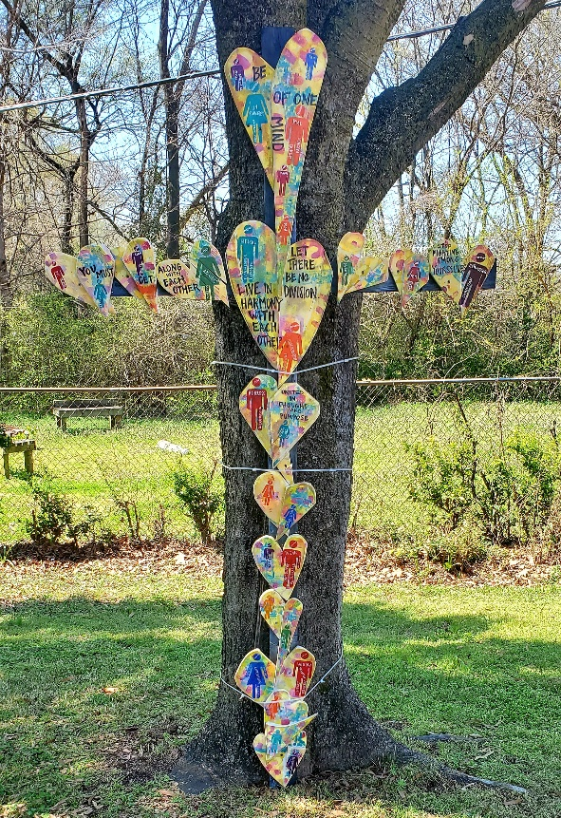
#11 The Love &Grace Cross by Lindsey Byard
With all of the labels we and the world put upon ourselves, we seem to foster division rather than community. The cross, the blood shed by Jesus, covered every label. The love and grace of Jesus was for everyone so that we may have life abundantly and eternally. In order for us to pick up the cross, to continue the work of Jesus in the world, we must be of one mind. We must get along with each other. We must live in harmony with each other and let there be no division between us. We must stop fighting among ourselves. In order to heal a hurting world, we must be united in thought and purpose. For through a united community of believers, God can do infinitely more than we ever thought possible.

#12 The Original Cross by Jesus Christ
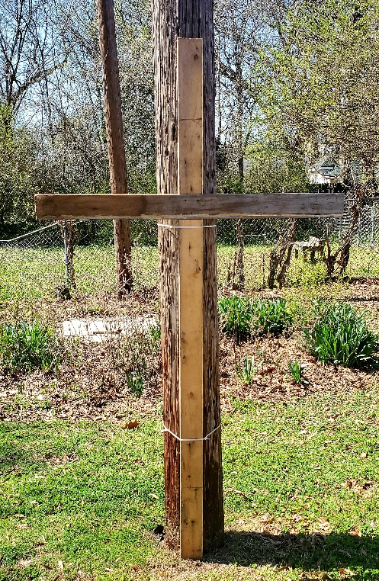
The one thing all of the crosses in our 2021 Crosswalk have in common is that when you strip away all the paint and various decorations what you have left is a simple wooden cross. The Christian cross, seen as a representation of the instrument of the crucifixion of Jesus, is the best-known symbol of Christianity. The cross evokes the passion, or the suffering, of Christ as he was betrayed, arrested, beaten, tried, (twice), mocked, & executed. As we remember the life, death, and resurrection of Jesus we know that Palm Sunday, Maundy Thursday, and Good Friday, all need to happen before the glory of the resurrection is proclaimed to the women at the tomb on Easter Sunday. So, it is with our faith. Every cross in this Crosswalk represents someone's faith journey. Countless stories that all bear the scars of living life, dying to an old way of living, and only then being resurrected into a new life in Christ Jesus. May these crosses bless your Lenten and Easter meditations on your faith journeys. May you find the love, grace, and mercy of Christ everywhere go. Amen.

