Order Form

(2 pages)

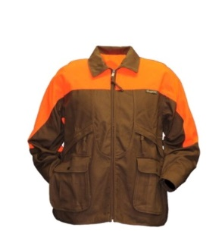

Men’s Rooster Upland Jacket

Front and rear loading jacket; two zippered storage pockets and two large dump pockets with additional side access. It also has a rear game bag with water bottle holders. The jacket will have the same logo as caps, but without the year.

Price is $139.99

Sizes available M L XL XXL XXXL Quantity ________

(Circle Size needed)

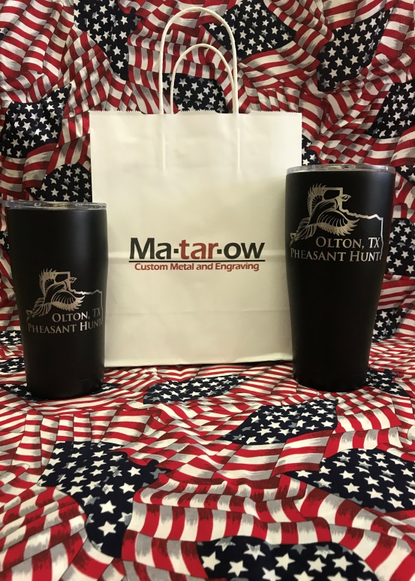

SIC 20oz or 30oz Black Tumbler with engraved logo

Double Wall Vacuum Insulated for extreme temperature retention! Made from kitchen grade 18/8 Stainless Steel the SIC cup is ready to roll with you anywhere you want! The double wall construction completely prevents any temperature transfer to exterior wall therefore eliminating any condensation or change in temperature where you hold your hand. Your cup will always remain a comfortable temperature for you to hold but your drink inside will be either ice cold or piping hot!

20oz SIC Tumbler $34.99

30oz SIC Tumbler $39.99

Name engraved on the other side is $10 more.

20oz _______ 30oz ________ Personalization __________________

Please remit this form and check with the registration forms. Thank you for your continued support.