Sandhills 8th Annual
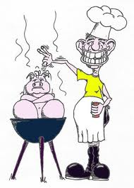
Bar-B-Que Cookoff
When: August 2-3, 2019
Where: Main Street – 1 block south of the Pavilion
What: Cook-off will consist of two categories (brisket and pork ribs)
Entry fee: $150 for both categories (meat is provided)
Awards: $300 cash for first place in each category
$150 cash for second place in each category
To Sign up for the Cookoff or for any questions, call
Ruben Renteria- 806-729-5067
Registration due July 26, 2019
We could also use volunteers to help – if interested, please call!

