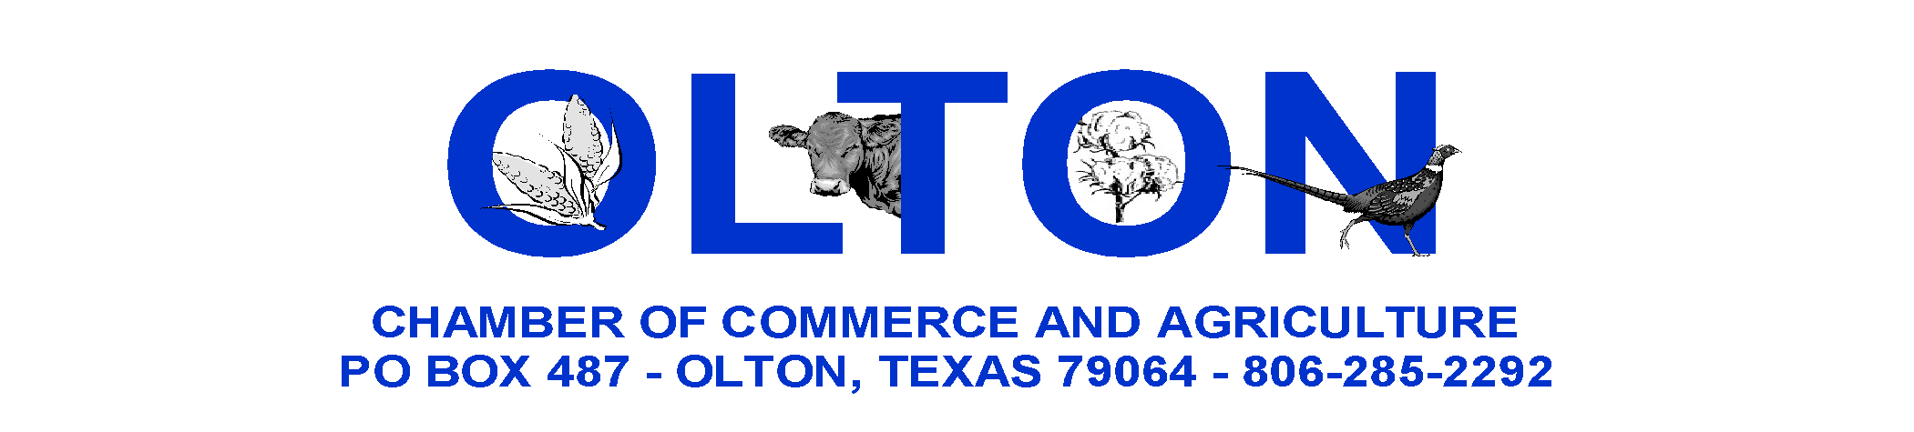

2020 PHEASANT HUNT LIABILITY WAIVER, DISCLAIMER, AND RELEASE
OLTON CCA COPY

Olton Chamber of Commerce and Agriculture (OCCA) organizes and sponsors the annual OCCA Pheasant Hunt ("Pheasant Hunt"). The Pheasant Hunt is a fund raising event of which the proceeds are intended to be used to promote commerce and economic growth in our local trade area. OCCA membership, guides, and landowners/operators do not directly profit from this event. There are risks inherent to the Pheasant Hunt. Therefore, before participating in the Pheasant Hunt, we must request you to waive liability for certain risks.

For the purpose of this waiver, the following terms shall be defined as follows.

"OCCA membership" shall mean Olton Chamber of Commerce and Agriculture, its members, officers, directors, and employees;
"Guides" shall mean any person who leads a group of Participants to hunt on land on which the OCCA Pheasant Hunt has secured permission to hunt pheasant or other birds in season;
"Landowners" shall mean any owner of land upon which the OCCA Pheasant Hunt has secured permission to hunt pheasants or other birds in season;
"Operators" shall mean any farmer or lessor of land who farms land upon which the OCCA Pheasant Hunt has secured permission to hunt pheasants or other birds in season;
"Participant" shall mean any person who pays a fee to the OCCA to hunt pheasants or other birds in season on land upon which the Pheasant Hunt has secured permission to hunt pheasant or other birds in season and guided by an OCCA approved guide.
Persons may serve in more that one capacity in the Pheasant Hunt. OCCA members also be guides, landowners, and/or operators.

For and in consideration of the services provided in connection with the Pheasant Hunt, OCCA membership, guides, landowners, and operators will not be held responsible and/or liable and are hereby released from responsibility and/or liability for the following:

- Any personal injury and/or death as a Participant in the Pheasant Hunt
- Any injury and/or death to others caused by me as a Participant (Participant may be liable to others)
- Any damage, destruction, and/or loss of property belonging to me
- Success of the hunt relating to number and/or quality of pheasant or land and/or weather conditions;
- Illegal shotguns, shot type, or bird cleaning.

Participant shall indemnify, defend and hold harmless OCCA and its members, guides, landowners, and operators from any and all claims, demands, expenses, attorney's fees, and liability arising out of Participant's acts or omissions or the acts and omissions of Participant's minor children. This waiver, disclaimer, release of liability, and indemnification agreement is not intended to limit the liability of any Participant to third parties.

Further, Participant shall indemnify, defend and hold harmless OCCA and its members, guides, landowners, and operators from any and all personal injury of death of Participant's minor child(ren) who participate in the Pheasant Hunt as a Participant or otherwise; and for any and all damage destruction, and/or loss of property belonging to the Participant's minor child(ren).

I have read and understand this document, agree to its terms and conditions, and I am aware that by signing it, I am giving up important rights.

_________________________________ _________________________________________ _________
Participant's Printed Name Participant’s Signature Date

_______________________________________________ _________________________________________
Participant’s Address Witness Signature

