**Kundalini Meditation: Bountiful, Beautiful, Blissful**

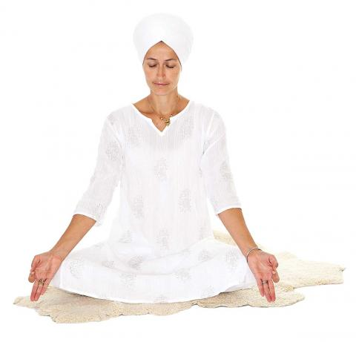**Posture:** Sit in Easy Pose, with a straight spine.

**Mudra:** Hands are in Gyan Mudra (tips of the index finger and the thumb touching each other, forming a circle), wrists on the knees.

**Eyes:** Look at the center of your chin, through closed eyes. Or, focus at the tip of your nose with your eyes 1/l0th open.

**Mantra:** Inhale deeply, suspend the breath and mentally recite:

*I am Bountiful. I am Blissful. I am Beautiful.*

This mantra is for self-esteem and confidence.

Exhale completely and hold the breath out as you mentally recite:

*Excel, Excel, Fearless.*

**Time:** Practice 3 minutes at a time, twice a day.

© KRI. This kriya is courtesy of YB Teachings, LLC. Used with permission.