**Preparatory Exercises for Lungs Magnetic Field and Deep Meditation**

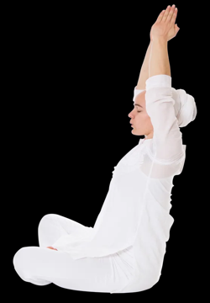

37 - 48 minutes

This series begins by purifying the blood and expanding the lung capacity. Then the circulatory system is stimulated. The thyroid and parathyroid secretions are added to the increased circulation and the upper magnetic field of the body is enlarged. This is an excellent preparation for beginners who need to learn deep meditation.

Published In

[**1. Whistle Breath**](https://kundalini.yoga/kriyas/preparatory-exercises-for-lungs-magnetic-field-and-deep-meditation#preparatory-exercises-for-lungs-magnetic-field-and-deep-meditation-0)

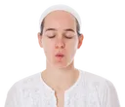

1. Sit in Easy Pose. Stretch the arms straight over the head with the palms flat together. Pull the spine up and then tilt it back as far as you can gracefully maintain balance.
2. Breathe consciously through the puckered mouth in a long whistle on the inhale and on the exhale.

4 - 6 minutes

**To End - (default)**

1. Inhale. Exhale, relax the breath.

[**Part 2 - Relax**](https://kundalini.yoga/kriyas/preparatory-exercises-for-lungs-magnetic-field-and-deep-meditation#preparatory-exercises-for-lungs-magnetic-field-and-deep-meditation-0-1)**)**

1. Inhale. Exhale, relax the breath.

[**2. Thumb Tip Touch**](https://kundalini.yoga/kriyas/preparatory-exercises-for-lungs-magnetic-field-and-deep-meditation#preparatory-exercises-for-lungs-magnetic-field-and-deep-meditation-1)

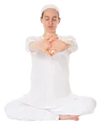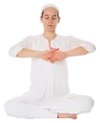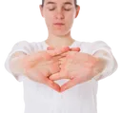

1. Stay in Easy Pose. Inhale and stretch the arms forward, parallel to each other and parallel to the ground.
2. Interlace the fingers so that the palms face forward. Touch the thumb tips together.
3. Inhale and hold the breath with the arms extended briefly. Exhale as you bend the elbows and bring the back of the palms near the chest at the level of the Heart Center.
4. Alternate rapidly between these two positions with a strong breath.

2 - 3 minutes

**To End**

1. Relax the breath and maintain the position to begin the next exercise.

[**3. Arm Pumps**](https://kundalini.yoga/kriyas/preparatory-exercises-for-lungs-magnetic-field-and-deep-meditation#preparatory-exercises-for-lungs-magnetic-field-and-deep-meditation-2)

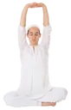

1. With arms extended from the last exercise, inhale, hold the breath in, and pump the arms up over the head and back down parallel to the ground.
2. Then exhale, bringing the hands near the chest. Quickly inhale back into the first position.

2 - 3 minutes

**To End**

1. Inhale with the arms extended and hold briefly for 10-15 seconds.

[**4. Tension Pull**](https://kundalini.yoga/kriyas/preparatory-exercises-for-lungs-magnetic-field-and-deep-meditation#preparatory-exercises-for-lungs-magnetic-field-and-deep-meditation-3)

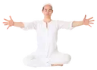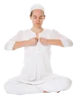

1. Immediately extend the arms parallel to the ground at a 60 degree angle to each other. The palms face each other and the elbows are straight.
2. Inhale a deep complete yogic breath. As you inhale, slowly clench the fists. Hold the breath in.
3. Slowly bend the arms and bring the fists toward the chest. Create tremendous tension in all the arm and hand muscles. Pull as if you are dragging a thousand pound weight.
4. When you finally touch the chest, release the breath with an explosive exhale.
5. Repeat.

2 - 3 minutes

**To End - (default)**

1. Inhale. Exhale, relax the breath.

[**5. Palm Up Pushup**](https://kundalini.yoga/kriyas/preparatory-exercises-for-lungs-magnetic-field-and-deep-meditation#preparatory-exercises-for-lungs-magnetic-field-and-deep-meditation-4)

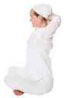Easy Pose, Arms Extended Straight Up, Fingers Interlaced Palms Facing Up, Thumbtips Touching

1. Sitting in Easy Pose, stretch the spine erect. Interlace the fingers and place the hands, palms up, an inch behind the neck.
2. Inhale as you stretch the arms straight up over the head. Keep the fingers interlocked. The thumb tips touch.
3. Exhale back into the first posture. Alternate rapidly, up and down, with a strong smooth breath.

2 - 3 minutes

**To End - (default)**

1. Inhale. Exhale, relax the breath.

[**6. Torso Twists**](https://kundalini.yoga/kriyas/preparatory-exercises-for-lungs-magnetic-field-and-deep-meditation#preparatory-exercises-for-lungs-magnetic-field-and-deep-meditation-5)

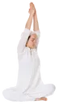

1. Immediately stretch the arms straight over the head with the palms flat together. Hug the ears. Cross the thumbs over each other to lock the hands together.
2. Inhale as you twist the torso and head to the left. Exhale as you turn toward the right.
3. Rotate side to side in a steady quick pace.

2 - 3 minutes

**To End**

1. Inhale in the center, hold and apply mulbandh. Exhale.

[**7. Flat Palm Push**](https://kundalini.yoga/kriyas/preparatory-exercises-for-lungs-magnetic-field-and-deep-meditation#preparatory-exercises-for-lungs-magnetic-field-and-deep-meditation-6)

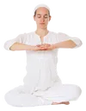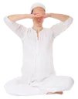

1. Interlace the fingers and place the hands, palms down, in front of the Heart Center.
2. Inhale as you raise the palms and forearms to the level of the Brow Point. Exhale down into the first position.
3. Create a rapid pumping motion, and a strong steady breath.

2 - 3 minutes

**To End**

1. Then inhale and hold 10-15 seconds. Exhale.

[**8. Spinal Twist**](https://kundalini.yoga/kriyas/preparatory-exercises-for-lungs-magnetic-field-and-deep-meditation#preparatory-exercises-for-lungs-magnetic-field-and-deep-meditation-7)

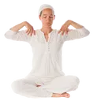

1. Place the hands on the shoulders with the fingers in front and the thumbs in back.
2. Raise the elbows to shoulder height. Inhale as you twist the torso and head to the left. Exhale as you twist the torso to the right.
3. Create a steady powerful swing. Open the lungs completely. Move with grace as if you rotate around a perfectly balanced and frictionless spinal column.

2 - 3 minutes

**To End**

1. Inhale in the center, apply mulbandh, and hold l0-15 seconds. Exhale.

[**9. Shoulder Shrugs**](https://kundalini.yoga/kriyas/preparatory-exercises-for-lungs-magnetic-field-and-deep-meditation#preparatory-exercises-for-lungs-magnetic-field-and-deep-meditation-8)

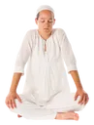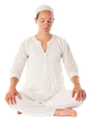

1. Sit in Easy Pose. Keep the spine erect and still.
2. Inhale as you raise both shoulders straight up toward the ears. Exhale as you drop both shoulders down.
3. Create a quick steady pace. This is a natural motion. Do it without stress or cramping.

2 - 3 minutes

**To End - (default)**

1. Inhale. Exhale, relax the breath.

[**10. Camel Ride**](https://kundalini.yoga/kriyas/preparatory-exercises-for-lungs-magnetic-field-and-deep-meditation#preparatory-exercises-for-lungs-magnetic-field-and-deep-meditation-9)

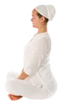

1. Sit in Easy Pose. Grab the shins in front with both hands.
2. Inhale. Flex the spine forward and rock forward on buttocks.
3. Then exhale, flex the spine backwards and roll back on buttocks.
4. Keep the head level and arms fairly straight and relaxed.

2 - 3 minutes

**To End - (default)**

1. Inhale. Exhale, relax the breath.

[**11. Meditate**](https://kundalini.yoga/kriyas/preparatory-exercises-for-lungs-magnetic-field-and-deep-meditation#preparatory-exercises-for-lungs-magnetic-field-and-deep-meditation-10)

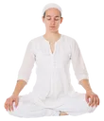

[TENTH GATE](https://kundalini.yoga/eye-focuses/tenth-gate)

1. Roll the eyes up as far as possible. Concentrate at the top of the head.

15 minutes

**To End - (default)**

1. Inhale. Exhale, relax the breath.