*In Kundalini Yoga it is often said that age is measured by the flexibility of the spine: to stay young, stay flexible. This series works systematically from the base of the spine to the top. All 26 vertebrae receive stimulation and all the chakras receive a burst of energy. This makes it a good series to do before meditation. Many people report greater mental clarity after regular practice of this kriya. A contributing factor may be the increased circulation of the spinal fluid, which is crucially linked to having a good memory.*

Spine Flex in Easy Pose

Spinal flexes have a "multistage reaction pattern" that greatly alters the proportions and strengths of alpha, theta and delta waves.

**Posture:** Sit in Easy Pose. Grab the ankles with both hands.

**Breath & Movement:** Inhale and flex the spine forward and lift the chest up. On the exhale, flex the spine backwards. Keep the head level so it does not "flipflop."

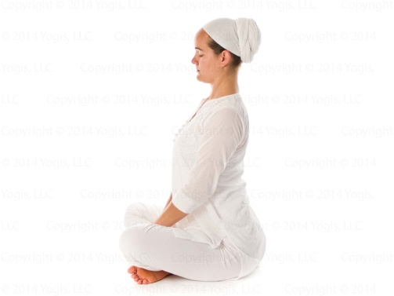

Repeat 26 – 108 times. Then relax for 1 - 2 minutes.

Spine Flex in Rock Pose

**Posture:** Sit on the heels in Rock Pose. Place the hands flat on the thighs.

**Breath, Movement, Mantra:** Flex the spine forward with the inhale, backward with the exhale. Mentally vibrate *Sat*on the inhale, *Nam*on the exhale.

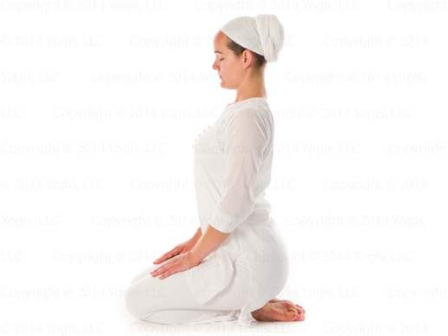

Repeat 26 – 108 times. Relax for 2 minutes.

Spinal Twist

**Posture:** In Easy Pose, grasp the shoulders with fingers in front, thumbs in back.

**Breath & Movement:** Inhale and twist to the left, exhale and twist to the right. Breathing is long and deep.

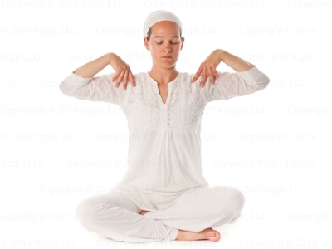

Repeat 26 times. To end, inhale facing forward. Exhale and relax for 1 minute.

Bear Grip

**Posture:** In Easy Pose, lock the fingers in Bear Grip at the heart center.

**Breath & Movement:** Move the elbows in a seesaw motion, breathing deeply with the motion.

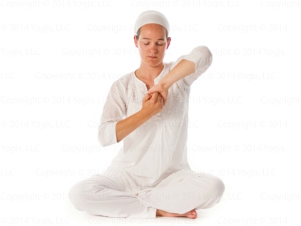

Continue 26 times. To end, inhale, exhale, pull on the lock, then relax for 30 seconds.

Spine Flex in Easy Pose with Arms Straight

**Posture:** In Easy Pose, grasp the knees firmly.

**Breath & Movement:** Keeping the elbows straight, begin to flex the upper spine. Inhale forward, exhale back.

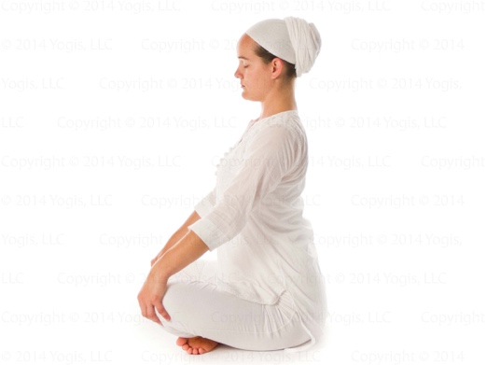

Repeat 26 -108 times. Relax for 1 minute.

Shoulder Shrugs

**Posture, Breath & Movement:** Shrug both shoulders up on the inhale, down on the exhale.

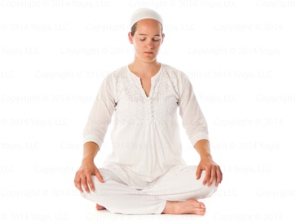

Continue for 1 – 2 minutes. To end, inhale and hold 15 seconds with shoulders pressed up. Then relax the shoulders.

Neck Rolls

**Posture & Movement:** Roll the neck slowly to the right 5 times. Then roll the neck to the left 5 times. To end, inhale and pull the neck straight.

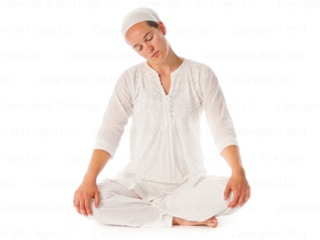

Complete 5 neck rolls to the right, then 5 to the left.

Bear Grip with Locks

**Posture, Locks, & Breath:** Lock the fingers in Bear Grip at the throat level. Inhale, hold the breath for 10 seconds and apply mulbandh (root lock). Exhale, hold the breath out for 10 seconds and apply mulbandh. Then raise the hands above the top of the head. Inhale, hold the breath and apply mulbandh (root lock). Exhale, hold the breath out and apply mulbandh.

Repeat the cycle two more times.

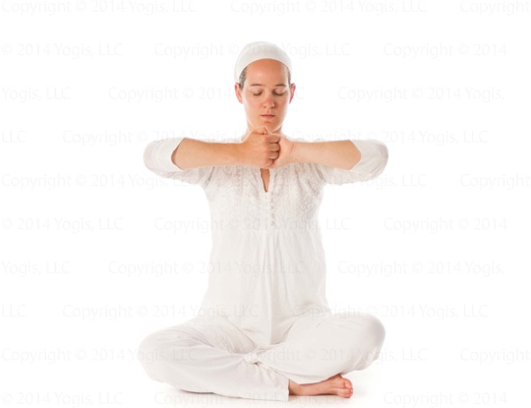

The complete exercise takes 2 minutes. To end, relax for 30 seconds.

Sat Kriya

**Posture:** Sit on the heels with the arms overhead and palms together. Interlace the fingers except for the index fingers, which point straight up. Male identifiers cross the right thumb over the left thumb; female identifiers cross the left thumb over the right. Do whichever feels right for you.

**Mantra:** Chant *Sat*and pull the Navel Point in; chant *Naam* and relax it.

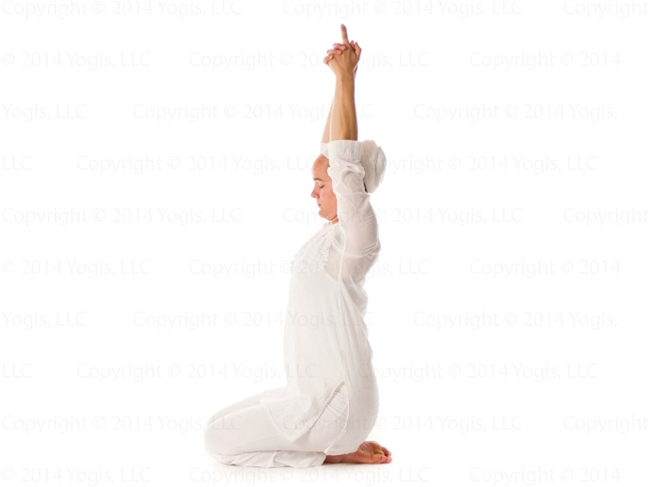

Continue powerfully with a steady rhythm for 3 minutes. To end, inhale, apply Root Lock and squeeze the energy from the base of the spine to the top of the skull. Exhale, hold the breath out and apply all the locks. Inhale and relax.

Deep Relaxation

**Posture:** Lie down on your back with the arms by your sides, palms up, and relax completely. Cover yourself with a blanket if desired.

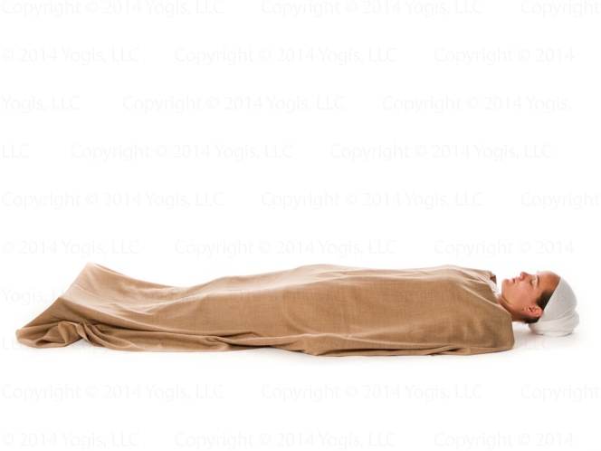

*Photos courtesy of Kundalini Mobile www.kundalinimobile.com*

Continue for 5 - 15 minutes.

Comments

In a beginner’s class, each exercise that lists 108 repetitions can be done 26 times. The rest periods are then extended from 1 to 2 minutes.

© 3HO. This kriya is courtesy of YB Teachings, LLC.

*This kriya can be found in the KRI International Teacher Training Manual Level 1 and in Sadhana Guidelines.*