**Kriya for Keep Up Spirit**

*Originally taught by Yogi Bhajan on November 2, 1983*

This kriya gives us the power to serve and uplift all.

1. Sit in Easy Pose. Extend the arms up at a 60 degree angle in front of the body. The hands are 2 ½ to 3 feet apart, palms facing each other, fingers together.

          There are 4 parts to the exercise:

          a. On the count of 1, bend the wrists so that the fingers point forward, parallel to the floor with the palms still facing each other.

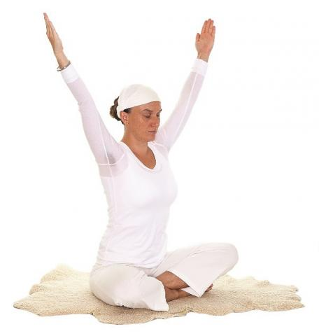

          b. On the count of 2, reposition the hands so that the fingers point up, palms still facing each other.

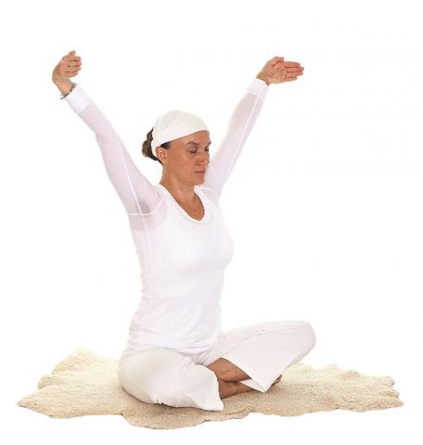

          c. On the count of 3, bend the wrists so that the palms face up.

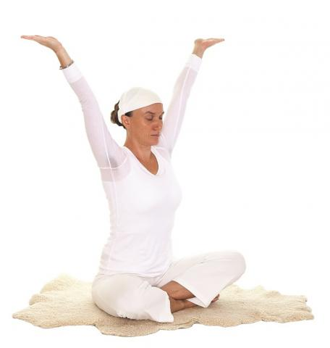

          d. On the count of 4, return to the original position.

Move the hands very fast, but rhythmically. Concentrate on the Third-Eye Point. Continue for 3 minutes. The coordination difficulties you may experience with this exercise can be alleviated by total concentration on the Third Eye Point

2. In Easy Pose, interlace the fingers so that the fingers are inside, between the palms, cross the thumbs and press the pads of the fingers of opposite hands together. Hold the mudra at chest level, fingers pointed toward the chest. Move the arms powerfully in and out from the center of the chest, in a sawing motion. Inhale as the arms extend and exhale as they return to the chest. Continue as fast as possible for 7-8 minutes.

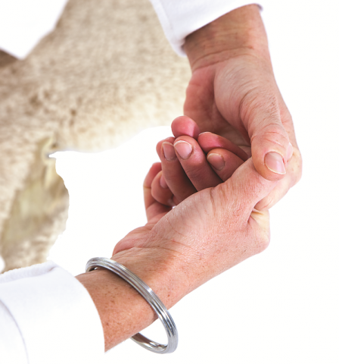

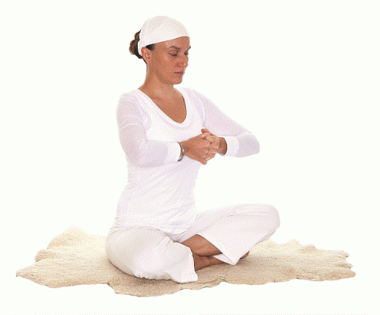

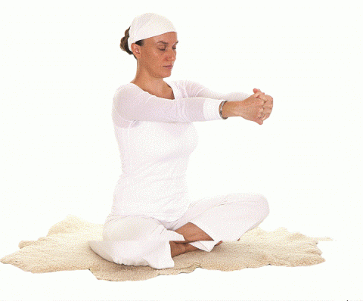

3. Lie down on your back. Place the hands, palms down, under the lower back. Begin alternate leg lifts: raise the left leg to 90 degrees as you inhale and lower it as you exhale repeat on the opposite side. Continue alternating for 4 minutes. In this exercise, pressure on the thigh muscles adjusts the body's calcium magnesium balance.

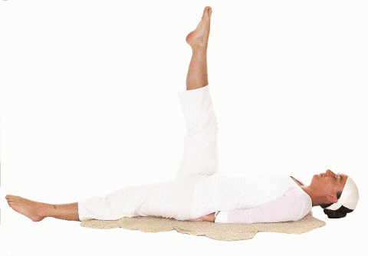

4. Life Nerve Stretch: Sit up with both legs stretched out straight in front. Catch hold of the toes tightly. Inhale and, pulling back on the toes, straighten the spine. Exhale and draw the forehead to the knees. Keep the knees straight throughout. Move powerfully for 3 minutes. This exercise helps you stay vigorous!y young.

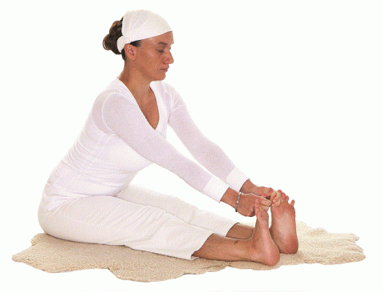

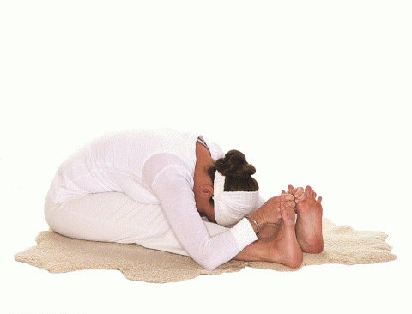

5. Cat-Cow: Come onto the hands and knees. Inhale and lift the head and arch the tailbone, allowing the spine to drop down; exhale and drop the head and curl the tailbone as the spine arches up. The arms and legs remain stationary. Continue for 1-2 minutes.

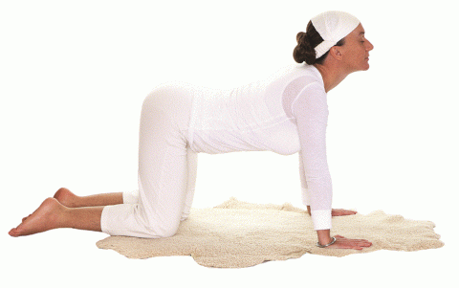

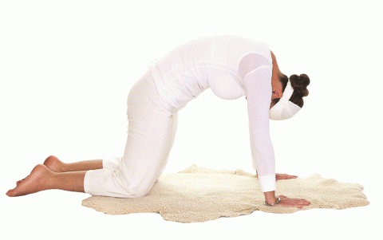

6. ln Cow Pose, the spine arched down and head up, begin kicking the buttocks powerfully and quickly with alternate heels. As one heel moves up to strike the buttocks, the other should be going down. Move only the lower part of your body. Create a sound like horses galloping. Continue for 1 minute. This exercise adjusts the buttocks.

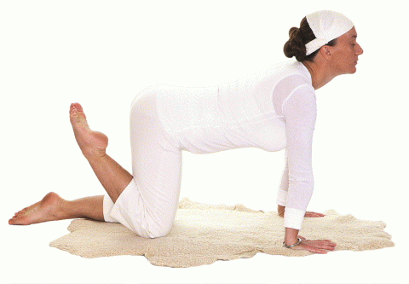

7. Stand up straight and place the hands on the hips. Begin rolling the torso around in full circles from the waist up. Get into it and really go! Extend the spine as far as possible in every direction. Continue very quickly for 2 minutes.

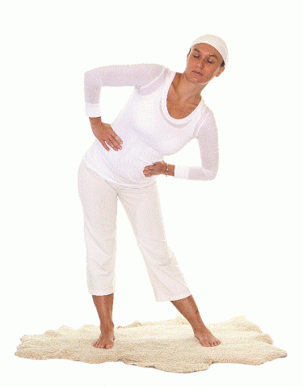

8. Still standing, stretch the arms up overhead as you inhale, then exhale as you bring the palms flat down onto the ground. Keep going fast and powerfully, without bending the knees for 1 minute.

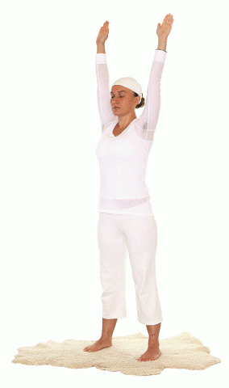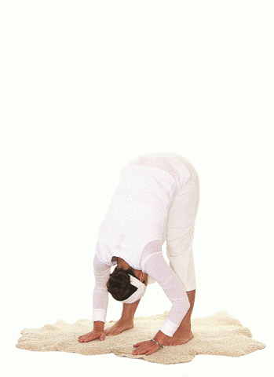

9. Spread the legs as wide as you can. Inhale as you stretch the arms up over the head and exhale as you bring the palms flat onto the ground. Continue for 1 minute.

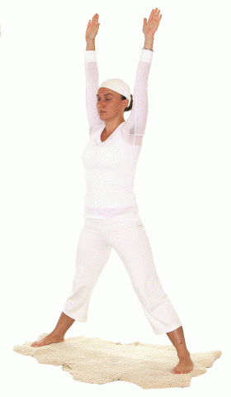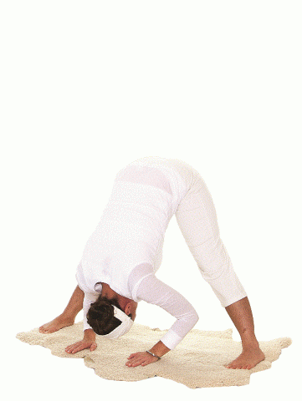

10. Stand with the feet close together. Inhale, stretching the arms straight up  overhead, and exhale touch the palms to the floor. Continue for 2-3 minutes. This is a little difficult; concentration is required in order to maintain balance. The exercise is good for the lymph glands.

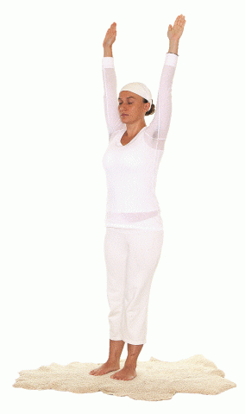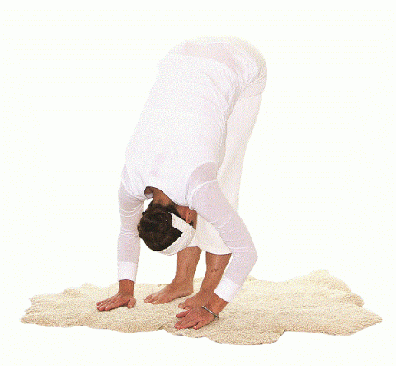

11. Still standing, feet shoulder-width apart, place the hands on the shoulders with the fingers pointing toward the neck. On the inhale, raise both arms straight up overhead; on the exhale, return the hands to the shoulders. Move very, very fast. Continue for 30 seconds.

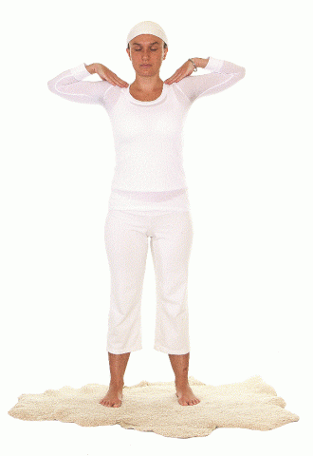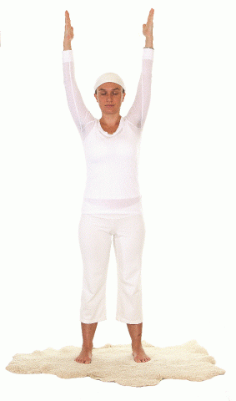

12. Sit in Easy Pose. Begin neck rolls, stretching the neck and making the head go in a full circle: chin to chest, ear to shoulder, and so on, round and round, very fast. Continue for 30 seconds.

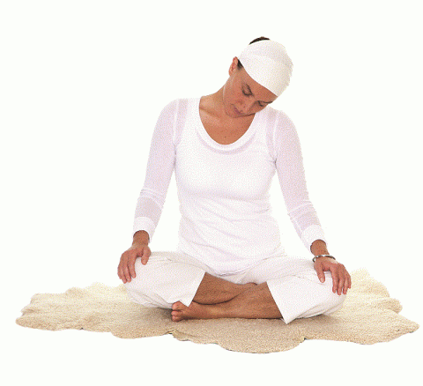

13. Relax for 3-10 minutes.

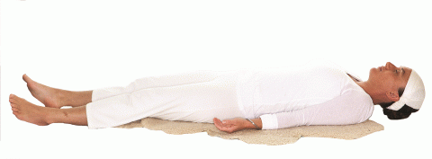

*"Blessed God, Beloved God, give us the best of life, the best of health. Give us priority over property and punctuality in life so that we may work out our karma and understand the depths of dharma (righteous living), the Guru's words. Give us joy. Give us tranquility. Give us peace. Give us the power to serve and uplift all those who need us. May we be healthy, happy and holy. Sat Naam."*  
*-Yogi Bhajan*

© KRI. This kriya is courtesy of YB Teachings, LLC. Used with permission.