Meditation for Gurprasad
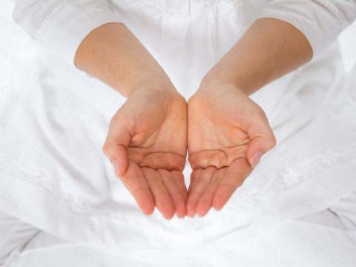
Guru is that guidance which takes you from darkness to light. Gurprasad means Guru’s Grace or Blessing; given by the grace and light of the Guru.
This is a very restful posture. The pressure against the rib cage meridian points gives relaxation.
When you are given a gift, a blessing, accept it as it is given. Don’t try to change it to your liking. Accept it with great devotion so it can open doors for you.
Posture: Sit in Easy Pose with a straight spine. With your upper arms close to your sides, bring your hands to the level of the heart with the hands side-by-side and cupped (the way they are for receiving prasad1).
Eyes: Eyes are one-tenth open and focused on the tip of the nose.
Mental focus: Allow all the blessings of heaven to flow to you; ask for whatever you need; know yourself to be blessed; feel the boundless flow of spirit. Just let it happen. Fill your heart and soul with all the bounties of nature. Simply meditate on the boundless flow of the Universal Soul, and feel a deep inflow of spirit. Feel the light, become pure light—the gift of GRATITUDE from gurprasad.
Time: There was no time given for this meditation. It is suggested to start with 3 to 11 minutes and work up to 31 minutes.
© 3HO. This kriya is courtesy of YB Teachings, LLC. Used with permission.

