Minutes of the Twenty-Sixth Annual Session
of the

Solid Rock Association
of
Old Time Baptists
of
Jesus Christ
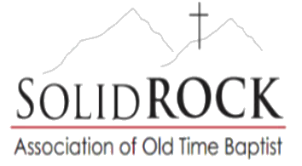

Held at the
Pilgrims Prayer
Old Regular Baptist Church
Dorton, Kentucky
September 12, 13, & 14, 2025

Elder Daryl G. Newsom, Moderator: (606) 424-3831

Elder David Nichols, Assistant Moderator: (606) 371-2840

Deacon Thomas Pinion, Clerk/Treasurer: (606) 213-4151
thomas.pinion@yahoo.com

Elder Brandon Newsom, Assistant Clerk: (336) 970-9073
bnewsom3@yahoo.com

www.solidrockassociation.com
Charter

We, the Crossroads Community Baptist Church, Garrett Regular Baptist Church, House of David Church of Old Regular Baptist, and Pilgrims Prayer Church of Old Regular Baptist, come together with the following Resolution:

We resolve to form this Association for the purpose of strengthening our correspondence. We agree to work toward welcoming Christian fellowship for ourselves, and everyone seeking to worship God in Spirit and in Truth, free from the prejudice of denominations. We will sustain the worship, ordinance, discipline and doctrine of the Association; not forsaking the assembling of ourselves together. We covenant, as members of Christ, to walk in brotherly love in order to be a light to sinners, and a shining example to our children. Our hope is to be a home for all of God’s children who have been trampled underfoot, or those who have been treated unjustly by men.

We pray that God will bless us with this endeavor until the final trump sounds and Christ presents us to the Father as his undefiled bride.

Proceedings of the
Twenty-Sixth Annual Session of the
Solid Rock Association of
Old Time Baptists of
Jesus Christ
Friday Morning Service
September 12, 2025
Many brothers and sisters traveled from across the country to gather together at the Pilgrims Prayer Church in Dorton, Kentucky for the Twenty-Sixth Annual Session of the Solid Rock Association of Old Time Baptists of Jesus Christ. After singing a few well-loved songs of Zion, our assistant moderator, Elder Daryl Newsom, stood and welcomed everyone who had met out. Elder Daryl Newsom asked Elder Chad Reinthaler to open the services.
Elder Chad Reinthaler preached on Proverbs and about iron sharpening iron. He said, “It’s important today to stand on the word of God. No matter what.”
Elder Josh Newsom lined, “The Day is Past and Gone,” and Elder Chris Newsom led us in prayer. He asked God to bless this association as we try to serve Him.
Elder William Adair, Jr. began to preach the Introductory Sermon. He spoke about being unworthy and the only thing he has learned to preach is Jesus. He asked, “If God be for you, then who could be against you?”
Brother Lucas Manns sang “I Just Want to Thank You Lord,” and our moderator, Elder Daryl Newsom stood to start the business portion of our meeting.

Item-1
Elder Daryl Newsom called for the church letters to be handed in to the clerk, along with any contributions, obituaries, queries, and/or requests. The assistant clerk, Elder Brandon Newsom, then read the letter from the Southern Home Church. A move by Deacon Joey Justice and a second by Brother Bryan Tuttle was made to receive the Southern Home Church’s letter and all other letters that were submitted in regular form.
Item-2
The moderator appointed Deacon Thomas Pinion, Elder Brandon Newsom, and Deacon Joey Justice to go back and take the vote for officer elections.
The officers selected to serve the association for the year were:
Moderator: Daryl G. Newsom
Assistant Moderator: David Nichols
Clerk/Treasurer: Thomas Pinion
Assistant Clerk: Brandon Newsom
The officers agreed to serve this association to the best of their ability.
Item-3
A move by Elder Josh Newsom and a second by Elder Larry Hankins was made for the moderator to make all temporary appointments.

Item-4
Elder Daryl Newsom asked if the delegates would like the Charter, the Rules of Decorum, the Constitution and the Articles of Faith read or omitted from being read. A move by Deacon Joey Justice and a second by Elder Jeremy Newsom was made to omit reading the Rules of Decorum, Constitution and Articles of Faith, but to read the Charter.
After the assistant clerk, Elder Brandon Newsom, read the Charter, Elder Daryl Newsom admonished the brothers to obey the Rules of Decorum.
Item-5
Elder David Nichols called for any existing fellowship churches that want to continue their relationship with the Solid Rock Association, and none responded.
Item-6
Elder Daryl Newsom called for any newly organized or duly constituted churches that desire membership, fellowship, or a working relationship with the Solid Rock Association and none responded.
Item-7
Elder Daryl Newsom called for any association that wants correspondence with our association. Elder Ronnie Houser gave some minute books to request continued correspondence. A move was made by Elder Larry Hankins and a second by Elder Elisha Justice was made to receive their request and give them the right hand of fellowship.
Item-8
Elder Daryl Newsom called for transient ministers or members to sign in with the clerk at this time. The following responded:
Bobby Cable Johnny Cable
Chris Newsom Mike Newsom
James Newsome Allan D. Osborne
Chad Reinthaler CD Roberts

Item-9
The moderator appointed a committee on finance consisting of the clerk, the assistant clerk, and Deacon Joey Justice. He reminded the churches that all donations should be turned in to the clerk at this time. The committee will be called upon Saturday morning to give a report.
Item-10
The moderator appointed a committee on ministry consisting of one delegate from each church, along with the entire delegation of the Pilgrim’s Prayer Church. The committee recommended the following:
Friday afternoon:
Introduction: Elder Josh Newsom
Prayer: Elder Larry Hankins
Second: Elder Rodney France
Close: Elder Mike Newsom

A move by Elder David Nichols and a second by Elder Jeremy Newsom was made to receive their report and retain the committee for tomorrow.
Item-11
Elder Daryl Newsom said he did not think we needed a Committee on Arrangements. Typically, the purpose of the Committee on Resolutions is to work with the Committee on Arrangements and write recommendations to come under consideration of the delegates for Saturday’s work. This committee typically consists of association officers and one delegate from each member church.
Item-12
A move by Brother Bryan Tuttle and a second by Elder Josh Newsom was made to adjourn for the day. Brother CD Roberts sand, “He’s My All and All,” and Elder William Adair, Sr. led us in prayer with asking a blessing over the food.

Friday Afternoon Service
September 12, 2025
After a few well-loved songs of Zion, Elder Josh Newsom began to preach. He said, “We must follow the Lord with everything in us.” He spoke about us being the light of the world once Christ left.
Brother Dee Osbourne lined, “Tarry with Me Oh My Savior” and Elder Larry Hankins led us in prayer.
Elder Rodney France began to preach. He said, “Many are called, but few are chosen.” He then said, “He is going to come back. Will you be ready?”
Elder Ronnie Houser sang, “He Was There,” and Elder Mike Newsom began to preach. He said, “There is no place I’d rather be then church.” He spoke about the difference between teaching (to inform) and preaching (to move).
Deacon Joey Justice sang and Brother Dee Osborne led us in a prayer of dismission.

Saturday Morning Proceedings
September 13, 2025
After singing a few well-loved songs of Zion, Elder David Nichols stood to welcome all who had met out.
Then Elder Shadd Walters began to introduce the services. He sang, “Homesick for Heaven,” and began to preach. He preached about Joshua and the piling up of stones to remember what God has done.
Elder Josh Newsom lined, “Savior’s Call,” and Elder Anthony Love led us in prayer. Afterwards, Elder Anthony Love began to preach. He said, “We just got to hold on,” and he thanked the Lord for allowing him to be with us one more time.
Elder Ronnie Houser sang, “Woke Up This Morning with My Mind on Jesus,” and Elder Barry Bowman began to preach. He sang, “God on the Mountain.” He read from 2nd Timothy 1:8-11. He asked, “Who is the who?” He also said, “We shouldn’t be ashamed of the gospel. The world needs to hear the gospel and know the Lord.”
With the preaching being ended, our moderator, Elder David Nichols stood to begin today’s association’s work.
Item-13
Our assistant moderator, Elder Daryl Newsom, stood and asked the clerk to call the roll of delegates from the churches of our union, and note the absentees.
Item-14
The moderator called for transient ministers or members to sign in with the clerk at this time. The following responded:
Jonah Justice Chris Newsom Mike Newsom James Newsome Dee Osborne Chad Reinthaler
Item-15
Elder David Nichols called for a report from the committee on finance. Deacon Thomas Pinion gave the following treasury report:

Balance after 2024 Association $1,414.85

Paid out for 2024 Minutes (-$910.00)
Postage (-$107.36)
Association Website (-$187.40)
Balance in Account $210.09

2025 Donations (Minutes):
Canaan’s Shore $125.00
Lexington United $200.00
Pilgrims Prayer $500.00
Turner $150.00
Southern Home $80.00

Contributions from Churches $1,055.00
Miscellaneous Contributions $125.00
TOTAL AMOUNT ON HAND $1,390.09
A move by brother Bryan Tuttle and a second by Elder Josh Newsom was made to receive this report and discharge the committee.

Item-16 Our moderator then called on the committee on ministry to set service arrangements for Saturday afternoon and Sunday morning. The committee recommended the following:
Saturday Afternoon
Introduction: Elder James McPherson
Prayer: Elder William Adair, Sr.
Second: Elder Jason Varney
Third: Elder Anthony Phelps
Fourth: Elder Burnis Simmons, Jr.
Closing: Elder Brandon Newsom
Sunday Morning
Introduction: Elder Burnis Simmons, Sr.
Prayer: Elder Joey Justice Second: Elder Danny Varney
Third: Elder David Nichols Fourth: Elder Ronnie Houser
Close: Elder Daryl Newsom
A move by Brother Bryan Tuttle and a second by Elder Jeremy Newsom was made to receive this report and discharge the committee.

Item-17
Elder David Nichols re-opened the door to Associations seeking correspondence with our association. Elder Anthony Phelps, from the Tates Creek Predestinarian Baptist Association gave some minute books and a letter requesting fellowship between our two Associations. A Move by Elder Larry Hankins and a second by brother Bryan Tuttle was made to receive their request and give them the right hand of fellowship.

Item-18
A move by Deacon Joey Justice and a second by Elder Jeremy Newsom was made for our clerks, Deacon Thomas Pinion and Elder Brandon Newsom, to superintend the printing of 350 minutes and have all obituaries printed in the minutes. This move included printing all obituary pictures at no expense to the family. Then they are to distribute them to the churches.
Item-19
A move by Elder Josh Newsom and a second by brother Bryan Tuttle was made to have all Union, Communion, and Memorial meetings printed in the minutes. The move was extended to include printing the date and time of any other “special” meetings the churches want listed.

Item-20
A move by Deacon Joey Justice and a second by Elder Jason Varney was made to have the Constitution, Articles of Faith, Rules of Decorum and our Charter printed in the minute book.
Item-21
Elder Elisha Justice, chosen by the delegates during the 2024 session to write this year’s circular letter, came and read his circular letter. After reading his letter, a move by Elder Jeremy Newsom and a second by Elder Jason Varney was made to receive the letter as written and print it in the minute books.
Item-22
Deacon Thomas Pinion stood to give a report on the association’s website. A move by Deacon Joey Justice and a second by Elder Josh Newsom was made to retain the social media committee with Elder Brandon Newsom as the chairperson, Deacon Thomas Pinion as a member, and to continue the association website.

Item-23
The moderator called on the standing Committee on Council to see if they had been called upon during the past year. It was reported the committee had not been called upon.
A move by brother Bryan Tuttle and a second by Elder Bruce Forsyth was made to retain the committee for the following year. The chairperson for this committee is the assistant moderator of the association, Elder David Nichols. Members of this council include all moderators, all assistant moderators, and all officers of this association.
Item-24
Elder David Nichols appointed tellers, Deacon Thomas Pinion, Elder Brandon Newsom, and Deacon Joey Justice to tally a vote from all delegates on who will preach next year’s introductory sermon and their alternate; as well as who will write next year’s circular letter and their alternate. The delegates selected the following:
Introductory Sermon: Elder Jason Varney
Alternate: Elder Larry Hankins
Circular Letter: Elder William Adair, Sr.
Alternate: Elder Eric Mullins

A move by Deacon Joey Justice and a second by Elder Bruce Forsyth was made to accept their vote.

Item-25
There were two requests sent this year:

25A: With there being no request made to host the 2026 Solid Rock Association, the Pilgrims Prayer Church has an ongoing request to host the following year’s association meeting if no other church requests to.
25B: Shiloh Primitive Baptist Church’s request to help fund new church. A move by Elder Jason Varney and a second by brother Bryan Tuttle to accept their request and to fulfill it as much as possible. SRA took up a $6,700 donation for this endeavor.
25C: Turner Church’s request for the Committee on Council to convene and help plan preaching visitation for 2026. A move by Elder Jason Varney and a second by brother Bryan Tuttle to accept their request and to fulfill it as much as possible.
Item-26
A move by Elder Bruce Forsyth and a second by Elder Jeremy Newsom was made to have the clerk write a letter dedicating this year’s minutes to the deceased members of our association who have died since last year.
Item-27
A move by Deacon Joey Justice and a second by Elder Jason Varney was made to have the assistant clerk write a letter of thanks to the hosting church, the Pilgrims Prayer Church, for their work and hospitality during the 2025 Solid Rock Association.
Item-28
A move by Deacon Joey Justice and a second by brother Bryan Tuttle was made to allow the clerks to make all grammatical corrections in the publishing of the minutes.

Item-29
There being no further work to be done, a move by Elder Bruce Forsyth and a second by brother Bryan Tuttle was made to cease work for the day and to adjourn the Twenty-Sixth Annual Session of the Solid Rock Association of Old Time Baptists.

After the association work was finished, brother Dee Osborne sang, “Jesus was Crucified,” and Elder Jeremy Newsom led us in prayer of dismission. He also asked for a blessing over the food.
Done and signed by the order of the association,
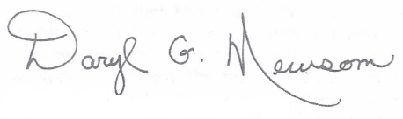
Elder Daryl G. Newsom, Moderator
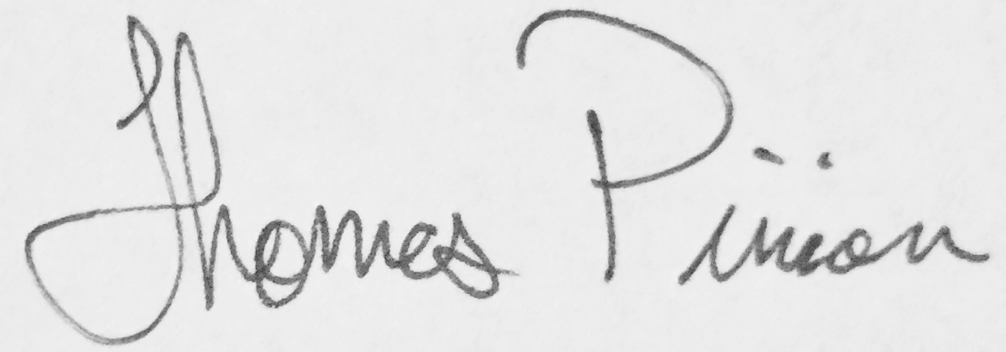
Deacon Thomas Pinion, Clerk
Saturday Afternoon Service
September 13, 2025
After singing a few well-loved songs of Zion, Elder Daryl Newsom welcomed everyone out and he asked Elder James McPherson to introduce the service.
Elder James McPherson began to preach. He recited John 3:16. Then he said, “When you leave here today, you ought to know that you know. Do you know God for yourself?”
Elder William Adair, Sr. led us in prayer and Elder Jason Varney began to preach. He said, “Your most important choice is to get to know God before it’s too late.” He concluded his sermon by saying, “Stand firm on the promises of God and He will deliver.”
Elder Barry Bowman sang a song, and Elder Anthony Phelps began to preach. He said, “He is worthy to be praised.” Then he recited Psalm 23 and John 3:16.
Elder Barry Bowman sand, “Don’t call the Role Until I Get There,” and Elder Burnis Simmons, Jr. began to preach. He read Jeremiah 23:10. He said, “Things sound good a lot in this world, but that doesn’t mean it’s from God,” and, “Everything that sounds good ain’t good.”
Elder Ronnie Houser sang, “Walking in Jerusalem Just Like John,” and Elder Brandon Newsom began to preach. He said, “I don’t understand why God is so good to me.” Then he described Satan as a roaring lion. He said, “I had to admit that I fell short of the glory of God,” and, “There is a Hell to shun and a Heaven to gain.”
Elder Barry Bowman sang, “I’m Going to Stay on the Battlefield Until I Die,” and Elder David Nichols led us in a prayer of dismission.

Sunday Morning Service
September 14, 2025
After singing a few well-loved songs of Zion, Elder Daryl Newsom welcomed all who had met out. He asked Elder Burnis Simmons, Sr. to introduce the services. He said, “Sometimes we move too fast and we miss what God has in store for us.” He spoke about not missing the train using an analogy of a kid missing the school bus.
Elder Josh Newsom lined, “I Have Started,” and Deacon Joey Justice led us in prayer.
Brother Danny Varney began to preach. He said, “I’m glad that I get to stand on the rock and proclaim that God is God and besides Him, there is no other.” Then he preached on the son who wanted his inheritance. He concluded his sermon by saying, “We have nothing in this land, but we got everything on the other side.”
Elder Ronnie Houser sang, “Walking in Jerusalem Just Like John,” and Elder David Nichols sang, “Old Ship of Zion,” before he began to preach. He read from Proverbs Chapter 8. He asked, “What do you want more than your next breath?” He said, “God so loved the world that He gave the best He had.”
Elder Ronnie Houser sang, “Jesus Knows,” and began to preach. He asked, “How much time do you have?” He said, “Parents, don’t give your children to the devil.” He sang, “I Want the World to See Jesus in My Life.”
Elder Daryl Newsom sang, “On That Shore,” and began to preach. He said, “God is so good to His children.” He explained that we may all be different, but God loves us all.
Elder William Adair, Sr. sang and Elder Larry Adkins led us in a prayer of dismission and asked for a blessing over the food.

Circular Letter
By: Elisha Justice

Dear Brothers and Sisters of The Solid Rock Association,
Through much prayer and trusting in the Lord I have attempted to write a letter that would be pleasing to the church and to God. Although I feel there are much more qualified brothers to be charged with this task, I consider it an honor to be asked. I have fought within myself on which direction I should go. And the one thing that kept coming back to me, was love. If we have been saved by the grace of God, I believe he has put this love inside each one of us.
As Christians, understanding we are by no means perfect, it should be our desire to be obedient to what God has asked us to do. In Ephesians 5:17 Apostle Paul tells us , “Wherefore, be ye not unwise, but understanding what the will of the Lord is.” Jesus even tried to simplify everything for us and left only two commandments. When asked what is the greatest commandment, Jesus replied “Thou shalt love the Lord thy God with all thy heart, soul, mind, and strength.” No doubt we would all confess that we love the Lord. These words are easily spoken. I have always been taught that actions speak louder than words. The book of James also tells us that faith without works is dead being alone. Sometimes we need to take a step back and examine ourselves, and ask the question, does God truly come first in our lives?
1 John 3:18 says “My little children, let us not love in word, neither in tongue, but in deed and in truth.” Our walk will speak much louder than our talk.
I believe that’s why Jesus spoke to the pharisees saying, “This people honoreth me with their lips but their heart is far from me.” This is not as simple as repeating after the preacher or quoting a scripture, but it is a heart condition. If it is nothing more than words to us, how can we expect to be a light to the world. We need to understand that without him, we would all still be lost without a hope. He has already expressed the greatest act of love toward everyone of us. John 15:13, “Greater love hath no man than this, that a man lay his life down for his friends.” He loved us and died for us while we were yet sinners, not worthy of that love. For this we owe him everything and ought to live our lives striving to please him, showing our love for him.
The second commandment he said to “Love thy neighbor as thyself.” Once again I would say that it is very easy to say the words. But how do we express this love one towards another? Is it through our gossip and jealous tendencies that come by the world? Or is it through sincerity of the heart? If this is not something that we live by, then what separates us from the world.
1 John 4:8 states “He that loveth not knoweth not God, for God is love.”
Therefore, if we do not love one another, how can we expect to draw those who are in the world. The book of Jeremiah even said “With loving kindness have I drawn thee.” Jesus took on the form of a servant and was made in the likeness of man. He was not concerned with how much he could gain in the world, but rather how many he could gain. He was feeding the hungry, healing the sick, and often found dining with the sinners. Jesus didn’t just say that he loved us but his actions showed just how much he loved us. I have been blessed to witness some amazing acts of love by great examples in my life. I’ve watched my grandparents feed complete strangers and welcome them into their home. I have watched my mamaw dig into her pockets to help someone else pay their bills. And in my papaws toughest hours after losing his wife of 72 years, he stood in front of the family telling us, “There is nothing in this world more important than love.” I agree wholeheartedly with his statement because as I stated before, God is love.
The world does not understand this love that I speak of. The devil is out there and he is always working to bring about confusion and division. We can see the effects of this all around us, by how confused the people of this world are. If we let him creep in, he will try to separate us. The devil is very good at his job. We have seen him separate churches, associations, separate families and friends. And no doubt there have been times when we have all felt alone. Even through all of our troubles and trials we can still rejoice in the Lord because we have a hope that goes far beyond this world. Time may have separated us from my dear sweet grandmother, but I will remember the shouts that were going up for the Lord during her funeral service, and long to hear the shouts that will be heard when I see her again. Though we may be separated from many things in this world, we have something the world can’t take from us.
Romans 8:35, “Who shall separate us from the love of Christ?”
Romans 8:37, “We are more than conquerors through him that loved us.”
If we continue to trust in the Lord and keep his commandments, he will see us through and he will make a way. I am thankful that he loved me and saved me. We surely are a blessed people, and we have something stronger than anything the world can throw at us. We have a lively hope in Jesus Christ. Although the outward man grows older and weaker, the inner man is getting stronger day by day. I hope if nothing else that I could encourage all of us to press onward striving to do the will of the father the best we can. Lets keep his commandments and love one another so that our light could shine before our children and before the whole world. In my papaws speech, he also said “Love will conquer everything.” Again I believe he is right, for love has already conquered everything, and love will take me home.

Your Brother in Christ
Elder Elisha Justice

Delegates & Alternates
To The 2025 Association

Canaan’s Shore Church
Delegates: Larry Hankins, Brandon Newsom, & Jeremy Newsom
Alternates: Chris Newsom

Lexington United Baptist Church
Delegates: Danny Varney, Eric Mullins, & David Nichols
Alternates: Jason Varney, Tony Rowe, & Tom Melton

Pilgrims Prayer Church
Delegates: Elisha Justice, Joey Justice, & Bryan Tuttle
Alternates: Johnny Cable, Dustin Charles, & James Newsome
Turner Church
Delegates: Josh Newsom, ET Turner, & Michael Turner
Alternates: Rocky Baker & Dustin Stanely
Southern Home Church
Delegates: William Adair, Jr., William Adair, Sr., & Bruce Forsyth
Alternates: Tommy Adair, Jr. & Edward Youmans

A Message from the Assistant Clerk
The Solid Rock Association of Old Time Baptists wishes once again to thank the Pilgrims Prayer Church for the use of their building and all its facilities for this great weekend.
We hope you had a blessed weekend, as we all did. Thank you so much for the warm welcome and the good food we shared. Thanks to all of you for being involved and making this one of the memorable weekends of our year.
We hope to be back next year on September 11, 12, & 13, 2026. We hope to see you all and hope you bring someone with you.
Your Servant in our Lord, Jesus Christ,
Brother Brandon Newsom, Assistant Clerk

Please Join Us for Our
27th Annual Session
It will be held Friday, Saturday, and Sunday
September 11-13, 2026
At the
Pilgrims Prayer Church
Located 20 miles south of Pikeville
Just off US-23 in
Dorton, Kentucky
We Would Love to See You There!

**Special Note**
Unless a church requests this to be different…. All regular meeting times are governed by the Saturday before the Sunday of the month.
This means: If a month begins on a Sunday, this would constitute an ODD or FIFTH Weekend of the month, and the following Sunday would be the First weekend.
To stay current throughout the year on news or new churches visit our web site for frequent updates (www.solidrockassociation.com).

Member Churches’ Information
Canaan’s Shore Old Regular Baptist Church
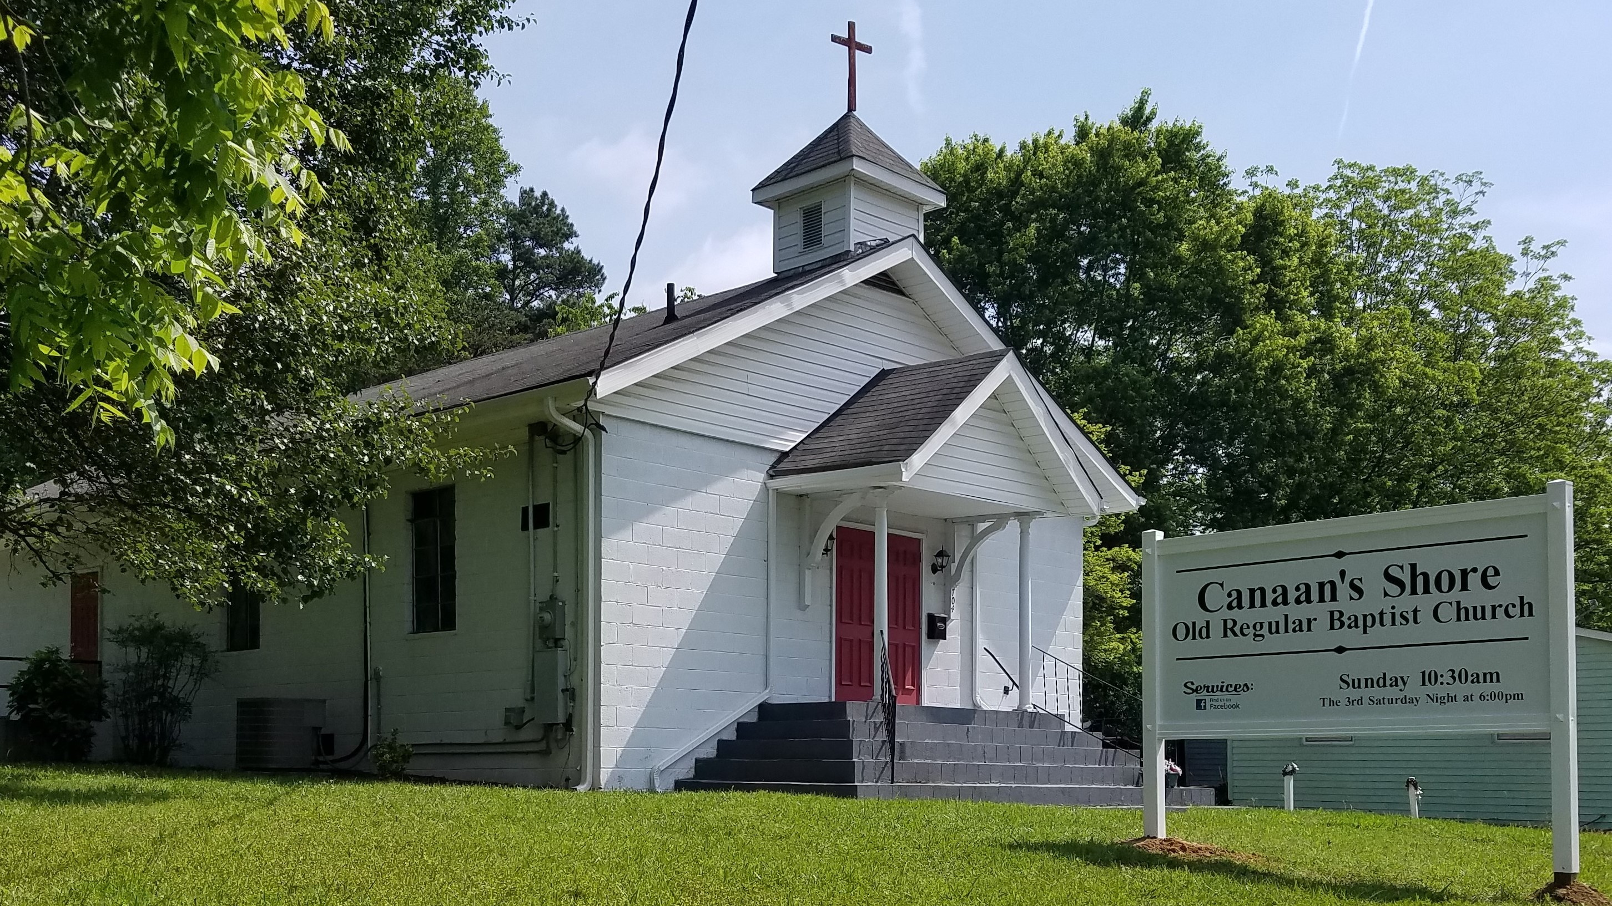

Located: Mount Airy, NC

Physical Address: 704 Worth Street
Mount Airy, NC 27030

Regular Meeting: Third Sunday of each month at 10:30 am
Business Session: Third Saturday of each month at 6:00 pm
Other Meetings: Every Sunday at 10:30 am

Moderator: Elder Chris Newsom (336) 701-7441
1545 W Westmoreland Dr
King, NC 27021

Asst. Moderator: Elder Brandon Newsom (336) 970-9073
2089 W Westmoreland Dr
King, NC 27021

Clerk: Elder Shadrach Newsome (336) 493-5188
1410 W Old Phillips Road
Pinnacle, NC 27043
Ordained Ministers: Larry Hankins (336) 351-3530
Brandon Newsom (336) 970-9073
Chris Newsom (336) 701-7441
Jeremy Newsom (743) 444-2325
Shadrach Newsome (336) 493-5188

Union Meeting: Third Weekend in March
Ministers Invited: Daryl Newsom, Danny Varney, & Shiloh Church Members

Communion Meeting: Third Weekend in October
Ministers Invited: Elisha Justice, Joey Justice (singing), Joel Hiatt, & Mike Newsom

Memorial Meeting: Third Weekend in May
Ministers Invited: David Nichols, Chad Reinthaler, Paul Staton, & Josh Newsom

Campfire Meeting: Third Weekend in November
Ministers Invited: Billy Adair, Jr., Joel Hiatt, & Jason Varney


facebook.com/CanaansShore youtube.com/user/CanaansShore

Lexington United Baptist Church
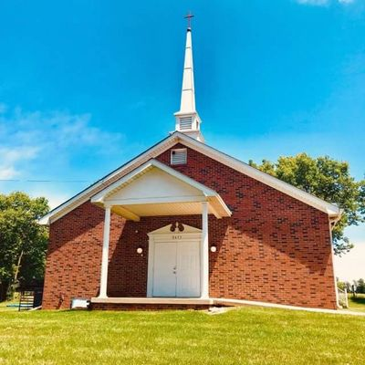

Located: Lexington, Kentucky

Physical Address: 9477 Rockwell Rd
Lexington, KY 40516

Regular Meeting: Every Sunday at 10:30 am
Business Session: Fourth Saturday of each month at 5:00 pm
Adult Bible Study: Every other Wednesday at 6:30 pm
Youth Bible Study: Every other Wednesday at 6:30 pm

Moderator: Elder David Nichols (606) 371-2840
2736 Lancaster Rd
Richmond, KY 40475

Asst. Moderator: Elder Ron Woodward (859) 229-0621
316 Potomic Drive
Winchester, KY 40391

Clerk: Brother Eric Mullins (606) 424-7930
3245 Becknerville Rd
Winchester, KY 40391

Treasurer: Brother Danny Varney (606) 416-0533
Asst. Clerk/Treasurer: Deacon Tony Rowe (859) 221-2060
Ordained Ministers: Jeff Cooper (859) 338-0617
Fred Neeley (606) 794-3690
David Nichols (606) 371-2840
Terry Ratliff (502) 603-1061
Chad Reinthaler (606) 367-1927
Johnny Sexton (606) 359-0352
Jason Varney (859) 229-8836
Ron Woodward (859) 229-0621

Liberated Ministers: Danny Varney (606) 416-0533
Union Meeting: Fourth Weekend in April
Ministers Invited: Ronnie Houser, Chris Newsom, Shad Newsome, & Chad Reinthaler
Communion Meeting: Fourth Weekend in June
Ministers Invited: Daryl Newsom, Elisha Justice, Joey Justice (special called singer), & Shad Walters
Memorial Meeting: Fourth Weekend in September
Ministers Invited: Clyde Bentley & Home Brothers
Special Service: New Year’s Eve
Ministers Invited: Billy Adair, Sr., Billy Adair, Jr. & Jeremy Newsom
Special Service: Fourth Weekend in February
Ministers Invited: Paul Staton
Fellowship Service: Fourth Weekend in May
Ministers Invited: All Fellowship Churches
Special Services: Fourth Weekend in July
Ministers Invited: Mike Newsom & Brandon Newsom

Church web site: https://solidrockassociation.com/lexington-united-baptist
Pilgrims Prayer Church

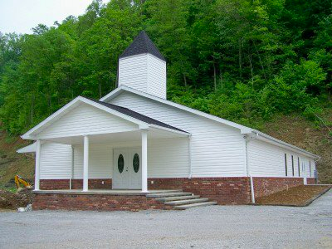

Located: Dorton, Kentucky

Physical Address: 121 Steve Wright Road Jenkins, KY 41537

Directions: Take US-23 about 20 miles South of Pikeville. Continue traveling South on US-23 through Dorton, about one-half mile. Church is located on the left and is visible from the four lane.

Regular Meeting: Second Sunday of each month at 10:00 am
Business Session: Second Saturday of each month at 6:00 pm
Other Meetings: Every Sunday at 10:00 am

Moderator: Elder Daryl G. Newsom (606) 424-3831
P.O. Box 241
Dorton, KY 41520

Asst. Moderator: Elder Mike Newsom (606) 213-6222
504 Caney Little Fork
Pikeville, KY 41501

Clerk: Deacon Thomas Pinion (606) 213-4151
42 Chick Jr Ln
Virgie, KY 41572

Asst. Clerk: Deacon Jonah Justice (606) 794-9549
Ordained Ministers: Larry Adkins (606) 854-7451 Elisha Justice (606) 939-4659 Daryl G. Newsom (606) 424-3831
Mike Newsom (606) 213-6222
Bennie Slone (606) 438-9384

Liberated Ministers: Mike Branham (606) 205-9271
Union Meeting: Second Weekend in June
Ministers Invited: Jeremy Newsom, Shiloh Brothers, & Danny Varney
Communion Meeting: Second Weekend in July
Ministers Invited: Joel Hiatt, Brandon Newsom, & Shad Newsome
Memorial Meeting: Second Weekend in August
Ministers Invited: David Nichols & Home Brothers
4th of July Memorial: Holifield/Tackett Memorial
Ministers Invited: Chris Newsom & Home Brothers

facebook.com/Pilgrims-Prayer-Church youtube.com/user/PilgrimsPrayer
Turner Old Regular Baptist Church

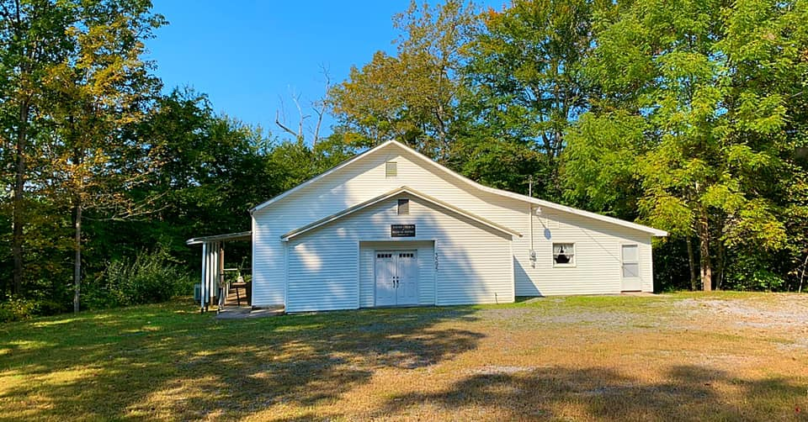

Located: Clinchco, Virginia

Physical Address: 3595 Backbone Ridge
Clinchco, VA 24226

Regular Meeting: First Sunday of each month at 10:00 am
Business Session: First Saturday of each month at 4:00 pm
Other Meetings: Every Sunday, except the Odd, of each month at 10:00 am

Moderator: Elder Josh Newsom (606) 213-1499
611 Bentley Honaker Rd
Pikeville, KY 41501

Clerk: Sister Aleisha Newsom (606) 213-1499
611 Bentley Honaker Rd
Pikeville, KY 41501

Ordained Ministers: Josh Newsom (606) 213-1499
Union Meeting: First Weekend in July
Ministers Invited: Elisha Justice, Paul Matthews, Mike Newsom, Dee Osborne, & Joey Justice (singing)
Communion Meeting: First Weekend in August
Ministers Invited: Daryl Newsom, Billy Adair, Jr., David Nichols, & William Adair, Sr.
Memorial Meeting: First Weekend in October
Ministers Invited: Jeremy Newsom, Shad Newsome, Chad Reinthaler, & Thomas Patrick

https://www.facebook.com/profile.php?id=100069170473011

Fellowship Churches
Southern Home Old Regular Baptist Church
(Granted Full Membership Rights in September 2021)
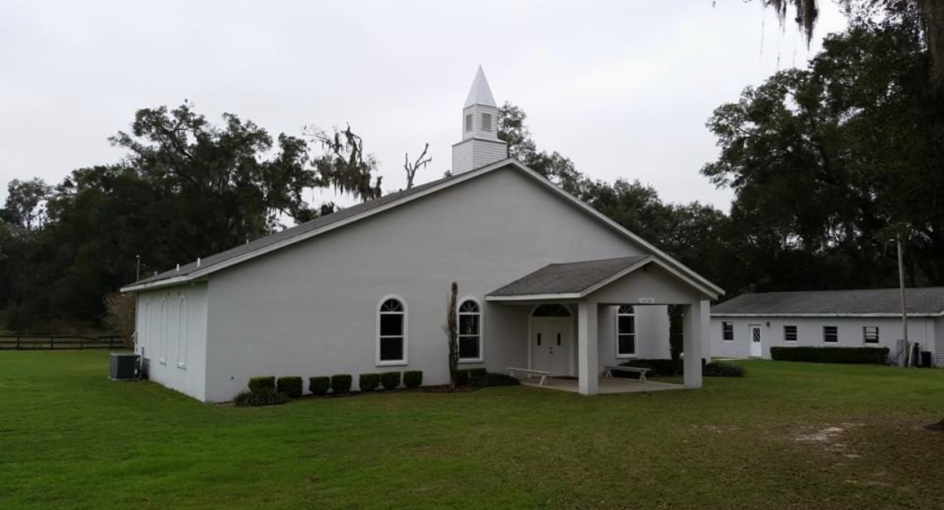
Located: Citra, FL
Physical Address: 14748 N Magnolia Avenue Citra, FL 32113-3647

Meeting Times: Every Sunday singing at 10:30 am, services
at 11:00am
Business Session: First Saturday at 11:00am

Moderator: Elder William A. Adair, Sr. (352) 875-6419
4358 NE 19th Avenue
Ocala, FL 34479

Asst. Moderator: Elder Bruce P. Forsyth (352) 817-5107
13067 NE 38th Avenue
Anthony, FL 32617

Clerk: Brother William R. Adair (352) 598-6432
1954 SE 88th Street
Ocala, FL 34480

Treasurer: Elder Tommy Adair, Jr. (352) 598-9573
Ordained Ministers: Tommy Adair, Jr. (352) 598-9573 William A. Adair, Jr. (352) 304-1078 William A. Adair, Sr. (352) 875-6419
Bruce P. Forsyth (352) 817-5107

Liberated Ministers: Brian Crossley (352) 300-6202
Edward Youmans (352) 857-4220
Communion Meeting: First Saturday in April
Ministers Invited: Clyde Bentley, David Nichols, Danny Varney, Jason Varney, & Ron Woodward
Memorial Meeting: First Sunday in June
Ministers Invited: Chris Newsom, Daryl Newsom, Kendrick Turner, & Shad Newsome
Special Meeting: First Saturday in October
Ministers Invited: David Baisden, William Baisden, Brandon Newsom, Jeremy Newsom, & Joey Evans

facebook.com/SHCORB youtube.com/@southernhomechurch7239

Fellowship Associations
Shiloh Primitive Baptist Association
Located: Elkin, NC

Physical Location: 10473 NC 268
Elkin, NC 28621

Phone: (336) 366-4389

Meeting Times: First, Third, and Fourth Sunday of each month at 11:00AM
Business Session: Saturday morning before the 3rd Sunday

Association Meeting: 4th Weekend in October
Ministers Invited: All Solid Rock Association Brothers
Moderator: Elder Ronnie Houser (336) 258-2055
Asst. Moderator: Elder Rodney France
Clerk: Elder Anthony Love

Tates Creek Association of Predestinarian Baptist Churches, Inc.
Located: Waco, KY

2025 Hosting Church
Physical Location: 377 College Hill Rd
Waco, KY 40385

Association Meeting: 3rd Weekend in August
Moderator: Elder Anthony Phelps
Vice Moderator: Elder Michael McPherson
Secretary: Elder Virgil Gardner
Asst. Secretary: Deacon York Stunson
Treasurer: Deacon Eric Garrett
Asst. Treasurer: Deacon Ricky McPherson
Dean of Religious
Education: Elder Barry Bowman

Constitution
From a long series of experiences, we the churches of Jesus Christ, being legally baptized upon a profession of our faith in Christ, and convinced of the necessity of a combination of churches in order to have a union and communion among us, and preserve, perpetuate, and maintain a correspondence with each other in our union, we therefore propose to keep the order and rules of an Association, in accordance with the following plan, or form, of government:

Article 1. The Association shall be called the Solid Rock Association of Old Time Baptist of Jesus Christ.

Article 2. The Association shall be composed of three (3) delegates from each church in our association, along with the elected officers. These delegates shall be duly sent to represent their church in the Association. They shall be members whom their church judge best qualified for that purpose. Upon producing letters from their respective churches, certifying their appointment, they shall be entitled to seats.

Article 3. Each church letter shall bear their annual statistics for numbers: in fellowship, baptized, received by letter, received by recommendation, received by restoration, dismissed by letter, dismissed by request, excluded and deceased.

Article 4. The delegates thus chosen and convened shall have no power to lord anything over God’s children, nor shall they have any clerical power over the churches, nor shall they infringe on any of the internal rights of any church in our union.

Article 5. The Association, when convened, shall be governed by a regular and proper decorum.

Article 6. The Association shall have a Moderator, Assistant Moderator, Clerk and Assistant Clerk. Each shall be chosen separately by a majority vote of the delegates present.

Article 7. Any church petitioning, for either full membership or fellowship status, is to submit formal paperwork to the Association at the annual Solid Rock Association meeting. They will fall under the watch care of the Association's Committee on Council for an examination period of one year. If, at the conclusion of the examination period, they are found to be orthodox and orderly, per report by the Committee on Council, they shall be received by the Association, and manifested by the Moderator, who shall give them the right hand of fellowship.

Article 8. Every church in the union shall be entitled to representation in the Association.

Article 9. Every query presented by a church to the Association, being first debated in their own church, shall come under the consideration of the Association.

Article 10. Every motion made and seconded shall be considered by the Association, unless it be withdrawn by the party who made it.

Article 11. We think it absolutely necessary that we have an Association fund, for defraying the expenses of the same. We think it the duty of each church in the union to contribute such sums as they think proper, and to send it by their delegates to the Association. Such sums shall be deposited in the hands of the Treasurer, chosen by the Association, who shall be accountable for the money.

Article 12. There shall be an Association Book kept wherein the proceedings of every association shall be recorded by a Secretary appointed by the Association. The Secretary shall receive annual compensation for his services.
Article 13. The minutes of the Association may be read, and
corrected if need be, and shall be signed by the Moderator and
Clerk before the Association arises, unless the same is dispensed with. All queries, requests and resolutions which have been debated in the current association, shall be read back.

Article 14. Amendments to this plan of government can only be made by unanimous decision of the union, if deemed necessary.

Article 15. The Association shall endeavor to furnish the churches with minutes of the Association; the best method of effecting the same shall be determined by the Association.

Article 16. All matters coming before the Association shall be decided by a will of the majority of the delegates present.

Article 17. The Association is to remain as an advisory council, and not as an administrative government. Each church SHALL hold its own Ecclesiastical Keys. Each church shall be the sole judge of its members’ conduct. Each church shall also have the right to decide who is worthy of membership, office or ordination.

Article 18. This Association shall have the power to:

A.) Provide for the general union of the churches, and to preserve an inviolable chain of communion between them;

B.) Give the churches all necessary advice in matters of church difficulty;

C.) Inquire into the cause as to why any church shall fail to represent themselves at any time in the Association;

D.) Appropriate the money contributed by the churches for any purpose it may think proper;
E.) Appoint any member, by their consent, to transact any business it may think necessary;
F.) Withdraw from any church in the union that does violate the Constitution, Articles of Faith or Rules of Decorum of the Association, or deviates from the orthodox principles of the Word of God as found in the book of Hebrews 6:1-2;

G.) To admit any orderly minister of our faith and order to a seat in the Association;

H.) To adjourn to any future time and place it deems convenient.

Articles of Faith
Article 1. We believe in one true and living God (1 Cor 8:6): Father, Son and Holy Ghost (1 John 5:7); and these three are one (John 14:8-11).

Article 2. We believe the scriptures of the Old and New Testaments, as translated in the King James Version, to be the inspired written word of God (2 Timothy 3:16; 2 Peter 1:21). The New Testament is the standard of faith and the ONLY authorized rule of faith and practice to the church of God under the gospel dispensation (Gal 5:4).

Article 3. We believe in the doctrine of election by Grace (Acts 10:43; Eph 2:8). We do not believe in particular election (Titus 2:11; Rom 10:13) and reprobation, so as to make God partial directly, or indirectly, or to injure any of the children of men.
Article 4. We believe in the doctrine of original sin (Rom 5:12), and of man’s inability to save himself from the fallen state he is in by nature; therefore, the Savior is needed for our redemption (Rom 5:17-19; Eph 2:8-9).

Article 5. We believe that sinners are called (Mark 2:17), converted, regenerated and sanctified by the Holy Spirit (1 Peter 1:23), and that all who are so regenerated and born again by the Spirit of God, shall never fall finally away (Eph 1:13; Heb 10:14).

Article 6. We believe that sinners are justified in the sight of God (Acts 13:39; Luke 18:13-14) only by the imputed righteousness of Jesus Christ in obedience to the calling of repentance (2 Timothy 1:9).

Article 7. We believe that baptism, the Lord’s Supper and feet washing are ordinances of Jesus Christ (Matt 3:13; Matt 26:26-29; John 13:4-14), and that true believers are the only proper subjects of these sacraments. And, we believe the only true mode of baptism is by immersion after receiving the spiritual baptism of the Holy Ghost (Rom 6:4).

Article 8. We believe in the resurrection of the dead (Luke 24:46; I Cor 15:51-53), and a general judgment, and that the joys of the righteous (1 Thess 4:16-17) and the punishment of the wicked will be eternal (John 5:28-29).

Article 9. We believe no minister has the right to administer the ordinances of the gospel, unless He has been called (Rom 10:15; 1 Cor 2:4) and has come under the imposition of hands by a presbytery of the church (Acts 13:2-3; Titus 1:5-15).
Article 10. We believe that every doctrine that goes to encourage or indulge people in their sins (1 Cor 5:2) or causes them to settle down on anything short of saving faith in Christ for salvation (Matt 7:13-14; Matt 7:21; Luke 13:23-24), is erroneous and such doctrine shall be rejected by us (Gal 1:8-10).

Article 11. We believe that all people reaching the age of accountability must be born again (Rom 7:9-10; John 3:3). We believe that all children dying in infancy, having not actually transgressed against the law of God (Rom 4:15), are only subject to the first death which was brought on them by the fall of the first Adam. No child dying in that state shall suffer punishment in hell by the guilt of Adam’s sin (Matt 18:1-5).

Article 12. We believe that God is not willing that any should perish, but that all should come to repentance and the knowledge of the truth, that they might be saved (2 Pet 3:9; John 3:16). All men, at one time or another, are found in such capacity as that through the grace of God they may be eternally saved (Rom 5:18).

Article 13. We believe that Christ has but one true and gospel church, and that it will finally persevere through grace to glory (Matt 16:18; 1 Cor 12:13). When the trump shall sound, the Son shall deliver up his church and present it to his Father, and so shall we ever be with the Lord (1 Thess 4:16-17).

Article 14. We believe that the Church is a congregation of faithful believers in Christ who have obtained fellowship with the Lord and with one another (Acts 2:41-42; 1 John 1:3). Jesus Christ is the head of the church, and the government thereof is upon His shoulders (Eph 5:23-24).

Rules of Decorum
Article 1. The Association shall be opened and closed with prayer.

Article 2. The Moderators and Clerks of the Association shall be selected by the delegates who are present.

Article 3. Only one member shall speak at a time and shall rise from his seat and address the Moderator when he is about to speak.

Article 4. The person speaking shall not be interrupted in his speech by anyone, except the Moderator, until he is done.

Article 5. The person speaking shall strictly adhere to his subject, and in no way reflect on the preceding speaker, but shall define his ideas on the proposition for debate so far as he can.

Article 6. No person shall abruptly absent himself from the Association without leave of the same.

Article 7. No member shall rise to speak more than three times on any one subject, without permission from the Association.

Article 8. No member of the Association shall have the liberty to laugh during the Association, nor whisper in time of public speech.

Article 9. No member shall address another in any other form or term other than that of “Brother” or “Sister.”

Article 10. The Moderator shall not interrupt a Brother, or prohibit him from speaking, until he gives his views on the subject, unless he has violated the Rules of Decorum.

Article 11. The names of the several members of the Association shall be enrolled by the Clerk and called over as often as the Association may require.
Article 12. The Moderator shall be entitled to the same privilege of speech as any member, provided the chair be filled. But, he shall have no vote, unless the Association be equally divided. In this event, he shall give the deciding vote.

Article 13. Any member who shall willfully and knowingly violate any of these rules shall be reprimanded by the Association as it may think proper.

Resolutions
Article 1. We believe that our article of faith #10 rejects sin, including homosexuality. We also believe that marriage is a union between a man and a woman, neither of which gender has been altered. It is further agreed that our ministers refrain from marrying people into this ungodly sin. (Adopted in 2004 minutes)

Article 2. In regard to letters of dismission, the association recognizes the complexity of this issue and agrees that this request falls under article #17 of our constitution, which states: The association is to remain as an advisory council and not as an administrative government. Each church shall be the sole judge of its members conduct. Each church shall also have the right to decide who is worthy of membership, office or ordination. (Adopted in 2004 minutes)

Article 3. We agree that several churches have already established a method of receiving previously ordained members into their fellowship. We recommend that the churches take care to uphold our articles of faith and constitution already established, particularly article of faith #9, and we note that the laying on of hands to issue credentials is an accepted practice with in our union. (Adopted in 2004 minutes)

Article 4. Under Article 7, any church organized under the authority of the Solid Rock Association, seeking membership, shall be immediately received and given the right hand of fellowship. This Article shall include any new associations seeking correspondence. Being a full member church of the Solid Rock Association grants voting rights to delegates, qualification to have members selected to preach the Introductory Sermon, and to write the Circular Letter. Fellowship churches only, are extended the right hand of fellowship as individual churches but do not have these authoritative rights. (Adopted in 2016 minutes)

Article 5. Under Article 14, the term "plan of government" pertains to the Association foundational documents including the Charter, Constitution, Articles of Faith, and Rules of Decorum. This does not apply to Article 16, which pertains to standard Association matters. (Adopted in 2016 minutes)
Article 6. We believe that our article of faith #10 rejects sin, including abortion. Many scriptures clearly state that God knew us while we were yet in our mother’s womb. (Adopted in 2022 minutes)

Obituaries
If you have an obituary you wish to publish in next year’s minute book please send it to the clerks by October 1, 2026. If the obituary is received later than this date, then it will be in the following year’s minute book.
Email or call Brandon Newsom for more information
bnewsom3@yahoo.com
(336) 970-9073

Precious in the sight of the Lord is the
death of His Saints.

(Psalm 116:15)

Ethel Ann Adair
September 1, 1943 – November 24, 2024 (age 81)
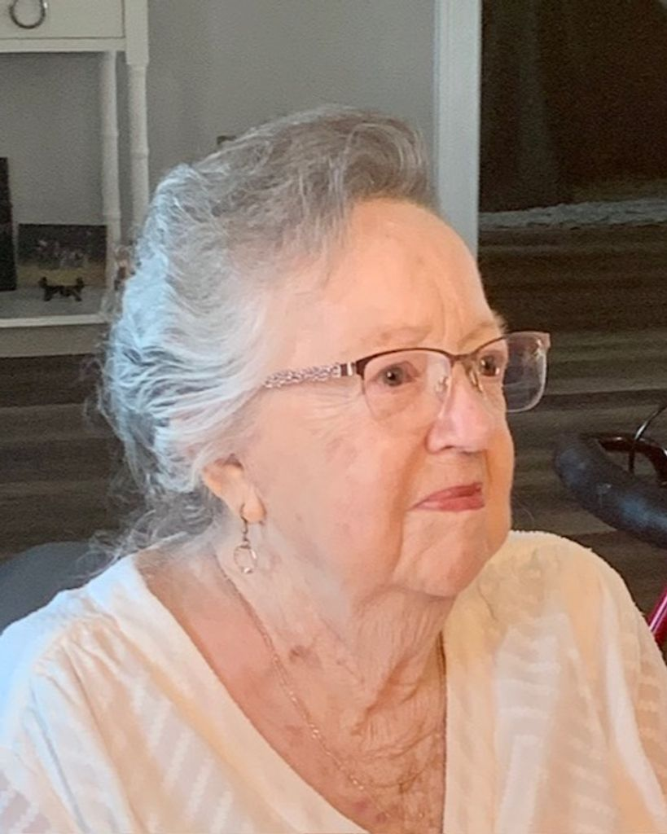
Ethel Ann Adair, age 81, of Anthony, Florida, passed away on November 24, 2024. She was born on September 1, 1943, in Delbarton, West Virginia, a daughter of Tommy and Margaret Adair. In addition to her parents, she is preceded by; son, Walter Gilley Jr; daughter, Angela Kay Gilley; sister, Ima Jean Watts.

She leaves behind; one son, Dennis Gilley (Patty); daughter-in-law, Sherri Janas; sisters, Rebecca Jarrell (Charley), Judy Young (Earnest), Erma Youmans (Edward), Lola Campbell (Stanley), Mary Paisley; brothers, Tommy Adair, Jr. (Karen), William Adair, Sr. (Colleen); nine grandchildren and nine great grandchildren.

Sister Ethel was a faithful member of the Southern Home Old Regular Baptist Church for more than 50 years. She exchanged this old world of sorrow for a mansion in heaven. She suffered in this life but is now singing with the angels in that “Land of Pure Delight”. We know she’s happy now, but it is so difficult to let her go. We’re sure there was much rejoicing when she joined all her loved ones as they welcomed her into her eternal home.

A Funeral Service will be held at Southern Home Old Regular Baptist Church on Friday, November 29, 2024, at 11:00 A.M. with visitation at 10:00 A.M. Interment will be in the Church cemetery.

Carolyn Sue (Scott) Hankins
August 5, 1945 – February 24, 2025 (age 79)
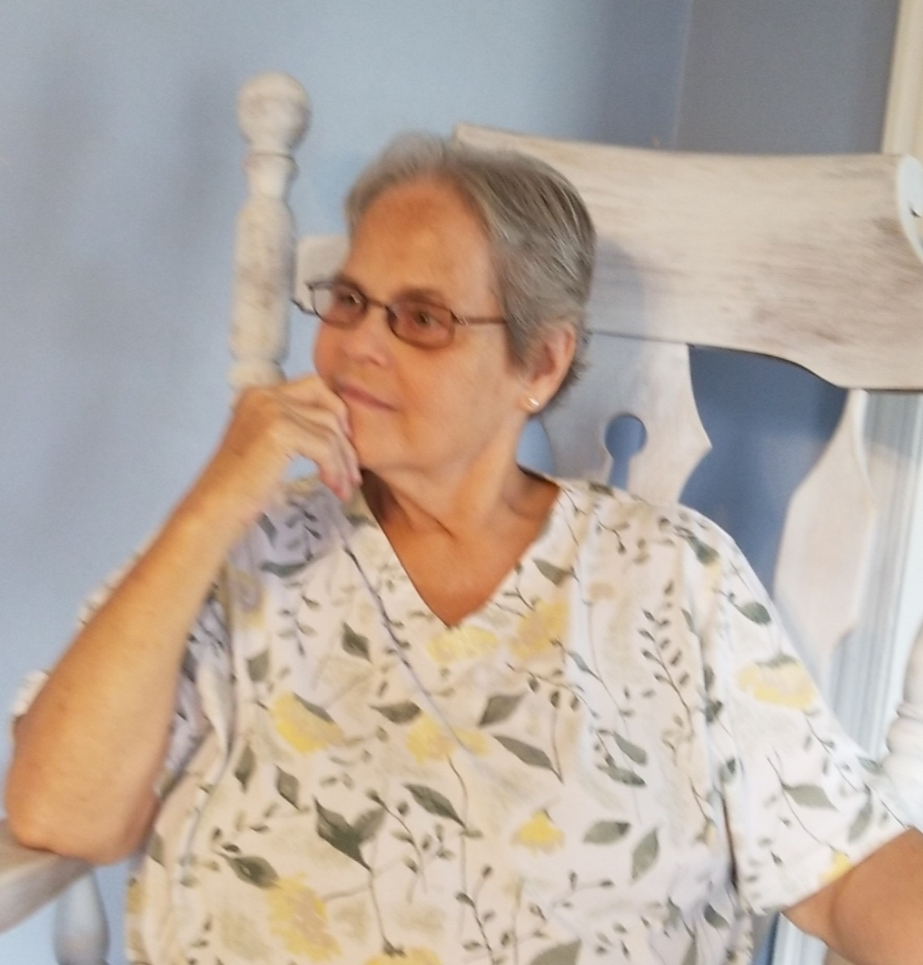
Carolyn Sue Scott Hankins. Mom, Mamaw, Nana, all names she proudly wore and cherished.
Nana was born on August 5th, 1945. She married Larry Hankins, Poppy, on Dec 25th, 1962. She was the greatest Christmas present he ever received. Together they had two loving daughters, 5 grandchildren, and 10 great grandchildren. But most importantly, December 4th, 1971, is when Nana found the Lord and was baptized. With this, their home and their life shined brightly for the Lord, which led a path in which their kids, grandkids, and even great grandkids have followed.
To know Nana and to be loved by her was one of Gods greatest gifts. Her words and actions were never not filled with love when you had her attention. She would praise God in all things and always let her light shine. She was a bold soldier for God but did so by being like a dove, soft and peacefully. The gentlest soul in the room. Never loud and never demanding. Never seeking the spotlight or attention. Just being content with what she had. If there was a crowd in the room you would find her sitting quietly, out of the way, with a smile on her face.
She had two great joys in her life: Her Lord and her family. The one time of year we would all be together, at Thanksgiving, before we could tear into the food, she would make us all take a moment and say what we were most thankful for. It was her favorite part of the day, and she would never waiver from this tradition of hers no matter how hard we groaned or rolled our eyes. Because even in this, she was able to have her family and reflect on the Lord at the same time. Thanksgiving will never be the same. She cherished having Shad come Wednesday night to prep the turkey, while taking goofy pictures, and then coming in the morning to cook it with her. She loved having both her girls there and beamed when her granddaughters would rave over her chocolate chip pies and pumpkin brownies. The last couple years, Nana would get very emotional talking to us around the table, just how thankful she was. Nana, I hope you know how thankful we are, for what you worked hard to build and instill in each of us.
Nana could sew and crochet anything. She made most of her girl’s clothes growing up, blankets to pass down for generations, and even made her daughter Carol’s wedding dress and all the bridesmaids’ dresses. It always comes to mind, “she works willingly with her hands.” Proverbs 31:13. As she got older, her hands began to not work quite like they used to. But she still tried to do what she could, like making all the floral arrangements for Rachel’s wedding. She passed down the sewing gene and a little bit of her granny spirit into her great granddaughter, Delilah, who could spend hours talking and sewing with her.
Nana would love to know anything and everything about you, if she figured out you liked something, she’d buy everything she could get her hands on for you. Growing up the grandkids were never in short supply of Tweety bird stuff, U of M and MSU apparel, and even ceramic cardinals because she knew that was her grandson’s school mascot. It was always a running joke, who would get another cardinal in their Christmas presents. She paid attention to detail with the great grand kids and made sure to keep their favorite snacks and toys. Nana would even get Shad a bag of jalapeños for his birthday every year because she knew he loves hot food, and Jeremy a can of mandarin oranges with his Christmas present. If it was your birthday, you could expect a phone call of her and Poppy singing to you.
Going up north to Nana and Poppy’s cabin was such a treat. Us grandkids knew we’d be spoiled endlessly. Looking for elk in the fields, playing badminton in their backyard, and laughing over and over again when Brandon and Jeremy swore they saw a huge bear, but it was actually a tree stump. Nana would love to sit in her sunroom, and she would tell Lauren and LeighAnna the story of David and Goliath because it was their favorite. She loved our visits up there and never said an ill word, just loved to have her family there with her.
When the grandkids started having kids, Nana and Poppy decided to move south to be closer to their great grandbabies. What a joy it was to have them close with these 10 kids running around. Nana loved to spend time with them and have her house full. She loved a clean house but never fussed when the kids were tearing it up. I hope she knew what an impact she’d had on her great granddaughters and their walk with the Lord.
At church she was known as the candy lady. It was her little trick to get the attention of all those great grandkids. They would mob her every Sunday, and she loved every minute of it. She would keep stock of each of their favorites, so she could get some love from them every Sunday while they took her treats.
Nana never met a stranger. She could talk your ears off about anything and everything. She could tell you someone’s life story, whether it be her favorite Arby’s worker, the Walmart employee they prayed with in the aisle, or so and so’s cousin. She wanted to know you, and she wanted you to know God. She didn’t shy away from praying with anyone and everyone. Any time you were on the phone, she’d have to tell you about it. Then she’d go on about how she was always praying for us and she’d end it with, “we will see you soon, Lord willing and the creek don’t rise. God bless ya honey, we love you lots.”
Her love for yellow roses, spaghetti and meatballs, Native American collectibles, the Gaithers, and anything coconut flavored, was only trumped by the love she had for us and her Jesus.
And for the last two weeks, she was surrounded by both, her family and God. While we have been beside ourselves with grief, knowing we were losing her, her faith never wavered. The scripture from 2nd Corinthians, chapter 4, verse 8, says, “We are troubled on every side, yet not distressed; we are perplexed, but not in despair.” That was her, as she knew her days were coming to an end, she never turned to self-pity, or got depressed, or anxious. She just patiently waited on the Lord. She continuously told us, how it was okay, she was looking forward to going home. While we doted on her and cared for her during her final weeks on this earth, she told us over and over again how much she loved us. We know Nana, you made sure we always felt it. The last couple days before she took her last breath, she was seeing and talking to someone who our earthly eyes and ears couldn’t see and hear. We could hear her whispering, with a smile on her face and her eyes closed. We’d ask her who she was talking to and she would become lucid for a moment and say, “Shh! You will know when your time comes.” I think that is the closest we will get to heaven on this earth, watching a child of God, pass from here to there. Just as her quiet and soft demeanor had always been, Nana quietly took her last breath and went home. She was surrounded by her loved ones, who softly rubbed her face and whispered, how much we loved her.
Now that we try to move on in life without our sweet Nana, we rest in God’s grace and peace that He has created the perfect place for us to go and that she is there waiting for us, probably sitting there quietly with a smile on her face. We are so thankful to have had her, to love us and show us how to be a light to others. If there is anything she would have wanted to leave behind for each and everyone us, it is to seek Jesus, don’t look to this world to fill the void in your life. Seek Him and go to Him with anything and everything. She would want you to have a conversation with a stranger, be the good in someone’s life. Show kindness and compassion, and she would want you to love with everything that you have.
We will see you soon Nana, Lord willing and the creek don’t rise. We love ya lots.

Grace Elizabeth Stanley
December 3, 1985 – November 14, 2024 (age 38)

Grace Elizabeth Stanley of 319 Jack Childress Hollow, Clinchco, VA was born on December 3rd, 1985 and passed away on November 14, 2024. Her stay here on earth was 38 years. She was the daughter of Mickey and the late Donna Blansett of Clintwood, VA. She was a member of the Turner Old Regular Baptist Church in Clinchco, VA.

She is survived by her husband, Dakota Stanley and five children: Allissa Dawn, Jesi Hope, Remi Ervin, Olivia Grace, and Tucker Ray Stanley; one estranged son, Mickey (Alliyah) Mullins of Pound, VA; sister, Patsy Howell of Dante, VA; and brother, Tommy Raines & companion, Ashley France of Birchleaf, VA.

Grace loved spending time with her kids and going fishing, attending the races, etc. She loved to draw, paint, and to work on race cars. She was an EMT and a member of the Haysi Rescue for 12 years. She also belonged to Clinchco & Clintwood Fire Departments for several years and Clintwood Rescue & Life Care Ambulance Service.

Grace was loved by everyone she met while serving her community. She helped save numerous lives during her career as an EMS worker for Dickenson & Wise Counties. She was in the process of obtaining her Advanced EMT when she was diagnosed with Stage 4 stomach cancer. She continued to work up until she could not any longer.

She had a very special dog named Stubby that stayed by her side until the very end. Words don’t do justice to the many things she accomplished during her lifetime.

Special Thanks to Kaydee, Nate, and her brother-in-law, Dustin Stanley.

A Celebration of Life will be held at a later date at Clinchco Fire Department

Melinda Joy Wright
March 5, 1965 – August 5, 2025 (age 60)
Melinda Joy Wright, age 60 of Dorton, Kentucky, a devoted wife and mother, passed away Tuesday, August 5, 2025. She was born on March 5, 1965, to Barbara Burke and the late Condred Burke.

Besides her father, she was preceded in death by one brother, Bobby Jack Burke. Other than her mother, Melinda is survived by her husband, Tiny Wright, of 41 years; one son, Donald Wright II; one brother, Condred Burke; and one sister, Vickie Eddington.

She loved her Pomeranians, Oscar of 16 years, and Buddy who is 6 years old. Melinda had a love for all different types of live flowers and plants. Christmas was her favorite time of the year. She would always have numerous trees and decorations up to celebrate the occasion.

Melinda was a true joy and blessed so many lives. If you were lucky to have known her, you would know exactly how true that statement is. She will always live in our hearts.
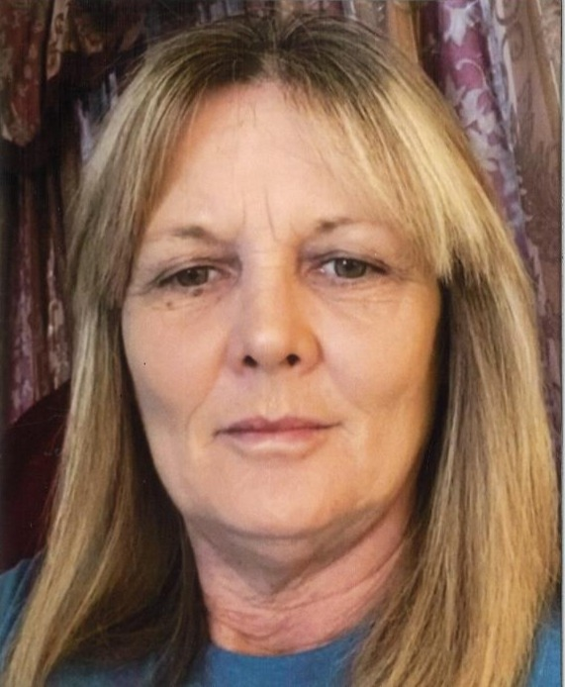

Notes

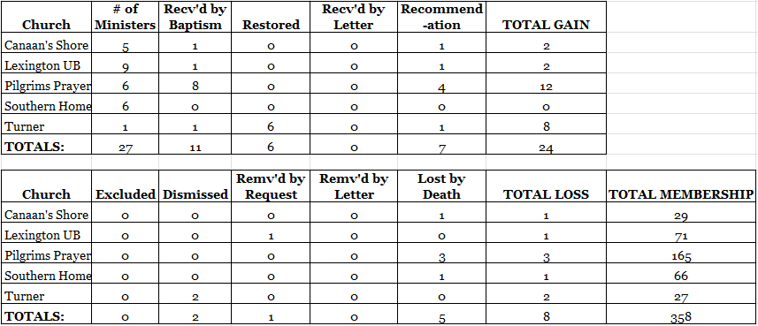

Dedication

The Solid Rock Association of Old Time Baptists would like to dedicate the time and love that we shared in this effort to the memory of our loved ones that have out-stripped us and gone on home. We hope to see them again on our judgment day. Until then, we will miss them and follow those steps that will lead us home also.

Officers of the
Solid Rock Association
of Old Time Baptists
of Jesus Christ

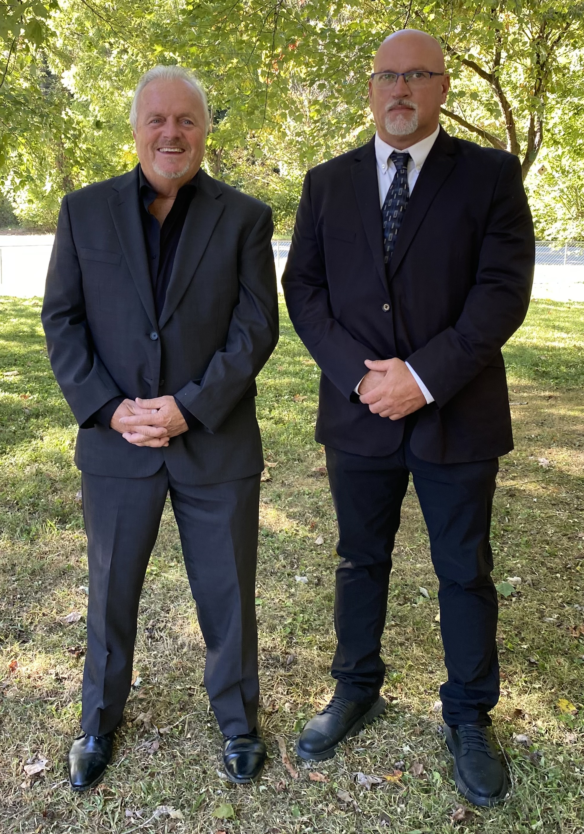
Daryl G. Newsom & David Nichols
Moderator & Assistant Moderator

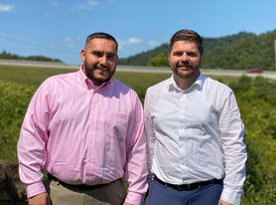
Thomas Pinion & Brandon Newsom
Clerk & Assistant Clerk

